

KINGKHALED UNIVERSITY
COLLEGE OF ARTS AND SCEINCE TANUMA
DEPARTMENT OF COMPUTER SCIENCES

"SMART LOCKER MANAGEMENT FOR PILGRIMS AND UMRAH PERFORMERS"

By:

Dalia Faiz Alshehri,444810348
Rinad Shaher Alsheri,444810057
Rania Dhafer Alshehri,444807162

Supervised by:

Dr.Ayman Alhalaybeh (Assistant Professor)
Sara Alsheri (Assistant Teacher)

This Project Documentation is submitted in partial fulfillment for the requirement for the Degree of Diploma
in information systems

September/2024
Rab.I /1446

COMMITTEE REPORT

We certify that we have read this graduation project report as examining committee, examined the student in its content and that in our opinion it is adequate as a project document for Diploma in information systems.

Examiner1
Name: ………………….

Signature: ….……….…..

Date: / /1446

Examiner2
Name: ………………….

Signature: ….……….…..

Date: / /1446

Supervisor
Name: ………………….

Signature: ….……….…..

Date: / /1446

ABSTRACT

The Deposit and Trust System for Pilgrims and Umrah Performers is a comprehensive framework designed to safeguard the financial assets and personal belongings of individuals undertaking pilgrimage. This system encompasses both financial deposits and physical items, ensuring that funds allocated for pilgrimage purposes are securely managed and easily accessible when needed. Key components include the establishment of dedicated trust accounts for financial deposits, which facilitate transparent transactions and protect against fraud. Additionally, the system provides secure storage options for personal belongings, minimizing the risk of loss or theft during travel. Support services are also integrated into the system, offering assistance to pilgrims in managing their finances and belongings effectively. Furthermore, awareness programs are conducted to educate pilgrims about their rights and responsibilities regarding their deposits and items. Overall, this system aims to enhance the safety and comfort of pilgrims and Umrah performers, contributing to a more positive and secure pilgrimage experience. We need some programming tools to build our website such as HTML, CSS , PHP , MySQL for dataset.

الملخص :

نظام أمانات وودائع المعتمرين والحجاج هو أطار شامل يهدف الى حماية الأصول المالية والممتلكات الشخصية للأفراد الذين يقومون بأداء مناسك الحج او العمرة يشمل هذا النظام كل من الودائع المالية والأغراض المادية مما يضمن إدارة الأموال المخصصة للأغراض الحج والعمرة بطريقة امنة وسهلة الوصول عند الحاجة تشمل المكونات الرئيسية إقامة حسابات امانات مخصصة للودائع المالية مما يسهل المعاملات الشفافة ويحمي من الاحتيال بالاضافة الى ذلك يوفر النظام خيارات تخزين امنة للممتلكات الشخصية مما يقلل من مخاطر الفقدان او السرقة اثناء الحج او العمرة .كما يتم دمج خدمات الدعم ضمن النظام حيث تقم المساعدة للمعتمرين في إدارة أموالهم وممتلكاتهم بشكل فعال علاوة على ذلك تعقد برامج توعية لتعريف المعتمرين والحجاج بحقوقهم وواجباتهم المتعلقة بودائعهم واغراضهم .بشكل عام يهدف هذا النظام الى تعزيز سلامة وراحة المعتمرين والحجاج مما يسهم في تحقيق تجربة حج او عمرة اكثر إيجابية وأمانا .نحتاج لانشاء موقعنا الى العديد من الأدوات البرمجية مثل: HTML, CSS, PHP, MySQL .

Acknowledgement
It is our privilege to express our sincerest regards to our project coordinator, Sarah Alshehri for their valuable inputs, able guidance, encouragement, whole-hearted cooperation and constructive criticism throughout the duration of our project. allowing us to present the project on the topic “SMART LOCKER MANAGEMENT FOR PILGRIMS AND UMRAH PERFORMERS “ at our department premises for the partial fulfillment for the requirement for the Degree of Diploma in Information systems. We take this opportunity to thank all our lecturers who have directly or indirectly helped our project.
We pay our respects and love to our parents and all other family members and friends for their love and encouragement throughout our career. Last but not the least we express our thanks to our friends for their cooperation and support.

TABLE OF CONTENTS

COMMITTEE REPORT II
ABSTRACT III
الملخص : IV
Acknowledgement V
TABLE OF CONTENTS VI
TABLE OF FIGURES IX
TABLE OF TABLES X
TABLE SYMBOLS/ABBREVIATIONS XI
CHAPTER ONE: INTRODUCTION 0
1.Introduction 1
1.1 Problem statement 2
1.2 Research Questions 3
1.3 Project Objectives 3
CHAPTER TWO: SYSTEM ANALYSIS 5
2.1 Overview 6
2.2 Functional Requirements 6
2.3 Non- Functional Requirements 7
2.4 Project Environment 8
2.5 Use Case diagram 9
2.6 Sequence Diagram 10
2.7 Dataflow Diagram 11
2.8 Class Diagram 12
2.9 ER Diagram 13
2.10 ER Tables 13
2.11 Use Case Tables 15
2.12 Project Scope 16
2.13 System Architecture 17
2.14 Project Chart 17
2.15 Methodology used 18
2.16 Literature Review 19
CHAPTER THREE: SYSTEM DESIGN 21
3.1 Overview 22
3.2 Welcome Page (index.php) 22
3.3 User Login Page (login_user.php) 23
3.4 Admin Login Page (login_admin.php( 24
3.5 Forgot Password Page (forgot_pass.php) 25
3.6 Admin Dashboard (admin_dashboard.php) 26
3.7 Manage Lockers Page (manage_lockers.php) 27
3.8 Add New Locker Page (add_locker.php) 28
3.9 Manage Users Page (manage_user.php) 29
3.10 Add New User Page (add_user.php) 30
3.11 Admin Profile Page (admin/profile.php) 31
3.12 Available Lockers and Reserve Locker Page (users/view_lockers.php) 32
3.13 View Reservations (admin/view_reservations.php) 33
3.14 My Reservations Page (users/my_reservations.php) 34
3.15 User Profile Page (users/profile.php) 35
3.16 User Signup Page (user_signup.php) 36
3.17 User Dashboard (user_dashboard.php) 37
CHAPTER FOUR : IMPLEMETATION 38
4.1 Welcome Page Code 39
4.2 User Login Page Code 40
4.3 Forgot Password Page Code 43
4.4 Admin Dashboard Code 46
4.5 Manage Lockers Page Code 48
4.6 Add New Locker Page Code 53
4.7 Manage Users Page Code 57
4.8 Add New User Page Code 62
4.9 Admin Profile Page Code 67
4.10 Available Lockers and Reserve Locker Page Code 71
4.11 View Reservations Code 79
4.12 My Reservations Page Code 84
4.13 User Signup Page Code 90
CHAPTER FIVE: CONCLUSION 95
5.1 Conclusion 95

TABLE OF FIGURES

Figure 2.1 Use Case Diagram………….………………………………………. 9
Figure 2.2 Sequence Diagram…………………………………………………. 10
Figure 2.3 Dataflow Diagram…….……………………………………………. 11
Figure 2.4 Class Diagram………………………………………………………. 12
Figure 2.5 ER Diagram………………………………………………………… 13
Figure 2.6 Project Scope…………………………………………..…………….16
Figure 2.7 Project Chart…………………...……………………………………17
Figure 2.8 Methodology Used………………………….………..………………18
Figure 3.1 Welcome Page …………….…………………………………………22
Figure 3.3 User Login Page.. ……………………………………………………23
Figure 3.4 Admin Login Page…………………………………………………...24
Figure 3.5 Forgot Password Page…………………………………………….…25
Figure 3.6 Admin Dashboard…………………………...………………………26
Figure 3.7 Manage Lockers Page…………………………………………….…27
Figure 3.8 Add New Locker Page…………………………………………….…28
Figure 3.9 Manage Users Page………………………………………….………29
Figure 3.10 Add New User Page…………………………………………...……30
Figure 3.11 Admin Profile Page………………………………...………………31
Figure 3.12 Available Lockers and Reserve Locker Page………………….…32
Figure 3.13 View Reservations ……………………………………………....…33
Figure 3.14 My Reservations Page ………………………………. ……………34
Figure 3.15 User Profile Page …………………… ……………….……………35
Figure 3.16 User Signup Page …………………… ………………….…………36
Figure 3.17 User Dashboard ………………………. …….…………………….37
Figure 4.1 Welcome Page Code…………………………………………………39
Figure 4.2 User Login Page Code…………………………………………….…40
Figure 4.3 Forgot Password Page Code………………………………….……43
Figure 4.4 Admin Dashboard Code……………………………………………46
Figure 4.5 Manage Lockers Page Code…………………………………..……48
Figure 4.6 Add New Locker Page Code…………………………………..……53
Figure 4.7 Manage Users Page Code……………...……………………………57
Figure 4.8 Add New User Page Code…………………………...………………62
Figure 4.9 Admin Profile Page Code…………...………………………………67
Figure 4.10 Available Lockers and Reserve Locker Page Code………………71
Figure 4.11 View Reservations Code…...………………………………………79
Figure 4.12 My Reservations Page Code………………………….……………84
Figure 4.13 User Signup Page Code………………………………………….…90

TABLE OF TABLES

Table 2.1 ER table for User………………………………………………… 13
Table 2.2 ER table for Locker……………………………………………… 14
Table 2.3 ER table for Reservation…….…………………………………... 14
Table 2.4 ER table for Payment…………………………………………….. 14
Table 2.5 Use Case Table……………………………………………………. 15
Table 2.6 System Architecture……………………………………………….17
Table 2.7 Methodology Used……………………………………………...….18
Table 2.8 Literature Review………..………………………………………...19

TABLE SYMBOLS/ABBREVIATIONS

Acronym | Definition
HTML | Hyper text markup language
CSS | Cascading style sheets
PHP | Hypertext Preprocessor
SQL | Structured query language

CHAPTER ONE: INTRODUCTION

CHAPTER 1: INTRODUCTION

1.Introduction

In recent years, the influx of pilgrims and Umrah performers has highlighted the need for efficient and secure storage solutions during their spiritual journeys. Smart locker management systems have emerged as an innovative solution to address these challenges, offering a blend of convenience, security, and advanced technology. These smart lockers allow pilgrims to store their belongings securely while they engage in religious activities without the burden of carrying extra luggage. Equipped with features such as mobile app integration, real-time tracking, and automated access, these lockers provide a seamless user experience.
This system not only enhances the safety of personal items but also contributes to a more organized and stress-free pilgrimage experience. By utilizing smart locker management, pilgrims can focus on their spiritual practices, knowing their belongings are secure and easily accessible when needed. As we explore the implementation and benefits of smart locker systems, we will examine how this technology can transform the experience for millions of pilgrims, making their journey more efficient and enjoyable.

1.1 Problem statement

The growing number of pilgrims and Umrah performers presents significant challenges in managing personal belongings during their spiritual journeys. Many pilgrims face issues such as:
1. Security Concerns: Traditional storage solutions often lack adequate security, leaving personal items vulnerable to theft or damage.
2. Limited Storage Options: Pilgrims frequently struggle to find secure and convenient places to store their belongings, leading to unnecessary stress and distraction from their spiritual practices.
3. Inefficient Access: Current storage systems can be cumbersome and time-consuming, requiring manual processes that detract from the overall experience.
4. Lack of Real-Time Tracking: Without the ability to track stored items, pilgrims may feel anxious about the safety of their belongings.
5. Technological Gap: Many existing solutions do not leverage modern technology, making them less appealing to a tech-savvy demographic.
The need for a comprehensive Smart Locker Management System arises from these challenges. By providing a secure, efficient, and user-friendly solution, this system aims to enhance the pilgrimage experience, allowing individuals to focus on their spiritual journey with peace of mind regarding their personal belongings.

1.2 Research Questions

1. What are the primary security concerns of pilgrims regarding their personal belongings during their journey?
- How do these concerns impact their overall pilgrimage experience?

2. How can smart locker systems enhance the safety and security of personal items for pilgrims?
- What technologies (e.g., biometric access, real-time tracking) are most effective in addressing these concerns?

3. What features do pilgrims prioritize in a smart locker management system?
- How do these preferences vary among different demographics (age, gender, nationality)?

4. What are the current limitations of existing storage solutions for pilgrims, and how can these be addressed with smart technology?
- What feedback do users provide regarding their experiences with traditional storage options?

1.3 Project Objectives

1.3.1 Aims
1. Enhance Security: To provide a secure storage solution for pilgrims' personal belongings, ensuring peace of mind during their pilgrimage.
2. Improve User Experience: To offer an intuitive and user-friendly smart locker system that caters to the diverse needs of pilgrims.
3. Optimize Operational Efficiency: To develop a system that maximizes space utilization and minimizes wait times for locker access.
4. Promote Economic Growth: To analyze the potential economic benefits of smart locker systems for service providers and local economies.

1.3.2 Objectives
1. Conduct User Research: Gather insights on pilgrims’ security concerns and preferences regarding storage solutions through surveys and interviews.
2. Develop Technological Specifications: Identify and integrate advanced technologies (biometric access, real-time tracking) into the smart locker system to enhance security and usability.
3. Design User-Centric Interface: Create a user-friendly interface for the smart locker system that accommodates varying levels of technological proficiency among users.
4. Evaluate Current Storage Solutions: Analyze existing storage options for pilgrims to identify gaps and opportunities for improvement through smart technology.
5. Implement Mobile Integration: Develop a website that facilitates easy access to locker management features and enhances overall user experience.
6. Assess Economic Impact: Conduct a cost-benefit analysis to determine the economic viability of implementing smart locker systems in pilgrimage areas.

CHAPTER TWO: SYSTEM ANALYSIS

- H

2.1 Overview
In this chapter, will discuss about the system requirement specification which is the functional and non-functional requirements to provide a clear direction to the user what services does the new system provide. Besides, UML diagrams such as Use Case Diagram, Activity Diagram, Business Level Activity Diagram, Sequence Diagram as well as Collaboration Diagram is provide to allow the user to better understanding on the system workflow.

2.2 Functional Requirements
2.2.1 User Registration and Management
- User Registration: Allow users to create an account by providing personal details (name, email, phone number, nationality).
- User Login: Enable users to log in using their name and password.
- User Profile Management: Allow users to update their profile information and change passwords.
2.2.2 Locker Management
- View Available Lockers: Provide users with a list of available lockers, including their locations and statuses.
- Reserve Lockers: Allow users to reserve a locker for a specific time slot.
- Check Locker Status: Allow users to check the current status of their reserved lockers.
2.2.3 Payment Processing
- Payment Options: Offer multiple payment methods (credit card, debit card, cash, mobile payment).
- Payment Confirmation: Provide users with confirmation of payment and a receipt..
2.2.4 Admin Management
- Admin Login: Provide an admin interface for authorized personnel.
- Manage Lockers: Allow admins to add, update, or remove lockers.
- View Reservations: Enable admins to view all current and past reservations.
- Manage Users: Allow admins to view and manage user accounts.
2.2.5 Security and Privacy
- Data Protection: Ensure that all user data is stored securely and complies with privacy regulations.
- Authentication: Implement secure authentication methods, including password encryption.

2.3 Non- Functional Requirements
- Performance: The system should handle multiple concurrent users without significant delays.
- Reliability: Ensure high availability of the system, especially during peak times like Umrah seasons.
- Usability: The interface should be user-friendly and accessible, particularly for users who may not be tech-savvy.
- Scalability: The system should be designed to scale easily with an increasing number of users and lockers.

2.4 Project Environment
For this project, an integrated development environment will be used for most of the development works while other tools will also be used as supplementary. The following are the software and tools that will be used for the development of this project.
2.4.1) Programming Languages :
- HTML
- CSS
- PHP
- JAVASCRIPT
2.4.2) Relational Database Management Software
• MySQL

2.5 Use Case diagram
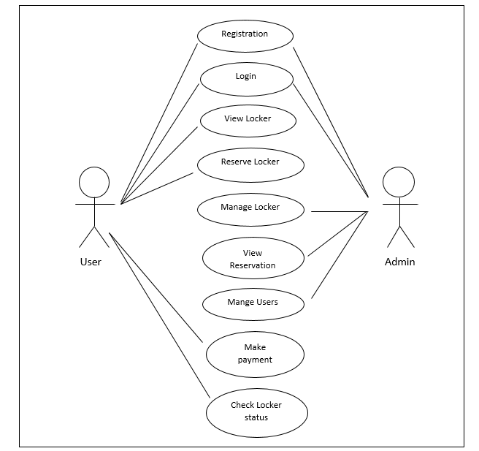
Figure2.1 Use case Diagram

2.6 Sequence Diagram
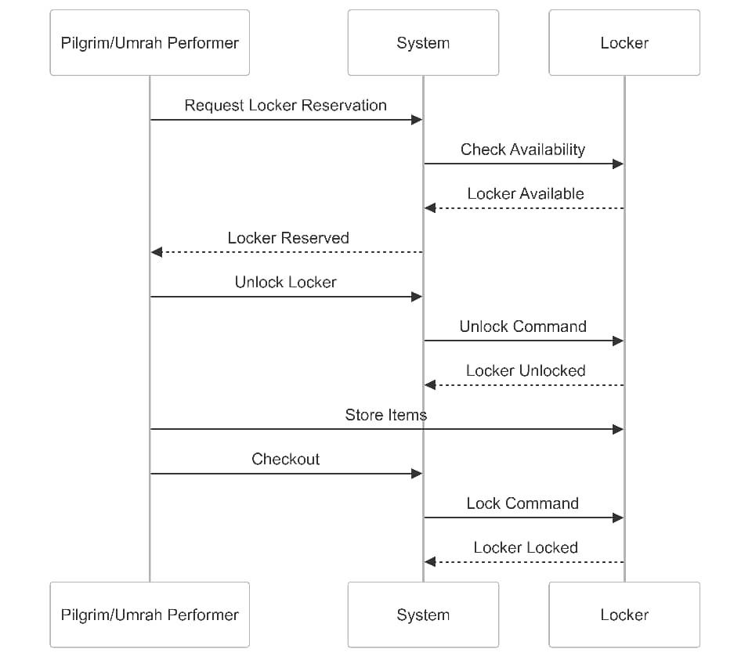
Figure2.2 Sequence Diagram

2.7 Dataflow Diagram
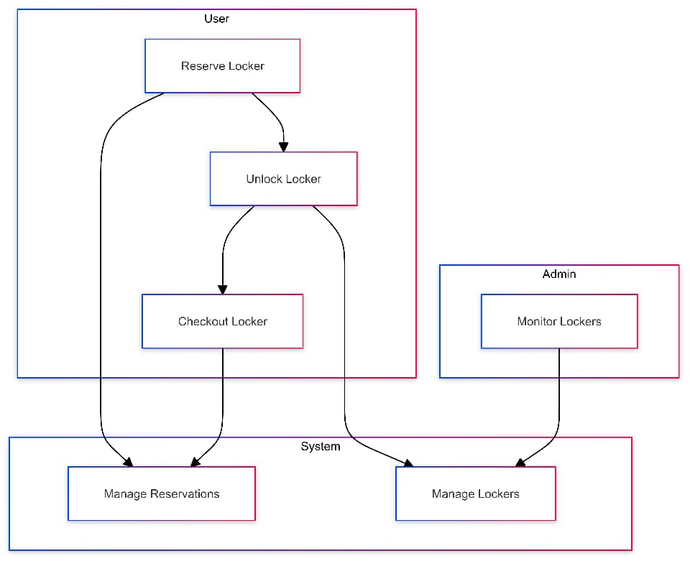
Figure2.3 dataflow diagram

2.8 Class Diagram
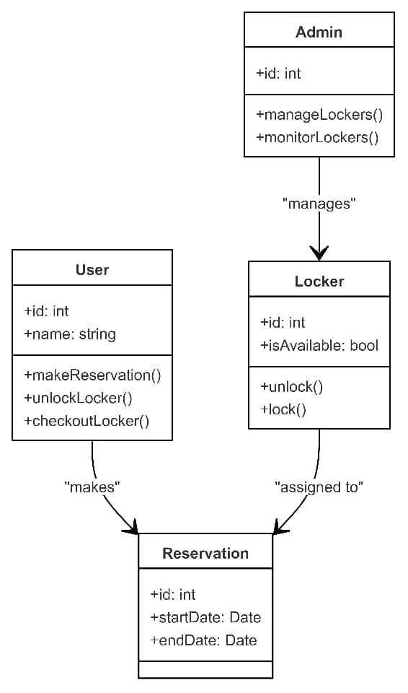
Figure2.4 class diagram

2.9 ER Diagram
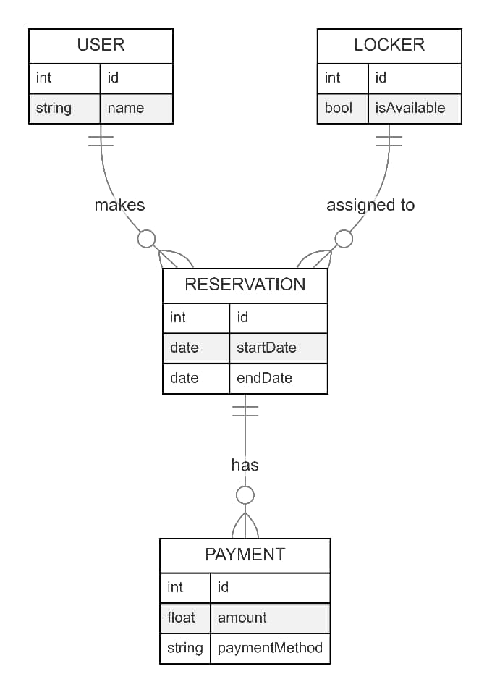
Figure 2.5 ER diagram

2.10 ER Tables
Field name | Data type | key
user_id | int | Primary key
name | varchar
email | email
phone_number | number
nationality | varchar
created_at | datetime

Table2.1 ER table for User

Field name | Data type | key
locker_id | int | Primary key
location | varchar
status | varchar
created_at | datetime
Table 2.2 ER Table for Locker

Field name | Data type | key
reservation_id | int | Primary key
user-id | int | Foreign key
locker_id | int | Foreign key
start_time | datetime
end_time | datetime
status | varchar
Table 2.3 ER table for Reservation

Field name | Data type | key
payment_id | int | Primary key
reservation_id | int | Foreign key
amount | float
payment_date | datetime
payment_method | varchar
Table 2.4 ER table for Payment

2.11 Use Case Tables
Use case ID | Use case name | Actor(s) | Description
Use case 1 | User Registration | User | Allow a user to create an account by providing required personal information.
Use case 2 | User Login | User | Enables a user to log into the system using their name and password.
Use case 3 | View Available Lockers | User | Display a list of lockers that are currently available for reservation
Use case 4 | Reserve Locker | User | Allow a user to reserve a select locker for a specified time period
Use case 5 | Make payment | User | Allow user to make a payment for a locker reservation using various method.
Use case 6 | Admin Login | Admin | Enables an admin to log into the management system.
Use case 7 | Mange Locker | Admin | Allow an admin to add, update locker information .
Use case 8 | View Reservations | Admin | Enables an admin to view all current and past locker reservation
Table 2.5 Use case table

2.12 Project Scope

SMART LOCKER MANAGEMENT FOR PILGRIMS AND UMRAH PERFORMERS

User
Admin

Registration
Registration

Login
Login

Add Locker
View Locker

Update Locker
Reserve locker

Payment
View Reservation

Figure 2.6 Project Scope

2.13 System Architecture
SMART LOCKER MANAGEMENT FOR PILGRIMS AND UMRAH PERFORMERS
Client-Side |  | Server-side
User | Admin | services | database
-Registration  -Login  -View Locker  -reserve Locker  -payment | -Registration  -Login  -Add Locker  -Update Locker  -View Reservation | -Locker information  -Reservation information  -View Available Reservation | -User  -Reservation  -Locker
Table 2.6 System Architecture

2.14 Project Chart

sep | oct | Nov | Dec | Jan | Feb
Feasibility study--------------------- 1sep -20 sep
Dyu
Requirements --------------------------------------- 21 sep- 30 sep
Dyu
Design ---------------------------------------------------------- 1oct – 30 oct
Dyu
Development ---------------------------------------------------------- 1Nov-15Feb
Dyu
Testing ------------------------------------------------------------------------------ 16 Feb-30Feb
Dyu
Figure2.7 Project chart

2.15 Methodology used
PLANNING

ANALYSIS
DESIGN
DEVELOPEMENT
TESTING

Figure2.8 Methodology used

Phase | Description
Planning Stage | Define project scope, objectives, and stakeholders. Identify project goals and deliverables. Engage with stakeholders to gather initial requirements. and Create a project charter outlining roles, responsibilities, and timelines.
Analysis Stage | Collect detailed functional and non-functional requirements. - Conduct interviews, surveys, and workshops with users and stakeholders. Document user stories to capture desired features from the user's perspective.
Design Stage | Create architectural and UI/UX designs. - Develop system architecture diagrams to outline components and interactions. Create wireframes and mockups for user interfaces. and Define database schema and data flow.
Development Stage | Build the system incrementally through iterative sprints. - Organize work into sprints. Conduct daily stand-up meetings (scrums) to track progress and address challenges. Implement features based on prioritized backlog items. Perform continuous integration to ensure code quality.
Testing Stage | Verify that the system meets requirements and is free of defects Conduct unit testing for individual components. Perform integration testing to ensure components work together. Facilitate user acceptance testing (UAT) with stakeholders to validate functionality.
Table 2.7 Methodology used

2.16 Literature Review
No | Title | Technique | Limitations
1 | Smart lockers in logistics: A review of applications and future directions | Literature review and case studies | Limited focus on specific user demographics; regional studies may vary
2 | The role of smart lockers in public transportation: Improving user experience | User surveys and interviews | Small sample size; may not represent all user groups
3 | Hardware and software components of smart lockers | Technical analysis and component evaluation | Lacks user-centered assessments of hardware usability
4 | User experience design for smart locker systems: A study on usability | Usability testing and heuristic evaluation | Focused on a single interface; may not cover diverse user experiences
Table2.8 Literature review

CHAPTER THREE: SYSTEM DESIGN

3.1 Overview
Smart locker management for pilgrims and Umrah performers is designed to provide a secure ,convenient ,and efficient solution for managing personal belongings during their spiritual journeys. By integrating modern technology with user-friendly interfaces, the system aims to enhance the overall experience of pilgrims and ensure peace of mind while they engage in their religious activities. also it is designed to enhance the safety, accessibility ,and overall experience of travelers .

3.2 Welcome Page (index.php)
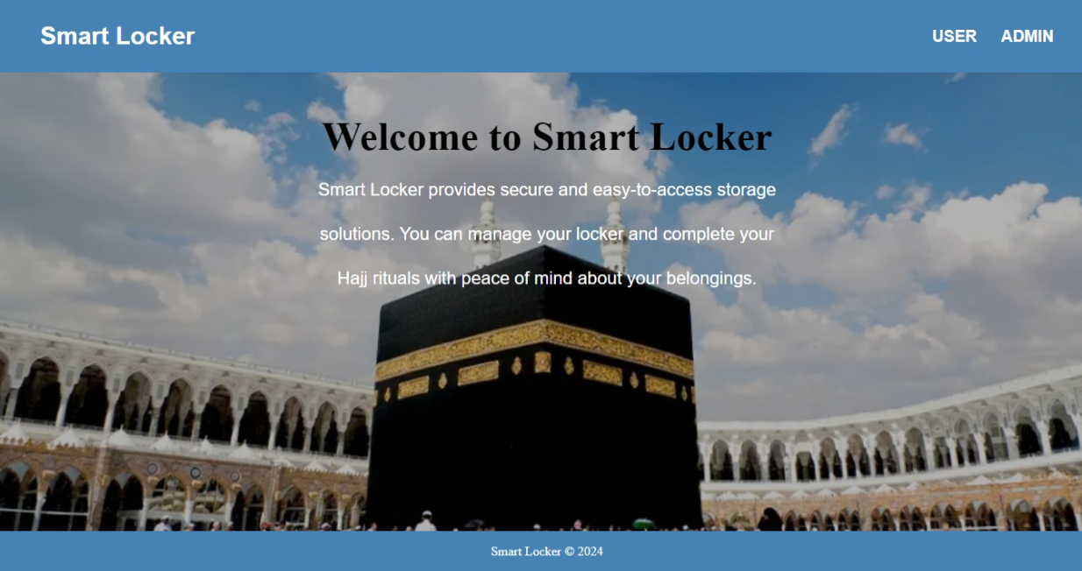
Figure 3.1 Welcome Page (index.php)
This is the main landing page for the "Smart Locker" application, presenting a welcoming message to users. The page introduces the service, highlighting secure and accessible locker storage, particularly useful for Hajj pilgrims to safely store belongings. The "User" and "Admin" links at the top allow navigation to the respective login pages.

3.3 User Login Page (login_user.php)
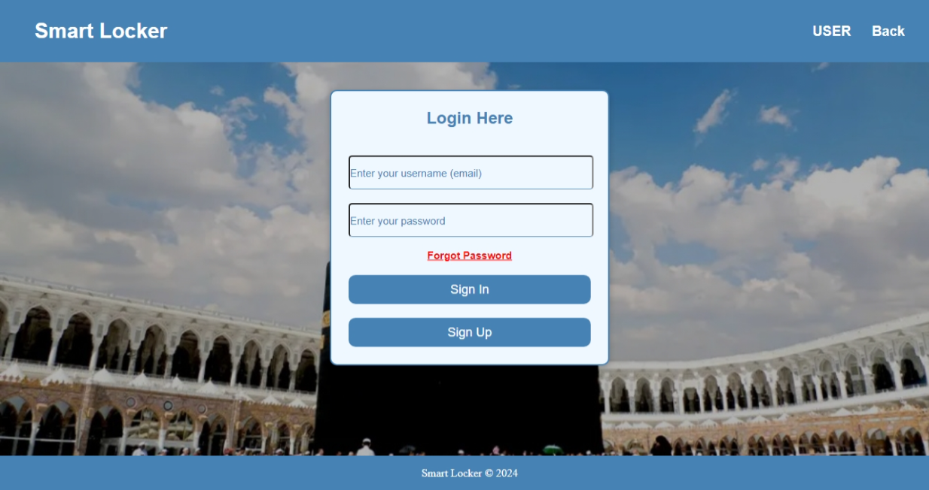
Figure 3.2 User Login Page (login_user.php)
This page is designated for user login. Users enter their email and password to access their personal dashboard. The page also provides options for signing in, registering a new account ("Sign Up"), and recovering forgotten passwords, ensuring smooth access for users.

3.4 Admin Login Page (login_admin.php(
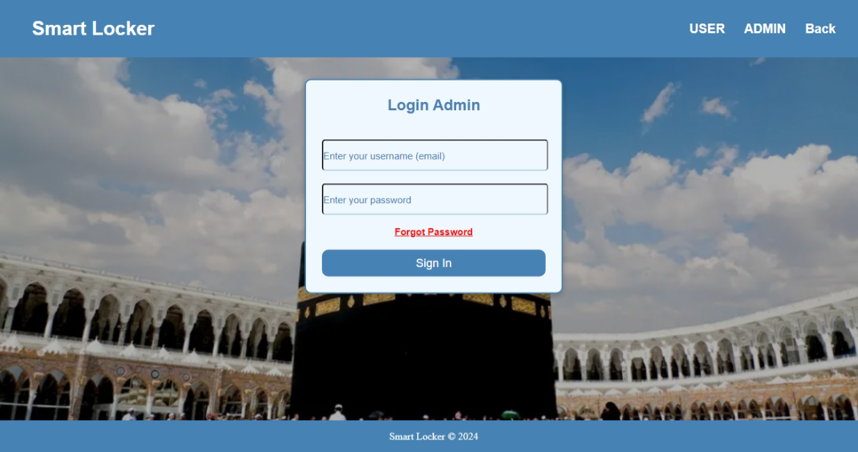
Figure 3.4 Admin Login Page (login_admin.php(
The admin-specific login page allows administrative staff to log in securely with their email and password. This separate login ensures that only authorized personnel access the administrative functions of the system. Similar to the user login, it also includes a "Forgot Password" link for recovery.

3.5 Forgot Password Page (forgot_pass.php)
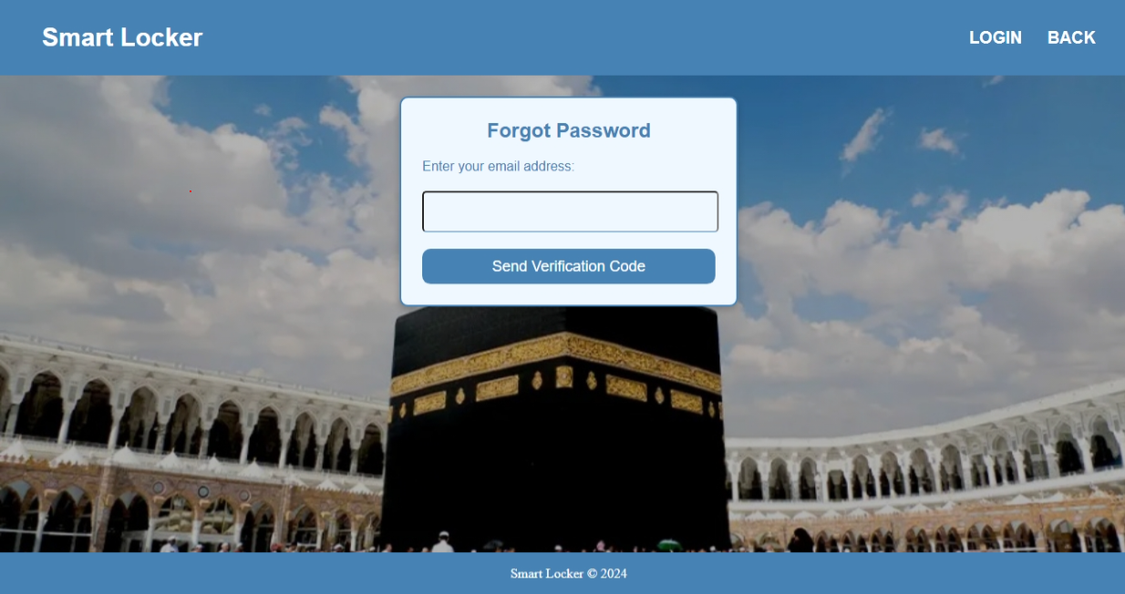
Figure 3.5 Forgot Password Page (forgot_pass.php)
This page allows users to recover access to their accounts. Users input their registered email address to receive a verification code, which helps in securely resetting the password without compromising the account’s security.

3.6 Admin Dashboard (admin_dashboard.php)
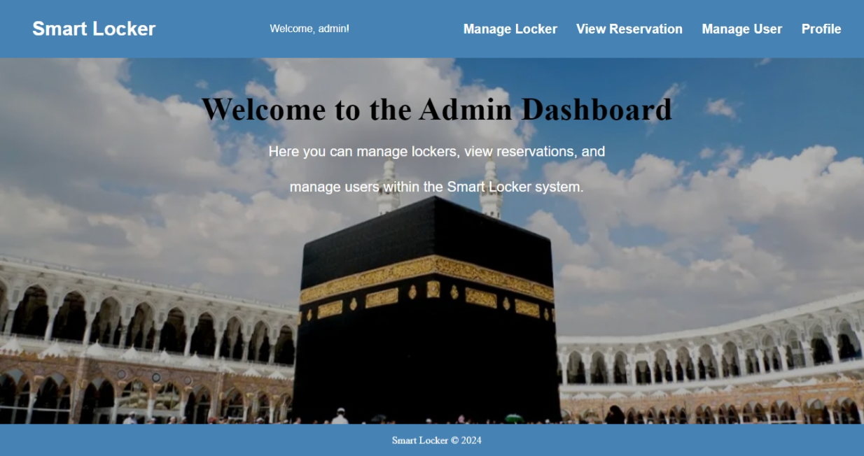
Figure 3.6 Admin Dashboard (admin_dashboard.php)
The Admin Dashboard is the primary interface for system administrators, offering them a comprehensive overview of the management functions within the "Smart Locker" system. From this central hub, admins can easily navigate to different sections such as "Manage Locker," "View Reservation," "Manage User," and "Profile." Each section is designed to facilitate efficient oversight and control of the locker system. For example, administrators can check the current status of lockers, review and manage user reservations, handle user accounts, and update their profile information. This dashboard ensures that all essential administrative functions are consolidated, allowing admins to maintain a smooth operation and provide a seamless experience for users.

3.7 Manage Lockers Page (manage_lockers.php)
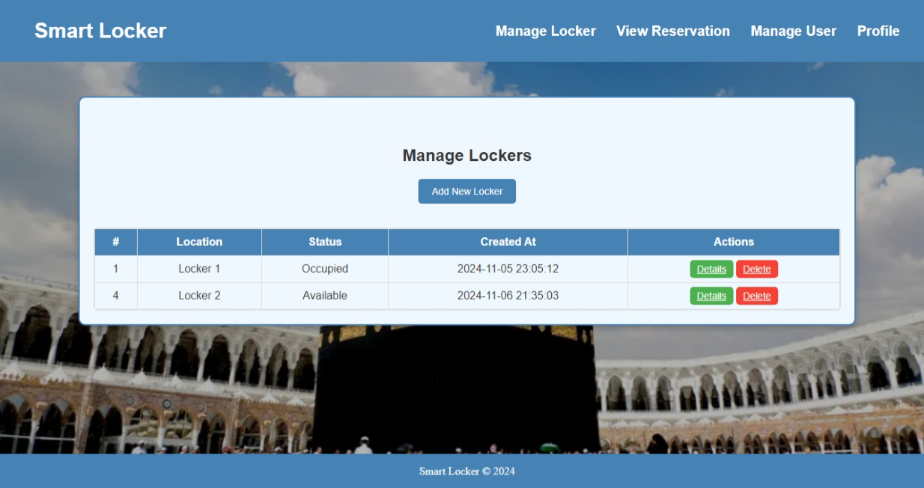
Figure 3.7 Manage Lockers Page (manage_lockers.php)
This page provides a detailed list of all lockers in the system, showing key information for each locker, such as its location, current status (e.g., occupied or available), and the date it was created. Administrators have control options beside each locker entry, with actions like "Details" for viewing more in-depth information about a specific locker and "Delete" for removing a locker from the system if it's no longer needed. The "Add New Locker" button allows admins to add additional lockers as demand increases, ensuring the system can scale to accommodate more users. This page plays a vital role in locker inventory management, helping admins to track locker availability and respond to user needs.

3.8 Add New Locker Page (add_locker.php)
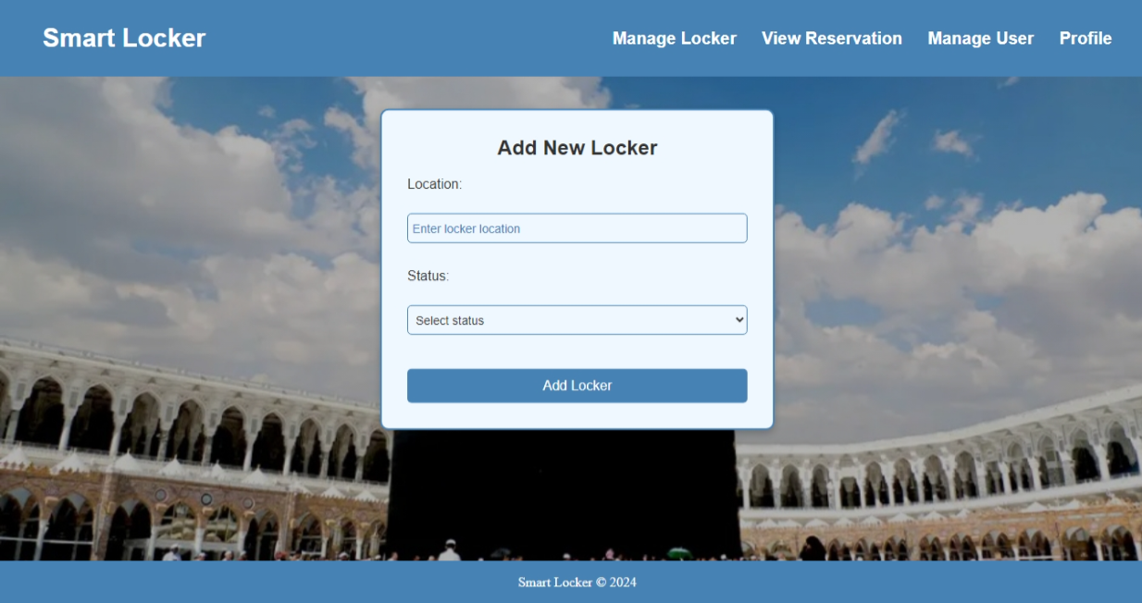
Figure 3.8 Add New Locker Page (add_locker.php)
The Add New Locker page allows administrators to expand the locker inventory by creating new locker entries. Admins input the location of the locker and select its status (e.g., available or occupied) to set up each locker according to the system’s requirements. This page streamlines the process of adding lockers, making it easy for admins to increase the number of available storage spaces as the user base grows or when more lockers are required during peak times, such as pilgrimage seasons. This page ensures that new lockers can be quickly added to the system, maintaining an organized approach to scaling resources.

3.9 Manage Users Page (manage_user.php)
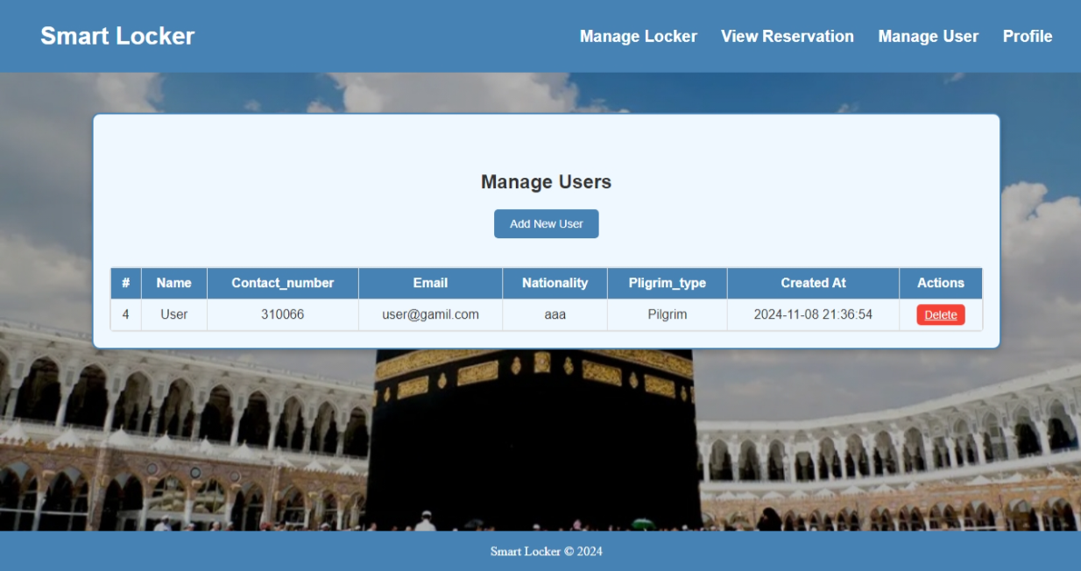
Figure 3.9 Manage Users Page (manage_user.php)
The Manage Users page displays a comprehensive list of all registered users in the system, along with pertinent details like their name, contact number, email address, nationality, pilgrim type, and the date they were added to the system. Each user entry includes an "Actions" column, allowing admins to delete users if necessary. This feature is crucial for maintaining a clean and secure user base, as admins can remove inactive or unauthorized users from the system. By providing easy access to user information, this page helps administrators manage the user community effectively, ensuring that only valid and active users have access to locker reservations and other features.

3.10 Add New User Page (add_user.php)
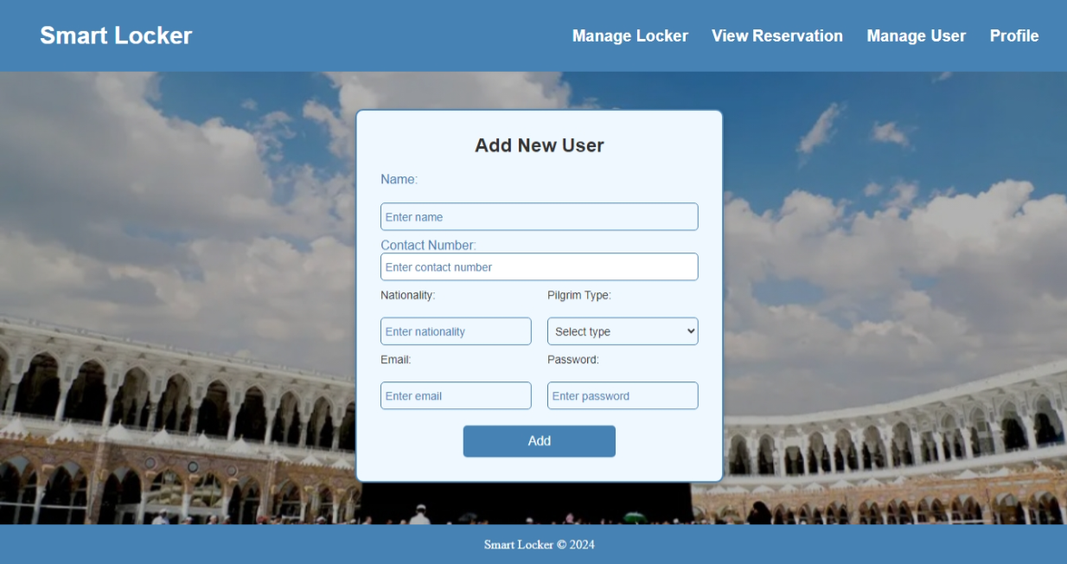
Figure 3.10 Add New User Page (add_user.php)
On the Add New User page, administrators can manually register new users by filling out a detailed form that includes fields for the user’s name, contact information, nationality, pilgrim type, email, and password. This page is particularly useful for onboarding users who may not be able to sign up themselves, such as those needing assistance with digital registration. By allowing admins to directly add users to the system, this page ensures that every potential user can be accommodated and that administrators can swiftly create accounts for individuals as needed, whether they are regular users or special types of pilgrims with specific requirements.

3.11 Admin Profile Page (admin/profile.php)
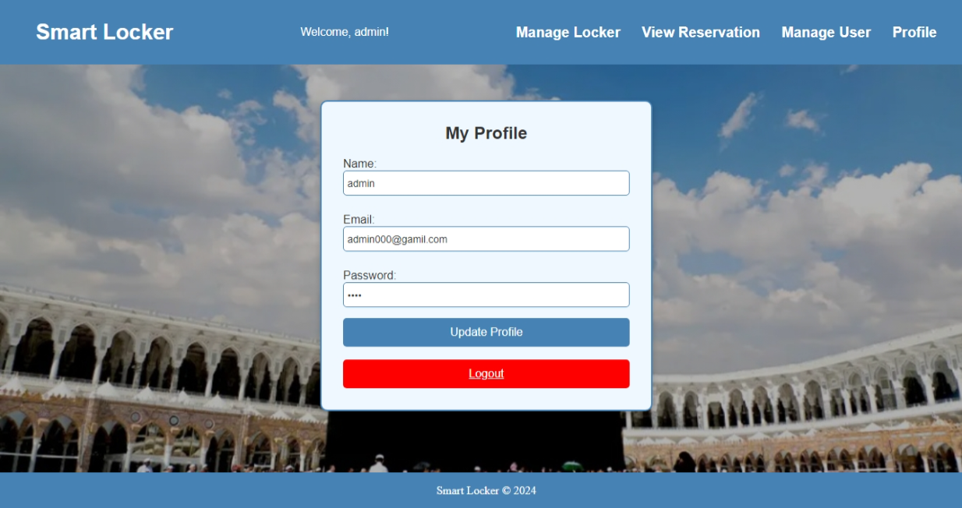
Figure 3.11 Admin Profile Page (admin/profile.php)
This page allows administrators to manage their profile information. Admins can update fields like name, email, and password, enabling them to keep their contact information current and secure. The page also includes a "Logout" button, providing a quick and secure way for administrators to exit the system. This profile management feature helps maintain security by allowing admins to change passwords regularly and ensure that their account details are accurate.

3.12 Available Lockers and Reserve Locker Page (users/view_lockers.php)
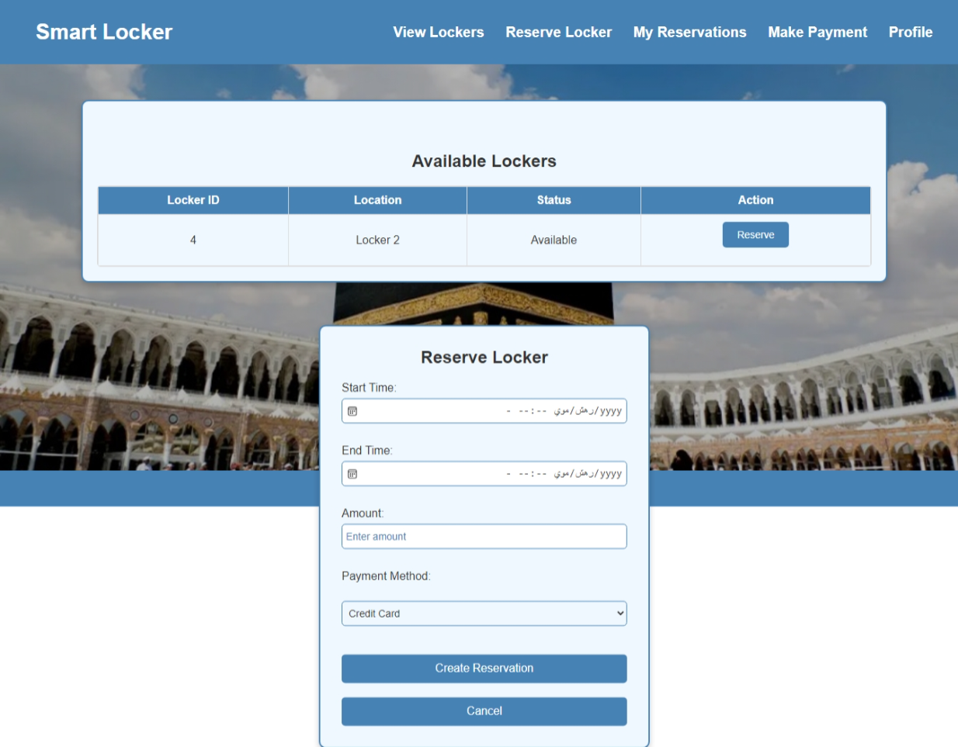
Figure 3.12 Available Lockers and Reserve Locker Page (users/view_lockers.php)
On this page, users can view the list of available lockers, showing details such as locker ID, location, and current status. Users have the option to reserve a locker by selecting an available one and filling out the reservation form below. The form requires a start time, end time, and payment details, ensuring that each reservation is specific and secure. This process gives users control over their storage needs while ensuring that only lockers with confirmed reservations are occupied, preventing misuse and optimizing locker availability.

3.13 View Reservations (admin/view_reservations.php)
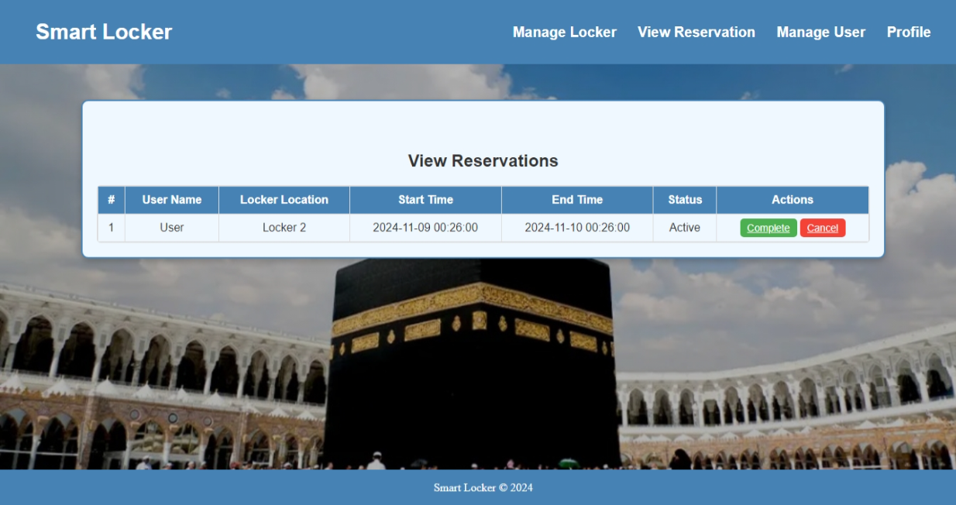
Figure 3.13 View Reservations (admin/view_reservations.php)
This page provides administrators with a comprehensive overview of all user reservations. Each reservation entry displays the user's name, locker location, start and end times, and current status. Admins have control options to either complete or cancel reservations as needed. This feature is critical for admins to monitor locker usage, ensuring that lockers are only reserved for legitimate users and allowing intervention if a reservation requires administrative action. It enhances system oversight and aids in managing locker availability efficiently.

3.14 My Reservations Page (users/my_reservations.php)
Figure 3.14 My Reservations Page (users/my_reservations.php)
Users can view their active and past reservations on this page. For each reservation, details such as locker location, start and end times, and status are displayed. Users have the option to cancel an upcoming reservation, offering flexibility and control over their locker usage. This page empowers users to manage their locker bookings, check upcoming reservations, and adjust their plans as needed, thus enhancing the user experience and enabling self-service.

3.15 User Profile Page (users/profile.php)
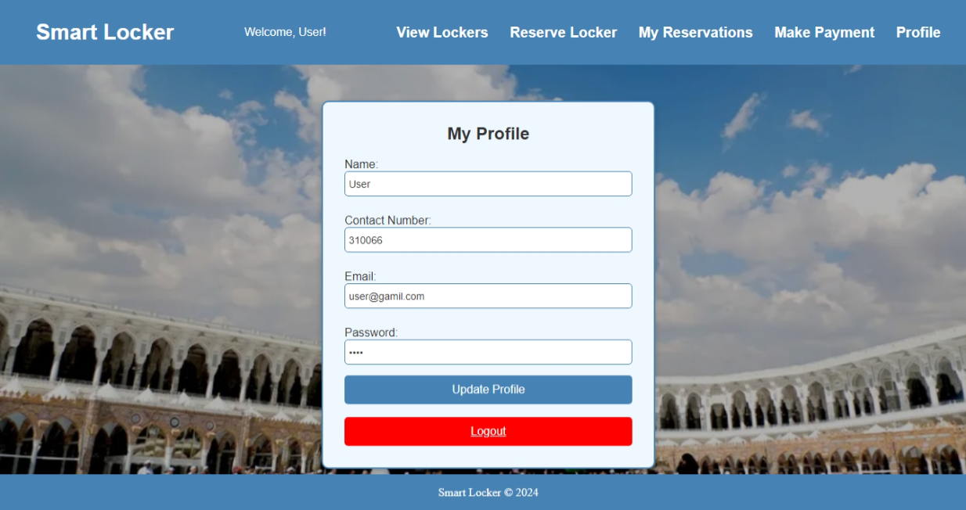
Figure 3.15 User Profile Page (users/profile.php)
This page allows users to view and update their profile information, including their name, contact number, email, and password. This profile management functionality ensures that users can maintain accurate contact details and update their passwords regularly for security. The page also includes a "Logout" button, allowing users to log out securely. This feature supports user autonomy in managing their personal information, ensuring they can keep their account details up-to-date and secure.

3.16 User Signup Page (user_signup.php)
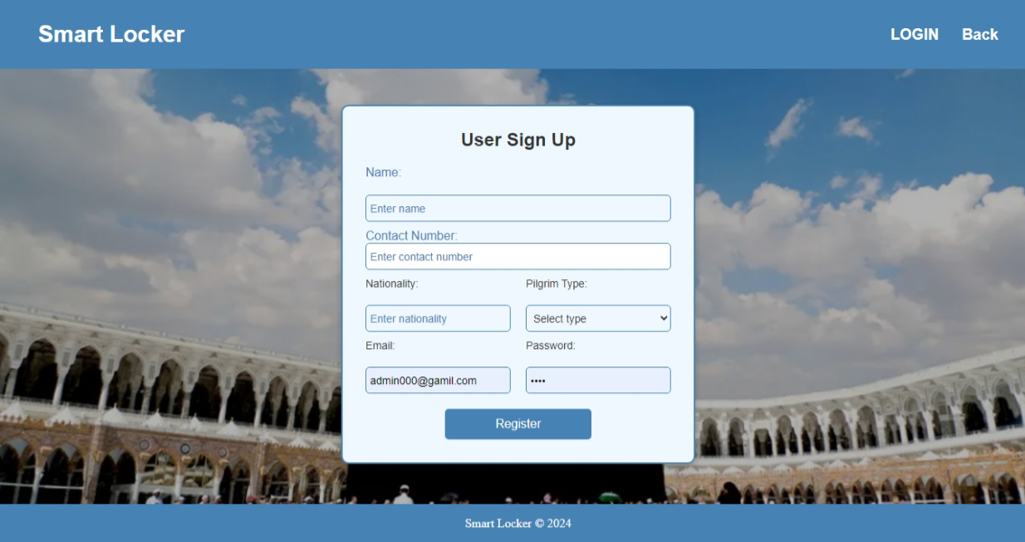
Figure 3.16 User Signup Page (user_signup.php)
This registration page enables new users to create an account. Required fields include name, contact number, nationality, pilgrim type, email, and password, ensuring the system gathers all essential details for account setup. This information aids in personalizing the experience and managing reservations efficiently.

3.17 User Dashboard (user_dashboard.php)
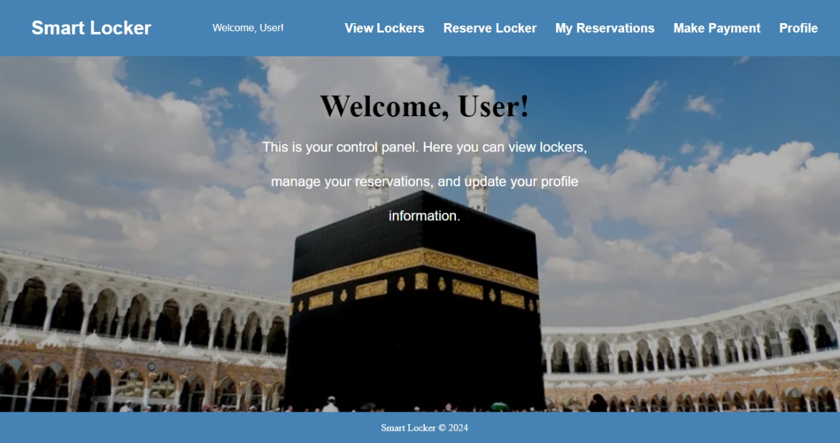
Figure 3.17 User Dashboard (user_dashboard.php)
Upon successful login, users arrive at this dashboard, which serves as their control panel. Here, they can view available lockers, reserve a locker, manage reservations, make payments, and update profile information. This centralized hub enhances user convenience by consolidating all key functions in one accessible location.

CHAPTER FOUR : IMPLEMETATION

4.1 Welcome Page Code
Figure 4.1 Welcome Page (index.php)
<!DOCTYPE html>
<html lang="en">
<head>
<meta charset="UTF-8">
<meta name="viewport" content="width=device-width, initial-scale=1.0">
<title>Smart Locker</title>
<link rel="stylesheet" href="css/style.css">
</head>
<body>
<div class="main">
<div class="navbar">
<div class="icon">
<h2 class="logo">Smart Locker</h2>
</div>
<div class="menu">
<ul>
<li><a href="users/login_user.php">USER</a></li>
<li><a href="admin/login_admin.php">ADMIN</a></li>
</ul>
</div>
</div>
<!-- Content Section -->
<div class="content">
<h1>Welcome to Smart Locker</h1>
<p class="description">Smart Locker provides secure and easy-to-access storage solutions. You can manage your locker and complete your Hajj rituals with peace of mind about your belongings.</p>
</div>
</div>
<!-- Footer -->
<footer class="foot">
<p>Smart Locker &copy; 2024</p>
</footer>
</body>
</html>

4.2 User Login Page Code
Figure 4.2 User Login Page (login_user.php)
<?php

?>
<!DOCTYPE html>
<html lang="en">

<head>
<meta charset="UTF-8">
<meta name="viewport" content="width=device-width, initial-scale=1.0">
<title>Smart Locker - user Login</title>
<link rel="stylesheet" href="../css/style.css">
<script>
function validateForm() {
var nameInput = document.querySelector('input[name="name"]');
var passwordInput = document.querySelector('input[name="password"]');
if (nameInput.value === "" || passwordInput.value === "") {
alert("Name and Password fields cannot be empty.");
return false;
}
return true;
}
</script>
</head>
<div class="main">
<!-- Navbar -->
<div class="navbar">
<div class="icon">
<h2 class="logo">Smart Locker</h2>
</div>
<div class="menu">
<ul>
<li><a href="login_user.php">USER</a></li>
<li><a href="../index.php">Back</a></li>
</ul>
</div>
</div>
<!-- Login Form -->
<div class="form">
<h2>Login Here</h2>
<?php
session_start();
include '../db_connection/conn.php';
if ($_SERVER["REQUEST_METHOD"] == "POST") {
$email = $_POST['username'];
$password = $_POST['password'];
$query = "SELECT * FROM users WHERE email='$email' AND password='$password'";
$result = mysqli_query($conn, $query);
if (mysqli_num_rows($result) > 0) {
$user = mysqli_fetch_assoc($result);
$_SESSION['user_name'] = $user['name'];
$_SESSION['user_id'] = $user['user_id'];
$_SESSION['user_phone'] = $user['contact_number'];
header("Location: user_dashboard.php");
exit();
} else {
echo "<p style='color: red;'>Invalid email or password. Please try again.</p>";
}
}
?>
<!-- Login Form HTML -->
<form method="post" action="login_user.php" onsubmit="return validateForm()">
<input type="text" name="username" placeholder="Enter your username (email)" required>
<input type="password" name="password" placeholder="Enter your password" required>
<br><br>
<h6>
<a href="../forgot_pass.php" style="font-size: 15px; color: red; margin-left: 0px;">Forgot Password</a>
</h6>
<button class="btnna" type="submit" name="log">Sign In</button>
</form>
<button class="btnna"><a href="user_signup.php" style="text-decoration: none; color: white;">Sign
Up</a></button>
</div>
</div>

<!-- Footer -->
<footer class="foot">
<p>Smart Locker &copy; 2024</p>
</footer>
</body>

</html>

4.3 Forgot Password Page Code
Figure 4.3 Forgot Password Page (forgot_pass.php)
<?php
session_start();
include 'db_connection/conn.php';
$message = "";
if (isset($_POST['send_code'])) {
$email = mysqli_real_escape_string($conn, $_POST['email']);
// Check if the email exists
$query = "SELECT * FROM users WHERE email = '$email'";
$result = mysqli_query($conn, $query);
if (mysqli_num_rows($result) > 0) {
// Generate and store the verification code
$verification_code = rand(100000, 999999);
$_SESSION['verification_code'] = $verification_code;
$_SESSION['reset_email'] = $email;
echo "<script>alert('Verification code sent to $email: $verification_code');</script>";
$message = "A verification code has been sent to your email.";
$show_verification = true;
} else {
$message = "Email not found. Please try again.";
}
}
// Step 2: Verify Code
if (isset($_POST['verify_code'])) {
$entered_code = $_POST['verification_code'];
if ($entered_code == $_SESSION['verification_code']) {
$message = "Code verified! Enter your new password.";
$show_reset_password = true;
} else {
$message = "Incorrect code. Please try again.";
}
}
// Step 3: Reset Password
if (isset($_POST['reset_password'])) {
$new_password = mysqli_real_escape_string($conn, $_POST['new_password']);
$email = $_SESSION['reset_email'];
// Update password in the database
$update_query = "UPDATE users SET password = '$new_password' WHERE email = '$email'";
if (mysqli_query($conn, $update_query)) {
$message = "Password has been reset successfully!";
unset($_SESSION['verification_code']);
unset($_SESSION['reset_email']);
} else {
$message = "Error updating password. Please try again.";
}
}
?>
<!DOCTYPE html>
<html lang="en">
<head>
<meta charset="UTF-8">
<title>Smart Locker - Forgot Password</title>
<link rel="stylesheet" href="css/style.css">
</head>
<body>
<div class="main">
<div class="navbar">
<div class="icon">
<h2 class="logo">Smart Locker</h2>
</div>
<div class="menu">
<ul>
<li><a href="users/login_user.php">LOGIN</a></li>
<li><a href="index.php">BACK</a></li>
</ul>
</div>
</div>

<div class="content">
<div class="form">
<h2>Forgot Password</h2>
<p><?php echo $message; ?></p>

<?php if (!isset($show_verification) && !isset($show_reset_password)) : ?>
<!-- Step 1: Enter Email -->
<form method="post">
<label for="email">Enter your email address:</label>
<input type="email" id="email" name="email" required>
<button type="submit" name="send_code">Send Verification Code</button>
</form>

<?php elseif (isset($show_verification)) : ?>
<!-- Step 2: Enter Verification Code -->
<form method="post">
<label for="verification_code">Enter the verification code sent to your email:</label>
<input type="text" id="verification_code" name="verification_code" required>
<button type="submit" name="verify_code">Verify Code</button>
</form>

<?php elseif (isset($show_reset_password)) : ?>
<!-- Step 3: Enter New Password -->
<form method="post">
<label for="new_password">Enter your new password:</label>
<input type="password" id="new_password" name="new_password" required>
<button type="submit" name="reset_password">Reset Password</button>
</form>
<?php endif; ?>
</div>
</div>
</div>

<footer class="foot">
<p>Smart Locker &copy; 2024</p>
</footer>
</body>
</html>

4.4 Admin Dashboard Code
Figure 4.4 Admin Dashboard (admin_dashboard.php)
<?php
session_start();
if (!isset($_SESSION['admin_name'])) {
header("Location: login_admin.php");
exit();
}
?>
<!DOCTYPE html>
<html lang="en">
<head>
<meta charset="UTF-8">
<meta name="viewport" content="width=device-width, initial-scale=1.0">
<title>Smart Locker - Admin Dashboard</title>
<link rel="stylesheet" href="../css/style.css">
</head>
<body>
<div class="main">
<!-- Navbar -->
<div class="navbar">
<div class="icon">
<h2 class="logo">Smart Locker</h2>
</div>
<p style="color: white;">Welcome, <?php echo htmlspecialchars($_SESSION['admin_name']); ?>!</p>
<div class="menu">
<ul>
<li><a href="manage_lockers.php">Manage Locker</a></li>
<li><a href="view_reservations.php">View Reservation</a></li>
<li><a href="User.php">Manage User</a></li>
<li><a href="profile.php">Profile</a></li>
</ul>
</div>
</div>

<!-- Content Section -->
<div class="content">
<h1>Welcome to the Admin Dashboard</h1>
<p class="description">Here you can manage lockers, view reservations, and manage users within the Smart Locker system.</p>
</div>
</div>

<!-- Footer -->
<footer class="foot">
<p>Smart Locker &copy; 2024</p>
</footer>
</body>
</html>

4.5 Manage Lockers Page Code
Figure 4.5 Manage Lockers Page (manage_lockers.php)
<?php
session_start();
if (!isset($_SESSION['admin_name'])) {
header("Location: login_admin.php");
exit();
}
include '../db_connection/conn.php';
if (isset($_GET['delete_id'])) {
$locker_id = $_GET['delete_id'];
$delete_query = "DELETE FROM lockers WHERE locker_id = '$locker_id'";
if (mysqli_query($conn, $delete_query)) {
$message = "Locker deleted successfully.";
} else {
$message = "Error: Could not delete locker.";
}
}
$query = "SELECT * FROM lockers ORDER BY locker_id ASC";
$result = mysqli_query($conn, $query);

?>

<!DOCTYPE html>
<html lang="en">
<head>
<meta charset="UTF-8">
<meta name="viewport" content="width=device-width, initial-scale=1.0">
<title>Smart Locker - Manage Lockers</title>
<link rel="stylesheet" href="../css/style.css">
<style>
.content {
width: 80%;
margin: 0 auto;
padding: 20px;
text-align: center;
background-color: #f0f8ff;
border-radius: 10px;
box-shadow: 0px 4px 8px rgba(0, 0, 0, 0.2);
border: 2px solid #4682b4;
margin-top: 50px;
color: #333;
}

.content h1 {
font-family: Arial, sans-serif;
font-size: 24px;
color: #333;
margin-bottom: 20px;
}

.table-container {
margin-top: 20px;
border: 1px solid #ddd;
border-radius: 5px;
overflow: hidden;
}

table {
width: 100%;
border-collapse: collapse;
}

table, th, td {
border: 1px solid #ddd;
padding: 10px;
text-align: center;
}

th {
background-color: #4682b4;
color: white;
font-weight: bold;
}

.btn {
padding: 5px 10px;
font-size: 14px;
color: white;
border: none;
border-radius: 5px;
cursor: pointer;
transition: background-color 0.3s ease;
}

.btn-add {
background-color: #4682b4;
margin-bottom: 15px;
text-decoration: none;
padding: 10px 20px;
display: inline-block;
}

.btn-add:hover {
background-color: #5f9ea0;
}

.btn-edit {
background-color: #4CAF50;
}

.btn-edit:hover {
background-color: #45a049;
}

.btn-delete {
background-color: #f44336;
}

.btn-delete:hover {
background-color: #e31e0f;
}

.message {
color: green;
font-size: 16px;
margin-top: 10px;
}
</style>
</head>
<body>
<div class="main">
<!-- Navbar -->
<div class="navbar">
<div class="icon">
<h2 class="logo">Smart Locker</h2>
</div>
<div class="menu">
<ul>
<li><a href="manage_lockers.php">Manage Locker</a></li>
<li><a href="view_reservations.php">View Reservation</a></li>
<li><a href="manage_users.php">Manage User</a></li>
<li><a href="profile.php">Profile</a></li>
</ul>
</div>
</div>

<!-- Content Section -->
<div class="content">
<h1>Manage Lockers</h1>
<?php if (isset($message)) { echo "<p class='message'>$message</p>"; } ?>
<a href="add_locker.php" class="btn btn-add">Add New Locker</a>
<div class="table-container">
<table>
<thead>
<tr>
<th>#</th>
<th>Location</th>
<th>Status</th>
<th>Created At</th>
<th>Actions</th>
</tr>
</thead>
<tbody>
<?php if (mysqli_num_rows($result) > 0): ?>
<?php while ($row = mysqli_fetch_assoc($result)): ?>
<tr>
<td><?php echo $row['locker_id']; ?></td>
<td><?php echo htmlspecialchars($row['location']); ?></td>
<td><?php echo htmlspecialchars($row['status']); ?></td>
<td><?php echo $row['created_at']; ?></td>
<td>
<a href="details_locker.php?id=<?php echo $row['locker_id']; ?>" class="btn btn-edit">Details</a>
<a href="manage_lockers.php?delete_id=<?php echo $row['locker_id']; ?>" class="btn btn-delete" onclick="return confirm('Are you sure you want to delete this locker?');">Delete</a>
</td>
</tr>
<?php endwhile; ?>
<?php else: ?>
<tr>
<td colspan="5">No lockers available.</td>
</tr>
<?php endif; ?>
</tbody>
</table>
</div>
</div>
</div>
</div>
<!-- Footer -->
<footer class="foot">
<p>Smart Locker &copy; 2024</p>
</footer>
</body>
</html>

4.6 Add New Locker Page Code
Figure 4.6 Add New Locker Page (add_locker.php)
<?php
session_start();
if (!isset($_SESSION['admin_name'])) {
header("Location: login_admin.php");
exit();
}

include '../db_connection/conn.php';

// Handle form submission
if ($_SERVER["REQUEST_METHOD"] == "POST") {
$location = $_POST['location'];
$status = $_POST['status'];
$created_at = date("Y-m-d H:i:s");

$query = "INSERT INTO lockers (location, status, created_at) VALUES ('$location', '$status', '$created_at')";

if (mysqli_query($conn, $query)) {
$message = "Locker added successfully.";
} else {
$message = "Error: Could not add locker. Please try again.";
}
}
?>

<!DOCTYPE html>
<html lang="en">
<head>
<meta charset="UTF-8">
<meta name="viewport" content="width=device-width, initial-scale=1.0">
<title>Smart Locker - Add Locker</title>
<link rel="stylesheet" href="../css/style.css">
<style>
.form {
width: 400px;
max-width: 100%;
background-color: #f0f8ff;
border-radius: 10px;
box-shadow: 0px 4px 8px rgba(0, 0, 0, 0.2);
border: 2px solid #4682b4;
padding: 30px;
text-align: center;
margin: 0 auto;
}

.form h2 {
font-family: Arial, sans-serif;
font-size: 24px;
color: #333;
margin-bottom: 20px;
}

.form label {
font-size: 16px;
color: #333;
display: block;
text-align: left;
margin-bottom: 5px;
}

.form input[type="text"],
.form select {
width: 100%;
height: 35px;
border: 1px solid #4682b4;
padding: 5px;
border-radius: 5px;
font-size: 14px;
color: #333;
box-sizing: border-box;
margin-bottom: 20px;
}

.form .button-group {
display: flex;
justify-content: center;
}

.form button {
width: 100%;
height: 40px;
background-color: #4682b4;
color: white;
font-size: 16px;
border: none;
border-radius: 5px;
cursor: pointer;
transition: 0.3s ease;
}

.form button:hover {
background-color: #5f9ea0;
}

.message {
color: green;
font-size: 16px;
margin-top: 10px;
}
</style>
</head>
<body>
<div class="main">
<!-- Navbar -->
<div class="navbar">
<div class="icon">
<h2 class="logo">Smart Locker</h2>
</div>
<div class="menu">
<ul>
<li><a href="manage_lockers.php">Manage Locker</a></li>
<li><a href="view_reservation.php">View Reservation</a></li>
<li><a href="manage_User.php">Manage User</a></li>
<li><a href="profile.php">Profile</a></li>
</ul>
</div>
</div>

<!-- Locker Creation Form -->
<div class="form">
<h2>Add New Locker</h2>
<?php if (isset($message)) { echo "<p class='message'>$message</p>"; } ?>
<form method="post" action="add_locker.php">
<label for="location">Location:</label>
<input type="text" id="location" name="location" placeholder="Enter locker location" required />

<label for="status">Status:</label>
<select id="status" name="status" required>
<option value="" disabled selected>Select status</option>
<option value="Available">Available</option>
<option value="Occupied">Occupied</option>
<option value="Maintenance">Maintenance</option>
</select>
<div class="button-group">
<button type="submit">Add Locker</button>
</div>
</form>
</div>
</div>

<!-- Footer -->
<footer class="foot">
<p>Smart Locker &copy; 2024</p>
</footer>
</body>
</html>

4.7 Manage Users Page Code
Figure 4.7 Manage Users Page (manage_user.php)
<?php
session_start();
if (!isset($_SESSION['admin_name'])) {
header("Location: login_admin.php");
exit();
}
include '../db_connection/conn.php';
if (isset($_GET['delete_id'])) {
$user_id = $_GET['delete_id'];
$delete_query = "DELETE FROM Users WHERE user_id = '$user_id'";
if (mysqli_query($conn, $delete_query)) {
$message = "User deleted successfully.";
} else {
$message = "Error: Could not delete User.";
}
}
$query = "SELECT * FROM users ORDER BY user_id ASC";
$result = mysqli_query($conn, $query);

?>

<!DOCTYPE html>
<html lang="en">
<head>
<meta charset="UTF-8">
<meta name="viewport" content="width=device-width, initial-scale=1.0">
<title>Smart Locker - Manage Users</title>
<link rel="stylesheet" href="../css/style.css">
<style>
.content {
width: 80%;
margin: 0 auto;
padding: 20px;
text-align: center;
background-color: #f0f8ff;
border-radius: 10px;
box-shadow: 0px 4px 8px rgba(0, 0, 0, 0.2);
border: 2px solid #4682b4;
margin-top: 50px;
color: #333;
}

.content h1 {
font-family: Arial, sans-serif;
font-size: 24px;
color: #333;
margin-bottom: 20px;
}

.table-container {
margin-top: 20px;
border: 1px solid #ddd;
border-radius: 5px;
overflow: hidden;
}

table {
width: 100%;
border-collapse: collapse;
}

table, th, td {
border: 1px solid #ddd;
padding: 10px;
text-align: center;
}

th {
background-color: #4682b4;
color: white;
font-weight: bold;
}

.btn {
padding: 5px 10px;
font-size: 14px;
color: white;
border: none;
border-radius: 5px;
cursor: pointer;
transition: background-color 0.3s ease;
}

.btn-add {
background-color: #4682b4;
margin-bottom: 15px;
text-decoration: none;
padding: 10px 20px;
display: inline-block;
}

.btn-add:hover {
background-color: #5f9ea0;
}

.btn-edit {
background-color: #4CAF50;
}

.btn-edit:hover {
background-color: #45a049;
}

.btn-delete {
background-color: #f44336;
}

.btn-delete:hover {
background-color: #e31e0f;
}

.message {
color: green;
font-size: 16px;
margin-top: 10px;
}
</style>
</head>
<body>
<div class="main">
<!-- Navbar -->
<div class="navbar">
<div class="icon">
<h2 class="logo">Smart Locker</h2>
</div>
<div class="menu">
<ul>
<li><a href="manage_lockers.php">Manage Locker</a></li>
<li><a href="view_reservations.php">View Reservation</a></li>
<li><a href="manage_User.php">Manage User</a></li>
<li><a href="profile.php">Profile</a></li>
</ul>
</div>
</div>

<!-- Content Section -->
<div class="content">
<h1>Manage Users</h1>
<?php if (isset($message)) { echo "<p class='message'>$message</p>"; } ?>
<a href="add_user.php" class="btn btn-add">Add New User</a>
<div class="table-container">
<table>
<thead>
<tr>
<th>#</th>
<th>Name</th>
<th>Contact_number</th>
<th>Email</th>
<th>Nationality</th>
<th>Pligrim_type</th>
<th>Created At</th>
<th>Actions</th>
</tr>
</thead>
<tbody>
<?php if (mysqli_num_rows($result) > 0): ?>
<?php while ($row = mysqli_fetch_assoc($result)): ?>
<tr>
<td><?php echo $row['user_id']; ?></td>
<td><?php echo htmlspecialchars($row['name']); ?></td>
<td><?php echo htmlspecialchars($row['contact_number']); ?></td>
<td><?php echo htmlspecialchars($row['email']); ?></td>
<td><?php echo htmlspecialchars($row['nationality']); ?></td>
<td><?php echo htmlspecialchars($row['pligrim_type']); ?></td>
<td><?php echo $row['created_at']; ?></td>
<td>
<a href="manage_user.php?delete_id=<?php echo $row['user_id']; ?>" class="btn btn-delete" onclick="return confirm('Are you sure you want to delete this user?');">Delete</a>
</td>
</tr>
<?php endwhile; ?>
<?php else: ?>
<tr>
<td colspan="5">No Users available.</td>
</tr>
<?php endif; ?>
</tbody>
</table>
</div>
</div>
</div>
</div>
<!-- Footer -->
<footer class="foot">
<p>Smart Locker &copy; 2024</p>
</footer>
</body>
</html>

4.8 Add New User Page Code
Figure 3.8 Add New User Page (add_user.php)
<!DOCTYPE html>
<html lang="en">

<head>
<meta charset="UTF-8">
<meta name="viewport" content="width=device-width, initial-scale=1.0">
<title>Smart Locker - Add User</title>
<link rel="stylesheet" href="../css/style.css">
<style>
.form {
width: 400px;
max-width: 100%;
background-color: #f0f8ff;
border-radius: 10px;
box-shadow: 0px 4px 8px rgba(0, 0, 0, 0.2);
border: 2px solid #4682b4;
padding: 30px;
text-align: center;
margin: 0 auto;
}

.form h2 {
font-family: Arial, sans-serif;
font-size: 24px;
color: #333;
}

.form .form-group {
display: flex;
flex-wrap: wrap;
gap: 20px;
}
.form-label{
font-size: 14px;
color: #333;
display: block;
text-align: left;
}
.form .form-group label {
font-size: 14px;
color: #333;
display: block;
text-align: left;
}

.form .form-group div {
flex: 1;
min-width: 100px;
}

.form input[type="text"],
.form input[type="email"],
.form input[type="password"],
.form input[type="tel"],
.form select {
width: 100%;
height: 35px;
border: 1px solid #4682b4;
padding: 5px;
border-radius: 5px;
font-size: 14px;
color: #333;
box-sizing: border-box;
}

.form .button-group {
display: flex;
justify-content: center;
}

.form button {
width: 48%;
height: 40px;
background-color: #4682b4;
color: white;
font-size: 16px;
border: none;
border-radius: 5px;
cursor: pointer;
transition: 0.3s ease;
}

.form button:hover {
background-color: #5f9ea0;
}
</style>
</head>

<body>
<div class="main">
<!-- Navbar -->
<div class="navbar">
<div class="icon">
<h2 class="logo">Smart Locker</h2>
</div>
<div class="menu">
<ul>
<li><a href="manage_lockers.php">Manage Locker</a></li>
<li><a href="view_reservations.php">View Reservation</a></li>
<li><a href="manage_User.php">Manage User</a></li>
<li><a href="profile.php">Profile</a></li>
</ul>
</div>
</div>

<!-- Signup Form -->
<form method="post" action="add_user.php" class="form">
<h2 align="center">Add New User</h2>
<?php
include '../db_connection/conn.php';
if (isset($_POST['save'])) {
$name = $_POST['name'];
$contact_number =$_POST['contact_number'];
$email = $_POST['email'];
$password = $_POST['password'];
$nationality = $_POST['nationality'];
$type = $_POST['type'];
$created_at = date("Y-m-d H:i:s");
$query = "INSERT INTO users (name, contact_number, email, password, nationality, pligrim_type, created_at) VALUES ('$name', '$contact_number', '$email', '$password', '$nationality', '$type', '$created_at')";
if (mysqli_query($conn, $query)) {
echo "<p style='color: green;'>$name has been added successfully.</p>";
} else {
echo "<p style='color: red;'>Error: Could not add user. Please try again.</p>";
}
}
?>

<div>
<label class="form-label" for="name">Name:</label>
<input type="text" id="name" name="name" placeholder="Enter name" required />
</div>
<div>
<label class="form-label" for="contact_number">Contact Number:</label>
<input type="tel" id="contact_number" name="contact_number" placeholder="Enter contact number"
required />
</div>

<div class="form-group">
<div>
<label for="nationality">Nationality:</label>
<input type="text" id="nationality" name="nationality" placeholder="Enter nationality" required />
</div>
<div>
<label for="pilgrim_type">Pilgrim Type:</label>
<select id="pilgrim_type" name="type" required>
<option value="" disabled selected>Select type</option>
<option value="Umrah Performer">Umrah Performer</option>
<option value="Pilgrim">Pilgrim</option>
</select>
</div>
</div>
<div class="form-group">
<div>
<label for="email">Email:</label>
<input type="email" id="email" name="email" placeholder="Enter email" required />
</div>
<div>
<label for="password">Password:</label>
<input type="password" id="password" name="password" placeholder="Enter password" required />
</div>
</div>

<div class="button-group">
<button type="submit" name="save">Add</button>
</div>
</form>
</div>
</div>

<!-- Footer -->
<footer class="foot">
<p>Smart Locker &copy; 2024</p>
</footer>
</body>

</html>

4.9 Admin Profile Page Code
Figure 4.9Admin Profile Page (admin/profile.php)
<?php
session_start();
if (!isset($_SESSION['admin_name'])) {
header("Location: login_admin.php");
exit();
}

include '../db_connection/conn.php';

$admin_id = $_SESSION['admin_id'];
$message = "";

// Fetch user details from the database
$query = "SELECT * FROM admin WHERE id = '$admin_id'";
$result = mysqli_query($conn, $query);
$admin = mysqli_fetch_assoc($result);

// Update user profile if form is submitted
if ($_SERVER["REQUEST_METHOD"] == "POST") {
$name = mysqli_real_escape_string($conn, $_POST['name']);
$contact_number = mysqli_real_escape_string($conn, $_POST['contact_number']);
$email = mysqli_real_escape_string($conn, $_POST['email']);
$password = mysqli_real_escape_string($conn, $_POST['password']);

// Update query
$update_query = "UPDATE admin SET name = '$name', email = '$email', password = '$password' WHERE id = '$admin_id'";

if (mysqli_query($conn, $update_query)) {
$message = "Profile updated successfully!";
// Refresh user details
$admin['name'] = $name;
$admin['email'] = $email;
$admin['password'] = $password;
} else {
$message = "Error updating profile. Please try again.";
}
}

mysqli_close($conn);
?>

<!DOCTYPE html>
<html lang="en">
<head>
<meta charset="UTF-8">
<meta name="viewport" content="width=device-width, initial-scale=1.0">
<title>Smart Locker - Admin Profile</title>
<link rel="stylesheet" href="../css/style.css">
<style>
.profile-container {
width: 400px;
max-width: 100%;
background-color: #f0f8ff;
border-radius: 10px;
padding: 30px;
text-align: center;
margin: 50px auto;
box-shadow: 0px 4px 8px rgba(0, 0, 0, 0.2);
border: 2px solid #4682b4;
}

.profile-container h2 {
font-size: 24px;
color: #333;
margin-bottom: 20px;
}

.profile-container label {
font-size: 16px;
color: #333;
text-align: left;
display: block;
margin-top: 10px;
}

.profile-container input {
width: 100%;
height: 35px;
border: 1px solid #4682b4;
padding: 5px;
border-radius: 5px;
font-size: 14px;
color: #333;
margin-bottom: 15px;
box-sizing: border-box;
}

.profile-container button {
width: 100%;
height: 40px;
background-color: #4682b4;
color: white;
font-size: 16px;
border: none;
border-radius: 5px;
cursor: pointer;
transition: 0.3s ease;
}

.profile-container button:hover {
background-color: #5f9ea0;
}

.message {
color: green;
font-size: 16px;
margin-top: 10px;
}
</style>
</head>
<body>
<div class="main">
<!-- Navbar -->
<div class="navbar">
<div class="icon">
<h2 class="logo">Smart Locker</h2>
</div>
<p style="color: white;">Welcome, <?php echo htmlspecialchars($admin['name']); ?>!</p>
<div class="menu">
<ul>
<li><a href="manage_lockers.php">Manage Locker</a></li>
<li><a href="view_reservations.php">View Reservation</a></li>
<li><a href="User.php">Manage User</a></li>
<li><a href="profile.php">Profile</a></li>
</ul>
</div>
</div>

<!-- Profile Container -->
<div class="profile-container">
<h2>My Profile</h2>
<?php if (!empty($message)) { echo "<p class='message'>$message</p>"; } ?>
<form method="post" action="profile.php">
<label for="name">Name:</label>
<input type="text" id="name" name="name" value="<?php echo htmlspecialchars($admin['name']); ?>" required />
<label for="email">Email:</label>
<input type="email" id="email" name="email" value="<?php echo htmlspecialchars($admin['email']); ?>" required />

<label for="password">Password:</label>
<input type="password" id="password" name="password" value="<?php echo htmlspecialchars($admin['password']); ?>" required />

<button type="submit">Update Profile</button>
<br><br>
<button type="button" style="background-color: red;"><a href="login_admin.php" style=" color: white; text-docoration: none; font-size: 16px;">Logout</a></button>
</form>
</div>
</div>

<!-- Footer -->
<footer class="foot">
<p>Smart Locker &copy; 2024</p>
</footer>
</body>
</html>

4.10 Available Lockers and Reserve Locker Page Code
Figure 4.10 Available Lockers and Reserve Locker Page (users/view_lockers.php)
<?php
session_start();
if (!isset($_SESSION['user_id']) || !isset($_SESSION['user_phone'])) {
header("Location: login_user.php");
exit();
}

include '../db_connection/conn.php';
$user_id = $_SESSION['user_id'];
$user_phone = $_SESSION['user_phone'];
$message = "";

$lockers_query = "SELECT * FROM lockers WHERE status = 'Available'";
$lockers_result = mysqli_query($conn, $lockers_query);
if ($_SERVER["REQUEST_METHOD"] == "POST" && isset($_POST['reserve'])) {
$locker_id = $_POST['locker_id'];
$start_time = $_POST['start_time'];
$end_time = $_POST['end_time'];
$amount = $_POST['amount'];
$payment_method = $_POST['payment_method'];
$temporary_code = rand(100000, 999999);

$reservation_query = "INSERT INTO reservations (user_id, locker_id, start_time, end_time, status)
VALUES ('$user_id', '$locker_id', '$start_time', '$end_time', 'Active')";

if (mysqli_query($conn, $reservation_query)) {
$reservation_id = mysqli_insert_id($conn);
if ($reservation_id) {
$update_locker_query = "UPDATE lockers SET status = 'Occupied' WHERE locker_id = '$locker_id'";
mysqli_query($conn, $update_locker_query);
$payment_query = "INSERT INTO payments (reservation_id, user_id, amount, payment_date, payment_method, temporary_code)
VALUES ('$reservation_id', '$user_id', '$amount', NOW(), '$payment_method', '$temporary_code')";
if (mysqli_query($conn, $payment_query)) {
$message = "Reservation and payment completed successfully! Your access code is $temporary_code.";
$phone = $user_phone;
$sms_message = "Your Smart Locker access code is: $temporary_code";

echo "<script>alert('$sms_message');</script>";
} else {
$message = "Error: Payment could not be processed. Please try again.";
}
} else {
$message = "Error: Reservation could not be created. Reservation ID not retrieved.";
}
} else {
$message = "Error: Reservation could not be created. Please try again.";
}
}

mysqli_close($conn);
?>

<!DOCTYPE html>
<html lang="en">
<head>
<meta charset="UTF-8">
<meta name="viewport" content="width=device-width, initial-scale=1.0">
<title>Smart Locker - Available Lockers</title>
<link rel="stylesheet" href="../css/style.css">
<style>
.content {
width: 80%;
margin: 0 auto;
padding: 20px;
text-align: center;
background-color: #f0f8ff;
border-radius: 10px;
box-shadow: 0px 4px 8px rgba(0, 0, 0, 0.2);
border: 2px solid #4682b4;
margin-top: 50px;
color: #333;
}

.content h1 {
font-family: Arial, sans-serif;
font-size: 24px;
color: #333;
margin-bottom: 20px;
}

.table-container {
margin-top: 20px;
border: 1px solid #ddd;
border-radius: 5px;
overflow: hidden;
}

table {
width: 100%;
border-collapse: collapse;
}

table, th, td {
border: 1px solid #ddd;
padding: 10px;
text-align: center;
}

th {
background-color: #4682b4;
color: white;
font-weight: bold;
}

.btn {
padding: 5px 10px;
font-size: 14px;
color: white;
border: none;
border-radius: 5px;
cursor: pointer;
transition: background-color 0.3s ease;
}

.btn-add {
background-color: #4682b4;
margin-bottom: 15px;
text-decoration: none;
padding: 10px 20px;
display: inline-block;
}

.btn-add:hover {
background-color: #5f9ea0;
}

.btn-edit {
background-color: #4CAF50;
}

.btn-edit:hover {
background-color: #45a049;
}

.btn-delete {
background-color: #f44336;
}

.btn-delete:hover {
background-color: #e31e0f;
}

.message {
color: green;
font-size: 16px;
margin-top: 10px;
}
.form {
width: 400px;
max-width: 100%;
background-color: #f0f8ff;
border-radius: 10px;
box-shadow: 0px 4px 8px rgba(0, 0, 0, 0.2);
border: 2px solid #4682b4;
padding: 30px;
text-align: center;
margin: 0 auto;
}

.form h2 {
font-family: Arial, sans-serif;
font-size: 24px;
color: #333;
margin-bottom: 20px;
}

.form label {
font-size: 16px;
color: #333;
display: block;
text-align: left;
margin-bottom: 5px;
}

.form input[type="datetime-local"],
.form input[type="text"],
.form input[type="number"],
.form select {
width: 100%;
height: 35px;
border: 1px solid #4682b4;
padding: 5px;
border-radius: 5px;
font-size: 14px;
color: #333;
box-sizing: border-box;
margin-bottom: 20px;
}

.form .button-group {
display: flex;
justify-content: center;
}

.form button {
width: 100%;
height: 40px;
background-color: #4682b4;
color: white;
font-size: 16px;
border: none;
border-radius: 5px;
cursor: pointer;
transition: 0.3s ease;
}

.form button:hover {
background-color: #5f9ea0;
}

.message {
color: green;
font-size: 16px;
margin-top: 10px;
}
</style>
</head>
<body>
<div class="main">
<!-- Navbar -->
<div class="navbar">
<div class="icon">
<h2 class="logo">Smart Locker</h2>
</div>
<div class="menu">
<ul>
<li><a href="view_lockers.php">View Lockers</a></li>
<li><a href="add_reservation.php">Reserve Locker</a></li>
<li><a href="my_reservations.php">My Reservations</a></li>
<li><a href="payment.php">Make Payment</a></li>
<li><a href="profile.php">Profile</a></li>
</ul>
</div>
</div>

<!-- Available Lockers Section -->
<div class="content">
<h1>Available Lockers</h1>
<?php if (!empty($message)) { echo "<p class='message'>$message</p>"; } ?>
<div class="table-container">
<table>
<thead>
<tr>
<th>Locker ID</th>
<th>Location</th>
<th>Status</th>
<th>Action</th>
</tr>
</thead>
<tbody>
<?php if (mysqli_num_rows($lockers_result) > 0): ?>
<?php while ($locker = mysqli_fetch_assoc($lockers_result)): ?>
<tr>
<td><?php echo $locker['locker_id']; ?></td>
<td><?php echo htmlspecialchars($locker['location']); ?></td>
<td><?php echo htmlspecialchars($locker['status']); ?></td>
<td>
<button class="btn btn-add" onclick="showReservationModal('<?php echo $locker['locker_id']; ?>')">Reserve</button>
</td>
</tr>
<?php endwhile; ?>
<?php else: ?>
<tr>
<td colspan="4">No available lockers.</td>
</tr>
<?php endif; ?>
</tbody>
</table>
</div>
</div>

<!-- Reservation Modal -->
<div id="reservationModal" class="form" style="display: none;">
<h2>Reserve Locker</h2>
<form method="post" action="view_lockers.php">
<input type="hidden" name="locker_id" id="locker_id">

<label for="start_time">Start Time:</label>
<input type="datetime-local" id="start_time" name="start_time" required>

<label for="end_time">End Time:</label>
<input type="datetime-local" id="end_time" name="end_time" required>

<label for="amount">Amount:</label>
<input type="number" id="amount" name="amount" placeholder="Enter amount" required>

<label for="payment_method">Payment Method:</label>
<select id="payment_method" name="payment_method" required>
<option value="credit">Credit Card</option>
<option value="debit">Debit Card</option>
<option value="cash">Cash</option>
<option value="mobile_p">Mobile Payment</option>
</select>
<button type="submit" name="reserve">Create Reservation</button>
<button type="button" onclick="closeReservationModal()">Cancel</button>
</form>
</div>
</div>

<!-- Footer -->
<footer class="foot">
<p>Smart Locker &copy; 2024</p>
</footer>
<script>
function showReservationModal(lockerId) {
document.getElementById('locker_id').value = lockerId;
document.getElementById('reservationModal').style.display = 'block';
}
function closeReservationModal() {
document.getElementById('reservationModal').style.display = 'none';
}
</script>
</body>
</html>

4.11 View Reservations Code
Figure 4.11 View Reservations (admin/view_reservations.php)
<?php
session_start();
if (!isset($_SESSION['admin_name'])) {
// Redirect to login if admin is not logged in
header("Location: login_admin.php");
exit();
}

include '../db_connection/conn.php';

// Handle reservation status update
if (isset($_GET['complete_id'])) {
$reservation_id = $_GET['complete_id'];
$complete_query = "UPDATE reservations SET status = 'Completed' WHERE reservation_id = '$reservation_id'";
mysqli_query($conn, $complete_query);
header("Location: view_reservations.php");
exit();
}

if (isset($_GET['cancel_id'])) {
$reservation_id = $_GET['cancel_id'];
$cancel_query = "UPDATE reservations SET status = 'Cancelled' WHERE reservation_id = '$reservation_id'";
mysqli_query($conn, $cancel_query);
header("Location: view_reservations.php");
exit();
}

// Retrieve reservation data
$query = "
SELECT r.reservation_id, u.name AS user_name, l.location AS locker_location,
r.start_time, r.end_time, r.status
FROM reservations r
JOIN users u ON r.user_id = u.user_id
JOIN lockers l ON r.locker_id = l.locker_id
ORDER BY r.start_time DESC";
$result = mysqli_query($conn, $query);
?>

<!DOCTYPE html>
<html lang="en">
<head>
<meta charset="UTF-8">
<meta name="viewport" content="width=device-width, initial-scale=1.0">
<title>Smart Locker - View Reservations</title>
<link rel="stylesheet" href="../css/style.css">
<style>
.content {
width: 80%;
margin: 0 auto;
padding: 20px;
text-align: center;
background-color: #f0f8ff;
border-radius: 10px;
box-shadow: 0px 4px 8px rgba(0, 0, 0, 0.2);
border: 2px solid #4682b4;
margin-top: 50px;
color: #333;
}

.content h1 {
font-family: Arial, sans-serif;
font-size: 24px;
color: #333;
margin-bottom: 20px;
}

.table-container {
margin-top: 20px;
border: 1px solid #ddd;
border-radius: 5px;
overflow: hidden;
}

table {
width: 100%;
border-collapse: collapse;
}

table, th, td {
border: 1px solid #ddd;
padding: 10px;
text-align: center;
}

th {
background-color: #4682b4;
color: white;
font-weight: bold;
}

.btn {
padding: 5px 10px;
font-size: 14px;
color: white;
border: none;
border-radius: 5px;
cursor: pointer;
transition: background-color 0.3s ease;
}

.btn-complete {
background-color: #4CAF50;
}

.btn-complete:hover {
background-color: #45a049;
}

.btn-cancel {
background-color: #f44336;
}

.btn-cancel:hover {
background-color: #e31e0f;
}
</style>
</head>
<body>
<div class="main">
<!-- Navbar -->
<div class="navbar">
<div class="icon">
<h2 class="logo">Smart Locker</h2>
</div>
<div class="menu">
<ul>
<li><a href="manage_lockers.php">Manage Locker</a></li>
<li><a href="view_reservations.php">View Reservation</a></li>
<li><a href="manage_User.php">Manage User</a></li>
<li><a href="profile.php">Profile</a></li>
</ul>
</div>
</div>

<!-- Content Section -->
<div class="content">
<h1>View Reservations</h1>
<div class="table-container">
<table>
<thead>
<tr>
<th>#</th>
<th>User Name</th>
<th>Locker Location</th>
<th>Start Time</th>
<th>End Time</th>
<th>Status</th>
<th>Actions</th>
</tr>
</thead>
<tbody>
<?php if (mysqli_num_rows($result) > 0): ?>
<?php while ($row = mysqli_fetch_assoc($result)): ?>
<tr>
<td><?php echo $row['reservation_id']; ?></td>
<td><?php echo htmlspecialchars($row['user_name']); ?></td>
<td><?php echo htmlspecialchars($row['locker_location']); ?></td>
<td><?php echo $row['start_time']; ?></td>
<td><?php echo $row['end_time']; ?></td>
<td><?php echo htmlspecialchars($row['status']); ?></td>
<td>
<?php if ($row['status'] == 'Active'): ?>
<a href="view_reservations.php?complete_id=<?php echo $row['reservation_id']; ?>" class="btn btn-complete">Complete</a>
<a href="view_reservations.php?cancel_id=<?php echo $row['reservation_id']; ?>" class="btn btn-cancel" onclick="return confirm('Are you sure you want to cancel this reservation?');">Cancel</a>
<?php elseif ($row['status'] == 'Completed'): ?>
<span style="color: green;">Completed</span>
<?php elseif ($row['status'] == 'Cancelled'): ?>
<span style="color: red;">Cancelled</span>
<?php endif; ?>
</td>
</tr>
<?php endwhile; ?>
<?php else: ?>
<tr>
<td colspan="7">No reservations found.</td>
</tr>
<?php endif; ?>
</tbody>
</table>
</div>
</div>
</div>

<!-- Footer -->
<footer class="foot">
<p>Smart Locker &copy; 2024</p>
</footer>
</body>
</html>

4.12 My Reservations Page Code
Figure 4.12 My Reservations Page (users/my_reservations.php)

<?php
session_start();
if (!isset($_SESSION['user_id'])) {
header("Location: login_user.php");
exit();
}
include '../db_connection/conn.php';
$user_id = $_SESSION['user_id'];
$message = '';
// Handle reservation cancellation with verification code
if (isset($_GET['cancel_id']) && isset($_GET['temporary_code'])) {
$reservation_id = $_GET['cancel_id'];
$entered_code = $_GET['temporary_code'];
// Verify the code with the one stored in the payment table
$code_query = "SELECT p.temporary_code FROM payments p JOIN reservations r ON p.reservation_id = r.reservation_id WHERE r.reservation_id = '$reservation_id' AND r.user_id = '$user_id'";
$code_result = mysqli_query($conn, $code_query);
$payment_data = mysqli_fetch_assoc($code_result);
if ($payment_data && $entered_code == $payment_data['temporary_code']) {
mysqli_begin_transaction($conn);
try {
// Update reservation status to "Cancelled"
$cancel_query = "UPDATE reservations SET status = 'Cancelled' WHERE reservation_id = '$reservation_id' AND user_id = '$user_id'";
if (mysqli_query($conn, $cancel_query)) {
// Update locker status to "Available"
$locker_query = "SELECT locker_id FROM reservations WHERE reservation_id = '$reservation_id'";
$locker_result = mysqli_query($conn, $locker_query);
$locker = mysqli_fetch_assoc($locker_result);
$locker_id = $locker['locker_id'];

$update_locker_query = "UPDATE lockers SET status = 'Available' WHERE locker_id = '$locker_id'";
if (mysqli_query($conn, $update_locker_query)) {
mysqli_commit($conn);
$message = "<p style='color: green;'>Reservation cancelled successfully.</p>";
} else {
throw new Exception("Error updating locker status.");
}
} else {
throw new Exception("Error cancelling reservation.");
}
} catch (Exception $e) {
mysqli_rollback($conn);
$message = "<p style='color: red;'>{$e->getMessage()}</p>";
}
} else {
$message = "<p style='color: red;'>Incorrect verification code. Please try again.</p>";
}
}

// Retrieve user's reservations
$reservations_query = "
SELECT r.reservation_id, l.location AS locker_location, r.start_time, r.end_time, r.status
FROM reservations r
JOIN lockers l ON r.locker_id = l.locker_id
WHERE r.user_id = '$user_id'
ORDER BY r.start_time DESC";
$reservations_result = mysqli_query($conn, $reservations_query);
?>

<!DOCTYPE html>
<html lang="en">

<head>
<meta charset="UTF-8">
<meta name="viewport" content="width=device-width, initial-scale=1.0">
<title>Smart Locker - My Reservations</title>
<link rel="stylesheet" href="../css/style.css">
<style>
.content {
width: 80%;
margin: 0 auto;
padding: 20px;
text-align: center;
background-color: #f0f8ff;
border-radius: 10px;
box-shadow: 0px 4px 8px rgba(0, 0, 0, 0.2);
border: 2px solid #4682b4;
margin-top: 50px;
color: #333;
}

.content h1 {
font-family: Arial, sans-serif;
font-size: 24px;
color: #333;
margin-bottom: 20px;
}

.content h1 {
font-family: Arial, sans-serif;
font-size: 24px;
color: #333;
}

.table-container {
margin-top: 20px;
border: 1px solid #ddd;
border-radius: 5px;
overflow: hidden;
}

table {
width: 100%;
border-collapse: collapse;
}

table,
th,
td {
border: 1px solid #ddd;
padding: 10px;
text-align: center;
}

th {
background-color: #4682b4;
color: white;
font-weight: bold;
}

.btn-cancel {
background-color: #f44336;
color: white;
border: none;
padding: 5px 10px;
border-radius: 5px;
cursor: pointer;
transition: background-color 0.3s ease;
}

.btn-cancel:hover {
background-color: #e31e0f;
}

.message {
color: green;
font-size: 16px;
margin-top: 10px;
}
</style>
<script>
function confirmCancellation(reservationId) {
const temporary_code = prompt("Enter the verification code sent to your phone:");
if (temporary_code !== null) {
window.location.href =
`my_reservations.php?cancel_id=${reservationId}&temporary_code=${temporary_code}`;
}
}
</script>
</head>

<body>
<div class="main">
<!-- Navbar -->
<div class="navbar">
<div class="icon">
<h2 class="logo">Smart Locker</h2>
</div>
<p style="color: white;">Welcome, <?php echo htmlspecialchars($_SESSION['user_name']); ?>!</p>
<div class="menu">
<ul>
<li><a href="view_lockers.php">View Lockers</a></li>
<li><a href="add_reservation.php">Reserve Locker</a></li>
<li><a href="my_reservations.php">My Reservations</a></li>
<li><a href="profile.php">Profile</a></li>
</ul>
</div>
</div>

<!-- Reservations Content -->
<div class="content">
<h1>My Reservations</h1>
<p><?php echo $message; ?></p>
<div class="table-container">
<table>
<thead>
<tr>
<th>#</th>
<th>Locker Location</th>
<th>Start Time</th>
<th>End Time</th>
<th>Status</th>
<th>Actions</th>
</tr>
</thead>
<tbody>
<?php if (mysqli_num_rows($reservations_result) > 0): ?>
<?php while ($reservation = mysqli_fetch_assoc($reservations_result)): ?>
<tr>
<td><?php echo $reservation['reservation_id']; ?></td>
<td><?php echo htmlspecialchars($reservation['locker_location']); ?></td>
<td><?php echo $reservation['start_time']; ?></td>
<td><?php echo $reservation['end_time']; ?></td>
<td><?php echo htmlspecialchars($reservation['status']); ?></td>
<td>
<?php if ($reservation['status'] == 'Active'): ?>
<button onclick="confirmCancellation('<?php echo $reservation['reservation_id']; ?>')"
class="btn-cancel">Cancel</button>
<?php else: ?>
<span style="color: gray;">Not Editable</span>
<?php endif; ?>
</td>
</tr>
<?php endwhile; ?>
<?php else: ?>
<tr>
<td colspan="6">No reservations found.</td>
</tr>
<?php endif; ?>
</tbody>
</table>
</div>
</div>
</div>

<!-- Footer -->
<footer class="foot">
<p>Smart Locker &copy; 2024</p>
</footer>
</body>

</html>

4.13 User Signup Page Code
Figure 4.13 User Signup Page (user_signup.php)
<!DOCTYPE html>
<html lang="en">

<head>
<meta charset="UTF-8">
<meta name="viewport" content="width=device-width, initial-scale=1.0">
<title>Smart Locker - User Signup</title>
<link rel="stylesheet" href="../css/style.css">
<style>
.form {
width: 400px;
max-width: 100%;
background-color: #f0f8ff;
border-radius: 10px;
box-shadow: 0px 4px 8px rgba(0, 0, 0, 0.2);
border: 2px solid #4682b4;
padding: 30px;
text-align: center;
margin: 0 auto;
}

.form h2 {
font-family: Arial, sans-serif;
font-size: 24px;
color: #333;
}

.form .form-group {
display: flex;
flex-wrap: wrap;
gap: 20px;
}
.form-label{
font-size: 14px;
color: #333;
display: block;
text-align: left;
}
.form .form-group label {
font-size: 14px;
color: #333;
display: block;
text-align: left;
}

.form .form-group div {
flex: 1;
min-width: 100px;
}

.form input[type="text"],
.form input[type="email"],
.form input[type="password"],
.form input[type="tel"],
.form select {
width: 100%;
height: 35px;
border: 1px solid #4682b4;
padding: 5px;
border-radius: 5px;
font-size: 14px;
color: #333;
box-sizing: border-box;
}

.form .button-group {
display: flex;
justify-content: center;
}

.form button {
width: 48%;
height: 40px;
background-color: #4682b4;
color: white;
font-size: 16px;
border: none;
border-radius: 5px;
cursor: pointer;
transition: 0.3s ease;
}

.form button:hover {
background-color: #5f9ea0;
}
</style>
</head>

<body>
<div class="main">
<!-- Navbar -->
<div class="navbar">
<div class="icon">
<h2 class="logo">Smart Locker</h2>
</div>
<div class="menu">
<ul>
<li><a href="login_user.php">LOGIN</a></li>
<li><a href="../index.php">Back</a></li>
</ul>
</div>
</div>

<!-- Signup Form -->
<form method="post" action="user_signup.php" class="form">
<h2 align="center">User Sign Up</h2>
<?php
include '../db_connection/conn.php';
if (isset($_POST['save'])) {
$name = $_POST['name'];
$contact_number =$_POST['contact_number'];
$email = $_POST['email'];
$password = $_POST['password'];
$nationality = $_POST['nationality'];
$type = $_POST['type'];
$created_at = date("Y-m-d H:i:s");
$query = "INSERT INTO users (name, contact_number, email, password, nationality, pligrim_type, created_at) VALUES ('$name', '$contact_number', '$email', '$password', '$nationality', '$type', '$created_at')";
if (mysqli_query($conn, $query)) {
echo "<p style='color: green;'>$name has been added successfully.</p>";
} else {
echo "<p style='color: red;'>Error: Could not add user. Please try again.</p>";
}
}
?>

<div>
<label class="form-label" for="name">Name:</label>
<input type="text" id="name" name="name" placeholder="Enter name" required />
</div>
<div>
<label class="form-label" for="contact_number">Contact Number:</label>
<input type="tel" id="contact_number" name="contact_number" placeholder="Enter contact number"
required />
</div>

<div class="form-group">
<div>
<label for="nationality">Nationality:</label>
<input type="text" id="nationality" name="nationality" placeholder="Enter nationality" required />
</div>
<div>
<label for="pilgrim_type">Pilgrim Type:</label>
<select id="pilgrim_type" name="type" required>
<option value="" disabled selected>Select type</option>
<option value="Umrah Performer">Umrah Performer</option>
<option value="Pilgrim">Pilgrim</option>
</select>
</div>
</div>
<div class="form-group">
<div>
<label for="email">Email:</label>
<input type="email" id="email" name="email" placeholder="Enter email" required />
</div>
<div>
<label for="password">Password:</label>
<input type="password" id="password" name="password" placeholder="Enter password" required />
</div>
</div>

<div class="button-group">
<button type="submit" name="save">Register</button>
</div>
</form>
</div>
</div>

<!-- Footer -->
<footer class="foot">
<p>Smart Locker &copy; 2024</p>
</footer>
</body>

</html>

CHAPTER FIVE: CONCLUSION

5.1 Conclusion

The implementation of smart locker management systems for pilgrims and Umrah performers represents a significant advancement in enhancing their experience during religious journeys. By providing secure, convenient, and efficient storage solutions, these systems alleviate concerns about personal belongings, allowing pilgrims to focus on their spiritual practices.
The integration of technology, such as mobile applications and real-time tracking, improves accessibility and user experience. It empowers pilgrims to manage their belongings seamlessly, reducing the logistical burdens often associated with large gatherings and crowded environments.Moreover, the smart locker system enhances safety and security by minimizing the risk of theft and loss, which is especially important in busy pilgrimage locations. As we look to the future, further innovation in this area could lead to even more personalized services, such as automated notifications and enhanced user interfaces.
In conclusion, smart locker management not only facilitates a smoother pilgrimage experience but also aligns with the broader goal of modernizing religious practices through technology. Embracing such innovations can significantly enrich the spiritual journey for millions of pilgrims worldwide.

