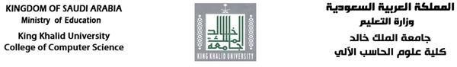

Blockchain-Based Real Estate

Investment Platform for Foreign Investors in Saudi Arabia

Section No. 2095

Student Name | University ID
JULIA ALI | 441816573
ABEER AHMED | 441816566

Supervised by

Ms. Mona Mushabab

Submitted to King Khalid University in fulfilment of the requirements for the B.Sc. Degree in Information Systems

Academic Year 2024-25/1445-1446 (Semester II) Department of Informatics and Computer Systems College of Computer Science
King Khalid University

Comments by Supervisor(s) / Examiner(s) Name signature of Supervisor and examiners

 | Comments | Signature

Abstract
The Blockchain-Based Real Estate Blockchain-Based Real Estate Investment Platform aims to revolutionize real estate transactions for foreign investors in Saudi Arabia by leveraging blockchain technology. This platform ensures transparency, security, and efficiency in property transactions,
addressing challenges such as legal complexities, transparency issues, and trust concerns. The system uses blockchain for secure, immutable property ownership records, facilitating smooth transactions through trusted Saudi banks instead of relying on cryptocurrencies. The platform integrates real estate brokers from various regions of Saudi Arabia to enhance
accessibility and ensure seamless investments. By utilizing smart contracts, the system enhances efficiency and ensures compliance with Saudi regulations, offering a secure and user-friendly solution for foreign investors.

Declarations
We, the creators of the Blockchain-Based Real Estate Blockchain-Based Real Estate Investment Platform, hereby declare that the work presented in this project is original and was developed as part of our
academic efforts. All data used for real estate transactions, ownership records, and
regulatory compliance has been sourced from publicly available datasets, and any external tools, libraries, or resources utilized have been appropriately referenced. We confirm that no portion of this project has been plagiarized or duplicated from other sources without proper citation.
This project aims to improve the process of real estate investment in Saudi Arabia through the use of blockchain technology, and it does not collect any personal data or provide real-time operational services at this stage.

Acknowledgements
We would like to express our sincere gratitude to everyone who contributed to the successful completion of the Blockchain-Based Real Estate Blockchain-Based Real Estate Investment Platform project.
We extend our heartfelt thanks to our academic advisors and professors for their guidance, support, and valuable feedback throughout the development process. Their insights have greatly influenced the direction and quality of our work.
We also appreciate the contributions of our peers for their collaborative spirit and feedback, which enhanced our project. Lastly, we thank our families for their unwavering support and motivation, helping us stay focused and committed.

Table of Contents
Abstract 3
Declarations 4
Acknowledgements 5
Chapter 1: Introduction and Background 11
1.1. Introduction 11
1.2. Research Problem Statement 11
1.3. Goal 12
1.4. Motivation 12
1.5. Significance 13
1.6. Methodology 13
1.7. Report Outline 14
Chapter 2: Literature Review 15
2.1. Introduction 15
2.2. Blockchain Technology: An Overview 15
2.3. Blockchain in Real Estate 16
2.3.1. Property Ownership and Title Management 16
2.3.2. Smart Contracts for Real Estate Transactions 16
2.3.3. Tokenization of Real Estate Assets 16
2.4. Existing Real Estate Investment Platforms 17
2.4.1. Propy 17
2.4.2. RealT 18
2.4.3. BitProperty 19
2.4.4. AqarMap (Arabic/Gulf Region) 19
2.5. Challenges in Current Solutions 21
2.5.1. Critique of Current Solutions 21
2.5.2. Blockchain Optimization in Real Estate 22
2.6. Research Gaps 22
2.7. Conclusion 22
Chapter 3: Project Management 23
3.1. Approach: Iterative Waterfall Model 23
3.1.1. Technologies and Frameworks: 23
3.1.2. Key Features: 24
3.1.3. Project Vision: 24
3.1.4. Registration and User Onboarding: 24
3.1.5. Development Approach: Iterative Waterfall Model 24
3.1.6. Stages of the Iterative Waterfall Model: 25
3.2. Risk Management 26
3.3. Project Plan: Phases, Milestones, and Timelines 29
3.3.1. Timeline and Gantt Chart 31
3.4. Final Remarks 32
Chapter 4: Requirements and Analysis 33
4.1. Introduction 33
4.2. Feasibility Analysis 34
4.2.1. Operational Feasibility 34
4.2.2. Technical Feasibility 35
4.2.3. Economic Feasibility 36
4.3. Data Requirements 36
4.3.1. Information Gathering 36
4.3.1.1. Interviews 37
4.4. System Requirements 38
4.3.2. Functional Requirements 38
4.3.3. Non-Functional Requirements 39
4.3.4. Hardware and Software Requirements 40
4.5. UML Diagrams 41
4.5.1. Use Case Diagram 41
4.5.2. Sequence Diagrams 42
4.5.2.1. User Registration and KYC Verification 42
4.5.2.2. Property Browsing and Selection 43
4.5.2.3. Investment and Smart Contract Execution 44
4.5.3. Class Diagram 45
Chapter 5: System Design 46
5.1. Introduction 46
5.2. System Architecture 46
5.2.1. Architecture Components 46
5.3. Database Design 48
5.3.1. Entity-Relationship Diagram 48
5.3.2. Data Dictionary 49
5.4. Blockchain Integration 50
5.4.1. Blockchain Selection 50
5.4.2. Smart Contract Role 50
5.4.3. Security Considerations 51
5.5. User Interface Design 51
5.5.1. Key UI Components 51
Chapter 6: Conclusions and Future Work 54
6.1. Conclusions 54
6.2. Future Work 54
6.2.1. Integration with National Databases 54
6.2.2. Support for Tokenized Investment 55
6.2.3. Real-time Currency Conversion and Fiat Payments 55
6.2.4. Mobile Application 55
6.2.5. AI-Based Property Recommendations 55
6.2.6. Full Smart Contract Audits 55
6.3. Final Reflection 55
References 56

List of Figures

Figure 1: Propy website 17
Figure 2: RealT website 18
Figure 3: BitProperty website 19
Figure 4: AqarMap website 20
Figure 5: Iterative Waterfall methodology 26
Figure 6: Gantt Chart 32
Figure 7: Use Case Diagram 41
Figure 8: User Registration and KYC Verification 42
Figure 9: Property Browsing and Selection 43
Figure 10: Investment and Smart Contract Execution 44
Figure 11: Class Diagram 45
Figure 12:System Architecture 47
Figure 13: ERD Diagram 48
Figure 14: Homepage & Property Listings 51
Figure 15: Search & Filter Interface 52
Figure 16: Mortgage Calculator 53

List of Tables

Table 1: Comparison Table: Pros and Cons 21
Table 2: Project Plan: Phases, Milestones, and Timelines 30
Table 3: Detailed Milestones and Deadlines 30
Table 4: Timeline and Gantt Chart 32
Table 5: Operational feasibility 34
Table 6: Technical System Components 35
Table 7: Economic feasibility 36
Table 8: Functional requirements 38
Table 9: Performance Requirements 39
Table 10: Security Requirements 39
Table 11: Usability & Accessibility 39
Table 12: Developer Environment 40
Table 13:End-User Environment 40
Table 14:Architecture Components 47
Table 15: User Table 49
Table 16:Property Table 49
Table 17: Investment Table 49
Table 18: Transaction Table 50

Chapter 1: Introduction and Background

Introduction
The real estate sector in Saudi Arabia has emerged as a key driver of economic growth, particularly in light of the Kingdom’s Vision 2030 initiative, which aims to diversify the economy and attract foreign investment. However, foreign investors face significant challenges when engaging in real estate transactions, including a lack of transparency, legal complexities, and trust deficits in the existing systems. These barriers hinder the full potential of foreign capital inflows into the Saudi real estate market.
To address these challenges, this project proposes the development of Blockchain-Based Real Estate, a blockchain-based platform designed to streamline and secure real estate transactions for foreign investors. By integrating blockchain technology for immutable property ownership records and leveraging trusted Saudi banking systems for financial transactions, Blockchain-Based Real Estate aims to create a seamless, transparent, and efficient investment ecosystem. This platform will not only enhance trust and security but also align with Saudi Arabia’s broader goals of fostering a robust and investor-friendly real estate market.

Research Problem Statement
The real estate sector in Saudi Arabia has emerged as a key driver of economic growth, particularly in light of the Kingdom's Vision 2030 initiative, which aims to diversify the economy and attract foreign investment. However, foreign investors face significant challenges when engaging in real estate transactions, including lack of transparency, legal complexities, and trust deficits in the existing systems. These barriers hinder the full potential of foreign capital inflows into the Saudi real estate market.
Current real estate investment platforms, both globally and regionally, often fail to address the unique regulatory, cultural, and infrastructural needs of the Saudi market. While platforms like Propy, RealT, and BitProperty leverage blockchain technology to enhance transparency and efficiency, they lack localization and integration with traditional banking systems, which are critical for ensuring trust and compliance in Saudi Arabia. Additionally, platforms like AqarMap, which cater to the Gulf region, do not utilize blockchain technology, missing out on the benefits of immutable property records, smart contracts, and fractional ownership.
The absence of a comprehensive, blockchain-based real estate investment platform tailored for Saudi Arabia creates a significant gap in the market. Foreign investors require a secure, transparent, and user-friendly platform that simplifies property transactions, ensures compliance with Saudi regulations, and integrates seamlessly with trusted banking systems. Without such a platform, the Kingdom risks losing out on valuable foreign investment opportunities, which are essential for achieving the economic diversification goals outlined in Vision 2030.
Therefore, the research problem can be stated as follows:
How can a blockchain-based real estate investment platform be designed and implemented to address the challenges of transparency, legal compliance, and trust faced by foreign investors in Saudi Arabia, while ensuring seamless integration with traditional banking systems and adherence to local regulations?
This research aims to develop a Blockchain-Based Real Estate Investment Platform that leverages blockchain technology to provide immutable property records, automate transactions through smart contracts, and enable fractional ownership, all while ensuring compliance with Saudi Arabia's regulatory framework. By addressing these challenges, the platform will enhance the accessibility, security, and efficiency of real estate transactions, fostering greater foreign investment in the Kingdom's real estate market.

Goal
The primary goal of this project is to design and implement a secure, transparent, and user-friendly platform that simplifies real estate transactions for foreign investors in Saudi Arabia. By utilizing blockchain technology, the platform will ensure the integrity and immutability of property ownership records, while trusted banking systems will facilitate secure financial transactions. The platform will also comply with Saudi regulatory frameworks, ensuring that all transactions are legally sound and transparent. Ultimately, Blockchain-Based Real Estate aims to reduce the barriers to entry for foreign investors, fostering greater participation in Saudi Arabia’s real estate market.

Motivation
The motivation behind this project stems from the persistent challenges faced by foreign investors in Saudi Arabia’s real estate market. Issues such as opaque transaction processes, legal ambiguities, and a lack of trust in financial systems have deterred many potential investors. These challenges not only limit foreign investment but also hinder the growth and modernization of the real estate sector.
Blockchain technology offers a transformative solution to these problems. Its decentralized nature ensures transparency, while its immutability guarantees the integrity of transaction records. By leveraging these features, Blockchain-Based Real Estate seeks to address the existing pain points and create a more accessible and trustworthy real estate investment environment. This project is driven by the belief that technology can play a pivotal role in unlocking the full potential of Saudi Arabia’s real estate market for foreign investors.

Significance
The significance of this project lies in its potential to revolutionize the real estate investment landscape in Saudi Arabia. By introducing a blockchain-based platform, Blockchain-Based Real Estate addresses critical issues such as transparency, security, and trust, which are essential for attracting foreign investment. The platform’s ability to provide immutable property records and secure financial transactions will significantly reduce the risks associated with real estate investments.
Moreover, this project aligns with Saudi Arabia’s Vision 2030 objectives by promoting economic diversification and enhancing the Kingdom’s appeal as a global investment destination. By simplifying the investment process and fostering trust, Blockchain-Based Real Estate has the potential to catalyze increased foreign participation in the real estate market, contributing to the Kingdom’s long-term economic goals.

Methodology
The development of the Blockchain-Based Real Estate platform will follow a structured and systematic approach. The platform will be built using Flask and Python, which are well-suited for developing scalable and secure web applications. Blockchain technology will be integrated to create smart contracts that automate and secure property transactions. These smart contracts will ensure that all transactions are transparent, tamper-proof, and compliant with Saudi regulations.
To facilitate secure financial transactions, the platform will collaborate with trusted Saudi banks, ensuring that all monetary exchanges are conducted within a regulated and secure framework. Additionally, the platform will integrate real estate brokers from across Saudi Arabia, providing foreign investors with access to a comprehensive network of properties and professionals. This integration will enhance the platform’s accessibility and usability, making it a one-stop solution for foreign real estate investors.

Report Outline
This thesis is organized into six chapters, each addressing a critical aspect of the project:
Chapter 2: Background and Literature Review
This chapter provides an overview of blockchain technology and its applications in real estate. It also reviews existing real estate investment platforms and identifies gaps that Blockchain-Based Real Estate aims to address.
Chapter 3: Project Management
This chapter outlines the project management approach, including the methodology, timeline, and risk management strategies employed during the development of Blockchain-Based Real Estate.
Chapter 4: System Requirements and Analysis
This chapter details the functional and non-functional requirements of the platform, along with a comprehensive analysis of the system’s needs and constraints.
Chapter 5: System Design
This chapter describes the architecture and design of the Blockchain-Based Real Estate platform, including its key functionalities, user interfaces, and integration with blockchain and banking systems.
Chapter 6: Conclusion and Future Enhancements
This chapter summarizes the project’s outcomes, evaluates its success in meeting the stated goals, and suggests potential future enhancements to further improve the platform.

Chapter 2: Literature Review

Introduction
The integration of blockchain technology into real estate has emerged as a transformative innovation, offering solutions to long-standing challenges such as lack of transparency, inefficiency, and trust deficits. This chapter reviews existing literature on blockchain technology, its applications in real estate, and the current state of real estate investment platforms. By examining these areas, this review identifies gaps in the current landscape and highlights the unique contributions of the Blockchain-Based Real Estate platform.

Blockchain Technology: An Overview
Blockchain technology, first introduced by Nakamoto (2008) as the underlying framework for Bitcoin, is a decentralized and distributed ledger system that records transactions in a secure, transparent, and immutable manner. Key features of blockchain include:
- Decentralization: Eliminates the need for a central authority, reducing the risk of single points of failure (Tapscott & Tapscott, 2016).
- Transparency: All participants in the network can view transaction records, ensuring accountability (Yli-Huumo et al., 2016).
- Immutability: Once recorded, data cannot be altered, ensuring the integrity of transaction records (Zheng et al., 2018).
- Smart Contracts: Self-executing contracts with predefined rules that automate and enforce agreements (Wang et al., 2019).
Blockchain has evolved beyond cryptocurrencies, finding applications in supply chain management, healthcare, and real estate (Tapscott & Tapscott, 2016). Its potential to disrupt traditional industries lies in its ability to provide secure, transparent, and efficient solutions to complex problems.

Blockchain in Real Estate
The real estate industry, traditionally characterized by complex and opaque processes, stands to benefit significantly from blockchain technology. Key applications of blockchain in real estate include:

Property Ownership and Title Management
One of the most promising applications of blockchain in real estate is the management of property titles. Traditional systems for recording property ownership are often prone to errors, fraud, and inefficiencies. Blockchain’s immutable ledger can provide a secure and transparent record of property ownership, reducing the risk of disputes and fraud (Yli-Huumo et al., 2016). For example, the Republic of Georgia has implemented a blockchain-based land registry system in collaboration with Bitfury, significantly improving transparency and reducing fraud (Shin, 2018).

Smart Contracts for Real Estate Transactions
Smart contracts automate and enforce the terms of real estate agreements, eliminating the need for intermediaries such as lawyers and brokers. This not only reduces transaction costs but also speeds up the process. Studies by Wang et al. (2019) have demonstrated the potential of smart contracts to streamline real estate transactions, particularly in cross-border investments. For instance, platforms like Propy use smart contracts to facilitate international property transactions, reducing the time and cost associated with traditional methods.

Tokenization of Real Estate Assets
Blockchain enables the tokenization of real estate assets, where properties are divided into digital tokens representing ownership shares. This allows for fractional ownership, making real estate investments more accessible to a broader range of investors (Fenu et al., 2018). Tokenization also enhances liquidity in the real estate market, which is traditionally illiquid. Platforms like RealT and REtoken have successfully implemented tokenization, enabling investors to purchase fractional shares in rental properties and earn passive income (Hudson, 2020).

Existing Real Estate Investment Platforms
Several platforms have emerged to leverage blockchain technology for real estate transactions. These platforms aim to address challenges such as transparency, efficiency, and accessibility. Examples include:

Propy
Type: Website
Region: Global, with a focus on cross-border transactions.
Link: https://propy.com
Description: Propy is a global real estate website platform that uses blockchain to facilitate cross-border property transactions. It offers features such as smart contracts, digital notarization, and secure payment systems. While Propy has achieved success in simplifying international transactions, it primarily focuses on cross-border markets and does not specifically address the unique regulatory and cultural challenges of markets like Saudi Arabia (Propy, 2023).
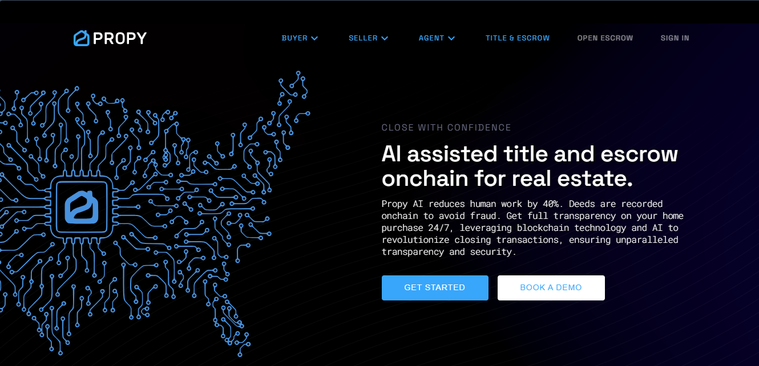
Figure 1: Propy website

RealT
Type: Website
Region: United States.
Link: https://realt.co
Description: RealT is a website platform that enables fractional ownership of real estate through tokenization. It allows investors to purchase tokens representing shares in rental properties, providing passive income opportunities. However, RealT’s focus is limited to the U.S. market, and it does not cater to the specific needs of foreign investors in emerging markets (RealT, 2023).
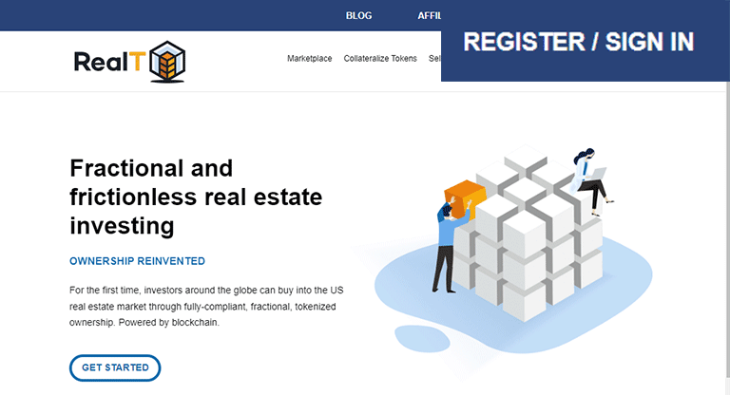
Figure 2: RealT website

BitProperty
Type: Website
Region: Global, with a focus on peer-to-peer real estate transactions.
Link: https://bitproperty.com
Description: BitProperty is a blockchain-based website platform that aims to democratize real estate investment by enabling fractional ownership and peer-to-peer transactions. While innovative, BitProperty lacks integration with traditional banking systems, which are critical for ensuring trust and compliance in regulated markets like Saudi Arabia (BitProperty, 2023).
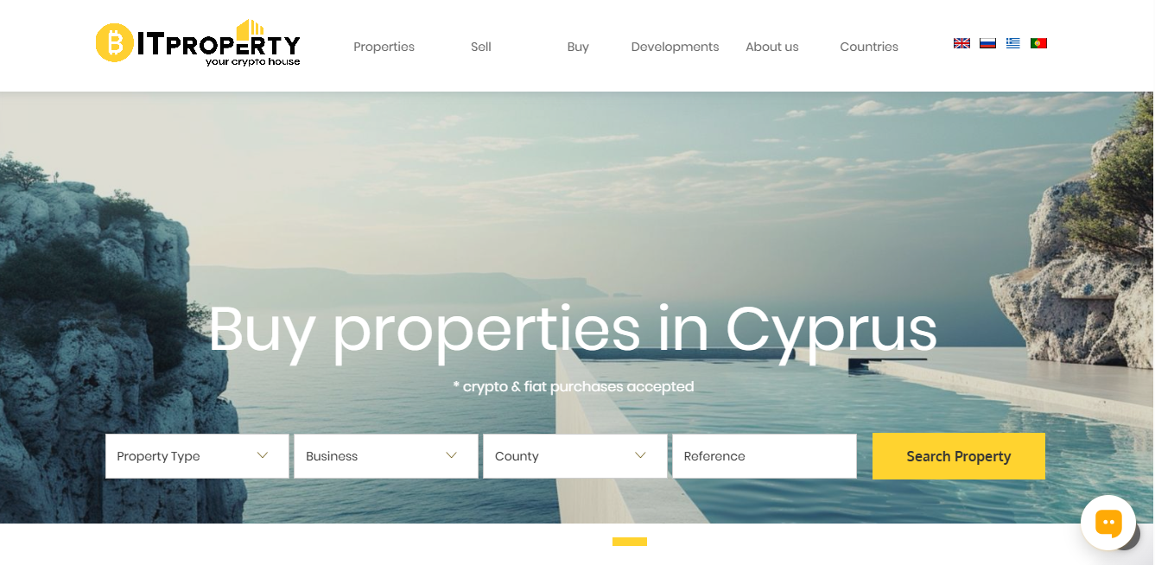
Figure 3: BitProperty website

AqarMap (Arabic/Gulf Region)
Type: Website and Mobile Application
Region: Middle East and North Africa (MENA), with a strong focus on Saudi Arabia, UAE, and Egypt.
Link: https://www.aqarmap.com
Description: AqarMap is a leading real estate platform in the MENA region, offering property listings, market analytics, and investment opportunities. It focuses on digitizing real estate transactions and providing data-driven insights for investors.
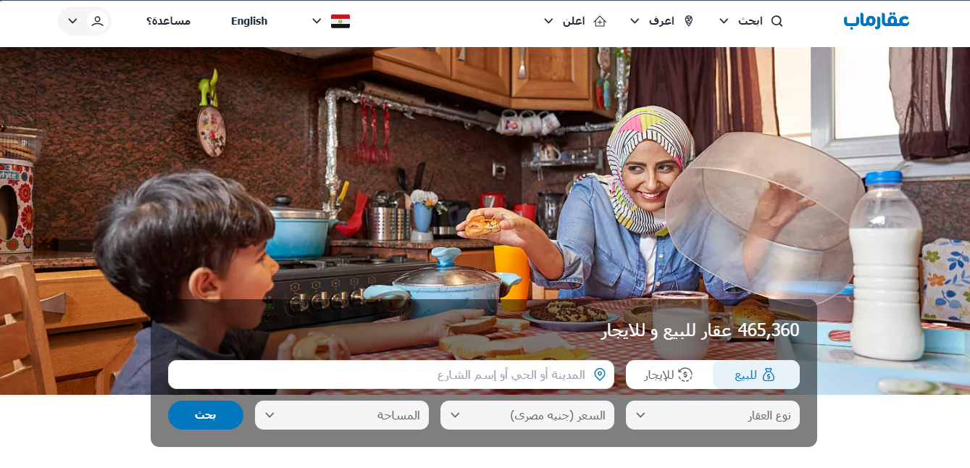
Figure 4: AqarMap website
Platform | Pros | Cons | Compared to Our Platform
Propy | -Global reach.  - Uses blockchain for cross-border transactions. | - Limited focus on Saudi Arabia.  - No fractional ownership. | Our platform is tailored for Saudi Arabia and offers fractional ownership, which Propy does not provide.
RealT | - Enables fractional ownership.  - Focuses on U.S. rental market. | - Limited to U.S. market.  - No integration with traditional banks. | Our platform integrates with trusted Saudi banks and is designed for Saudi regulations, unlike RealT.
BitProperty | - Peer-to-peer transactions.  - Uses blockchain for transparency. | - No integration with traditional banking systems.  - Limited market reach. | Our platform integrates with Saudi banks and offers a comprehensive ecosystem, which BitProperty lacks.
AqarMap | - Strong focus on MENA region.  - Provides market analytics. | - No blockchain integration.  - No smart contract functionality. | Our platform offers blockchain-based transparency and smart contracts, which AqarMap lacks.
Table 1: Comparison Table: Pros and Cons

Challenges in Current Solutions
Despite the advancements in blockchain-based real estate platforms, several challenges remain:
- Regulatory Compliance: Many platforms, such as Propy and BitProperty, struggle to navigate the complex regulatory environments of different countries. For example, Propy focuses on cross-border transactions but does not address Saudi Arabia's specific legal requirements.
- Integration with Traditional Systems: Platforms like RealT and BitProperty lack integration with traditional banking systems, which are critical for ensuring trust and compliance in regulated markets like Saudi Arabia.
- Localization: Existing platforms often fail to address the specific cultural, regulatory, and infrastructural needs of markets like Saudi Arabia. For instance, AqarMap provides excellent market analytics but does not leverage blockchain technology.
- User Adoption: Many investors are unfamiliar with blockchain technology, and platforms like BitProperty do not provide sufficient educational resources or user-friendly interfaces to bridge this gap.

Critique of Current Solutions
- Propy: While Propy excels in cross-border transactions, it does not cater to the unique needs of Saudi Arabia's real estate market. Its lack of fractional ownership limits its appeal to investors looking for diversified portfolios.
- RealT: RealT's focus on the U.S. market and lack of integration with traditional banking systems make it unsuitable for Saudi investors. Its decentralized approach may also face regulatory hurdles in the Gulf region.
- BitProperty: BitProperty's peer-to-peer model is innovative but lacks integration with traditional financial systems, which are essential for building trust in regulated markets like Saudi Arabia.
- AqarMap: AqarMap provides valuable market insights but does not leverage blockchain technology, missing out on the benefits of transparency, security, and automation that blockchain offers.

Blockchain Optimization in Real Estate
Recent scientific papers highlight the potential of blockchain technology to optimize real estate transactions:
- Transparency and Security: Blockchain's immutable ledger ensures that property records cannot be altered, reducing the risk of fraud and disputes (Yli-Huumo et al., 2016).
- Smart Contracts: Automated contracts streamline transactions, reduce costs, and eliminate the need for intermediaries (Wang et al., 2019).
- Tokenization: Blockchain enables fractional ownership, making real estate investments more accessible and liquid (Fenu et al., 2018).
- Regulatory Compliance: Blockchain can be designed to comply with local regulations, ensuring that all transactions are legally sound (Shin, 2018).

Research Gaps
The literature review reveals several gaps that the Blockchain-Based Real Estate platform aims to address:
- Localized Solutions: Existing platforms often lack localization, failing to address the specific regulatory, cultural, and infrastructural needs of markets like Saudi Arabia.
- Trust and Transparency: While blockchain inherently provides transparency, few platforms integrate trusted banking systems to enhance investor confidence.
- Comprehensive Ecosystem: Most platforms focus on specific aspects of real estate transactions (e.g., tokenization or smart contracts) but fail to provide a holistic solution that covers the entire transaction lifecycle.

Conclusion
The literature highlights the transformative potential of blockchain technology in real estate, particularly in addressing challenges related to transparency, efficiency, and trust. However, existing platforms often fall short in providing localized, comprehensive, and regulatory-compliant solutions for markets like Saudi Arabia. Blockchain-Based Real Estate aims to bridge these gaps by offering a secure, transparent, and user-friendly platform tailored to the needs of foreign investors in Saudi Arabia’s real estate market.

Chapter 3: Project Management
This chapter discusses the planning and execution of the real estate investment plat form project. It focuses on methodologies, risk management, and project scheduling, outlining the approach, key risks, and detailed phases to ensure successful development and deployment.

Approach: Iterative Waterfall Model
The development of the Blockchain-Based Real Estate Investment Platform will follow a structured and systematic approach, ensuring a secure, transparent, and user-friendly experience for foreign investors in Saudi Arabia. The platform will leverage modern technologies and frameworks, with a focus on compliance with Saudi regulations and seamless integration with existing financial systems.

Technologies and Frameworks:
- Backend Development: The platform will be developed using Flask and Python, chosen for their scalability, flexibility, and robust ecosystem of libraries. These technologies will enable the creation of a secure and efficient backend infrastructure capable of handling complex real estate transactions.
- Blockchain Integration: Blockchain technology will be at the core of the platform, ensuring immutable property ownership records and transparent transaction histories. Smart contracts, written in Solidity or a similar language, will automate and enforce the terms of real estate agreements, reducing the need for intermediaries and minimizing the risk of disputes.
- Frontend Development: The user interface will be designed using modern web development frameworks such as React.js or Vue.js, ensuring a responsive and intuitive experience for investors. The frontend will provide easy access to property listings, transaction histories, and investment opportunities.
- Database Management: A secure and scalable database system, such as PostgreSQL or MongoDB, will be used to store property details, user information, and transaction records. The database will be designed to ensure data integrity and compliance with Saudi data protection laws.
- Banking Integration: The platform will integrate with trusted Saudi banks to facilitate secure financial transactions. This integration will ensure that all monetary exchanges are conducted within a regulated and secure framework, enhancing investor confidence.

Key Features:
- Immutable Property Records: Blockchain will be used to create tamper-proof records of property ownership, reducing the risk of fraud and disputes.
- Smart Contracts: Automated contracts will streamline the transaction process, ensuring that all parties adhere to the agreed terms without the need for intermediaries.
- Tokenization of Assets: The platform will explore the possibility of tokenizing real estate assets, allowing for fractional ownership and increased liquidity in the market.
- User-Friendly Interface: The platform will feature an intuitive and accessible interface, designed to cater to both tech-savvy investors and those unfamiliar with blockchain technology.
- Regulatory Compliance: The platform will be designed to comply with Saudi Arabia's real estate and financial regulations, ensuring that all transactions are legally sound and transparent.

Project Vision:
The Blockchain-Based Real Estate Investment Platform will serve as a one-stop solution for foreign investors looking to participate in Saudi Arabia's real estate market. By leveraging blockchain technology, the platform will address key challenges such as lack of transparency, legal complexities, and trust deficits. The platform will provide a seamless and secure environment for property transactions, enabling investors to browse listings, conduct due diligence, and complete transactions with confidence.

Registration and User Onboarding:
The platform will include a registration system for users, allowing foreign investors to create accounts and verify their identities. The registration process will be designed to comply with Saudi Arabia's Know Your Customer (KYC) and Anti-Money Laundering (AML) regulations. Once registered, users will have access to the platform's full range of features, including property listings, transaction histories, and investment opportunities.

Development Approach: Iterative Waterfall Model
The project will follow the Iterative Waterfall Model, a development methodology that combines the structured approach of the traditional Waterfall Model with iterative feedback loops. This approach is well-suited for projects with well-defined requirements and regulatory constraints, such as the Blockchain-Based Real Estate Investment Platform. The development process will be divided into clear phases, with each phase building on the previous one while allowing for feedback and adjustments.

Stages of the Iterative Waterfall Model:
- Requirements Analysis:
- Gather and document all functional and non-functional requirements.
- Consult with stakeholders, legal experts, and industry professionals to ensure compliance with Saudi regulations.
- Deliverable: Comprehensive requirements document.
- System Design:
- Design the system architecture, including blockchain frameworks, smart contracts, and database schemas.
- Create wireframes and mockups for the user interface.
- Define integration with Saudi banks and real estate brokers.
- Deliverable: System architecture diagram and UI mockups.
- Implementation (Development):
- Develop the backend infrastructure, smart contracts, and frontend interface.
- Integrate the platform with blockchain networks and banking systems.
- Deliverable: Functional alpha version of the platform.
- Testing and Quality Assurance:
- Conduct unit testing, integration testing, and system testing to ensure all components function correctly.
- Perform user acceptance testing (UAT) with real estate agents and investors.
- Deliverable: Test reports and performance optimization.
- Deployment and Maintenance:
- Deploy the final version of the platform.
- Provide post-launch support and maintenance.
- Gather user feedback and implement further improvements.
- Deliverable: Live platform and maintenance reports.

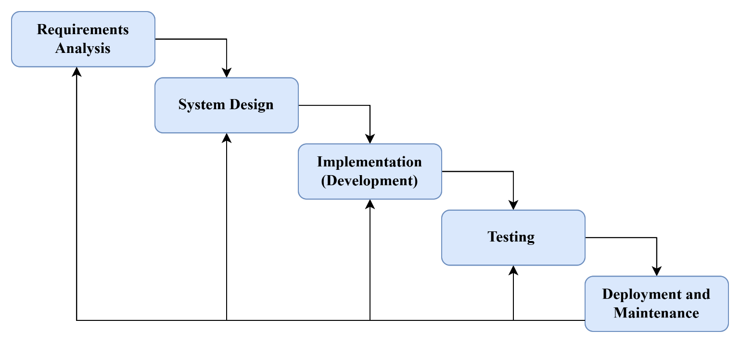
Figure 5: Iterative Waterfall methodology

Risk Management
Risk management is a critical component of the Blockchain-Based Real Estate Investment Platform project, ensuring that potential challenges are identified and addressed proactively. The following key risks and mitigation strategies have been outlined:
- Regulatory and Legal Compliance Risks
- Risk: Compliance with Saudi Arabian real estate and financial laws may require modifications to the platform's design and implementation. Changes in regulations during the project lifecycle could also impact development.
- Mitigation: Regular consultations with legal experts and regulators will be conducted to ensure adherence to all relevant policies. A flexible design approach will be adopted to accommodate potential regulatory changes.
- Blockchain Security Risks
- Risk: Potential vulnerabilities in smart contracts or the blockchain network could lead to security breaches, compromising the integrity of property records and transactions.
- Mitigation: Extensive smart contract audits will be conducted, employing security best practices and multi-layer encryption protocols. Regular security assessments will be performed to identify and address vulnerabilities.
- User Adoption and Technological Understanding
- Risk: Foreign investors unfamiliar with blockchain technology may hesitate to use the platform, leading to low adoption rates.
- Mitigation: The platform will feature a user-friendly interface, educational resources, and customer support to ensure a smooth onboarding experience. Tutorials and guides will be provided to help users understand blockchain technology and its benefits.
- Data Integrity and Privacy Risks
- Risk: Unauthorized access to transaction and ownership data could compromise investor confidence and violate data protection laws.
- Mitigation: Strict access controls, encryption, and compliance with Saudi Arabia's data protection laws will be implemented. Regular audits will ensure data integrity and privacy.
- Integration with Banking Systems
- Risk: Delays or technical issues in integrating the platform with Saudi banks could hinder the platform's functionality and user experience.
- Mitigation: Early partnerships with financial institutions will be established, and thorough pre-launch testing will be conducted to ensure seamless integration.
- Scalability and Performance Risks
- Risk: Increased user demand may affect system performance and transaction speed, leading to a poor user experience.
- Mitigation: Scalable blockchain solutions will be used, and the system architecture will be optimized for high efficiency. Load testing will be conducted to ensure the platform can handle peak usage.
- Team Collaboration and Communication Risks
- Risk: If discussions with stakeholders (e.g., legal experts, advisors) are moved from in-person to online unexpectedly, it could lead to miscommunication or delays in decision-making.
- Mitigation: Clear communication protocols will be established, and regular virtual meetings will be scheduled to ensure continuous collaboration. Documentation of all discussions and decisions will be maintained to avoid misunderstandings.
- Technological Knowledge Gaps
- Risk: If one team member introduces a new technology or tool that others are unfamiliar with, it could slow down development and lead to inefficiencies.
- Mitigation: Team members will undergo training sessions to ensure everyone is proficient in the technologies being used. Knowledge-sharing sessions will be conducted regularly, and documentation will be maintained for reference. If a team member lacks understanding of a new technology, the solution will be for another team member to take the lead while providing guidance and support.
- Data Availability and Quality
- Risk: Limited access to reliable real estate data could hinder testing and validation, impacting the platform's accuracy and functionality.
- Mitigation: Partnerships with real estate brokers and data providers will be established to ensure access to high-quality data. Data validation processes will be implemented to ensure accuracy.
- Stakeholder Collaboration Challenges
- Risk: Coordinating with real estate brokers, investors, and banking institutions may be challenging due to varying levels of technical familiarity and differing priorities.
- Mitigation: Clear communication channels will be established, and stakeholders will be involved in the development process from the beginning. Regular updates and feedback sessions will ensure alignment and address any concerns.
- Testing Limitations
- Risk: Real-world testing with financial transactions may be restricted due to regulatory compliance concerns, necessitating extensive simulations instead.
- Mitigation: Comprehensive simulation environments will be created to mimic real-world scenarios. Regulatory approvals will be sought for limited real-world testing where possible.

Project Plan: Phases, Milestones, and Timelines
The project will be divided into structured phases, with clear milestones and deliverables at each stage. The following phases outline the approach and expected timeline for the project.
Phase | Tasks | Deliverables | Timeline
Phase 1: Research and Feasibility Study | - Analyze the Saudi real estate market.  - Study global blockchain applications in real estate.  - Review legal and regulatory requirements for blockchain-based property transactions in Saudi Arabia. | - Market analysis report.  - Legal and regulatory challenges report.  - Project Proposal Submission. | Weeks 2–4  (23rd January – 5th February 2025)
Phase 2: System Design | - Design system architecture (blockchain framework, smart contracts, and database).  - Develop wireframes and mockups for user interfaces.  - Define integration with Saudi banks. | - System architecture diagram.  - UI mockups and technical specifications.  - Chapter 1 Submission. | Weeks 5–7  (12th February – 26th February 2025)
Phase 3: Development and Integration | - Develop smart contracts and integrate blockchain with the platform.  - Build backend infrastructure for property transactions.  - Integrate the front-end platform with banking systems. | - Smart contract code.  - Functional backend systems.  - Alpha version of the platform.  - Chapter 4 Submission. | Weeks 9–12  (12th March – 10th April 2025)
Phase 4: Testing and Quality Assurance | - Conduct unit testing, system testing, and integration testing.  - Perform user acceptance testing (UAT) with real estate agents and investors. | - Test reports, issue logs, and performance optimization.  - Chapters Review.  - Report Submission for Review and Approvals. | Weeks 14–15  (15th – 23rd April 2025)
Phase 5: Deployment and Maintenance | - Deploy the final version of the platform.  - Provide post-launch support and maintenance.  - Gather user feedback and implement further improvements. | - Live platform and maintenance reports.  - Project Final Presentation. | Week 16  (27th April – 1st May 2025)
Table 2: Project Plan: Phases, Milestones, and Timelines

Detailed Milestones and Deadlines
Week | Date Range | Task/Milestone | Description | Deadline
1 | 22nd – 28th January 2025 | Project Proposal Submission | Submit the initial project proposal for review. | 29th January 2025
2 | 29th January – 4th February 2025 | Project Proposal Approval | Await approval of the project proposal. | 5th February 2025
3 | 5th – 11th February 2025 | Project Plan Submission | Submit the detailed project plan. | 12th February 2025
4 | 12th – 18th February 2025 | Chapter 1 Submission | Complete and submit Chapter 1 of the project report. | 18th February 2025
5 | 19th – 25th February 2025 | Chapter 2 Submission | Complete and submit Chapter 2 of the project report. | 26th February 2025
6 | 26th February – 4th March 2025 | Chapter 3 Submission | Complete and submit Chapter 3 of the project report. | 5th March 2025
7 | 5th – 11th March 2025 | Chapter 4 Submission | Complete and submit Chapter 4 of the project report. | 12th March 2025
8 | 12th – 18th March 2025 | Mid-Exam Presentation | Prepare and present the mid-exam presentation. | 16th – 20th March 2025
9 | 19th – 25th March 2025 | Chapter 5 Submission | Complete and submit Chapter 5 of the project report. | 26th March 2025
10 | 26th March – 1st April 2025 | Report Review | Submit the report to the supervisor for review and approval. | 2nd April 2025
11 | 2nd – 8th April 2025 | Approved Report Submission | Submit the approved report to the project coordinator. | 9th April 2025
12 | 9th – 15th April 2025 | Final Presentation Preparation | Prepare for the final project presentation. | 16th April 2025
13 | 16th – 22nd April 2025 | Project Final Presentation | Present the final project to the evaluation committee. | 27th April – 1st May 2025
Table 3: Detailed Milestones and Deadlines

Timeline and Gantt Chart

Week | Date Range | Task/Milestone | Description | Deadline
1 | 22nd - 28th January  2025 | Project Proposal  Submission | Submit the initial project  proposal for review. | 29th January  2025
2 | 29th January - 4th  February 2025 | Project Proposal  Approval | Await approval of the  project proposal. | 5th February  2025
3 | 5th - 11th February  2025 | Project Plan  Submission | Submit the detailed  project plan. | 12th February  2025
4 | 12th - 18th February 2025 | Chapter 1 Submission | Complete and submit Chapter 1 of the project  report. | 18th February 2025
5 | 19th - 25th February 2025 | Chapter 2 Submission | Complete and submit  Chapter 2 of the project report. | 26th February 2025
6 | 26th February - 4th March 2025 | Chapter 3 Submission | Complete and submit  Chapter 3 of the project report. | 5th March 2025
7 | 5th - 11th March 2025 | Chapter 4 Submission | Complete and submit Chapter 4 of the project  report. | 12th March 2025
8 | 12th - 18th March  2025 | MID EXAM  Presentation | Prepare and present the  mid-exam presentation. | 16th - 20th  March 2025
9 | 19th - 25th March 2025 | Chapter 5 Submission | Complete and submit Chapter 5 of the project  report. | 26th March 2025
10 | 26th March - 1st April 2025 | Report Review | Submit the report to the  supervisor for review and approval. | 2nd April 2025
11 | 2nd - 8th April 2025 | Approved Report Submission | Submit the approved report to the project  coordinator. | 9th April 2025
12 | 9th - 15th April 2025 | Final Presentation  Preparation | Prepare for the final  project presentation. | 16th April  2025
13 | 16th - 22nd April 2025 | Project Final  Presentation | Present the final project to  the evaluation committee. | 27th April -  1st May 2025
Table 4: Timeline and Gantt Chart

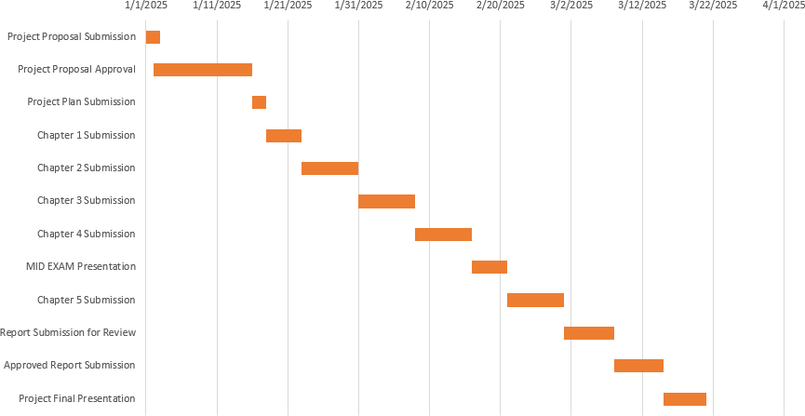
Figure 6: Gantt Chart

Final Remarks
The project management strategy follows a structured, iterative approach to ensure successful development and deployment of the platform. By using Agile methodologies and clear risk management, the project aims to address the challenges that foreign investors face when purchasing real estate in Saudi Arabia. Through effective planning, collaboration, and continual improvement, the platform is well-positioned to deliver an innovative and user-friendly solution for property transactions.

Chapter 4: Requirements and Analysis
This chapter defines the functional and non-functional requirements of the Blockchain-Based Real Estate Investment Platform for foreign investors in Saudi Arabia. The analysis ensures the system aligns with its core objectives: transparency, security, efficiency, and regulatory compliance. We outline feasibility studies, system requirements, and UML diagrams to guide development.

Introduction
This chapter presents a comprehensive analysis of the system requirements and feasibility of the Blockchain-Based Real Estate Investment Platform for Foreign Investors in Saudi Arabia. The purpose of this analysis is to define the core system functionalities, examine the project's viability from technical and operational perspectives, and establish a clear foundation for system design and development.
The goal of the platform is to enable foreign investors to securely and transparently purchase, co-invest in, or manage Saudi real estate through smart contracts and blockchain technology. To support this goal, the platform must facilitate identity verification, property listing and browsing, secure investment initiation, and automated ownership registration using blockchain records. Administrative oversight and integration with traditional banking channels are also key to building trust and ensuring regulatory compliance.
Requirements for the system were gathered through a combination of academic research, analysis of similar real-world platforms (e.g., Propy, RealT, and Smartlands), and theoretical modeling. The feasibility of the system has been evaluated across operational, technical, economic, and schedule-related dimensions to confirm the project's readiness for development and deployment.

Feasibility Analysis
The feasibility analysis aims to determine whether the proposed platform can be realistically implemented using the available technologies, time frame, resources, and budget. This section evaluates the project’s operational, technical, economic, and schedule feasibility.

Operational Feasibility
Operational feasibility focuses on the practicality of operating the system in a real-world environment, from both user and administrator perspectives. The platform is designed to be web-based and user-friendly, minimizing friction for foreign investors who may be unfamiliar with local regulations or technologies.
Aspect | Details
Target Users | Foreign investors, Saudi-based administrators, real estate agents
Access Method | Web browser (desktop and mobile), no installation required
User Authentication | Secure registration and login with identity verification (passport/ID upload)
Investment Process | Step-by-step guided workflows for selecting properties and initiating investments
Ownership Validation | Blockchain-based ownership records stored via smart contracts
Support and Compliance | Admin interface to manage listings, users, and regulatory documents
Table 5: Operational feasibility
The system is highly operable with minimal technical skill required from the investor. The administrative side is built for centralized oversight, while blockchain ensures transparent asset registration.

Technical Feasibility
This component assesses whether the system can be implemented using current technologies and tools within the team’s technical capabilities. The architecture is designed to integrate modern web development frameworks, blockchain functionality, and a document-oriented database.
Component | Technology | Purpose
Backend | Python (Flask) | RESTful API for business logic and data handling
Frontend | HTML, CSS, JavaScript (React.js optional) | Web-based user interface for investors and admin
Blockchain Layer | Ethereum testnet (e.g., Goerli) with Solidity | Smart contract execution for secure, immutable investment transactions
Database | MongoDB (NoSQL) | Flexible storage of property data, user records, and transaction history
Security Protocols | HTTPS, JSON Web Tokens (JWT), role-based access | Data privacy, authenticated sessions, user role separation
Wallet Integration | MetaMask or similar | Enables investors to interact with smart contracts via secure crypto wallets
Table 6: Technical System Components
All components of the system can be implemented using widely adopted and well-supported technologies. The tools and frameworks are free and open-source, reducing complexity and cost while supporting scalability.

Economic Feasibility
Economic feasibility determines whether the project is financially viable, especially at the minimum viable product (MVP) level intended for academic evaluation.
Cost Component | Estimated Cost (USD) | Notes
Domain name & SSL | $30–40 annually | Secure HTTPS access, critical for trust and usability
Web hosting (shared/VPS) | $60–100 annually | Hosting backend services and frontend application
Blockchain testnet usage | $0 | Ethereum test networks are free (Goerli, Sepolia)
Development tools | $0 | All selected tools are open-source
Smart contract audit | ~$500 (optional/future) | Not required for MVP, only for real deployment
Table 7: Economic feasibility

Data Requirements

Information Gathering
The information-gathering process for this study involved a combination of qualitative and comparative research methods, including interviews with industry stakeholders and a review of existing blockchain-based real estate platforms. This multifaceted approach enabled a comprehensive understanding of both the market needs and the challenges inherent in implementing a blockchain solution within the Saudi real estate investment sector. The findings provided critical insights into investor expectations, operational limitations, and regulatory constraints.

Interviews
Interviews were conducted with a sample of prospective foreign investors and real estate professionals to assess the practical barriers and investment pain points experienced in the Saudi Arabian real estate market. A recurring theme across responses was the lack of accessibility and transparency in traditional real estate processes, particularly for non-resident investors.
Participants cited several key challenges:
- High transactional costs associated with brokers, middlemen, and documentation.
- Complex and opaque regulatory frameworks, especially regarding property ownership eligibility for foreign nationals.
- Delayed or unreliable verification of property titles and ownership documents.
- Inefficient cross-border financial transactions, often hindered by currency exchange delays or compliance bottlenecks.
A significant portion of the interviewees expressed enthusiasm for blockchain-based solutions. They recognized the potential of blockchain to offer decentralized, transparent, and tamper-proof systems that could address these limitations. Most respondents emphasized the importance of:
- Digitally managed ownership records using smart contracts.
- Cross-border payment automation and verification using blockchain wallets and tokens.
- Public, verifiable records of property investment history to build trust and reduce fraud.
These insights directly influenced the formulation of the platform’s core features, such as:
- A smart contract-enabled investment engine.
- A blockchain-backed property registry.
- User verification with secure identity documentation.
By aligning the system’s functional requirements with the feedback gathered from real stakeholders, the platform design was refined to address real-world needs and improve foreign investor engagement in the Saudi property market.

System Requirements
System requirements define the specific capabilities that the platform must possess in order to fulfill its objectives. These are divided into functional requirements, non-functional requirements, and hardware/software requirements to provide a full picture of what the system should do, how it should perform, and what resources it needs.

Functional Requirements
Functional requirements describe the key services and actions the system must support to enable property investment through blockchain smart contracts.
ID | Requirement | Actor | Priority
FR1 | Users can register and log in using secure authentication (email + password + KYC). | Investor, Admin | High
FR2 | Admin can verify and approve users before granting access to investment features. | Admin | High
FR3 | Investors can view, search, and filter available real estate listings. | Investor | High
FR4 | Admin can add, update, or delete real estate property listings. | Admin | High
FR5 | Investors can initiate investments and confirm payment via integrated wallet (MetaMask). | Investor | High
FR6 | Smart contract is deployed and executed upon investment confirmation. | System | High
FR7 | Blockchain transaction ID and property ownership are recorded and viewable. | Investor, Admin | Medium
FR8 | Admin can view platform analytics and manage users/investments. | Admin | Medium
Table 8: Functional requirements

Non-Functional Requirements
Non-functional requirements ensure that the platform performs reliably, securely, and is user-friendly.

Performance Requirements
ID | Requirement | Priority
NFR-P1 | The system must respond to user actions within 3 seconds under normal load. | High
NFR-P2 | Blockchain transaction confirmation (on testnet) should not exceed 30 seconds. | Medium
NFR-P3 | The system should support up to 500 concurrent user sessions. | Medium
Table 9: Performance Requirements

Security Requirements
ID | Requirement | Priority
NFR-S1 | All user data must be transmitted over HTTPS (TLS 1.2 or higher). | High
NFR-S2 | The system must implement role-based access control (Investor/Admin). | High
NFR-S3 | Smart contracts must prevent reentrancy and overflow vulnerabilities. | High
NFR-S4 | Authentication should use encrypted passwords and session tokens (JWT). | High
Table 10: Security Requirements

Usability & Accessibility
ID | Requirement | Priority
NFR-U1 | UI should be intuitive and support both Arabic and English languages. | High
NFR-U2 | Mobile responsiveness must be ensured for key user actions. | Medium
NFR-U3 | Forms must use client-side validation for completeness and accuracy. | Medium
Table 11: Usability & Accessibility

Hardware and Software Requirements

Developer Environment
Component | Specification
Operating System | Windows 10/11, Linux Ubuntu
IDE | Visual Studio Code
Backend Framework | Python with Flask
Smart Contracts | Solidity on Ethereum (Testnet)
Frontend Tools | HTML, CSS, JavaScript (with Bootstrap or React.js)
Database | MongoDB
Table 12: Developer Environment

End-User Environment
Component | Specification
Device | Desktop, Laptop, or Mobile
Browser | Chrome, Edge, or Firefox (latest version)
Wallet Integration | MetaMask browser extension
Access Mode | Web browser (responsive design)
Table 13:End-User Environment

UML Diagrams
This section presents UML diagrams to describe how users interact with the system and how system components collaborate to execute core functionalities.

Use Case Diagram
Foreign investors communicate through the Use Case Diagram with the blockchain-based real estate platform. The users, who register themselves, get their identity verified, search for properties, and make secure investments, are all users of the blockchain. Admin users manage users. the system shall provide security, transparency, and efficiency in real estate transactions.
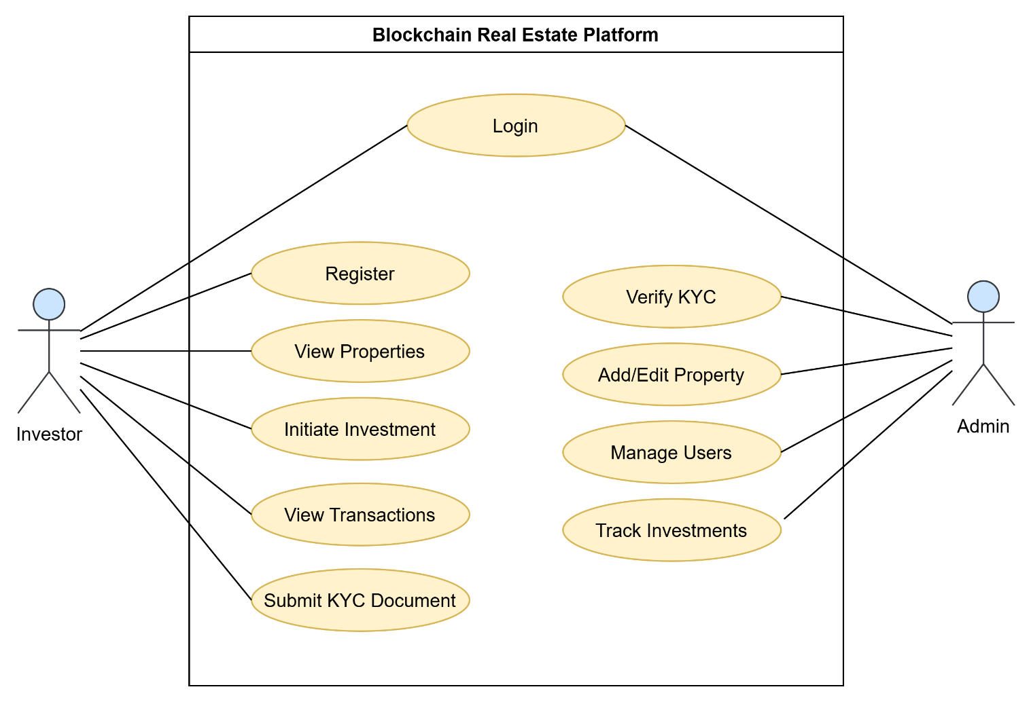
Figure 7: Use Case Diagram

Sequence Diagrams

User Registration and KYC Verification
Purpose:
This diagram illustrates the process of a new investor registering on the platform and undergoing Know Your Customer (KYC) verification.
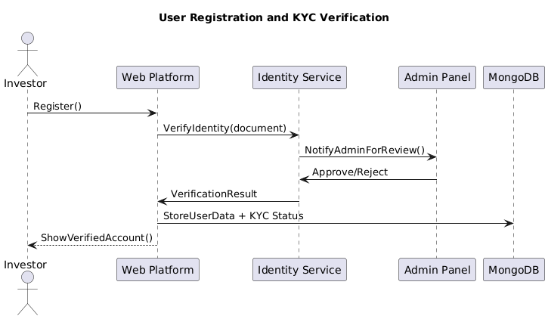
Figure 8: User Registration and KYC Verification
Explanation:
- The Investor begins by submitting a registration form through the Web Platform.
- The platform forwards the investor's identity documents to the Identity Service, which notifies the Admin Panel for manual review.
- The admin verifies the documents and returns the result (approved or rejected) to the Identity Service.
- The identity service then sends the verification result back to the web platform.
- The Web Platform stores the user and KYC status in MongoDB and notifies the investor whether their account is verified.
This process ensures that only verified users can invest, which maintains compliance with regulations and prevents fraud.

Property Browsing and Selection
Purpose:
This diagram demonstrates how an investor interacts with the platform to browse and select properties.
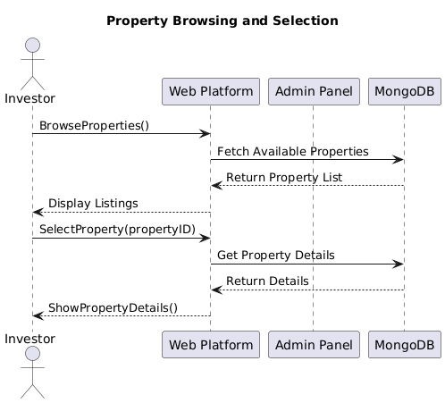
Figure 9: Property Browsing and Selection
Explanation:
- After logging in, the Investor requests a list of available properties.
- The Web Platform retrieves property data from the MongoDB database and displays it.
- When the investor selects a specific property, a detailed request is sent.
- The web platform fetches the selected property’s full details and presents them to the investor.
This interaction ensures that users are provided with up-to-date and verified property listings before making investment decisions.

Investment and Smart Contract Execution
Purpose:
This diagram captures the critical investment workflow — from investor action to smart contract deployment and blockchain confirmation.
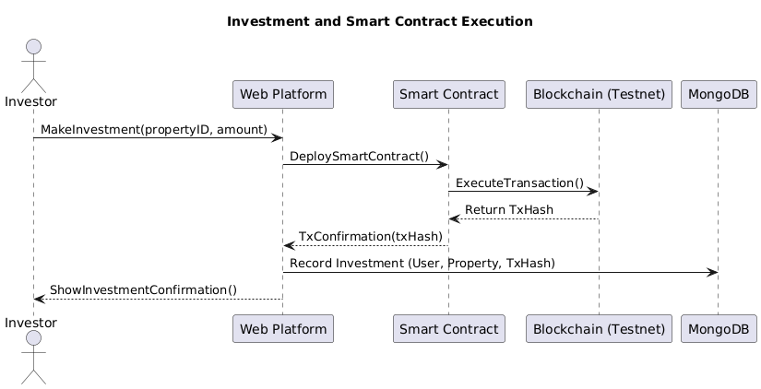
Figure 10: Investment and Smart Contract Execution
Explanation:
- The Investor initiates an investment in a selected property.
- The Web Platform triggers the deployment of a Smart Contract that defines the investment logic.
- The smart contract sends the transaction to the Blockchain (Testnet) for execution.
- Once the transaction is confirmed, the Blockchain returns a unique transaction hash (TxHash).
- The smart contract sends the confirmation back to the web platform, which stores the investment record, including the TxHash, in MongoDB.
- Finally, the investor receives a confirmation of the successful investment.
This sequence ensures secure, immutable, and transparent recording of property investments using blockchain.

Class Diagram
The structure of the system is illustrated through a UML class diagram representing all significant classes such as User, Property, Investment, and Blockchain Transaction. Each class contains the required attributes and methods to encapsulate the business logic, such as authentication, listing management, and incorporation through blockchains.

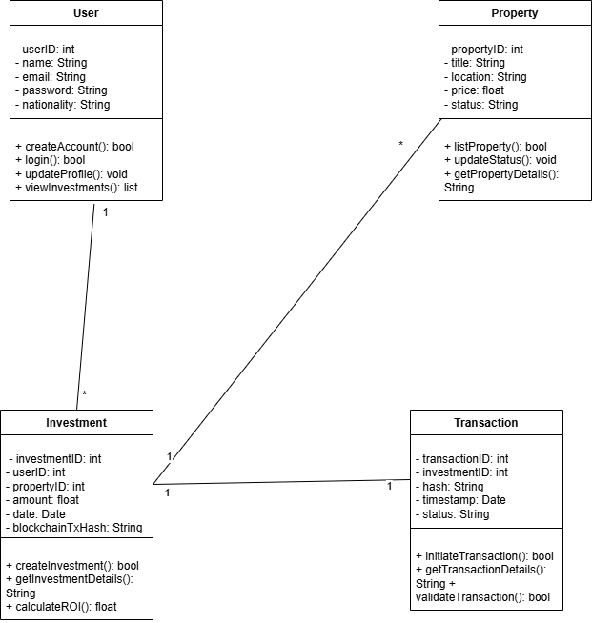
Figure 11: Class Diagram

Chapter 5: System Design

Introduction
This chapter presents the design architecture of the Blockchain-Based Real Estate Investment Platform for Foreign Investors in Saudi Arabia. The purpose of this design is to translate the functional and non-functional requirements defined in Chapter 4 into a modular and implementable system structure.
The platform is designed as a decentralized, web-based application that integrates blockchain technology with traditional web development components. The system emphasizes security, usability, scalability, and transparency. The design covers all key components, including frontend and backend systems, database schema, and smart contract logic.
The following sections elaborate on the architectural layers, system components, and database structure required to deliver the platform’s functionalities.

System Architecture
The system follows a multi-tier architecture with the following key layers:
- Frontend Layer (Client Interface)
- Backend Layer (Application Logic – Flask API)
- Blockchain Layer (Smart Contract Engine – Ethereum Testnet)
- Database Layer (NoSQL – MongoDB)
This architecture ensures a separation of concerns between user interface, business logic, data storage, and blockchain transactions.

Architecture Components
Layer | Technology | Responsibilities
Frontend | HTML, CSS, JavaScript (Bootstrap or React.js) | User interaction, data entry, visual feedback
Backend API | Python (Flask) | Processes request, handles authentication, connects frontend to database and smart contract
Blockchain | Solidity on Ethereum (Goerli Testnet) | Executes smart contracts for investment transactions
Database | MongoDB | Stores user profiles, property listings, KYC docs, and investment records
Table 14:Architecture Components
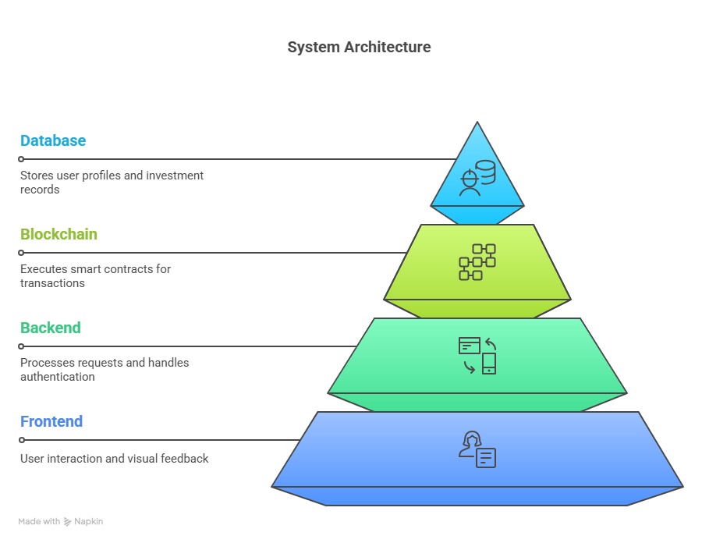
Figure 12:System Architecture

Database Design
Database design has been given serious thought, as data-intensive applications will handle data regarding user profiles, property listings, and blockchain transactions, among others. A highly demanding design will be necessary for coping with huge amounts of data. Therefore, MongoDB-a NoSQL database, was chosen because of its scalability and flexibility in adopting unstructured data in a more friendly manner.

Entity-Relationship Diagram
The ER diagram describes the relationships of the main entities in the system: Users, Properties, Investments, and Transactions. It comprises primary keys, foreign keys, and cardinalities that will create integrity in data and facilitate the execution of queries.
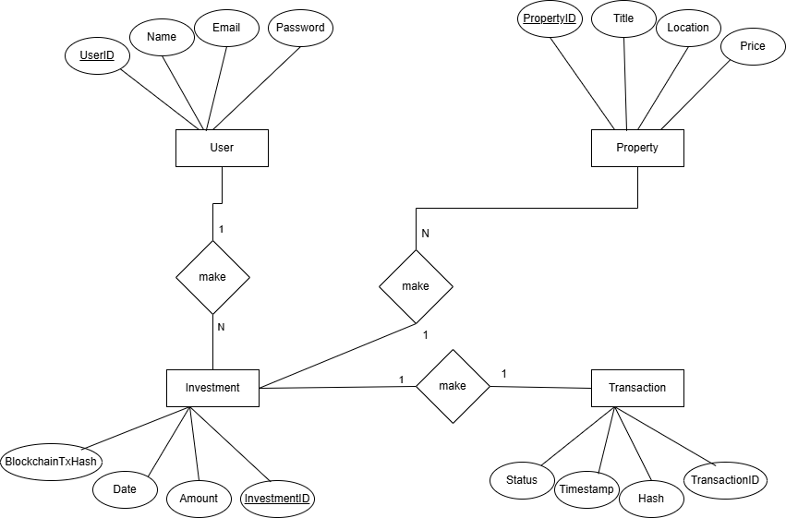
Figure 13: ERD Diagram

Data Dictionary
The data dictionary defines attributes and data types for the major tables in the database used in the platform:
- User Table
This table stores information about the users of the platform.
Column Name | Data Type | Description | Constraints
userID | INT | Unique identifier for each user. | Primary Key, Auto Increment, Not Null
name | VARCHAR(255) | Full name of the user. | Not Null
email | VARCHAR(255) | User’s email address. | Unique, Not Null
password | VARCHAR(255) | Password for the user’s account. | Not Null
Table 15: User Table
- Property Table
This table stores information about properties listed for investment.
Column Name | Data Type | Description | Constraints
propertyID | INT | Unique identifier for each property. | Primary Key, Auto Increment, Not Null
title | VARCHAR(255) | Title or name of the property. | Not Null
location | VARCHAR(255) | The location or address of the property. | Not Null
price | DECIMAL(15, 2) | Price of the property. | Not Null
Table 16:Property Table
- Investment Table
This table stores data about the investments made by users in properties.
Column Name | Data Type | Description | Constraints
investmentID | INT | Unique identifier for each investment. | Primary Key, Auto Increment, Not Null
amount | DECIMAL(15, 2) | Amount invested by the user. | Not Null
date | DATETIME | Date and time when the investment was made. | Default: CURRENT_TIMESTAMP
blockchainTxHash | VARCHAR(255) | Blockchain transaction hash. | Optional
Table 17: Investment Table

- Transaction Table
This table stores details about blockchain transactions related to investments.
Column Name | Data Type | Description | Constraints
transactionID | INT | Unique identifier for each transaction. | Primary Key, Auto Increment, Not Null
hash | VARCHAR(255) | Blockchain transaction hash. | Not Null
timestamp | DATETIME | Date and time when the transaction occurred. | Default: CURRENT_TIMESTAMP
status | VARCHAR(50) | Status of the transaction (e.g., Pending, Completed). | Not Null
Table 18: Transaction Table

Blockchain Integration
The integration of blockchain technology is the cornerstone of the platform’s innovation. Blockchain enhances trust, transparency, and immutability in real estate investment transactions.

Blockchain Selection
The platform uses the Ethereum blockchain (Goerli Testnet) for development and testing due to its support for:
- Smart contracts using Solidity
- Widespread documentation and tooling
- Wallet integration via MetaMask

Smart Contract Role
Smart contracts automate and secure the property investment process. Each investment transaction triggers a contract that:
- Verifies user eligibility (KYC approved)
- Transfers investment funds (test Ether)
- Updates ownership records
- Generates a verifiable transaction hash (TxHash)

Security Considerations
- Reentrancy protection
- Integer overflow prevention
- Only verified contracts can update ownership
- Read-only functions for viewing contract state

User Interface Design
The platform prioritizes usability, accessibility, and modern aesthetics to ensure smooth onboarding for both investors and admins.

Key UI Components
Homepage & Property Listings
  - Responsive cards displaying image, location, price, and brief description.
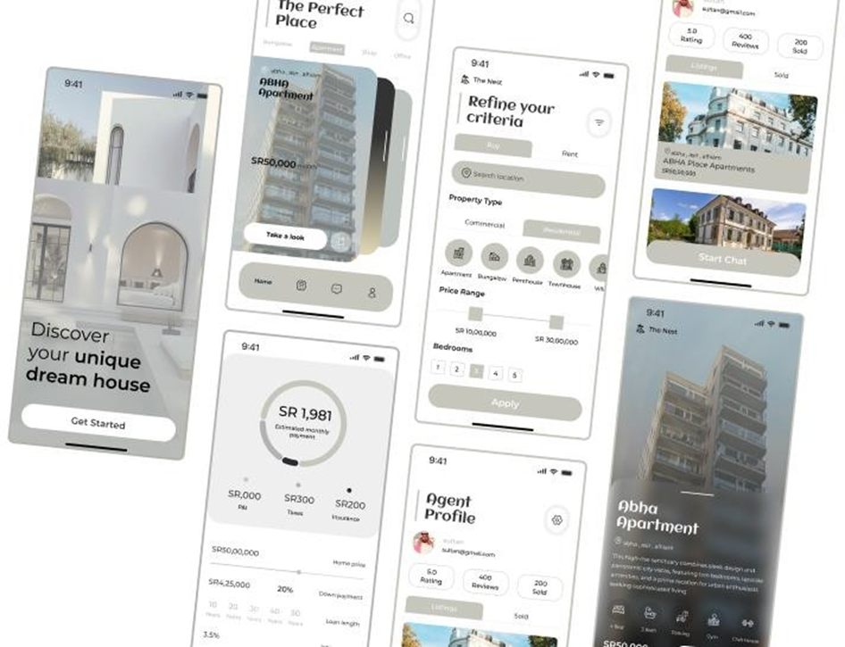
Figure 14: Homepage & Property Listings
Search & Filter Interface
  - Users refine property listings by type (e.g., apartment, villa), price range, location, and number of bedrooms.
  - Aesthetically designed sliders and icons.
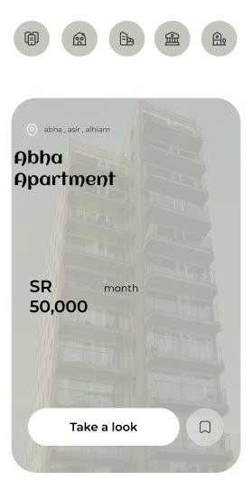
Figure 15: Search & Filter Interface

Mortgage Calculator
  - Interactive visual gauge showing estimated monthly payments.
  - Users input price, down payment, loan term, and interest rate.
  - Calculation is done client-side using JavaScript or React.
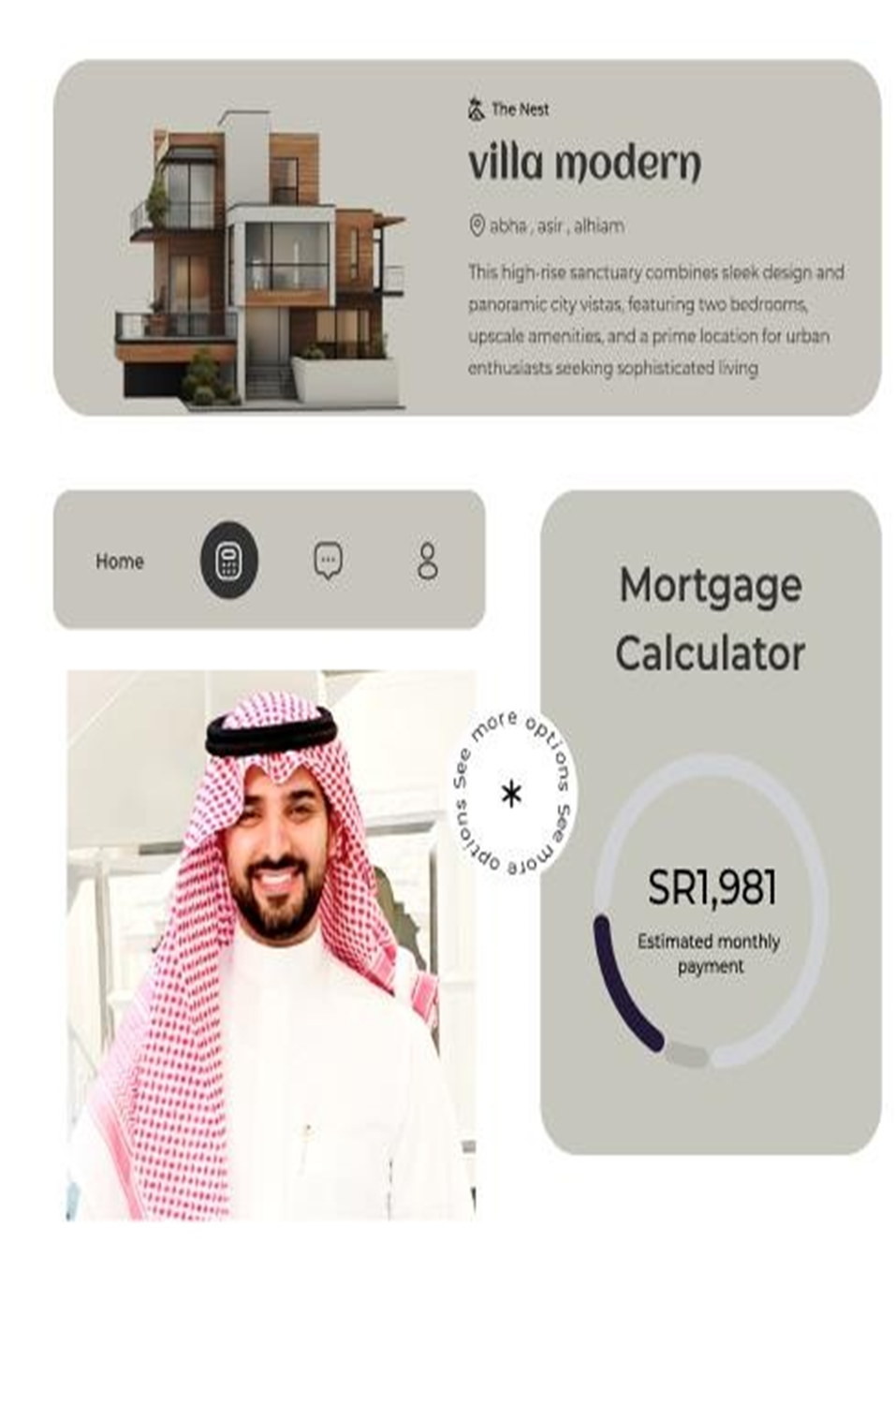
Figure 16: Mortgage Calculator

Chapter 6: Conclusions and Future Work

Conclusions
This project set out to address the challenges foreign investors face when participating in Saudi Arabia’s real estate market, including issues related to ownership verification, regulatory complexity, transaction transparency, and cross-border payment barriers. Through the design and prototype development of a blockchain-based real estate investment platform, the project has successfully demonstrated how decentralized technologies can be applied to create a more secure, transparent, and investor-friendly environment.
Key accomplishments include:
- Requirement analysis and stakeholder interviews that identified pain points such as high transaction fees, lack of trust in documentation, and limited access to verified properties.
- A modular system design using Flask (Python), MongoDB, and Ethereum smart contracts to implement a functional backend, database, and investment engine.
- Integration of smart contracts to manage property ownership, automate investments, and generate immutable transaction records.
- Development of a user-friendly interface that allows investors to browse listings, calculate mortgage estimates, and initiate investments with ease.
- Use of secure identity verification (KYC) and administrative tools to ensure regulatory compliance and fraud prevention.
The project illustrates the viability of using blockchain as a trust infrastructure for real estate investment and provides a foundation for real-world deployment in regulated environments.

Future Work
While the current system delivers a functional prototype that fulfills core objectives, several improvements and extensions are recommended for future development and deployment:

Integration with National Databases
Linking the platform with official government property registries (e.g., the Saudi Real Estate Registry) would ensure that the ownership transfer and verification processes are recognized legally and institutionally.

Support for Tokenized Investment
Future iterations could include fractional ownership through tokenization, allowing users to invest smaller amounts and receive real estate-backed tokens representing shares of properties.

Real-time Currency Conversion and Fiat Payments
Adding currency conversion APIs and integration with payment gateways (e.g., STC Pay, Mada, or Mastercard) would simplify transactions for international users and increase adoption.

Mobile Application
A cross-platform mobile app version (using Flutter or React Native) would improve accessibility for investors on the go, especially in regions with limited desktop access.

AI-Based Property Recommendations
Though not implemented in this version, a future system could incorporate AI or machine learning models to recommend properties based on user preferences, investment history, and market trends.

Full Smart Contract Audits
Before launching the system commercially, smart contracts should undergo formal security audits by third-party blockchain security firms to eliminate vulnerabilities.

Final Reflection
This project confirms that blockchain can offer innovative solutions to long-standing problems in real estate investment, particularly in emerging markets like Saudi Arabia. By prioritizing transparency, automation, and user trust, the proposed system contributes meaningfully to the modernization of property investment and sets the stage for broader digital transformation in the sector.

References
- Nakamoto, S. (2008). Bitcoin: A Peer-to-Peer Electronic Cash System. https://bitcoin.org/bitcoin.pdf
- Tapscott, D., & Tapscott, A. (2016). Blockchain Revolution: How the Technology Behind Bitcoin is Changing Money, Business, and the World. Penguin.
- Yli-Huumo, J., Ko, D., Choi, S., Park, S., & Smolander, K. (2016). Where is Current Research on Blockchain Technology?—A Systematic Review. PLOS ONE, 11(10), e0163477.
- Zheng, Z., Xie, S., Dai, H., Chen, X., & Wang, H. (2018). An Overview of Blockchain Technology: Architecture, Consensus, and Future Trends. IEEE International Congress on Big Data.
- Wang, S., Ouyang, L., Yuan, Y., Ni, X., Han, X., & Wang, F. Y. (2019). Blockchain-Enabled Smart Contracts: Architecture, Applications, and Future Trends. IEEE Transactions on Systems, Man, and Cybernetics: Systems, 49(11), 2266-2277.
- Fenu, G., Marchesi, L., Marchesi, M., & Tonelli, R. (2018). The ICO Phenomenon and Its Relationships with Ethereum Smart Contract Environment. International Workshop on Blockchain Oriented Software Engineering (IWBOSE).
- Shin, L. (2018). The First Government to Secure Land Titles on the Bitcoin Blockchain Expands Project. Forbes. https://www.forbes.com
- Hudson, R. (2020). Tokenization of Real Estate: A New Era of Investment. Journal of Property Investment & Finance, 38(6), 541-553.
- Propy. (2023). Propy: Global Real Estate Transactions. https://propy.com
- RealT. (2023). RealT: Fractional Real Estate Ownership. https://realt.co
- BitProperty. (2023). BitProperty: Blockchain-Based Real Estate Platform. https://bitproperty.com

