

King Khalid University
College of Science and Arts
Al-Majardah

The Village Of My Throughout Country

A Digital Platform to Boost Tourism and Commerce in Al-Majardah Governorate

Department of Computer Science,
King Khalid University

2024

Abstract
﻿ The Village of My Throughout Country, a historical and cultural marvel in Al Majardah Governorate, Saudi Arabia, has been revitalized over the past three decades to become a unique tourist and community destination. The village, which spans 125,000 square meters, boasts heritage-rich structures, decorative stone carvings, forts, castles, and open spaces that embody the architectural legacy of Saudi heritage.
This project, "The Village of My Throughout Country," aims to create a dedicated website that not only highlights the village’s heritage but also promotes it as a center for tourism and economic engagement. The website will serve as a comprehensive digital platform that provides information on the village’s history, events, services, and visitor opportunities. Sections will include details on local attractions, such as the heritage museum, a residential lodge, a hotel, an open-air theater, and various interactive spaces for events and activities. Additionally, users will be able to access a calendar of events, register for workshops, view museum publications, and connect with local service providers. The ultimate goal of this digital platform is to showcase
The Village of My Throughout Country as a symbol of cultural pride and an economic resource, inviting tourists and supporting young entrepreneurs interested in investing in the local tourism industry.
This project also aligns with Saudi Arabia’s broader vision of cultural heritage preservation and economic diversification as part of Vision 2030 [1].

Table of Contents
Abstract 2
List of Figures 5
List of Tables 6
Chapter 1: Introduction 7
1.1. Introduction 7
1.2. ﻿Research Problem 8
1.3. Assumptions 9
1.4. Questions 9
1.5. Objectives 10
1.6. Project Scope 10
1.7. Professional and Social Impacts of the System 11
Chapter 2: Feasibility Study and Related Work 13
2.1. Introduction 13
2.2. Related Work 13
2.2.1. UNESCO World Heritage Sites 13
2.2.2. Historic England 14
2.2.3. Visit Scotland 14
2.2.4. Saudi Tourism Authority (Visit Saudi) 15
2.3. Comparison Study 15
2.4. Feasibility Study 16
2.4.1. Technical Feasibility 16
2.4.2. Operational Feasibility 17
2.4.3. Legal Feasibility 17
2.4.4. Economic Feasibility 18
2.5. Methodology 18
Chapter 3: System Analysis 20
3.1. Introduction 20
3.2. Functional Requirements 20
3.3. Non-Functional Requirements 21
3.4. System Users and Interactions 22
3.4.1. System Users: 22
3.4.2. Interactions: 23
3.5. UML Diagrams 23
3.5.1. Use Case Diagram 23
3.5.2. Sequence Diagram 24
3.5.2.1. Tourist Sequence Diagram 24
3.5.2.2. Resident Sequence Diagram 25
3.5.2.3. Employee Sequence Diagram 26
3.5.2.4. Tour Guide Sequence Diagram 27
3.5.2.5. Administrator Sequence Diagram 28
3.5.3. Activity Diagram 29
3.5.4. DFD Diagram 30
3.5.5. Class Diagram 31
3.5.6. Collaboration Diagram 32
Chapter 4: System Design 33
4.1. Introduction 33
4.2. User Interface Design 33
4.3. System Architecture 35
4.3.1. Three-Tier Architecture 35
4.3.2. System Interaction Workflow 36
4.3.3. System Diagram 36
4.4. Database Design 37
4.4.1. Entity-Relationship Diagram (ERD) 37
4.4.2. Database Tables 39
4.5. System Flow Design 42
4.6. Security Design 44
4.7. Conclusion 45
Chapter 5: Prototype 46
5.1. Introduction 46
5.2. Interfaces 47
5.3. Conclusion 53
5.4. Future Work 53
References 54

List of Figures
Figure 1: UNESCO World Heritage Sites 14
Figure 2: Historic England 14
Figure 3: Visit Scotland 14
Figure 4: Saudi Tourism Authority’s 15
Figure 5: waterfall methodology 18
Figure 6: Use Case Diagram 23
Figure 7: Tourist Sequence Diagram 24
Figure 8: Resident Sequence Diagram 25
Figure 9: Employee Sequence Diagram 26
Figure 10: Tour Guide Sequence Diagram 27
Figure 11: Administrator Sequence Diagram 28
Figure 12: Activity Diagram 29
Figure 13: DFD Diagram 30
Figure 14: Class Diagram 31
Figure 15: Collaboration Diagram 32
Figure 16:System Diagram 37
Figure 17:Entity-Relationship Diagram (ERD) 38
Figure 18: System Flow Design 43
Figure 19: Home Page 47
Figure 20: About Us Page 48
Figure 21: Services Page 49
Figure 22: Events Page 50
Figure 23: Contact Us Page 51
Figure 24: Login Page 52

List of Tables
Table 1: Comparison Study 15
Table 2: User Table 39
Table 3: Event Table 39
Table 4: Business Table 40
Table 5: Feedback Table 40
Table 6: Event Registration Table 41

Chapter 1: Introduction

Introduction
﻿ Tourism has long been recognized as a powerful driver of economic growth, cultural preservation, and community engagement. The Village of My Throughout Country in Al Majardah Governorate exemplifies these possibilities, having transformed from a traditional village to a revitalized heritage site that celebrates Saudi culture. As nations across the globe increasingly leverage digital platforms to promote their unique cultural sites, the need for an online presence that accurately reflects a location’s history and heritage becomes essential [2]. This project, therefore, envisions a dedicated website for The Village of My Throughout Country, designed to position it as a premier destination for cultural tourism and a catalyst for local economic growth.
The Village of My Throughout Country is not just a collection of heritage sites but a vibrant symbol of Saudi Arabia's historical resilience and cultural pride. Encompassing structures like heritage palace museums, residential lodges, open theaters, and decorative stone carvings, the village is a testament to the country’s commitment to preserving its past. However, like many heritage sites globally, The Village of My Throughout Country lacks a cohesive digital platform to consolidate its offerings and reach a broader audience. According to the United Nations Educational, Scientific, and Cultural Organization (UNESCO), such platforms are crucial in ensuring sustainable tourism and enabling cultural heritage to thrive in a modern context [3].
The primary aim of The Village of My Throughout Country website is to create a digital experience that brings the heritage and cultural assets of the village closer to potential visitors. Through features like event registration, detailed service listings, and interactive content, the website seeks to not only inform but also engage. Users will have access to a range of resources, including information about the village’s historical significance, upcoming events, and opportunities for community involvement. The website will also provide tools for investors and young entrepreneurs to explore potential economic opportunities within the village, thus supporting the local economy and fostering a spirit of sustainable tourism. Studies have shown that integrating local businesses with heritage tourism through digital channels can significantly boost community income and enhance the visitor experience [4].
Furthermore, this project aligns with Saudi Arabia’s Vision 2030, which emphasizes the importance of preserving and promoting the country’s cultural heritage while fostering economic diversification [5].
As Saudi Arabia continues to attract international attention for its cultural sites, The Village of My Throughout Country’s digital presence will not only meet the needs of modern-day tourists but also reflect the country's broader commitment to sustainable heritage development. By positioning The Village of My Throughout Country as both a cultural and economic hub, this project aims to bridge the gap between tradition and innovation, creating a lasting impact on the village’s future as a tourism and community destination.

﻿Research Problem
Heritage sites, with their unique cultural and historical significance, play a crucial role in preserving the identity and legacy of a community. The Village of My Throughout Country in Al Majardah Governorate is a prime example of such a site, having undergone extensive restoration over the past 30 years to emerge as a center of Saudi heritage and cultural pride. However, despite its breathtaking architecture, historical landmarks, and potential as a tourist destination, the village lacks a comprehensive digital presence that can attract visitors and engage the community. This gap is particularly significant in the digital age, where travelers rely on online platforms to explore, plan, and engage with destinations prior to visiting [1].
Currently, The Village of My Throughout Country faces a substantial barrier: there is no dedicated digital platform that provides accurate, up-to-date information about the village’s attractions, events, and services. This absence of a cohesive online resource not only limits visitor engagement but also hinders local businesses and community activities from reaching a wider audience. According to research by the World Tourism Organization (UNWTO), digital tourism platforms are essential in modern tourism for increasing accessibility, encouraging local participation, and ensuring that cultural heritage reaches a global audience [2].
The core research problem of this project, therefore, is: How can we develop a comprehensive digital platform for The Village of My Throughout Country that effectively promotes tourism, supports community engagement, and fosters economic growth?
Addressing this problem requires a platform that not only offers essential information but also serves as an interactive space where tourists, locals, and investors can connect. The lack of such a platform limits the village’s ability to attract a consistent stream of visitors, promote local culture, and support sustainable development, which are essential goals for the future of this heritage site.

Assumptions
Several assumptions guide the development of The Village of My Throughout Country website:
- Increased Visitor Interest: It is assumed that creating a digital presence will significantly increase interest from both domestic and international tourists. The platform’s accessibility and interactive features are expected to attract a wider audience and inspire visits.
- Community Participation: Residents and local businesses will actively engage with the platform, contributing event proposals, feedback, and content updates, which will enable the site to grow in response to community needs.
- Adequate Digital Literacy: It is assumed that both tourists and local users possess basic digital literacy, allowing them to navigate the website, register for events, and utilize its interactive features effectively.
- Reliable Digital Infrastructure: Al Majardah Governorate has the necessary digital infrastructure to support a responsive website, ensuring that it operates smoothly for users both within the region and beyond.
- Alignment with Vision 2030 Goals: Saudi Arabia’s Vision 2030 encourages heritage tourism and economic diversification, suggesting that the project will have institutional support and align with national priorities [3].

Questions
The project aims to answer several key questions:
- How can a digital platform effectively promote the unique heritage and attractions of The Village of My Throughout Country to a broader audience?
- What features are essential for creating an engaging, user-friendly experience that caters to both tourists and local residents?
- How can the website foster community involvement, enabling locals to contribute event proposals, participate in feedback, and shape the village’s tourism landscape?
- What functionalities will best support local businesses in connecting with visitors and promoting their services in the tourism sector?
- How can the platform be designed to scale and adapt as the village’s tourism and community needs evolve, ensuring long-term sustainability?

Objectives
The project sets out to achieve several core objectives:
- Promote The Village of My Throughout Country as a Tourist Destination: Develop a comprehensive, accessible digital platform that highlights the village’s unique architectural and cultural features, making it an attractive destination for tourists.
- Enhance Community Engagement: Empower residents to participate in the platform through features like event proposals, feedback submissions, and content contributions. This will foster a sense of ownership and pride within the community, encouraging collaboration in tourism development.
- Support Local Economic Growth: Provide a space for local businesses to showcase their services, such as the village’s hotel, museum, theater, and workshops. By increasing visibility and accessibility, the platform will drive economic growth through tourism.
- Create an Interactive Visitor Experience: Ensure the platform offers valuable tools and resources, such as an event calendar, registration forms, and detailed service listings, to provide tourists with a seamless and immersive experience.
- Align with Vision 2030 for Sustainable Tourism Development: Build a platform that aligns with Saudi Arabia’s Vision 2030 by supporting the preservation of cultural heritage, promoting tourism, and contributing to economic diversification within the region [4].
- Foster a Sustainable and Scalable Platform: Design the website with scalability in mind, allowing it to grow as tourism and local needs evolve. This includes potential future features like multilingual support, advanced analytics, and additional sections as the village expands its offerings.

Project Scope
The scope of this project encompasses the design, development, and deployment of a digital platform for The Village of My Throughout Country. The platform will serve as a comprehensive online hub for tourists, residents, and local businesses, promoting the village’s heritage, events, and services. This project will address the specific needs of each user group by providing an engaging and interactive experience.
The platform’s core features include:
- Village Overview and Historical Background: Detailed descriptions of the village’s historical significance, architectural marvels, and cultural relevance to Saudi heritage.
- Attraction Listings: Information about key village attractions, such as the heritage museum, residential lodge, hotel, open-air theater, and decorative stone carvings.
- Service Directory: Listings of available services, including workshops, guided tours, event spaces, and accommodations.
- Event Management: A calendar of upcoming events with registration options for workshops, theater shows, and cultural festivals. Past events will be archived, enabling visitors to explore the village’s event history.
- Community Interaction Features: A form for visitors to submit feedback and suggestions, creating a participatory environment. This feature will also support the submission of event proposals, allowing locals to shape the platform’s offerings.
- Business Directory: Profiles for local businesses that operate within the village, such as hotels, cafes, and souvenir shops, with contact information and service descriptions to support local commerce.
- Visitor Engagement and Resources: A section dedicated to sharing tips and inspiring experiences from past visitors, with ratings and reviews, to guide future tourists in planning their trips.
The website will be developed as a responsive, user-friendly platform, accessible from both desktop and mobile devices. Additionally, the scope includes setting up secure databases to manage user data, event details, and business listings. While the initial launch will focus on essential features, the platform will be designed with scalability in mind, allowing for future updates and additional sections as the village’s tourism offerings expand.

Professional and Social Impacts of the System
The development of a dedicated digital platform for The Village of My Throughout Country has the potential to yield significant professional and social impacts, benefiting individuals, local businesses, and the broader community.
    - Individual Impact
For tourists, the platform provides an accessible and comprehensive source of information, enabling them to discover the village’s attractions, plan their visits, and engage with cultural events. By providing an interactive experience, the platform allows users to explore the village’s offerings at their own pace, enhancing overall visitor satisfaction. Furthermore, studies have shown that a well-structured digital platform improves the quality of a visitor’s experience by reducing the uncertainties often associated with exploring heritage sites in unfamiliar regions [1].

    - Organizational Impact
Local businesses and service providers stand to benefit greatly from the platform, as it serves as an essential promotional tool. With dedicated listings for hotels, cafes, shops, and other services, businesses can reach a broader audience, attract more customers, and build brand recognition. According to research by the Organisation for Economic Co-operation and Development (OECD), tourism platforms that integrate local businesses foster sustainable growth by increasing economic opportunities and encouraging entrepreneurship [2]. Additionally, the platform offers an organized, professional space for event organizers and entrepreneurs to showcase their services, helping them engage directly with tourists and build a network within the local community.
    - Community Impact
For the residents of Al Majardah Governorate, the platform provides a means of active involvement in the village’s tourism and cultural landscape. Community members can contribute to the platform through event proposals, feedback, and participation in workshops. By encouraging local engagement, the platform fosters a sense of pride and ownership among residents, aligning with research showing that community-driven tourism initiatives lead to more sustainable and inclusive development [3].
Moreover, this participatory model empowers residents to play a direct role in the promotion of their cultural heritage, which in turn strengthens communal ties and enhances social cohesion within the village.
    - Cultural Impact
On a broader scale, the platform contributes to the preservation and promotion of Saudi cultural heritage. As Saudi Arabia expands its tourism sector under Vision 2030, The Village of My Throughout Country can serve as a symbol of national pride and cultural resilience. By creating a digital space where local traditions, stories, and customs are accessible to a global audience, the platform plays a vital role in safeguarding the heritage of the village for future generations.

Chapter 2: Feasibility Study and Related Work

Introduction
The development of a dedicated digital platform for The Village of My Throughout Country involves careful consideration of feasibility and related work to ensure that the project meets its objectives and addresses the needs of the target audience. Feasibility studies are a critical part of project planning, allowing us to assess the technical, economic, and operational aspects of the project to determine its viability. For heritage sites and tourism platforms, such studies help identify any potential constraints, required resources, and opportunities for enhancing visitor engagement and community involvement [6].
In addition to examining feasibility, this chapter will explore related work by reviewing digital platforms that have successfully promoted cultural heritage, community engagement, and local economic development. By analyzing these case studies, we can gather valuable insights and best practices that will inform the design and implementation of The Village of My Throughout Country website. Furthermore, a comparison study will highlight the unique features and benefits of this project in contrast to similar digital platforms, showcasing the innovative aspects of the proposed solution and its alignment with Saudi Arabia's Vision 2030 for sustainable tourism growth [1].

Related Work
Digital platforms have transformed the way heritage sites and cultural destinations engage with visitors, offering new ways to showcase local culture, historical significance, and tourist activities. Globally, heritage sites have embraced websites and applications to enhance visibility, provide virtual tours, and engage with local communities. Digital platforms for heritage tourism have proven effective in promoting cultural sites and engaging communities. Below are notable platforms that serve as examples for developing The Village of My Throughout Country website:

UNESCO World Heritage Sites
UNESCO’s platform provides comprehensive information on heritage sites worldwide. It includes images, videos, and interactive content that allow users to virtually explore each site. The focus is on raising global awareness about the importance of preserving cultural heritage [3].
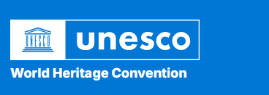
Figure 1: UNESCO World Heritage Sites

Historic England
Dedicated to England’s historical landmarks, Historic England provides resources on heritage conservation, historical research, and events. It encourages community involvement by allowing locals to share personal stories, participate in volunteer opportunities, and engage with preservation efforts, fostering a sense of ownership and pride in cultural heritage [7].

Figure 2: Historic England

Visit Scotland
This platform promotes Scottish heritage sites and tourist attractions with event listings, visitor guides, and local business information. It offers a range of multimedia content and booking options for tours and accommodations. Visit Scotland emphasizes both heritage preservation and economic growth, supporting local tourism [8].
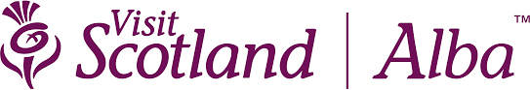
Figure 3: Visit Scotland

Saudi Tourism Authority (Visit Saudi)
The Saudi Tourism Authority’s platform is aligned with Vision 2030 and promotes various tourist destinations across Saudi Arabia, including heritage sites. It provides detailed descriptions, travel tips, and activity recommendations. The platform helps raise awareness of Saudi heritage while attracting tourists by integrating interactive and user-friendly features [9].

Figure 4: Saudi Tourism Authority’s

Comparison Study
To underscore the unique qualities of The Village of My Throughout Country platform, the following table compares it with other heritage platforms, focusing on the distinct features and areas where this project will offer unique value:
Platform | Key Features | Community Engagement | Unique Elements of Our platform
UNESCO World Heritage Sites | Virtual tours, rich media content, detailed heritage information | Limited; emphasizes global awareness | Localized focus with event proposals, feedback options, and youth investment opportunities
Historic England | Research resources, preservation projects, event listings | High; supports storytelling, volunteering, and feedback | Direct support for local business promotion and youth investment aligned with Vision 2030
Visit Scotland | Visitor guides, event calendars, local business information | Moderate; promotes tourism through business support | Emphasis on Saudi heritage with community-driven events and user-generated feedback
Saudi Tourism Authority (Visit Saudi) | Comprehensive destination info, activities, Vision 2030 alignment | Moderate; promotes heritage awareness through activities | Specific platform for the heritage village with interactive tools for community and tourist engagement
Table 1: Comparison Study
Unique Aspects of The Village of My Throughout Country Platform
The Village of My Throughout Country platform differentiates itself through:
- Community-Driven Event Proposals: Unlike broader platforms, this project enables local residents to propose events and provide direct feedback, making tourism a collaborative effort.
- Support for Local Entrepreneurs: By offering dedicated sections for local businesses, it supports economic growth and aligns with Saudi Vision 2030 by encouraging youth investment and community involvement.
- Cultural Heritage Focused on Saudi Identity: While platforms like UNESCO provide a global perspective, this project emphasizes the specific cultural significance of the village, highlighting Saudi heritage and values through an interactive, localized platform.

Feasibility Study
A comprehensive feasibility study assesses the viability of developing and implementing the website for The Village of My Throughout Country. This analysis covers technical, operational, legal, and economic factors to ensure that the project is practical, sustainable, and aligned with the village’s mission to promote tourism, cultural preservation, and community engagement.

Technical Feasibility
The technical feasibility of this project involves evaluating the technological resources required to develop and maintain a user-friendly, responsive, and secure website for The Village of My Throughout Country.
- Platform and Tools: The website will be developed using modern web technologies such as HTML, CSS, and JavaScript for front-end development, and PHP for back-end development. A MySQL database will handle data storage for user information, event details, and business listings, ensuring smooth data management.
- Mobile Responsiveness: Considering the diverse user base, the website will be fully responsive, optimized for both desktop and mobile devices to accommodate visitors from various regions with different access capabilities. This responsiveness aligns with current trends in digital tourism platforms, where mobile-friendly access is critical for user engagement [2].
- Maintenance and Updates: A maintenance plan will ensure that the platform remains updated, secure, and functional over time. This includes regular content updates, troubleshooting, and software updates to support scalability as user traffic and content grow.

Operational Feasibility
Operational feasibility assesses how well the project will fulfill its objectives and meet the needs of stakeholders, including tourists, residents, and local businesses.
- Alignment with Community Goals: The Village Of My Throughout Country platform is designed to enhance tourism, support local businesses, and encourage community involvement. By providing features like event listings, a business directory, and user feedback options, the platform meets community objectives, promoting both tourism and economic development [5].
- Support for Saudi Vision 2030: The project aligns with Saudi Vision 2030, which encourages cultural preservation, economic diversification, and increased tourism. By showcasing the village’s heritage and providing local investment opportunities, the platform supports national goals for sustainable growth [1].
- Community and Business Engagement: The platform will encourage active participation from both residents and local businesses. Community members can propose events and share feedback, while businesses gain visibility through dedicated listings. This engagement model ensures that the platform remains relevant and valuable to local stakeholders.

Legal Feasibility
Legal feasibility examines the project’s compliance with local, national, and international regulations regarding digital platforms, data protection, and copyright.
- Data Privacy: As the platform will collect and store user data, it must comply with data protection laws, such as Saudi Arabia’s Personal Data Protection Law (PDPL) and, for international visitors, General Data Protection Regulation (GDPR) if applicable. This involves implementing policies to protect personal data and ensuring users have rights over their data [11].
- Intellectual Property Rights: Content used on the platform, such as images, text, and videos, must be original or properly licensed to avoid copyright infringement. Any multimedia content related to the village’s heritage must be used with the necessary permissions to maintain legal compliance.
- Business and E-commerce Regulations: If the platform integrates payment options for event registrations or ticketing, it will need to adhere to Saudi Arabia’s e-commerce regulations, ensuring transparency, consumer protection, and secure payment processing [12].

Economic Feasibility
Economic feasibility assesses the financial costs, benefits, and sustainability of the project to determine whether it is a sound investment.
- Project Costs: Initial development costs include expenses for web development, hosting, and domain registration. Additional costs for multimedia content creation (e.g., photography, videos) and marketing to promote the platform are also considered. Maintenance costs for updates, security, and server fees are expected to be ongoing expenses [13].

Methodology
The Waterfall Model is a sequential, step-by-step approach to development, where each phase must be completed before moving to the next. For The Village of My Throughout Country project, this model ensures a structured and organized progression from initial planning to final operations.
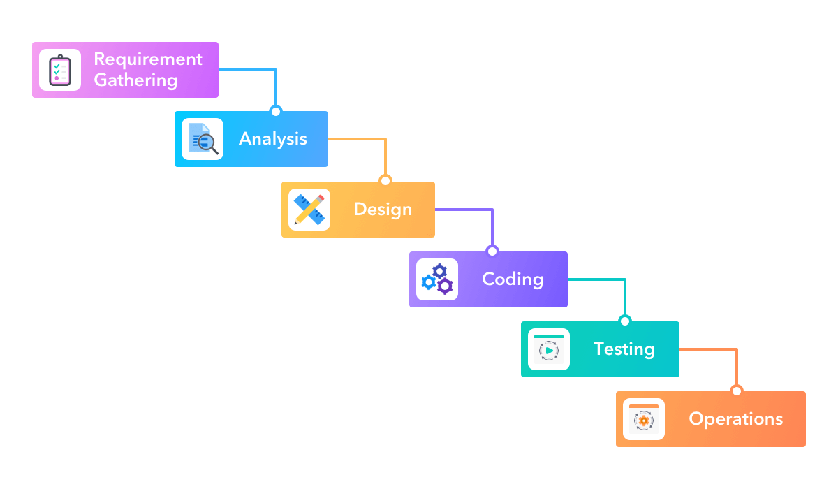
Figure 5: waterfall methodology
  - Requirement Gathering
- Objective: Collect detailed information about what the website needs to achieve.
- Activities: Meet with stakeholders, conduct surveys, and document all requirements for the platform, such as user functionalities, design preferences, and technical specifications.
- Outcome: A clear set of requirements that define what the website will include and how it should function.

  - Analysis
- Objective: Analyze the gathered requirements to assess feasibility and refine project objectives.
- Activities: Evaluate technical, economic, and operational feasibility. Determine if the project is viable with the resources, skills, and budget available.
- Outcome: A feasibility report that confirms the project can proceed and outlines any necessary adjustments to the initial plan.
  - Design
- Objective: Develop a blueprint for the website's structure, layout, and functionality.
- Activities: Create wireframes, flowcharts, and database models. Decide on the website's appearance, navigation, and interaction design to enhance user experience.
- Outcome: A detailed design document that serves as a guide for the coding phase, ensuring developers know exactly how the website should look and function.
  - Coding
- Objective: Build the website according to the design specifications.
- Activities: Develop the front-end (using HTML, CSS, JavaScript) and back-end (using PHP, Laravel) code. Set up the MySQL database for storing user data, events, and business listings.
- Outcome: A fully coded website with all required functionalities in place, ready for testing.
  - Testing
- Objective: Verify that the website works as intended, free from bugs and security vulnerabilities.
- Activities: Perform usability testing, functional testing, and security checks to ensure the platform meets all requirements and provides a smooth user experience.
- Outcome: A thoroughly tested website that is functional, secure, and user-friendly, with any identified issues resolved.
  - Operations (Deployment and Maintenance)
- Objective: Launch the website for public access and keep it updated.
- Activities: Deploy the website to a secure web server, and monitor performance. Regularly update content, security patches, and address user feedback for continuous improvement.
- Outcome: A live, maintained website that serves as a reliable digital hub for THE Village of My Throughout Country, ready to engage visitors and support local tourism.

Chapter 3: System Analysis

Introduction
System analysis is a critical phase in the development process, serving as the foundation for creating a robust, user-friendly, and functional platform for The Village Of My Throughout Country. This stage involves understanding the requirements of the system, modeling user interactions, and designing the underlying database structure to ensure smooth operation.
For this project, system analysis focuses on identifying the functional and non-functional requirements that address the needs of tourists, residents, local businesses, and administrators. Additionally, diagrams such as use case, sequence, and activity diagrams are utilized to visually represent system interactions and workflows. By defining these requirements and visualizing interactions, this chapter lays the groundwork for the technical development of the platform.
The analysis also includes database design, where the structure of the platform's data storage is defined. This ensures that the system is capable of efficiently handling data such as event registrations, user accounts, and feedback submissions. Overall, the analysis phase bridges the gap between conceptual planning and technical implementation, ensuring that the platform aligns with user needs and project objectives.

Functional Requirements
Functional requirements define the specific features and functionalities the platform must provide to meet user needs. These requirements are derived from the goals of THE VILLAGE OF MY THROUGHOUT COUNTRY to promote tourism, support local businesses, and engage the community.
- User Registration and Login
  - Users (tourists, residents, and Tour guide) can create accounts and log in to access personalized features.
  - Administrators will have separate login credentials to manage content and monitor user activity.
- Event Management
  - Visitors can view a calendar of upcoming events, register for participation, and receive confirmation emails.
  - Administrators can create, edit, or delete events.

- Feedback and Reviews
  - Visitors can submit feedback and reviews on events or services provided in the village.
  - Feedback is stored in the database and displayed to improve transparency and engagement.
- Business Directory
  - A searchable directory lists local businesses, including hotels, shops, and cafes, with contact information and services offered.
  - Admin can update their profiles through their accounts.
- Community Engagement
  - Residents can propose new events and activities through a form submission system.
  - Administrators review and approve or reject proposed events.
- Interactive Map
  - An interactive map highlights the village’s attractions, including the heritage museum, theater, and key landmarks.
  - Users can navigate the map to plan their visits.
- Media and Publications
  - A section for multimedia content, including images, videos, and brochures, showcases the history and culture of the village.
  - Administrators can upload and manage media files.
- Contact and Support
  - A form for inquiries and support is available, along with phone and email contact details.
  - Users can submit queries, and administrators respond through the platform.

Non-Functional Requirements
Non-functional requirements define the quality attributes of the system, focusing on performance, security, scalability, and usability. These requirements ensure the platform is reliable, user-friendly, and adaptable to future needs.
- Performance
  - The website must load within 3 seconds for 90% of users to provide a seamless browsing experience.
  - It should handle concurrent access by at least 500 users without performance degradation [11].
- Scalability
  - The system should be designed to accommodate future expansions, such as additional features or increased user traffic.
  - The database must support the addition of new tables for storing expanded data sets, such as additional services or new event categories.
- Security
  - All user data must be encrypted during transmission using SSL encryption.
  - The system must comply with Saudi Arabia’s Personal Data Protection Law (PDPL) and GDPR for international users, ensuring data privacy and protection [12].
- Usability
  - The website must be intuitive and easy to navigate, with a consistent design across all pages.
  - Accessibility features, such as compatibility with screen readers and keyboard navigation, must be included to accommodate users with disabilities [13].
- Responsiveness
  - The platform must be fully responsive, functioning seamlessly on both desktop and mobile devices.
  - It should adapt to different screen sizes without compromising functionality or design.
- Availability
  - The website should have an uptime of at least 99.5%, ensuring that users can access it reliably.
  - A backup system should be in place to restore functionality quickly in case of failures.
- Maintainability
  - The system must allow administrators to update content, such as event details and media files, without requiring technical expertise.
  - Documentation for developers must be maintained to facilitate future updates or changes to the platform.

System Users and Interactions

System Users:
- Tourists: Users who visit the platform to explore attractions, events, and services offered in the village.
- Residents: Community members who propose events and provide feedback.
- Tour guide: Local businesses that showcase their services on the platform.
- Administrators: System managers who maintain the website, approve events, and manage content.

Interactions:
- Tourists: Browse attractions, register for events, provide feedback, and explore local businesses.
- Residents: Submit event proposals, give feedback, and access event information.
- Tour guide: guide tourists.
- Administrators: Manage events, approve content, monitor feedback, and oversee system operations.

UML Diagrams

Use Case Diagram
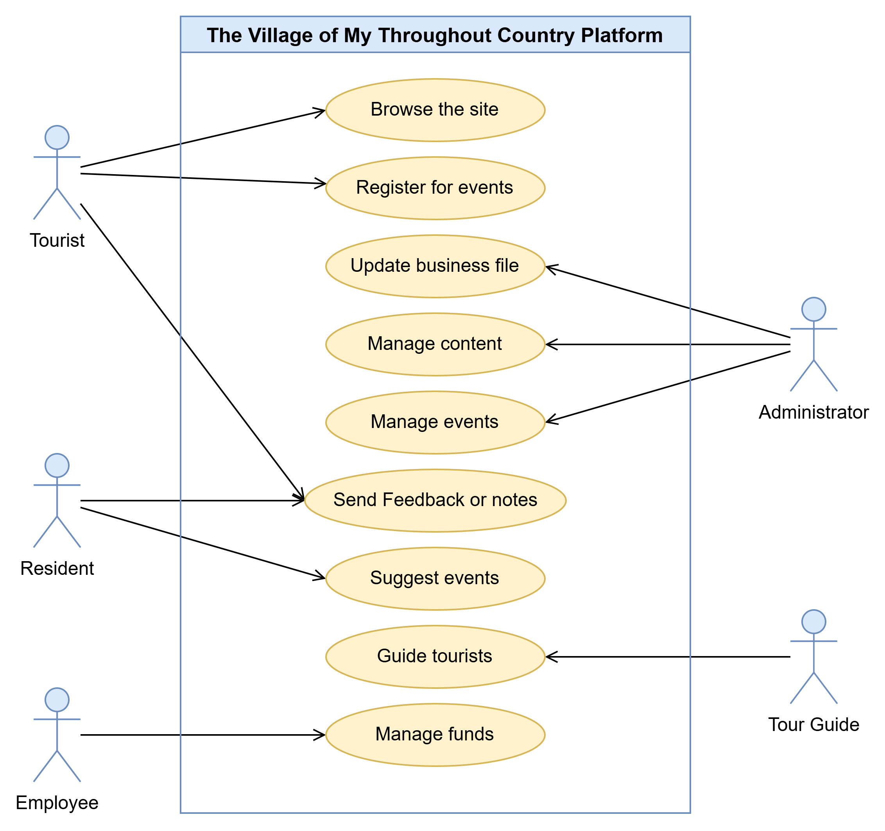
Figure 6: Use Case Diagram
Explanation of Use Case Diagram:
The use case diagram shows the interactions between system users and functionalities:
- Tourists can browse attractions, register for events, and submit feedback.
- Residents can propose events and provide feedback to improve the platform.
- Employee can Manage funds
- Tour Guide can Guide tourists
- Administrators Update business file, Manage content, Manage events.

Sequence Diagram

Tourist Sequence Diagram
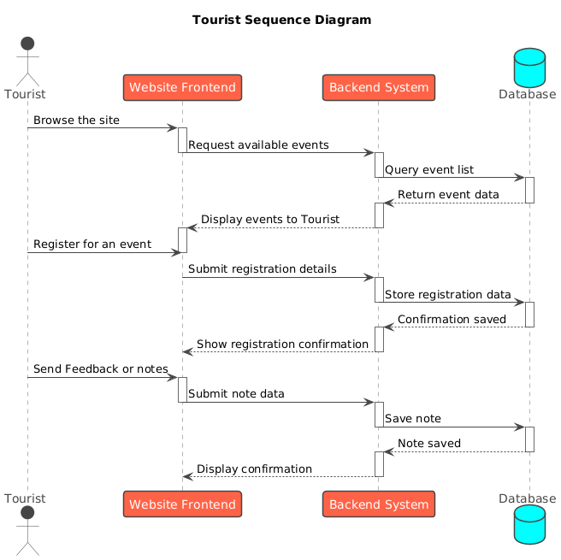
Figure 7: Tourist Sequence Diagram

Resident Sequence Diagram
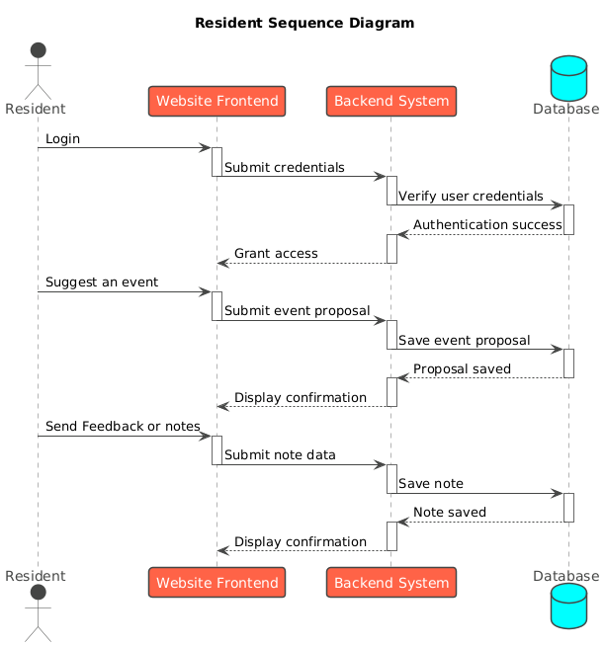
Figure 8: Resident Sequence Diagram

Employee Sequence Diagram
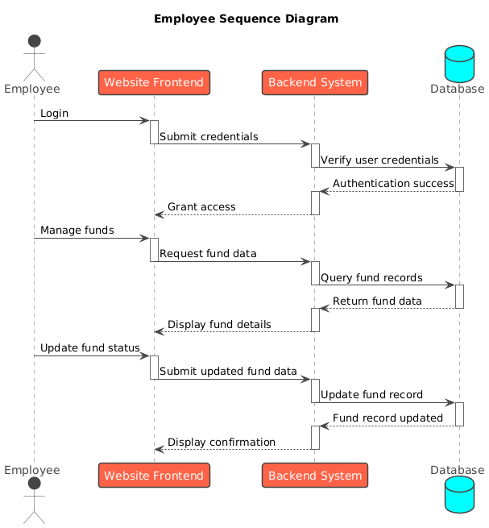
Figure 9: Employee Sequence Diagram

Tour Guide Sequence Diagram
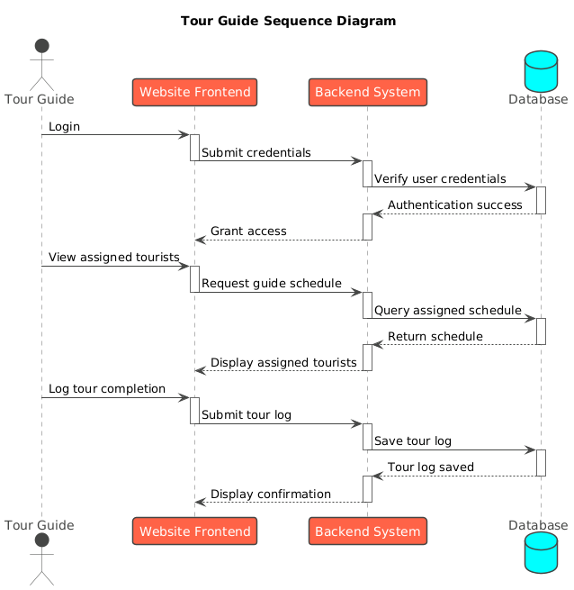
Figure 10: Tour Guide Sequence Diagram

Administrator Sequence Diagram
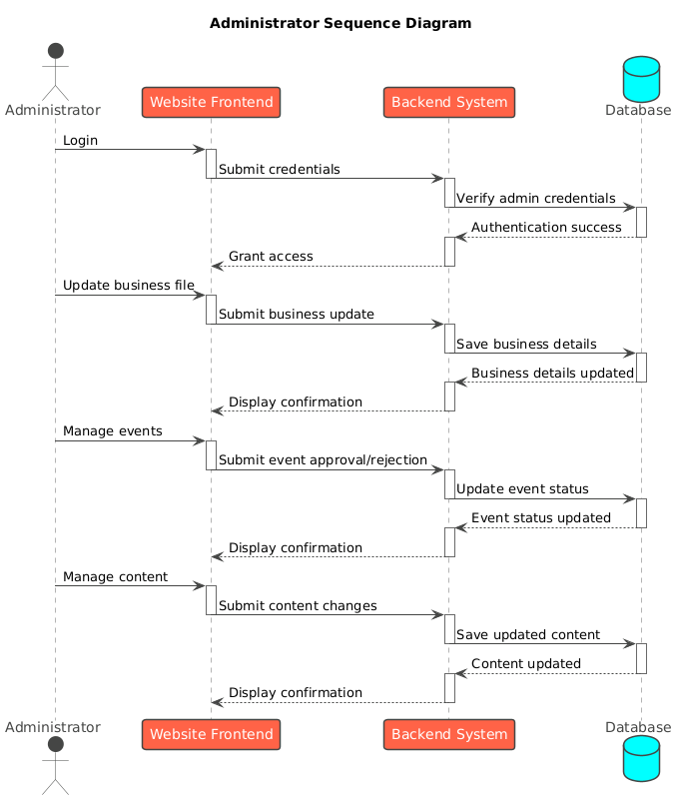
Figure 11: Administrator Sequence Diagram

Activity Diagram
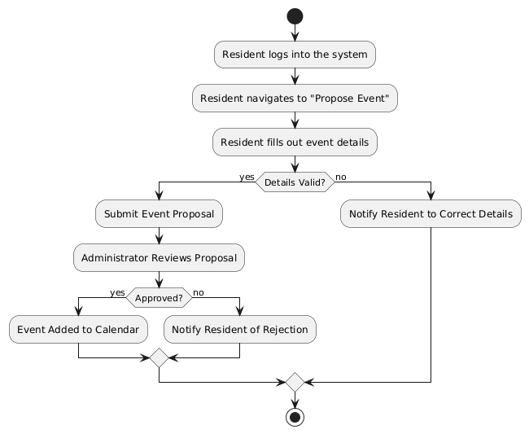
Figure 12: Activity Diagram

Explanation of Activity Diagram:
The activity diagram shows the process of proposing an event:
- A resident logs in and navigates to the "Propose Event" section.
- The resident fills out event details.
- If the details are valid, the proposal is submitted for review.
- The administrator reviews the proposal:
  - If approved, the event is added to the calendar.
  - If rejected, the resident is notified with a reason.
- If the details are invalid, the resident is prompted to correct them.

DFD Diagram
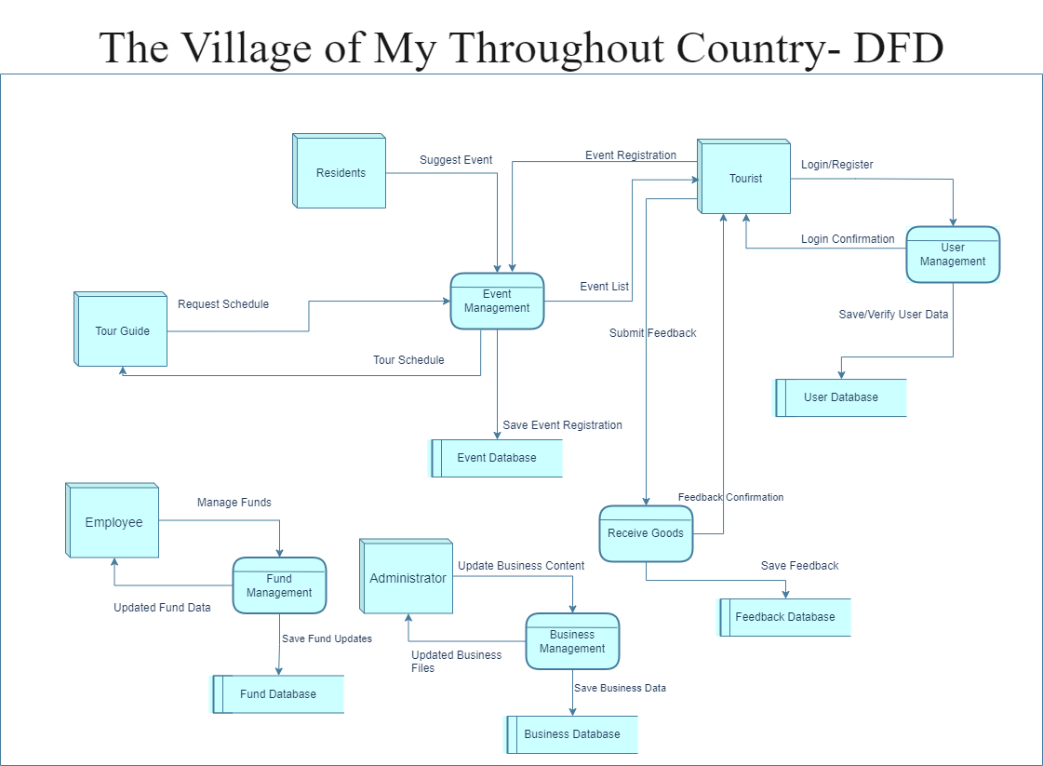
Figure 13: DFD Diagram

Class Diagram
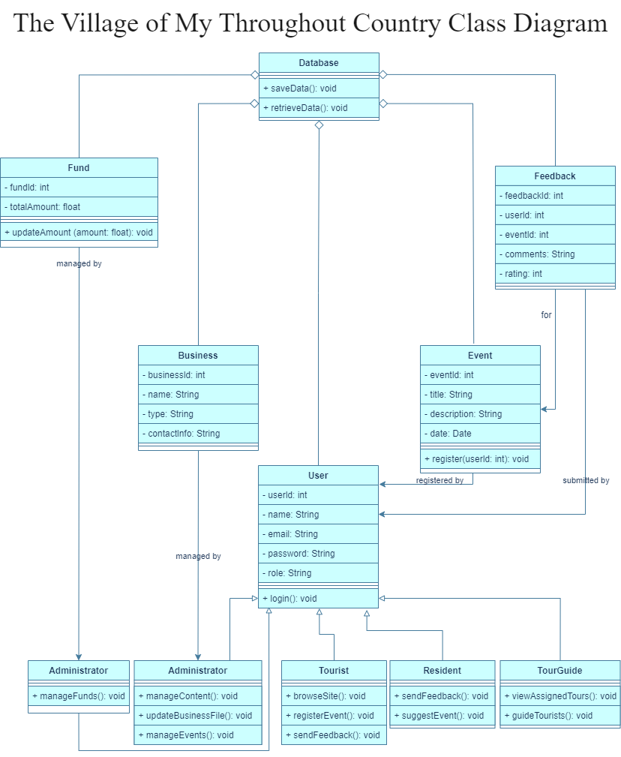
Figure 14: Class Diagram

Collaboration Diagram
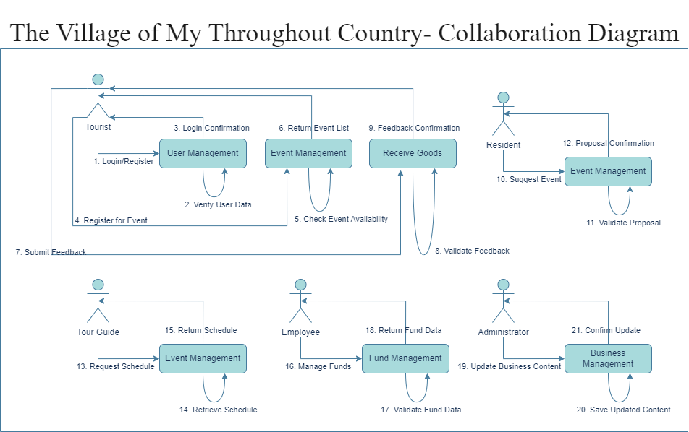
Figure 15: Collaboration Diagram

Chapter 4: System Design

Introduction
The design phase plays a critical role in translating project requirements into a structured, functional, and visually appealing platform. For THE VILLAGE OF MY THROUGHOUT COUNTRY, the design focuses on delivering an engaging user experience while ensuring the system is robust, scalable, and secure. This chapter outlines the user interface design, system architecture, database design, and other technical aspects that form the backbone of the platform.
The design process adheres to key principles such as usability, accessibility, and responsiveness to ensure the website caters to diverse users, including tourists, residents and administrators. Each component of the design is carefully aligned with the project’s objectives of promoting tourism, supporting local businesses, and fostering community engagement.

User Interface Design
The user interface (UI) design emphasizes simplicity, clarity, and responsiveness, providing a seamless experience across devices. Each page is designed with specific functionalities to serve the needs of different users while maintaining a cohesive aesthetic that reflects the heritage and cultural significance of the village.
Key Pages on the Website
- Homepage
  - Purpose: Serves as the entry point for visitors, providing a brief overview of the village and easy navigation to other sections.
  - Features:
    - A visually appealing banner showcasing key attractions of the village.
    - Quick links to upcoming events, the business directory, and contact information.
    - A brief description of the village’s history and significance.
- Almajardah Page
  - Purpose: Highlights the key landmarks and attractions in the village, encouraging tourists to explore.
  - Features:
    - Detailed descriptions of the heritage museum, open theater, decorative stone carvings, and other notable sites.
    - An interactive map with markers for each attraction, helping visitors plan their trip.
- Event Management Page
  - Purpose: Provides information about upcoming events and allows users to register for them.
  - Features:
    - Event details, including date, time, and location.
    - Registration forms for event participation.
    - Options for residents to propose new events.
- Business Directory Page
  - Purpose: Showcases local businesses and services, promoting economic growth within the village.
  - Features:
    - Listings of businesses such as hotels, restaurants, and shops, with contact details and service descriptions.
    - A search bar to filter businesses by type (e.g., accommodation, dining, shopping).
- Feedback Page
  - Purpose: Allows users to share their experiences and provide feedback on events, attractions, or services.
  - Features:
    - Feedback submission form with fields for comments and ratings (1–5 stars).
    - Display of aggregated feedback and ratings for transparency and improvement.
- About Us Page
  - Purpose: Provides information about the mission, vision, and values of the village.
  - Features:
    - A section on the history and goals of the village.
    - Profiles of team members and specialists managing the village.
- Contact Us Page
  - Purpose: Enables users to get in touch with administrators for inquiries or support.
  - Features:
    - Contact form for submitting questions or concerns.
    - Display of phone numbers, email addresses, and links to social media platforms.
- Multimedia and Publications Page
  - Purpose: Showcases visual and educational materials to enrich visitors’ understanding of the village.
  - Features:
    - Photo and video galleries featuring the village’s attractions and events.
    - Downloadable publications such as brochures, historical records, and guides.
Design Principles
- Consistency: Uniform design elements, such as color schemes, fonts, and navigation menus, ensure a cohesive user experience.
- Accessibility: Pages are designed to accommodate users with disabilities, including support for screen readers and keyboard navigation.
- Responsiveness: The layout adapts to different screen sizes, ensuring usability on both desktop and mobile devices.

System Architecture
The system architecture of The Village Of My Throughout Country is based on a three-tier architecture to ensure scalability, security, and efficient data management. Each layer is designed to handle specific responsibilities, ensuring the smooth functioning of the platform.

Three-Tier Architecture
- Presentation Layer (Frontend)
  - Purpose: This layer interacts directly with the users, providing an intuitive and responsive interface.
  - Technologies Used:
    - HTML, CSS, JavaScript (for creating user-friendly interfaces).
    - Bootstrap or Tailwind CSS (for styling and responsive design).
    - Interactive map API (e.g., Google Maps API) to display village attractions.
  - Features:
    - Event calendar and registration forms.
    - Business directory and feedback submission forms.
    - Interactive navigation for browsing attractions and services.
- Application Layer (Backend)
  - Purpose: This layer processes user requests, enforces business logic, and manages interactions with the database.
  - Technologies Used:
    - PHP (for handling requests and processing logic).
  - Features:
    - User authentication and authorization.
    - Event management, feedback handling, and content updates.
    - Business profile creation and modification.
- Data Layer (Database)
  - Purpose: This layer stores and retrieves all system data securely and efficiently.
  - Technologies Used:
    - MySQL (for relational database management).
  - Features:
    - Tables for users, events, feedback, and businesses.
    - Data encryption and secure storage to comply with legal requirements like PDPL.
    - Backup and recovery mechanisms to ensure data integrity.

System Interaction Workflow
- A user (tourist, resident, or Tour guide) sends a request through the frontend (e.g., browsing events or registering for one).
- The request is processed by the application layer, which validates inputs and applies business logic.
- The application layer retrieves or updates data in the database and sends the response back to the frontend.
- The frontend displays the processed information (e.g., confirmation of event registration or a list of businesses).

System Diagram
The system diagram visually represents the interaction between the layers and users:
- Frontend: Interfaces with tourists, residents, tour guide, and administrators.
- Backend: Handles requests from the frontend and communicates with the database.
- Database: Stores user data, events, feedback, and business information.

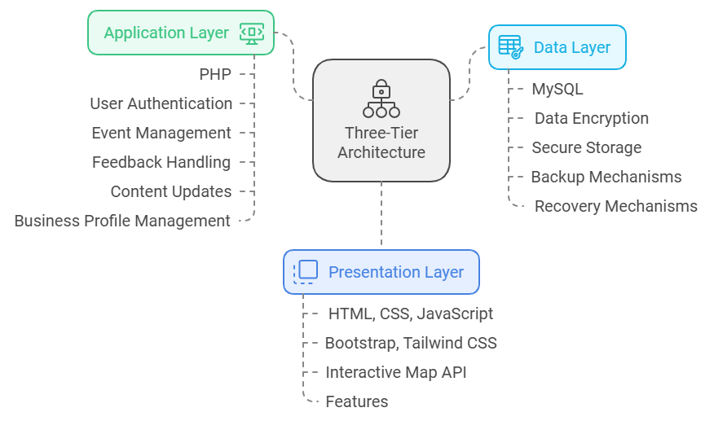
Figure 16:System Diagram

Database Design
The database for The Village Of My Throughout Country is designed to store and manage information about users, events, businesses, feedback, and more. The design ensures that data is well-structured, scalable, and secure, adhering to best practices for relational database management systems (RDBMS).

Entity-Relationship Diagram (ERD)
Below is the conceptual design of the database, with the main entities and their relationships.
- User Table
  - Stores information about tourists, residents, tour guide, and administrators.
  - Relationship: One-to-many with feedback and event registrations.
- Event Table
  - Contains details of events hosted in the village, including event name, date, and organizer.
  - Relationship: Many-to-one with administrators (who approve events).
- Business Table
  - Includes details of local businesses such as hotels, restaurants, and shops.
  - Relationship: Managed by administrators.
- Feedback Table
  - Stores feedback submitted by users about events or services.
  - Relationship: Many-to-one with users and events.
- Event Registration Table
  - Tracks which users have registered for which events.
  - Relationship: Many-to-many with users and events.
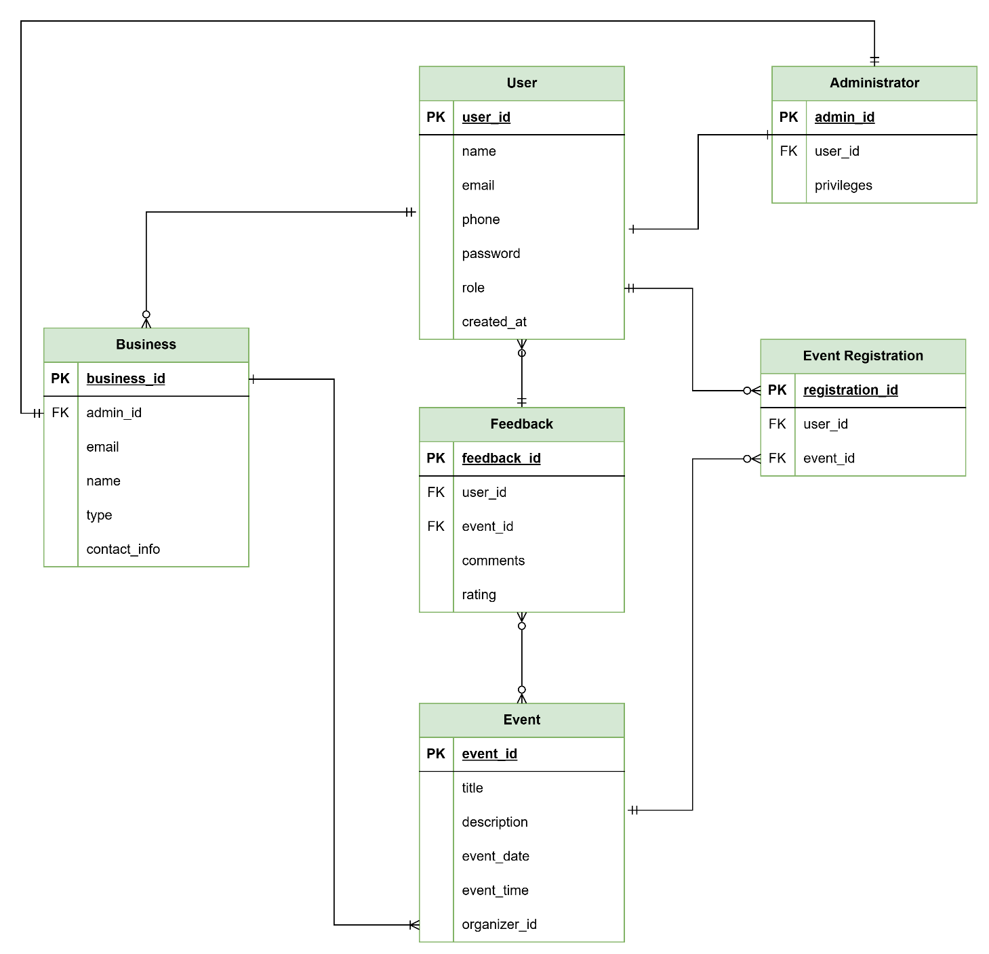

Figure 17:Entity-Relationship Diagram (ERD)

Database Tables
Below are the key database tables with their attributes, keys, and relationships:
  - User Table
Column Name | Data Type | Constraints | Description
user_id | INT | PRIMARY KEY, AUTO_INCREMENT | Unique identifier for each user.
name | VARCHAR(100) | NOT NULL | Full name of the user.
email | VARCHAR(150) | UNIQUE, NOT NULL | Email address of the user.
phone | VARCHAR(100) | NOT NULL | Mobile number of user
password | VARCHAR(255) | NOT NULL | Encrypted password.
role | ENUM('Resident', 'tour guide ', 'Admin') | NOT NULL | User's role in the system.
created_at | DATETIME | DEFAULT CURRENT_TIMESTAMP | Timestamp of account creation.
Table 2: User Table
  - Event Table
Column Name | Data Type | Constraints | Description
event_id | INT | PRIMARY KEY, AUTO_INCREMENT | Unique identifier for each event.
title | VARCHAR(200) | NOT NULL | Name of the event.
description | TEXT | NULL | Description of the event.
event_date | DATE | NOT NULL | Scheduled date of the event.
event_time | DATETIME | NOT NULL | Scheduled time of the event.
organizer_id | INT | FOREIGN KEY (User Table) | Links to the administrator managing the event.
Table 3: Event Table

  - Business Table
Column Name | Data Type | Constraints | Description
business_id | INT | PRIMARY KEY, AUTO_INCREMENT | Unique identifier for each business.
Admin_id | INT | FOREIGN KEY (Admin Table) | Reference to the Admin
name | VARCHAR(150) | NOT NULL | Name of the business.
type | VARCHAR(100) | NOT NULL | Type of business (e.g., hotel, shop).
contact_info | TEXT | NULL | Contact details of the business.
Table 4: Business Table
  - Feedback Table
Column Name | Data Type | Constraints | Description
feedback_id | INT | PRIMARY KEY, AUTO_INCREMENT | Unique identifier for each feedback.
user_id | INT | FOREIGN KEY (User Table) | Links to the user providing feedback.
event_id | INT | FOREIGN KEY (Event Table) | Links to the event being reviewed.
comments | TEXT | NULL | User-provided feedback.
rating | INT | CHECK (rating BETWEEN 1 AND 5) | Star rating given to the event/service.
Table 5: Feedback Table
  - Event Registration Table
Column Name | Data Type | Constraints | Description
registration_id | INT | PRIMARY KEY, AUTO_INCREMENT | Unique identifier for each registration.
user_id | INT | FOREIGN KEY (User Table) | Links to the user registering for the event.
event_id | INT | FOREIGN KEY (Event Table) | Links to the event being registered for.
Table 6: Event Registration Table
  - Administrator Table
Column Name | Data Type | Constraints | Description
admin_id | INT | PRIMARY KEY, AUTO_INCREMENT | Unique identifier for the administrator.
user_id | INT | FOREIGN KEY (User Table) | Reference to the user with administrative rights.
privileges | INT | NOT NULL | List of administrative privileges.
Table 7: Administrator Table

System Flow Design
The system flow design for THE VILLAGE OF MY THROUGHOUT COUNTRY illustrates how users interact with the platform and how data flows between different components. This ensures that the website operates efficiently and provides a seamless experience for all user types.
Key System Flows:
- User Registration and Login
  - Flow:
    - User accesses the login/registration page.
    - Registration: User provides name, email, password, and role (Tourist, Resident, Administrator).
    - Login: User enters email and password.
    - System validates credentials using the database.
    - If valid, the user is granted access to their respective dashboard.
  - Data Flow: Inputs are securely stored in the user table and authenticated during login.
- Event Browsing and Registration
  - Flow:
    - User navigates to the Event Management Page.
    - System queries the database for available events and displays them.
    - User selects an event and fills out the registration form.
    - System validates inputs and stores the registration in the database.
    - A confirmation is displayed to the user.
  - Data Flow: Event and user data are linked via the Event Registration Table.
- Feedback Submission
  - Flow:
    - User accesses the Feedback Page.
    - User selects the event or service they wish to review.
    - Feedback and ratings are submitted and stored in the database.
    - Feedback is displayed for transparency and user engagement.
  - Data Flow: User feedback is stored in the Feedback Table, linked to the respective event or service.
- Business Profile Management
  - Flow:
    - Admin logs in and navigates to their dashboard.
    - Admin updates business details (e.g., contact information, description).
    - System validates inputs and updates the Business Table.
    - Changes are reflected on the Business Directory Page.
  - Data Flow: Updates are stored in the Business Table and retrieved for display.
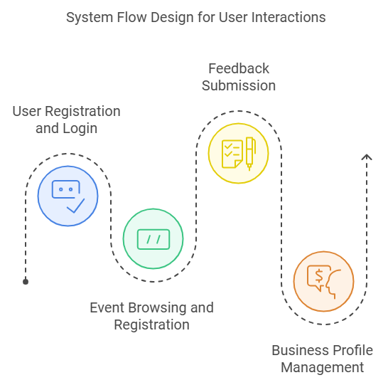
Figure 18: System Flow Design

Security Design
Security is a critical aspect of the platform, ensuring the protection of user data, system integrity, and overall trustworthiness. The design incorporates multiple layers of security to safeguard against threats.
Key Security Measures:
- Data Encryption
  - All sensitive data, such as passwords and personal information, is encrypted during transmission using SSL (Secure Sockets Layer).
  - Passwords are hashed and stored securely in the database using algorithms like bcrypt.
- Authentication and Authorization
  - Role-based access control ensures that users can only access features relevant to their roles. For example:
    - Tourists can browse events but cannot propose new ones.
    - Administrators have full access to manage content and events.
  - Multi-factor authentication (MFA) is recommended for administrative accounts.
- Input Validation
  - All user inputs are validated on both the client and server sides to prevent SQL injection, cross-site scripting (XSS), and other vulnerabilities.
  - Strict constraints are enforced on database fields to ensure data integrity.
- Data Privacy Compliance
  - The platform complies with Saudi Arabia’s Personal Data Protection Law (PDPL) and GDPR for international visitors.
  - Users are informed about data usage through a privacy policy, and they can request account deletion.
- System Monitoring and Logs
  - Activities such as login attempts, changes to content, and failed logins are logged for monitoring and auditing.
  - Regular security audits and penetration testing are conducted to identify and mitigate risks.
- Backup and Recovery
  - Automated daily backups ensure that data can be restored in case of system failure.
  - Recovery plans are in place to minimize downtime during incidents.

Conclusion
The design phase for THE VILLAGE OF MY THROUGHOUT COUNTRY has laid the foundation for a robust, user-friendly, and secure platform. The system flow design ensures seamless interactions between users and the platform, from event registration to feedback submission. A well-structured security framework protects user data and ensures compliance with privacy regulations, fostering trust and reliability.
By integrating these design elements, the project successfully addresses the objectives of promoting tourism, supporting local businesses, and engaging the community. The combination of responsive user interfaces, a scalable architecture, and rigorous security measures positions the platform as a model for sustainable heritage tourism. This design chapter bridges the gap between planning and implementation, setting the stage for the successful realization of the platform.

Chapter 5: Prototype

Introduction
The prototype of "The Village of My Throughout Country" web application provides a visual representation of the project's core functionalities and design. This chapter highlights the key interfaces developed to enhance user experience and accessibility for both visitors and stakeholders. By showcasing a responsive design and user-friendly navigation, the prototype aims to effectively convey the rich cultural heritage, services, and events offered by the village. The interfaces have been designed to reflect the project's objectives of fostering community engagement, promoting tourism, and preserving cultural heritage.

Interfaces
    - Home Page
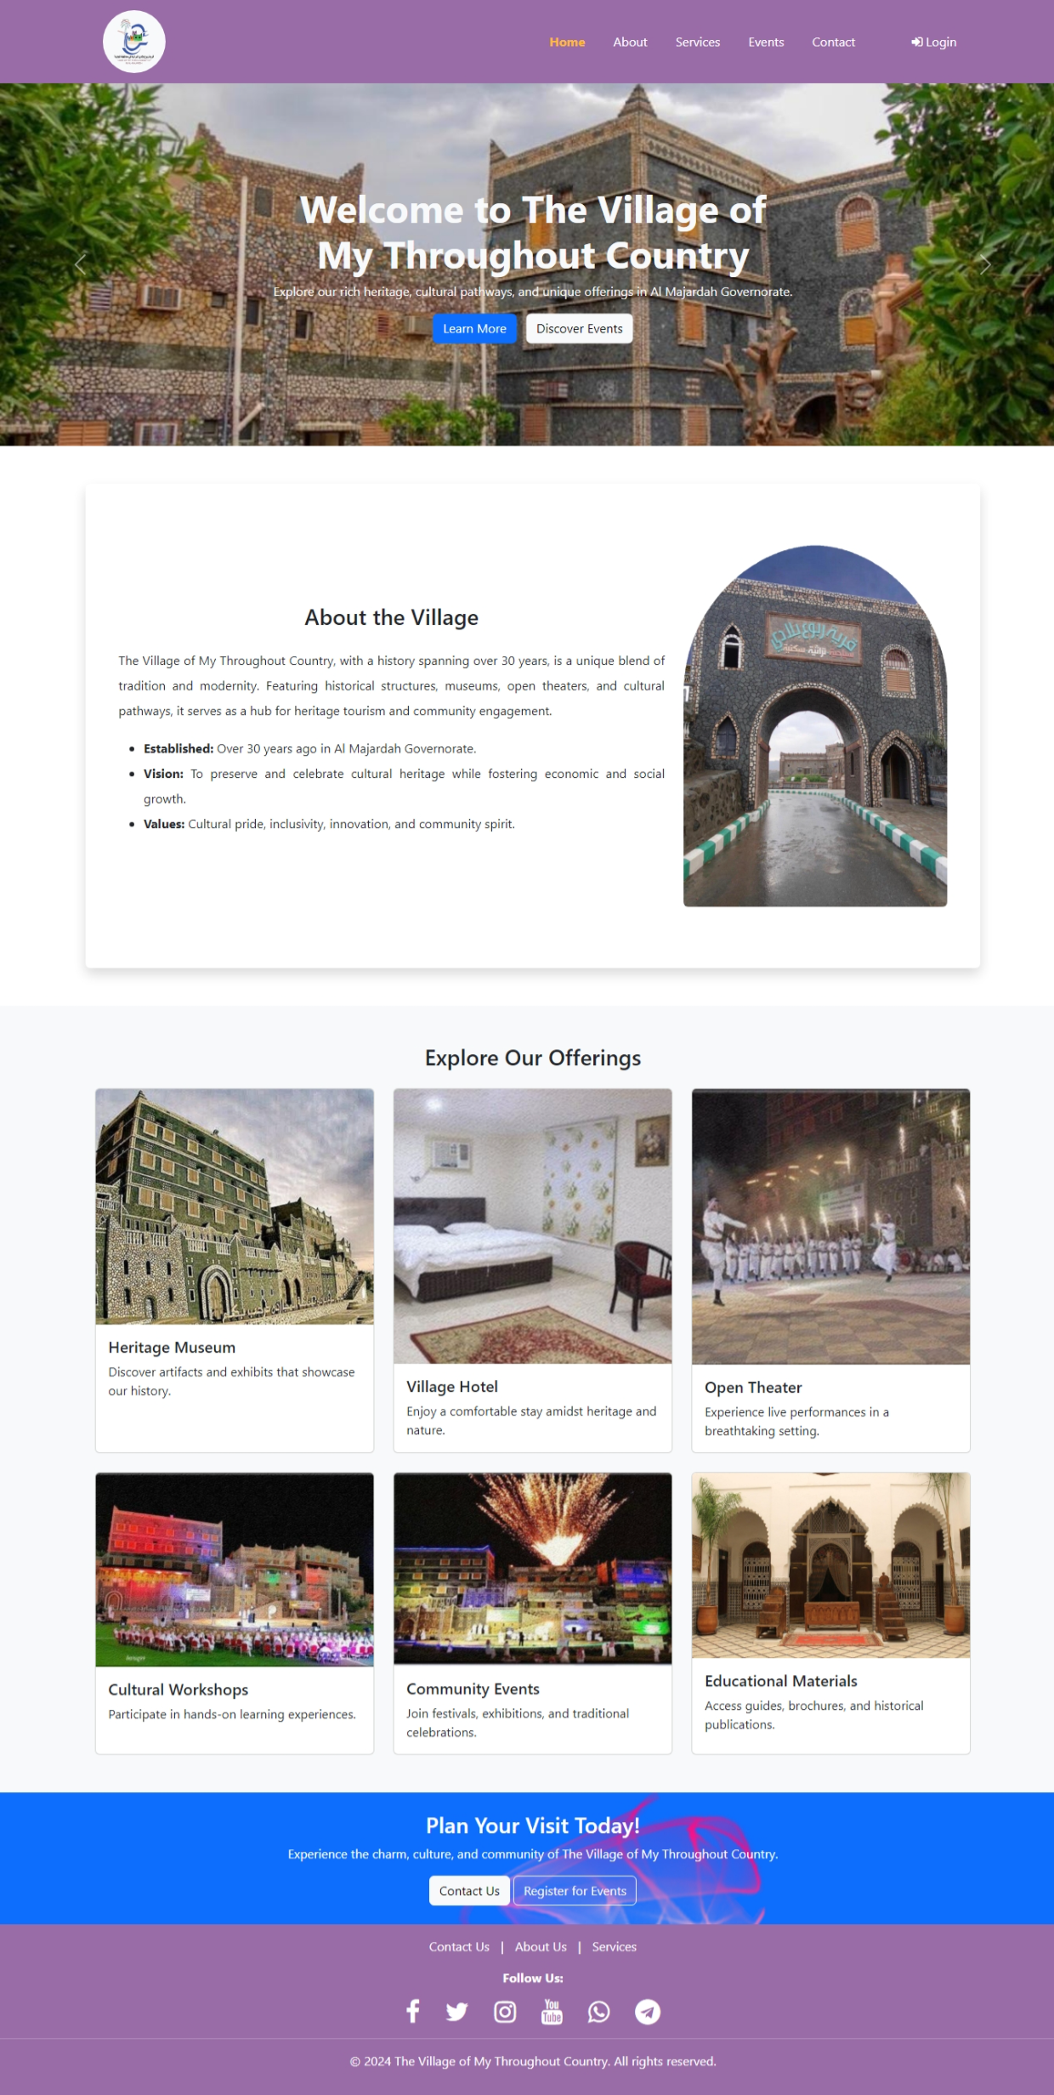
Figure 19: Home Page
The home page serves as the entry point for users visiting the website. It includes:
- A prominent welcome banner with the village's slogan and call-to-action buttons: "Learn More" and "Discover Events."
- A brief introduction to the village, its history, and values.
- An "Explore Our Offerings" section showcasing various services such as the heritage museum, cultural workshops, and more.
- A footer with navigation links and social media icons for user engagement.
    - About Us Page
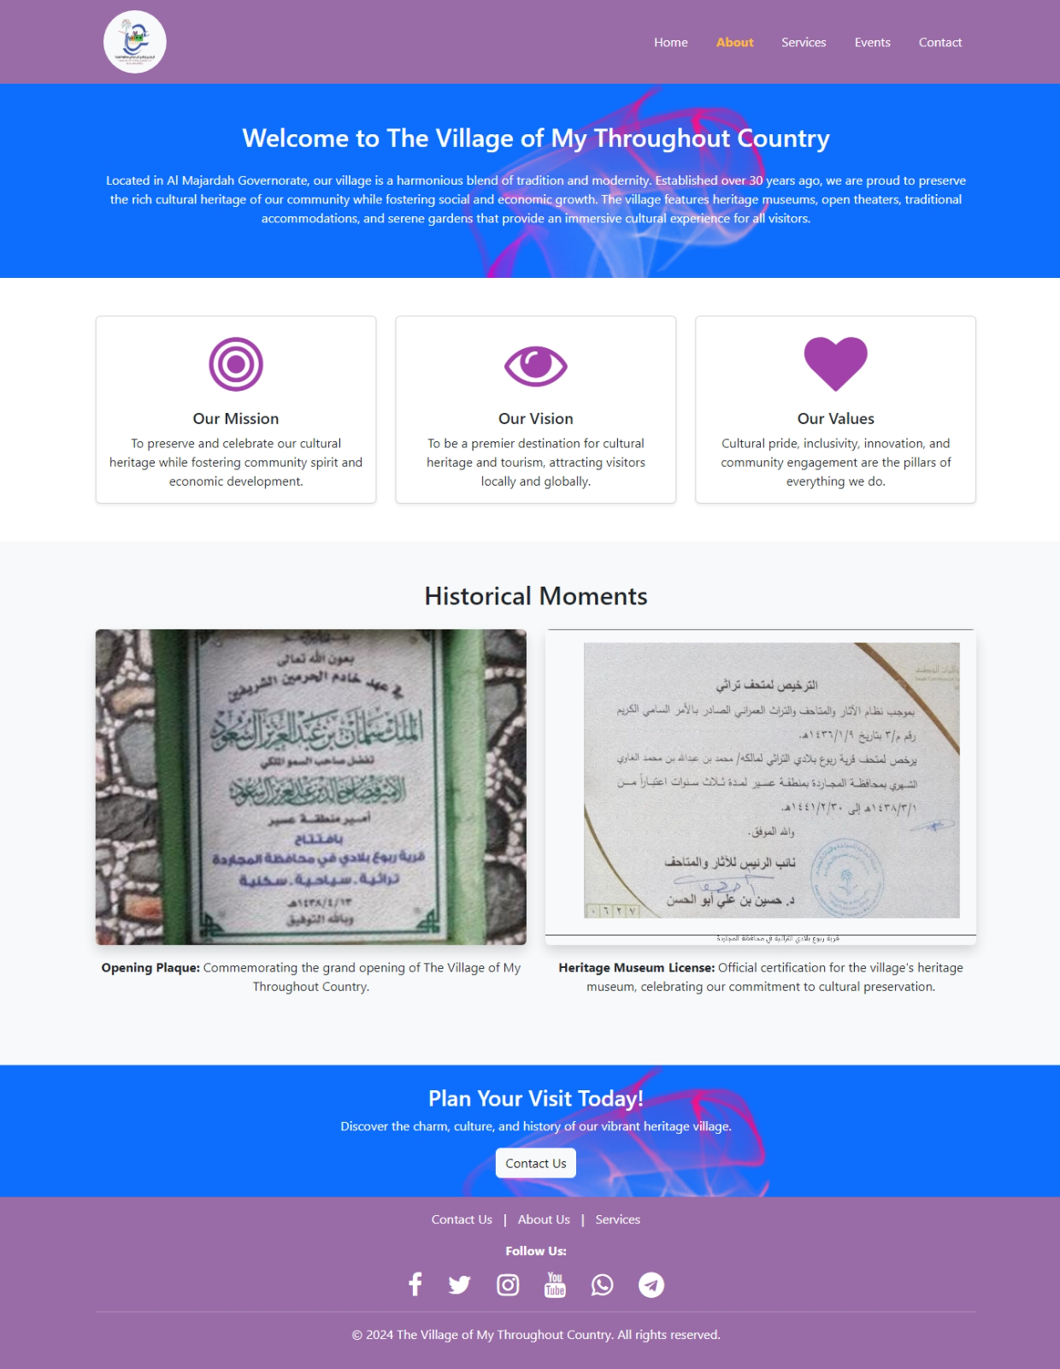
Figure 20: About Us Page
This page provides an overview of the village's mission, vision, and values. Key features include:
- A banner with a summary of the village's purpose and cultural significance.
- Cards displaying the mission, vision, and values, each represented with an icon for visual appeal.
- A "Historical Moments" section showcasing images of significant milestones such as the village's opening plaque and the heritage museum license.
- A call-to-action section encouraging users to visit the village.

    - Services Page
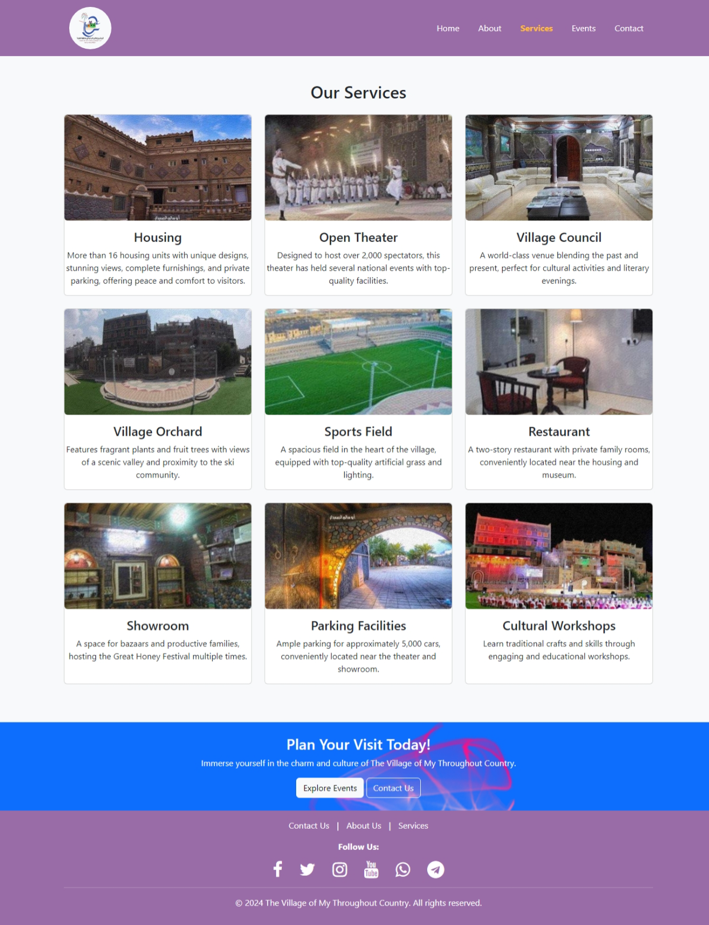
Figure 21: Services Page
The services page highlights the diverse offerings of the village. It includes:
- A grid of cards showcasing services such as housing, open theater, village council, orchard, sports field, restaurant, showroom, parking facilities, and cultural workshops.
- Each card features an image, title, and description of the service for clarity and user engagement.
- A footer with links to explore more about the services and contact the village.
    - Events Page
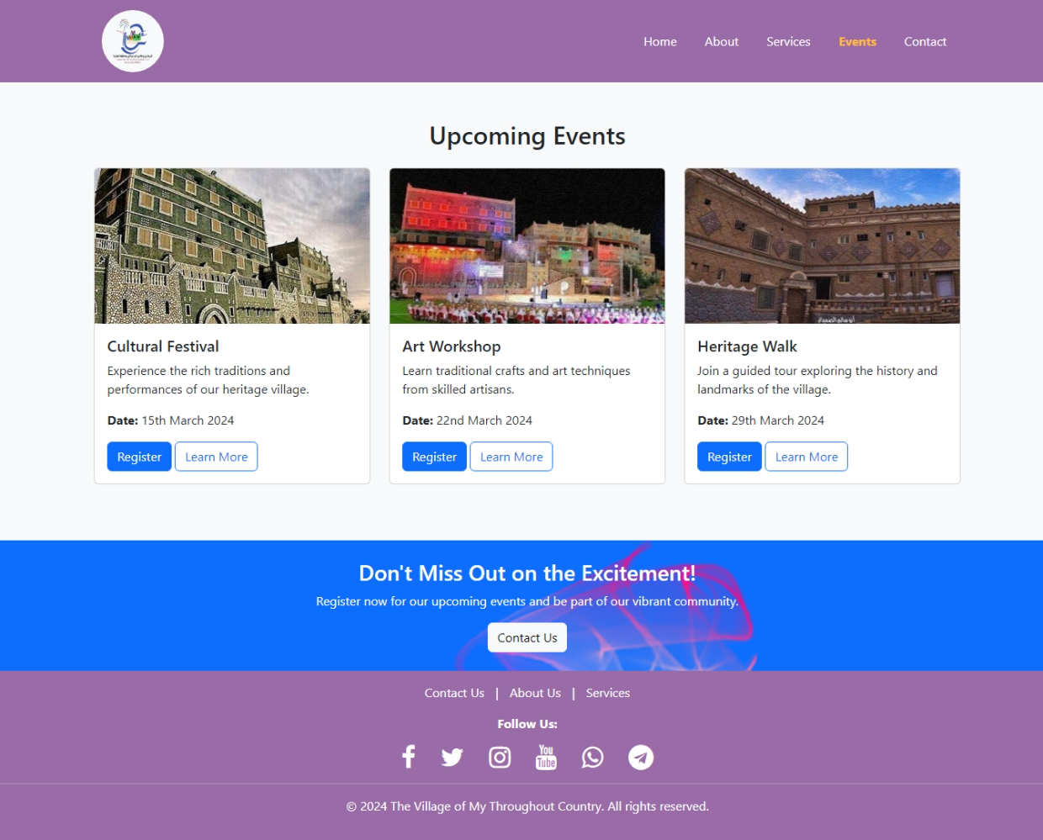
Figure 22: Events Page
The events page allows users to explore and register for upcoming events. Features include:
- A list of upcoming events displayed in cards, each with an image, event title, description, date, and action buttons ("Register" and "Learn More").
- A call-to-action section encouraging users to participate in the events and connect with the village.

    - Contact Us Page
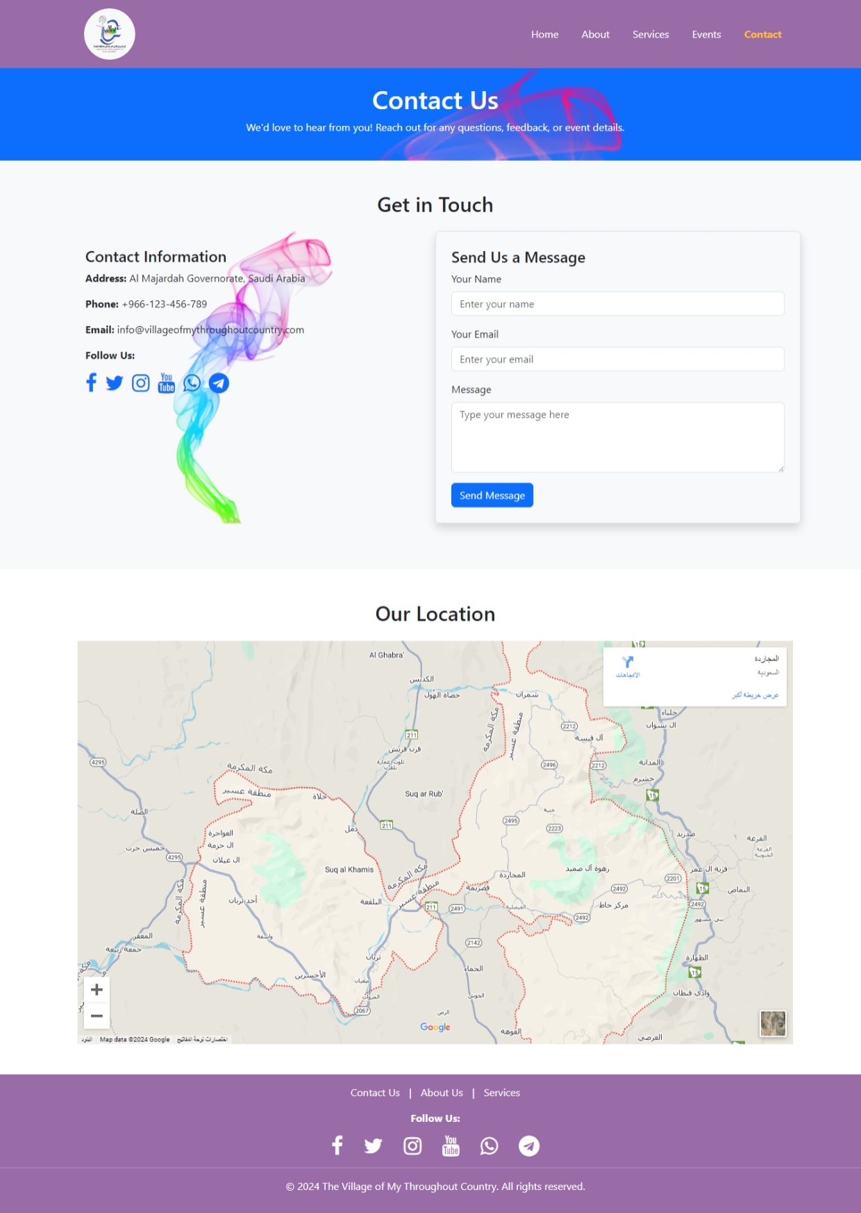
Figure 23: Contact Us Page
This page facilitates communication between users and the village administration. It contains:
- Contact information including the address, phone number, email, and social media links.
- A "Send Us a Message" form for users to submit inquiries directly.
- An interactive map showcasing the village's location for easy navigation.

    - Login Page
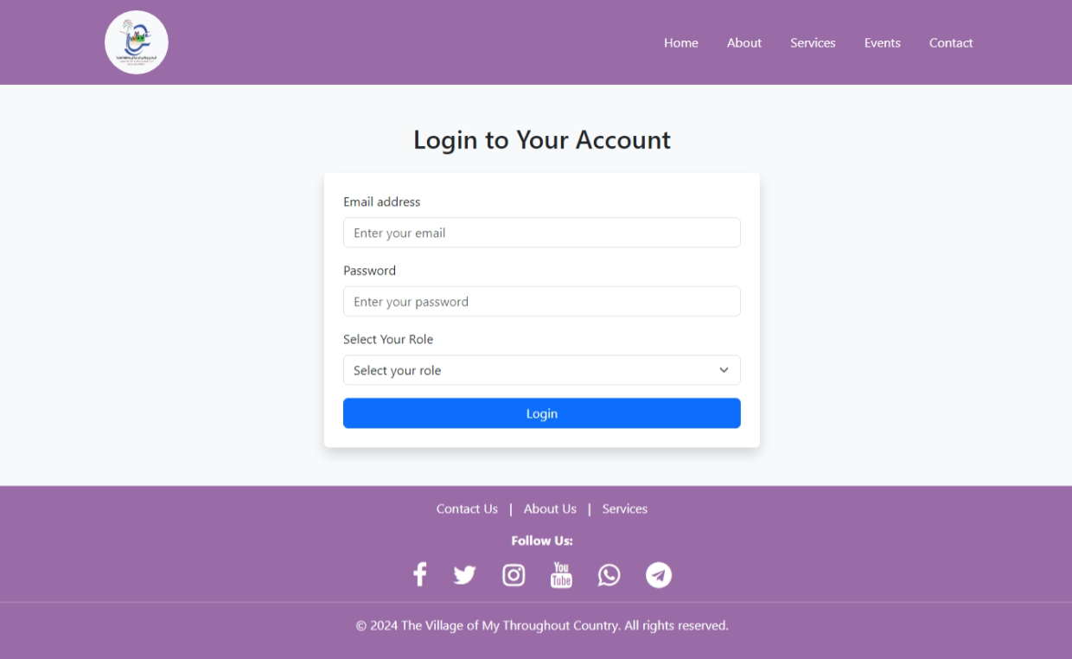
Figure 24: Login Page
The login page provides access to different user roles: admin, employee, and tour guide. It includes:
- Fields for email and password input.
- A dropdown menu for selecting the user's role.
- A "Login" button to access the respective dashboard.

Conclusion
The prototype of the project demonstrates how "The Village of My Throughout Country" web application can serve as a digital platform to connect the village with its visitors. Through its thoughtfully designed interfaces, the website provides users with a seamless experience to explore services, learn about events, and interact with the village's administration. Each page of the prototype is crafted with a focus on responsiveness, visual appeal, and usability, ensuring accessibility across various devices. The prototype represents a significant step toward achieving the project's goals of promoting cultural heritage and supporting community-driven initiatives.

Future Work
While the current prototype effectively captures the core functionalities of the web application, there are several areas for future development and enhancement:
- Interactive Features: Incorporate dynamic features such as live event registration tracking and user dashboards for personalized experiences.
- Multilingual Support: Add support for multiple languages to cater to a diverse audience and attract international visitors.
- Mobile Application Integration: Develop a mobile application to complement the web platform, offering enhanced accessibility on mobile devices.
- Advanced Analytics: Implement analytics to monitor user behavior, event participation, and service utilization to continuously improve the user experience.
- E-commerce Integration: Introduce online payment options for event registration, ticket bookings, and purchases from the village showroom.
- Virtual Tours: Include virtual reality tours of the village to attract remote audiences and offer a glimpse of its attractions.
- Feedback System: Add a comprehensive feedback mechanism to gather insights from users and visitors for further improvements.

References
- Saudi Vision 2030. (2016). National Transformation Program. https://vision2030.gov.sa/en
- World Tourism Organization (UNWTO). (2023). The Role of Digital Platforms in Tourism Promotion. UNWTO https://www.unwto.org/digital-platforms-and-tourism
- United Nations Educational, Scientific and Cultural Organization (UNESCO). (2021). Sustainable Tourism and Heritage Preservation. UNESCO https://en.unesco.org/sustainable-tourism
- Smith, M., & Richards, G. (2022). Cultural Tourism and Community Development: Trends and Future Directions. Journal of Cultural Tourism Studies, 15(4), 123-137. Cultural Tourism Journal https://www.tourismjournal.com
- Al-Turki, R. (2021). Vision 2030 and the Growth of Heritage Tourism in Saudi Arabia. Middle Eastern Journal of Tourism, 10(3), 85-97. Middle Eastern Journal of Tourism https://www.me-tourismjournal.org
- Schilling, M. (2020). Project Feasibility and Tourism Planning. Journal of Tourism and Development, 19(4), 145-160. Tourism Journal https://www.tourismjournal.com
- Historic England. (2023). Heritage Preservation and Community Involvement. Retrieved from Historic England https://historicengland.org.uk
- Visit Scotland. (2022). Explore Scotland's Heritage Sites. Available at: Visit Scotland
- Saudi Tourism Authority. (2023). Explore Saudi Arabia’s Heritage Sites. Available at: Saudi Tourism
- World Tourism Organization (UNWTO). (2022). Mobile-Responsive Tourism Platforms. Retrieved from UNWTO
- Saudi Data & AI Authority (SDAIA). (2021). Saudi Personal Data Protection Law (PDPL). Available at: SDAIA
- Ministry of Commerce, Saudi Arabia. (2022). E-commerce Regulations in Saudi Arabia. Available at: Ministry of Commerce
- Smith, J. (2021). Cost-Benefit Analysis in Cultural Heritage Projects. Journal of Cultural Economics, 23(4), 305-322. Available at: Cultural Economics Journal
- Davis, S., & Smith, J. (2021). Performance Metrics for Tourism Websites. Journal of Web Performance Research, 29(3), 45-62. Available at: [Web Performance Research Journal](https://www.webperformanceresearch.com
- World Wide Web Consortium (W3C). (2022). Web Content Accessibility Guidelines (WCAG) 2.1. Retrieved from [W3C](https://www.w3.org/WAI/standards-guidelines/wcag/

