
King Khalid University
College of Science And Arts
Department Of Information Systems

Depressed Helping
An application to Help People with Depression

By

Rahaf Saed Alshehri
Nada Abdullah Alshehri
Dania Mardom Alshehri
Lama Ahmad Alahmari
Dalal Osman Alshehri

Supervised by

This Project Documentation is submitted in partial fulfillment
for the Requirement for the Degree of B.Sc. in
Information Systems

September 2024

COMMITTEE
We ensure we have perused this graduation venture report as looking at advisory group, analyzed the understudy in its substance and that as we would like to think it is sufficient asan undertaking archive for B.Sc. in Computer Science.
Supervisor:
Examiner
Name: Name:

Signature Signature
Examiner Name:
Signature
Date: /
Date: /
Date: /

ABSTRACT

In recent years, depression has emerged as a critical global health challenge, affecting millions across age groups and regions. This project introduces a web-based application designed to support individuals experiencing depression by offering accessible, user-friendly tools. By integrating evidence-based interventions such as mood tracking, cognitive behavioral techniques, and mindfulness exercises, the platform provides a digital avenue for users to manage their mental health independently. This web application emphasizes immediate, tailored support aimed at alleviating symptoms of depression and fostering emotional resilience. The theoretical framework underpinning this project explores the application’s design, objectives, and anticipated impact on users, while also examining the current technological landscape of digital mental health support. This study thus not only highlights the necessity of digital solutions in mental health care but also anticipates the challenges and potential effectiveness of web-based interventions in improving mental health outcomes.

الملخص
في السنوات الأخيرة، برز الاكتئاب كتحدٍ صحي عالمي بالغ الأهمية، يؤثر على ملايين الأشخاص في مختلف الفئات العمرية والمناطق. يقدم هذا المشروع تطبيقًا قائمًا على الويب مصممًا لدعم الأفراد الذين يعانون من الاكتئاب من خلال تقديم أدوات سهلة الوصول إليها وسهلة الاستخدام. من خلال دمج التدخلات القائمة على الأدلة مثل تتبع الحالة المزاجية، والتقنيات السلوكية المعرفية، وتمارين اليقظة، توفر المنصة وسيلة رقمية للمستخدمين لإدارة صحتهم العقلية بشكل مستقل. يؤكد تطبيق الويب هذا على الدعم الفوري والمخصص الذي يهدف إلى تخفيف أعراض الاكتئاب وتعزيز المرونة العاطفية. يستكشف الإطار النظري الذي يدعم هذا المشروع تصميم التطبيق وأهدافه والتأثير المتوقع على المستخدمين، مع فحص المشهد التكنولوجي الحالي للدعم الرقمي للصحة العقلية. وبالتالي، لا تسلط هذه الدراسة الضوء على ضرورة الحلول الرقمية في رعاية الصحة العقلية فحسب، بل تتوقع أيضًا التحديات والفعالية المحتملة للتدخلات القائمة على الويب في تحسين نتائج الصحة العقلية.

ACKNOWLEDGEMENT

First, at every outset we express our gratitude and thanks to Allah. We feel great pleasure in submitting our graduation project on " Depressed Helping ". We wish to express true sense of gratitude towards our project supervisor ………….. for her constant encouragement and valuable guidance and for providing all the necessary facilities, which were indispensable in the completion of this project. We thank everyone who help and guide us to complete this part of the project. Finally, we express our sincere thanks to all those who helped us directly and indirectly in many ways in completion of this project.

With Sincere Regard
Table of Content
ABSTRACT 3
الملخص 4
CHAPTER 1. Introduction 10
1.1. Introduction 11
1.1.1. The Need for Digital Solutions in Mental Health 11
1.1.2. Objectives of the Application 12
1.1.3. The Growing Role of Technology in Mental Health Care 12
1.1.4. Why Focus on Depression? 13
1.2. Research Problem 13
1.3. Assumptions 14
1.4. Questions 14
1.5. Objectives 15
CHAPTER 2. System Analysis 16
2.1. Overview 17
2.2. Functional Requirements 17
2.3. Non-Functional Requirements 18
2.4. Project Environment 18
2.4.1. Programming Languages 18
2.4.2. Development Tools 19
2.4.3. Relational Database Management Software 19
2.5. UML Diagrams 19
2.5.1. Use Cases 19
2.5.2. Overview of Use Cases 21
2.5.3. Sequence Diagram 25
2.5.4. Data Flow Diagram (DFD) 27
2.5.5. Class Diagram 29
2.5.6. Entity-Relationship Diagram (ER Diagram) 31
1. Table courses 31
2. Table lessons 32
3. Table users 32
4. Table user_activity 32
5. Table user_test_results 32
6. Table feelings 33
7. Table articles 33
8. Table books 33
9. Table tests 33
10. Table test_questions 34
2.6. Project Scope 34
2.7. System Architecture 35
2.7.1. Client Layer 35
2.7.2. Application Layer (Web Server) 36
2.7.3. External API Layer 36
2.7.4. Data Layer (Database Server) 37
2.8. Project Chart 37
2.9. Methodology Used 39
2.10. Literature Review 40
2.10.1. Woebot 40
2.10.2. Wysa 41
2.10.3. Headspace 42
2.10.4. Hakini 43
Chapter 3: System Design 44
3.1. Introduction to the System Design 45
3.2. Website Design Overview 45
3.3. Programs and Tools Used 45
3.4. Interface Designs and Their Services 47
3.4.1. Login Interface 47
3.4.2. Registration Interface 48
3.4.3. User Dashboard (Main Panel) 48
3.4.4. Articles Interface 50
3.4.5. Psychological and Self-Help Programs Interface 51
3.4.6. Chatbot Interface 53
3.4.7. Tests Interface 54
3.4.8. User Profile Page 56
3.4.9. Admin Dashboard Interface 57
3.4.10. User Management Page (Administrator) 58
3.4.11. Program Management Page (Administrator) 58
3.4.12. Lessons and Article Management Page (Administrator) 59
3.4.13. Test Management Page (Administrator) 60
3.5. Conclusion 61
Chapter 4: Implementation 62
Implementation 63
4.1. Login Page 63
4.2. Registration Page 66
4.3. User home page 69
4.4. Programs page 79
4.5. Articles page 84
4.6. Tests page 89
4.7. Bot chat page 95
4.8. Profile page 102
4.9. Admin dashboard page 111
4.10. User management page 119
4.11. Programs management page 121
4.12. Articles management page 124
4.13. Tests management page 127
Chapter 5: Conclusion 130
6.1. Conclusion 131
6.2. Recommendations for the Future 131
References: 133

LIST OF FIGURES
Figure 1: use case Diagram 20
Figure 2: User sequence diagram 25
Figure 3: Admin sequence diagram 26
Figure 4: User Activity diagram 27
Figure 5: Admin Activity diagram 28
Figure 6: Class Diagram 29
Figure 7: ER Diagram 31
Figure 8: System Architecture 35
Figure 9: Client Layer 35
Figure 10: Application Layer 36
Figure 11: API Layer 36
Figure 12: Data Layer 37
Figure 13: Project Chart 38
Figure 14: waterfall methodology 39
Figure 15: Woebot App 40
Figure 16: Wysa App 41
Figure 17: Headspace App 42
Figure 18: Hakini App 43
Figure 19: Login page 47
Figure 20:Registration Interface 48
Figure 21:User Dashboard (Main Panel) 49
Figure 22: All Articles interface 50
Figure 23: View article content 51
Figure 24:All Self-Help Programs Interface 52
Figure 25:View Self-Help Programs Interface 52
Figure 26: Open Self-Help Program Interface 53
Figure 27: Chatbot Interface 53
Figure 28: All Tests Interface 54
Figure 29: Take Test and View Results 55
Figure 30: User Profile Page 56
Figure 31: Admin Dashboard Interface 57
Figure 32: Lessons Management Page 59
Figure 33:Article Management Page 60
Figure 34: Test Management Page 60
Figure 35: Add New tests 61

LIST OF TABLES
Table 1: User use case 1# 22
Table 2: User use case 2# 22
Table 3: User use case 3# 22
Table 4: User use case 4# 22
Table 5: Admin use case 1# 23
Table 6: Admin use case 2# 23
Table 7: Admin use case 3# 24
Table 8: Courses Table 31
Table 9: Lessons Table 32
Table 10: Users Table 32
Table 11: user_activity Table 32
Table 12: user_test_results Table 33
Table 13: Feelings Table 33
Table 14: Articles Table 33
Table 15: Books Table 33
Table 16: Tests Table 33
Table 17: test_questions Table 34
Table 18: Project Time Table 38
Table 19: Programs and Tools Used 46

CHAPTER 1. Introduction

Introduction
﻿Depression remains one of the maximum urgent mental fitness issues globally, affecting over 280 million individuals in keeping with recent information from the World Health Organization (WHO) [1].
Characterized via enduring disappointment, disinterest in each day existence, and varied emotional and bodily symptoms, depression significantly impairs functionality and high-quality of existence. Although it's far treatable, a massive share of humans does now not get hold of ok care, going through limitations consisting of restrained intellectual fitness services, excessive expenses, and the stigma surrounding mental illness.
As virtual technologies more and more combine into daily existence, there's an urgent need to make use of those tools to make mental health assist more available and flexible. This task addresses that want through growing an internet software mainly tailored to aid people managing depression. By imparting reachable, tested gear for self-care and immediate help, the utility empowers customers to take proactive steps in handling their mental nicely-being, making mental fitness care handier for folks who may additionally in any other case be underserved.

The Need for Digital Solutions in Mental Health
﻿Despite advancements in expertise mental health, a full-size treatment gap persists for melancholy. In high-profits areas, only about half of people with melancholy receive any form of remedy, and the fee drops to about 15% in low- and center-income countries [2]. Furthermore, stigma related to mental illness and fear of judgment discourage many from looking for expert assist, exacerbating the accessibility trouble.
Digital mental fitness solutions, in particular internet-based applications, have emerged as promising gear to deal with those gaps. With widespread internet get entry to and the growing acceptance of on-line health services, digital structures provide a unique possibility to reach individuals who may otherwise cross without aid. Research indicates that web-primarily based interventions for mental fitness can efficiently reduce depressive signs, offering on the spot access to resources and guide equipment designed to beautify emotional resilience and well-being [3]. This net utility targets to bridge the existing remedy hole by imparting an on hand, engaging, and stigma-free surroundings for mental health support.

Objectives of the Application
The web application developed in this project aims to deliver a suite of supportive features for individuals experiencing depression, structured around evidence-based practices to facilitate self-care. Key objectives include:
- Mood Tracking: Enables users to monitor emotional changes over time, fostering self-awareness and recognizing patterns that may influence mental health. Studies suggest that self-monitoring can promote positive coping strategies and reduce depressive symptoms [4].
- Guided Cognitive Behavioral Therapy (CBT): CBT exercises and reflective prompts, tailored for a web platform, assist users in identifying and challenging negative thoughts, contributing to a more balanced perspective [5].
- Mindfulness and Relaxation Techniques: Through guided exercises, breathing techniques, and other mindfulness tools, the application encourages users to practice emotional regulation, which has been shown to help mitigate symptoms of depression [6].
- Crisis Support Resources: For users in acute distress, the application includes links to crisis hotlines and mental health resources. Offering access to immediate support resources can be critical in preventing crises from escalating [7].
These core features are designed to empower users by providing consistent, reliable support that can be accessed anytime, creating a holistic approach to managing depression through digital means.

The Growing Role of Technology in Mental Health Care
Recent advancements in technology have underscored the potential for web-based applications to supplement traditional mental health treatment. Digital interventions have demonstrated promising results; for instance, controlled studies have shown that participants engaging in online mental health programs report significant improvements in mood and reductions in depressive symptoms compared to control groups [8].
The convenience of a web-based platform allows users to engage with mental health content on their own terms, which increases accessibility and reduces barriers related to scheduling and location.
Moreover, the flexibility of web applications allows for a high degree of personalization, which can enhance user engagement and retention. While these applications are not intended to replace in-person mental health services, they provide valuable interim support for individuals lacking consistent access to professional care. By focusing on user-friendly design and evidence-based content, this project’s application aims to fill gaps in mental health services by providing a versatile and accessible resource.

Why Focus on Depression?
Depression is a multifaceted condition with wide-reaching effects, including economic and societal impacts. The WHO estimates that productivity losses due to depression and anxiety cost the global economy around $1 trillion annually. Importantly, research suggests that each dollar invested in mental health treatment yields a fourfold return in improved health and productivity [9].
Addressing depression with scalable, digital interventions can thus yield both societal and personal benefits.
The choice to focus on depression stems from its prevalence, its complex effects on individuals’ lives, and the pressing need for innovative treatment approaches. Those suffering from depression frequently experience isolation and hopelessness, which often makes it difficult to reach out for help. A web application that provides immediate, accessible, and non-judgmental support can encourage users to take an active role in managing their symptoms, facilitating self-management while fostering a sense of connection and understanding.

Research Problem
Depression often is going undiagnosed or untreated, resulting in worsening signs which could result in severe outcomes, consisting of social isolation, reduced productiveness, substance misuse, and, in extreme instances, suicide. The remedy gap is enormous, with a brilliant disparity among the want for mental health services and the availability or accessibility of such care. Traditional fashions of mental fitness treatment regularly do no longer completely accommodate character needs, especially given the varied schedules, personal commitments, and geographical constraints faced by using those suffering with mental fitness challenges.
Moreover, the pervasive stigma surrounding mental illness discourages many individuals from searching for help, as they fear judgment, misunderstanding, or discrimination. The lack of handy, non-stigmatizing aid options creates a barrier that often worsens the condition of individuals who may want to benefit from early intervention. This project addresses these challenges by using developing an internet utility that provides instantaneous, stigma-loose, and person-targeted assist. By making resources accessible on-line, the application ambitions to empower individuals to manage depressive symptoms independently, imparting important equipment for early intervention and ongoing guide.

Assumptions
The following assumptions underpin the design and functionality of this web utility:
- Access to Technology: Users could have get entry to to gadgets with net connectivity, permitting them to interact with the net application regularly.
- Complementary Role: The application is designed to supplement, no longer replace, expert mental fitness services. It affords equipment for self-management, which can enhance customers' intellectual nicely-being between expert consultations or function a standalone support for the ones unable to get entry to normal remedy.
- User Engagement: Regular interaction with the software’s gear—such as mood monitoring, CBT physical games, and mindfulness practices—will aid users in dealing with depressive symptoms.
- Voluntary Participation: Users are anticipated to have interaction with the utility willingly, trusting the content material and strategies as powerful aids in self-dealing with intellectual health.
- Evidence-Based Design: The utility’s content is founded on scientifically verified therapeutic processes, developed in collaboration with mental health experts, to ensure reliability and relevance to customers’ wishes.

Questions
This challenge seeks to discover numerous vital questions about the role and impact of digital gear in intellectual health care:
- How powerful can web-based programs be in aiding customers to manage depression and beautify usual intellectual nicely-being?
- Which features and therapeutic interventions must be prioritized to maximise the application’s effect on users' mental fitness?
- Can an internet application independently supply meaningful guide to users with out direct involvement from intellectual fitness specialists?
- What techniques can be carried out within the utility to preserve sustained person engagement over the long time, thereby maximizing its effectiveness?

Objectives
The primary goals of this net utility challenge are as follows:
- Design a Supportive Platform: Create a web application that provides a dependent yet bendy tool for individuals to become aware of and control symptoms of depression in a safe and personal environment.
- Integrate Evidence-Based Methods: Incorporate effective therapeutic procedures, along with Cognitive Behavioral Therapy (CBT) and mindfulness practices, into the application’s design to make sure customers obtain aid that aligns with mounted mental fitness interventions.
- Enhance Self-Awareness thru Mood Tracking: Develop a temper-monitoring feature that encourages customers to reveal their feelings through the years, supporting them discover patterns and capacity triggers of their intellectual fitness journey.
- Provide Immediate Crisis Support: Offer get admission to to actual-time crisis assets for customers in pressing want, consisting of links to emergency hotlines and virtual support alternatives.
- Evaluate Application Effectiveness: Assess the effect of the internet utility on users’ intellectual health consequences through feedback, engagement metrics, and, in which possible, clinical assessment, aiming to improve and amplify the software’s services continuously.

CHAPTER 2. System Analysis

Overview
This chapter outlines the analysis of the proposed web application, “Depressed Helping”, intended to support individuals experiencing depression by providing accessible mental health tools and resources. The analysis includes a breakdown of the application’s functional and non-functional requirements and a discussion of the technological environment needed to develop and maintain the system effectively.
This project utilizes a systematic approach to ensure that the application’s functionality aligns with the intended user experience and meets mental health support standards [10].

Functional Requirements
The functional requirements specify the core functionalities that the web application must provide to fulfill its purpose. For Depressed Helping, the functional requirements are as follows:
- User Registration and Authentication: The application will provide a secure registration and login system, enabling users to create accounts and securely access personal mental health data. Authentication is essential to protect sensitive information and ensure privacy compliance [11].
- Mood Tracking: Users will be able to record and monitor their emotional state over time. This feature will display trends in mood patterns and enable users to reflect on factors that may impact their mental health [12].
- CBT-Based Exercises: The application will offer guided exercises based on Cognitive Behavioral Therapy (CBT), allowing users to engage with structured prompts to address negative thought patterns and reinforce positive thinking [13].
- Mindfulness and Relaxation Tools: The platform will include mindfulness exercises and breathing techniques designed to help users manage stress and improve emotional regulation, which research has shown to be beneficial in reducing symptoms of depression [14].
- Crisis Resources: Users experiencing acute distress will have access to emergency contact resources, such as crisis hotlines and chat-based support links, facilitating immediate help if needed [15].
These functional requirements are aimed at providing users with comprehensive, evidence-based tools to support mental health management, aligning with best practices in digital mental health interventions [16].

Non-Functional Requirements
Non-functional requirements define the qualities and constraints of the system, impacting usability, performance, and security. For Depressed_Helping, the non-functional requirements include:
- Usability: The interface must be intuitive, accessible, and user-friendly to ensure that users with varying levels of technical proficiency can navigate the application easily. Accessibility standards, such as WCAG 2.1, will be adhered to, enabling individuals with disabilities to use the platform effectively [17].
- Scalability: The application will be designed to handle a growing number of users and expanding data needs without performance degradation, allowing it to adapt to future demands [18].
- Security: Given the sensitive nature of mental health data, robust security measures such as encryption, secure authentication protocols, and regular vulnerability assessments will be applied to protect user information from unauthorized access and data breaches [19].
- Reliability: The system must be dependable, ensuring consistent uptime and minimal downtime. Regular maintenance and updates will be scheduled to ensure the platform remains stable and secure.
- Performance: The application must provide responsive performance, with load times kept minimal to ensure an uninterrupted and seamless user experience. Optimization techniques such as caching and server load balancing will be applied [20].
These non-functional requirements ensure that the application delivers a safe, reliable, and accessible user experience, reinforcing the trustworthiness and effectiveness of the platform in supporting mental health.

Project Environment
The project environment outlines the technical ecosystem necessary for developing, deploying, and maintaining Depressed_Helping. This environment consists of programming languages, development tools, and relational database management software, each chosen to align with the project’s functional and non-functional requirements.

Programming Languages
The primary programming languages selected for this project include HTML, CSS, PHP, and JavaScript. HTML and CSS will be used for structuring and styling the user interface, ensuring that the application is visually appealing and accessible. PHP, a server-side scripting language, will handle back-end operations such as user authentication, data processing, and interaction with the database. PHP’s efficiency and compatibility with relational databases make it ideal for creating dynamic, interactive web applications [21]. JavaScript will enable interactive features on the client side, allowing smooth user interactions and enhancing the overall responsiveness of the platform [22].

Development Tools
The development tools chosen for this project include Bootstrap, Laravel, and a code editor such as Visual Studio Code. Bootstrap, a front-end framework, provides pre-designed components and responsive design templates, which will ensure that the application is mobile-friendly and easily accessible on various devices. Laravel, a PHP framework, will facilitate back-end development by providing built-in features for user authentication, routing, and database management, significantly reducing development time while ensuring best practices in application security and performance [23]. Visual Studio Code, known for its versatility and extensive library of extensions, will serve as the primary coding environment, streamlining the development workflow [23].

Relational Database Management Software
MySQL has been chosen as the Relational Database Management System (RDBMS) for this project. MySQL is widely recognized for its efficiency, scalability, and ease of integration with PHP, making it an ideal choice for applications requiring robust data management and security [25]. The database will store all user data, including registration details, mood tracking logs, CBT entries, and user engagement with mindfulness exercises. MySQL’s capabilities in handling complex queries and supporting data integrity constraints will enable the application to manage sensitive mental health data securely and reliably [24].

UML Diagrams

Use Cases
Use cases are essential for understanding the specific interactions between the user and the system, defining how the system is expected to respond to various user inputs and actions. In Depressed Helping, use cases help clarify the functional requirements by providing detailed descriptions of each feature’s purpose and functionality within the application’s environment [26].
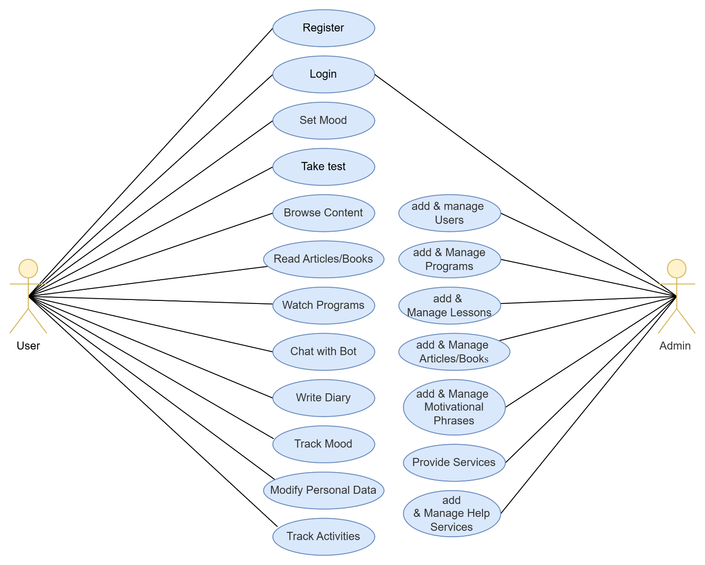
Figure 1: use case Diagram

Overview of Use Cases
User Use Cases
The user interacts with the Depressed_Helping application through the following use cases:
- Log In: The user logs into the system using their credentials, accessing their personalized data and resources.
- Register: If the user does not have an account, they can create one by entering the required details and completing the registration process.
- Set Mood: The user selects their current mood, which is stored in the database for future reference. This allows for mood tracking over time.
- Watch Programs: The user can view helpful programs designed to improve mental well-being.
- Read Articles/Books: The user accesses mental health articles and motivational books available in the system.
- Browse Content: This use case allows the user to browse available programs, articles, books, and exercises.
- Write Diary: The user can maintain a personal diary, writing and saving their thoughts and reflections.
- Chat with Bot: The user can engage with a chatbot for emotional support and general conversations, including requesting help.
- Modify Personal Data: The user has the ability to edit their personal details such as email, password, or other profile information.
- Track Mood: This feature allows users to view their mood trends over time, represented through a graphical interface.
- Track Activities: The user can view their progress in terms of programs completed, lessons taken, and exercises performed.
Use Case Table for User
Use Case ID: 1 | Use Case Name: Register
Actors | User
Description | This use case allows the user to register for the application.
Use case dialog | 1. Download the application.  2. Select the registration button.  3. Enter name, email, and password.  4. Click the register button.
Exceptions | If the user is already registered.
Table 1: User use case 1#
Use Case ID: 2 | Use Case Name: Login
Actors | User
Description | This use case allows the user to log in to the application.
Use case dialog | 1. Open the application.  2. Enter email and password.  3. Click the login button.
Exceptions | If the user enters invalid credentials.
Table 2: User use case 2#
Use Case ID: 3 | Use Case Name: Set Mood
Actors | User
Description | This use case allows the user to select and save their mood for the day.
Use case dialog | 1. Log in to the application.  2. Select mood from the mood options.  3. Save mood entry.
Exceptions | If the system fails to save mood data.
Table 3: User use case 3#
Use Case ID: 4 | Use Case Name: Browse Content
Actors | User
Description | This use case allows the user to browse available content (programs, articles, books).
Use case dialog | 1. Log in to the application.  2. Navigate to content section.  3. Select and browse content.
Exceptions | If the system fails to retrieve content.
Table 4: User use case 4#
Admin Use Cases
The admin interacts with the system in more management-oriented tasks through the following use cases:
- Log In: The admin logs into the system using a special administrative account with higher privileges.
- Manage Users: The admin can manage user accounts, including creating, editing, or deleting accounts, ensuring appropriate user access and security.
- Manage Programs: This use case allows the admin to manage the programs available to users, including adding new programs, updating existing ones, or removing outdated programs.
- Manage Lessons: The admin can manage lessons, ensuring that they are up-to-date and relevant to user needs.
- Manage Articles/Books: The admin manages the collection of articles and books, ensuring that users have access to the latest resources.
- Manage Motivational Phrases: The admin can add, edit, or remove motivational phrases displayed to users, providing daily encouragement and support.
- Provide Services: The admin offers additional services, possibly based on users’ individual conditions, by making personalized content or interventions available.
- Manage Help Services: The admin provides help services based on the needs of users, including adding emergency contact information or real-time help resources.
Use Case Table for Admin
Use Case ID: 6 | Use Case Name: Manage Users
Actors | Admin
Description | This use case allows the admin to manage user accounts (create, edit, delete).
Use case dialog | 1. Log in to the admin dashboard.  2. Navigate to user management.  3. Add, edit, or delete user information.  4. Save changes.
Exceptions | If the system fails to update user data.
Table 5: Admin use case 1#
Use Case ID: 7 | Use Case Name: Manage Programs
Actors | Admin
Description | This use case allows the admin to add, edit, or delete programs.
Use case dialog | 1. Log in to the admin dashboard.  2. Navigate to program management.  3. Add, edit, or delete program details.  4. Save changes.
Exceptions | If the system fails to update the program.
Table 6: Admin use case 2#

Use Case ID: 8 | Use Case Name: Manage Lessons
Actors | Admin
Description | This use case allows the admin to manage lessons within the application.
Use case dialog | 1. Log in to the admin dashboard.  2. Navigate to lesson management.  3. Add, edit, or delete lessons.  4. Save changes.
Exceptions | If the system fails to update lesson details.
Table 7: Admin use case 3#

Sequence Diagram
A sequence diagram visually represents the interactions between different system components for each use case, showing the sequence of events from user action to system response. In the Depressed_Helping application, the following diagrams represent a sequence diagram for the user
and another for the admin:
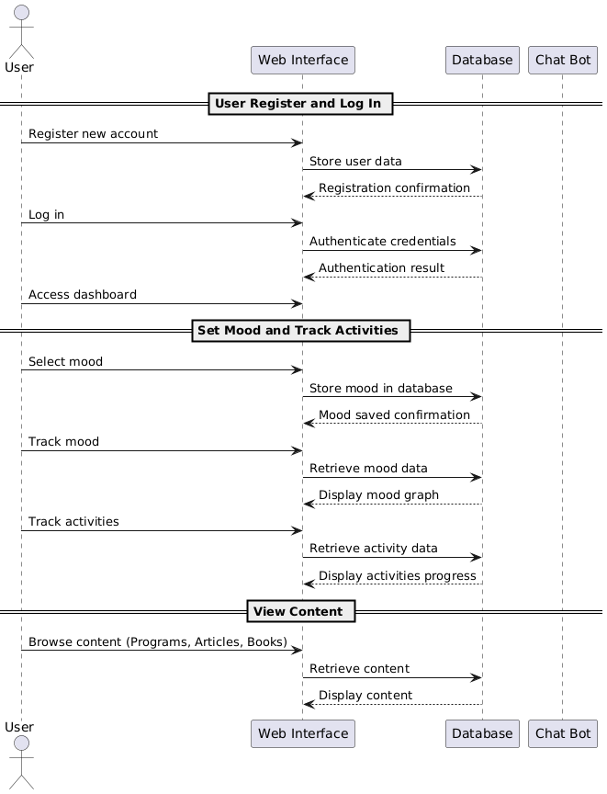
Figure 2: User sequence diagram
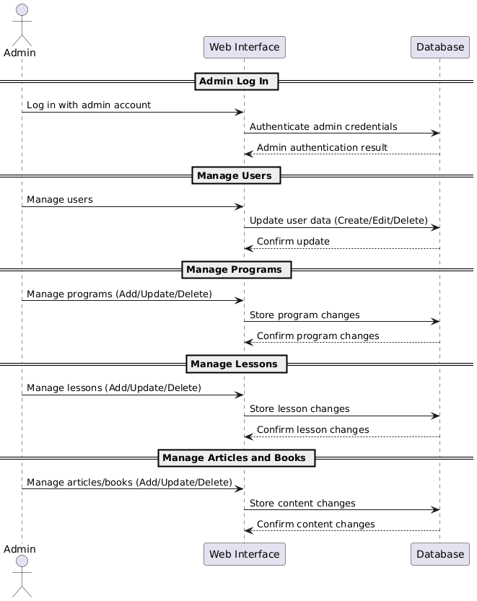
Figure 3: Admin sequence diagram

Data Flow Diagram (DFD)
A Data Flow Diagram (DFD) provides an overview of how information flows within the system. In the Depressed_Helping application, the DFD illustrates how user inputs, such as mood entries or CBT responses, move through the system and interact with the database.
In the Depressed_Helping application, the following data flow diagrams illustrate the login and account creation processes for the user and the admin’s interaction with the system for managing users, content, and services.

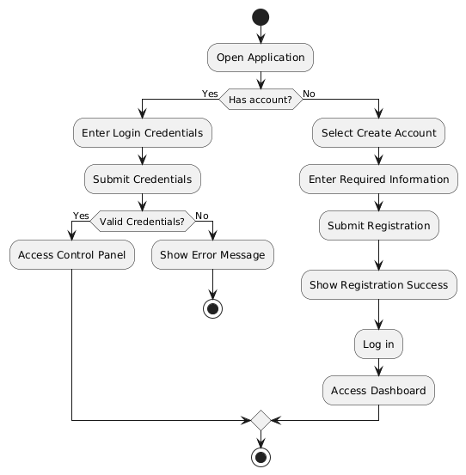
Figure 4: User Activity diagram

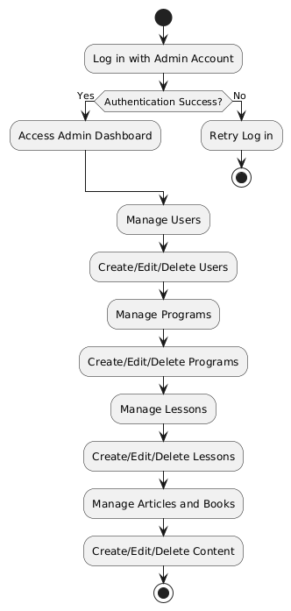
Figure 5: Admin Activity diagram

Class Diagram
The class diagram provides a structural overview of the Depressed_Helping application by defining the classes, their attributes, and the relationships between them.
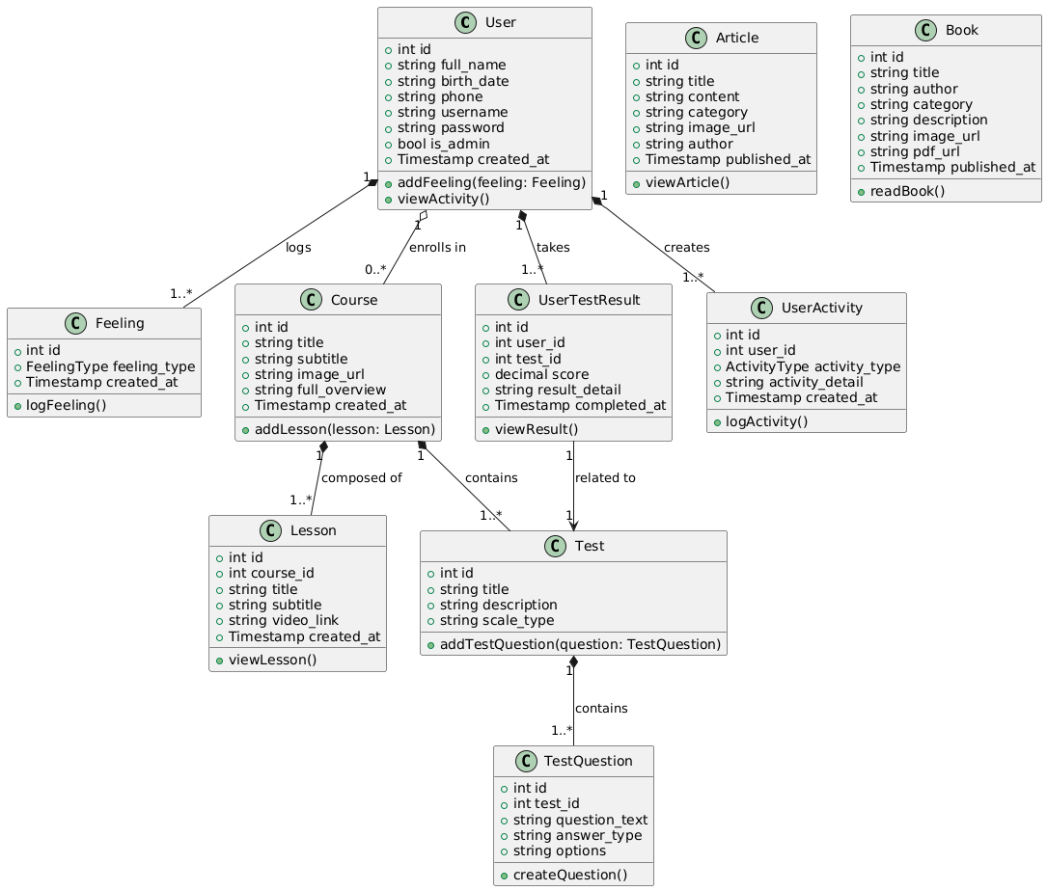
Figure 6: Class Diagram
Key Relationships Added:
- Association:
- User --> Lesson: A user can view lessons.
- User --> Article: A user can read articles.
- User --> Book: A user can read books.
- UserTestResult --> Test: Test results are related to tests taken by users.
- Composition:
- Course *-- Lesson: A course is composed of multiple lessons. If the course is deleted, the lessons related to it should also be deleted.
- Test *-- TestQuestion: A test is composed of multiple questions, representing a strong lifecycle dependency between a test and its questions.
- Aggregation:
- Course o-- User: A user enrolls in multiple courses, but deleting a course does not necessarily delete the user, showing a weak relationship.
- Article o-- User: Articles are written by users (authors), but deleting a user does not delete the article.
- Book o-- User: Books are authored by users, but deleting a user does not delete the book.
- Classes and Relationships:
- User: Can log feelings, create activities, take tests, enroll in courses, view lessons, and read articles and books.
- Feeling: Represents the user's feelings that can be logged and stored in the system.
- Course: A program or course that contains lessons and tests, which users can enroll in.
- Lesson: Represents the educational content in the course that users can view.
- Test: A psychological or personality test that contains multiple questions.
- TestQuestion: Represents individual questions within a test.
- UserTestResult: Stores the results of the tests taken by users.
- Article: Represents written content that users can read.
- Book: Represents books that users can read.
- UserActivity: Logs user actions, such as viewing lessons, completing tests, or interacting with programs.

Entity-Relationship Diagram (ER Diagram)
In the Depressed_Helping application, the ERD diagram shows relationships between multiple entities, such as courses, lessons, users, tests, feelings, books, and articles. Below are the major components and their relationships:
- Courses are linked to multiple Lessons.
- Users can interact with multiple Courses, take Tests, and record Feelings.
- User activity is stored in the user_activity table to track the user’s interaction with courses, lessons, and tests.
- Admins manage the addition of Courses, Lessons, Books, and Articles.
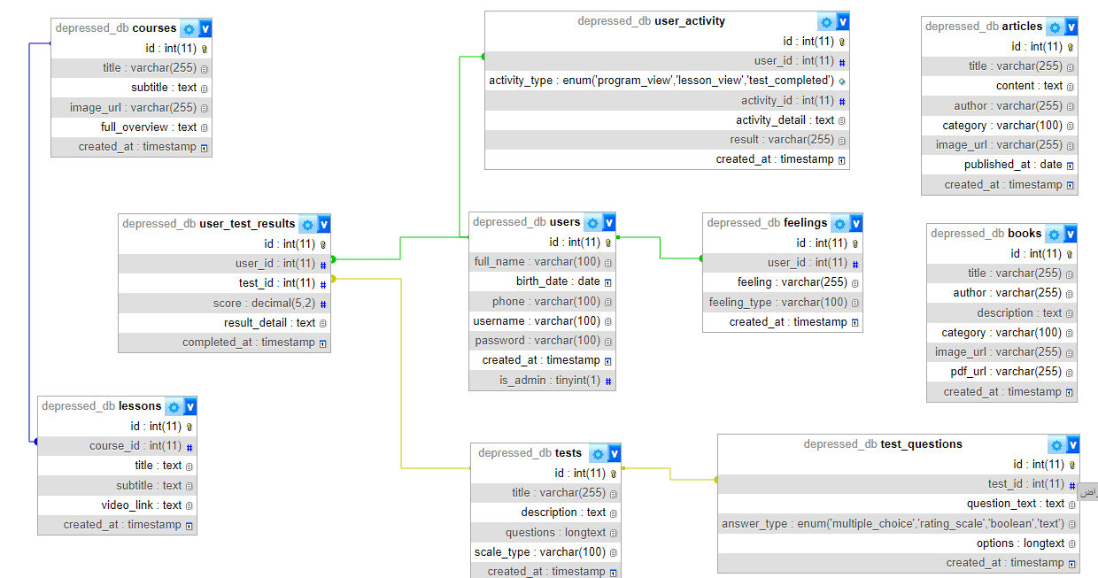
Figure 7: ER Diagram
Here are the explanatory tables for the database tables, each table containing:
- Field Name
- Data Type
- Constraints

Table courses
Field Name | Data Type | Constraints
id | INT(11) | Primary Key, Auto_Increment
title | VARCHAR(255) | Not Null
subtitle | TEXT | Not Null
image_url | VARCHAR(255) | Not Null
full_overview | TEXT | Not Null
created_at | TIMESTAMP | Default Current_Timestamp
Table 8: Courses Table

Table lessons
Field Name | Data Type | Constraints
id | INT(11) | Primary Key, Auto_Increment
course_id | INT(11) | FOREIGN KEY, REFERENCES Courses(Id) ON DELETE CASCADE
title | TEXT | Not Null
subtitle | TEXT | Not Null
video_link | TEXT | Not Null
created_at | TIMESTAMP | Default Current_Timestamp
Table 9: Lessons Table

Table users
Field Name | Data Type | Constraints
id | INT(11) | Primary Key, Auto_Increment
full_name | VARCHAR(100) | Not Null
birth_date | DATE | Not Null
phone | VARCHAR(100) | Not Null
username | VARCHAR(100) | Unique, Not Null
password | VARCHAR(100) | Not Null
created_at | TIMESTAMP | Default Current_Timestamp
is_admin | TINYINT(1) | Default 0
Table 10: Users Table

Table user_activity
Field Name | Data Type | Constraints
id | INT(11) | PRIMARY KEY, AUTO_INCREMENT
user_id | INT(11) | FOREIGN KEY, REFERENCES users(id) ON DELETE CASCADE
activity_type | ENUM('program_view', 'lesson_view', 'test_completed') | NOT NULL
activity_detail | TEXT | NOT NULL
result | VARCHAR(255)
created_at | TIMESTAMP | DEFAULT CURRENT_TIMESTAMP
Table 11: user_activity Table

Table user_test_results
Field Name | Data Type | Constraints
id | INT(11) | Primary Key, Auto_Increment
user_id | INT(11) | Foreign Key, References Users(Id) On Delete Cascade
test_id | INT(11) | Foreign Key, References Tests(Id) On Delete Cascade
score | DECIMAL(5,2) | Not Null
result_detail | TEXT | Not Null
completed_at | TIMESTAMP | Default Current_Timestamp
Table 12: user_test_results Table

Table feelings
Field Name | Data Type | Constraints
id | INT(11) | Primary Key, Auto_Increment
user_id | INT(11) | FOREIGN KEY, REFERENCES Users(Id) ON DELETE CASCADE
feeling | VARCHAR(100) | Not Null
feeling_type | VARCHAR(100) | Not Null
created_at | TIMESTAMP | Default Current_Timestamp
Table 13: Feelings Table

Table articles
Field Name | Data Type | Constraints
id | INT(11) | Primary Key, Auto_Increment
title | VARCHAR(255) | Not Null
content | TEXT | Not Null
author | VARCHAR(255) | Not Null
category | VARCHAR(100) | Not Null
image_url | VARCHAR(255) | Not Null
published_at | DATE | Not Null
Table 14: Articles Table

Table books
Field Name | Data Type | Constraints
id | INT(11) | Primary Key, Auto_Increment
title | VARCHAR(255) | Not Null
author | VARCHAR(255) | Not Null
category | VARCHAR(100) | Not Null
description | TEXT | Not Null
pdf_url | VARCHAR(255) | Not Null
created_at | TIMESTAMP | Default Current_Timestamp
Table 15: Books Table

Table tests
Field Name | Data Type | Constraints
id | INT(11) | Primary Key, Auto_Increment
title | VARCHAR(255) | Not Null
description | TEXT | Not Null
scale_type | VARCHAR(100) | Not Null
created_at | TIMESTAMP | Default Current_Timestamp
Table 16: Tests Table

Table test_questions
Field Name | Data Type | Constraints
id | INT(11) | Primary Key, Auto_Increment
test_id | INT(11) | FOREIGN KEY, REFERENCES Tests(Id) ON DELETE CASCADE
question_text | LONGTEXT | Not Null
answer_type | ENUM('multiple_choice', 'rating_scale', 'boolean', 'text') | Not Null
options | LONGTEXT
created_at | TIMESTAMP | Default Current_Timestamp
Table 17: test_questions Table

Project Scope
The project scope defines the boundaries, deliverables, and objectives of the "Depressed_Helping" application. The application aims to assist users, particularly those suffering from depression, by providing various self-help tools such as psychological tests, courses, articles, books, and a chatbot assistant. The key modules included in the scope are:
- User Management:
  - Users can create accounts, log in, and manage their profiles.
  - Admin users have the ability to manage the content such as courses, lessons, tests, and books.
- Courses and Lessons:
  - Users can browse through various self-help courses.
  - Each course consists of lessons, which may include videos and interactive content.
- Tests and Scales:
  - The system provides users with psychological tests to assess their mental well-being.
  - Test results are stored and can be viewed in the user’s profile.
- Content Management (Articles & Books):
  - The system allows users to browse and read articles and books related to self-help.
  - Admins can add and manage articles and books.
- Feelings Log:
  - Users can log their feelings, which will be stored and analyzed over time.
- Chatbot:
  - A chatbot is integrated into the system to provide interactive support for users.
- User Activity Tracking:
  - The system tracks user activities such as courses followed, tests completed, and feelings logged.

System Architecture

The following are the architecture of the "Depressed Helping" web application, which employs a layered approach to effectively separate the client interface, server logic, external API integration, and data storage. The architecture is designed to optimize performance, scalability, and security while providing a seamless user experience.
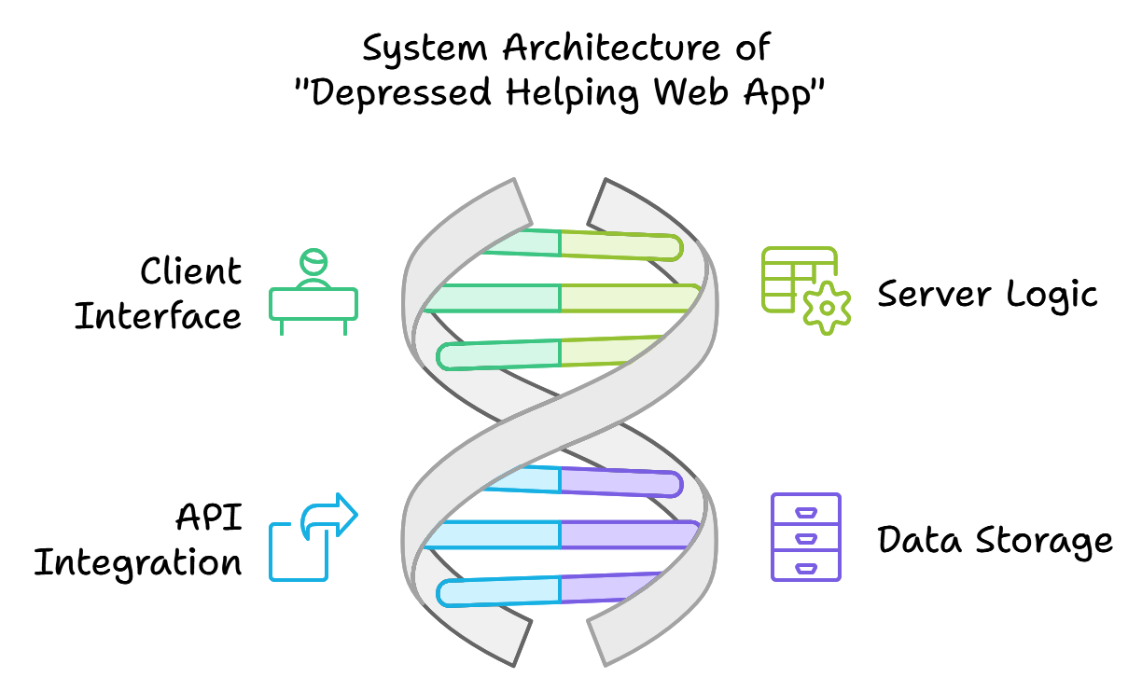
Figure 8: System Architecture

Client Layer
The client layer serves as the entry point for users, who can access the system through a web or mobile interface. This interface is developed using HTML, CSS, Bootstrap, and JavaScript, ensuring a responsive and user-friendly experience. Users can easily navigate through various features, including courses, tests, and chatbot support, making the application accessible and engaging.
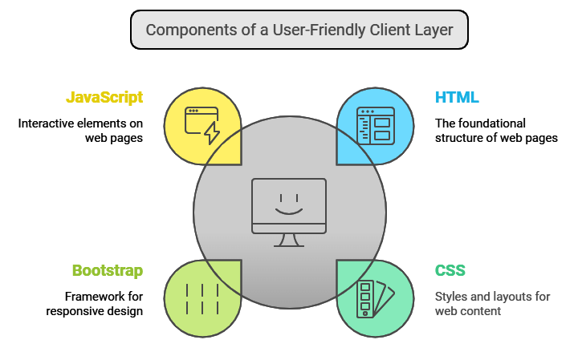
Figure 9: Client Layer

Application Layer (Web Server)
At the heart of the application is the application layer, powered by PHP. This backend layer is responsible for processing user requests and managing business logic. It interfaces with both the database and external APIs, ensuring efficient data handling, user authentication, and dynamic content delivery. The application layer acts as a bridge between the client and the data, facilitating smooth interactions and operations.
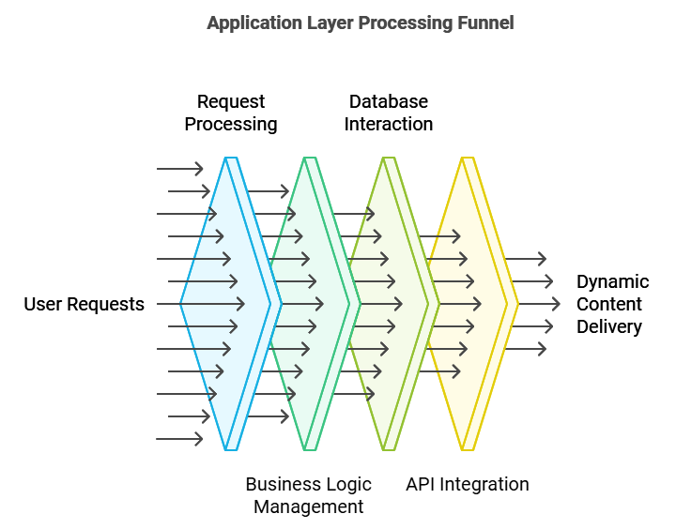
Figure 10: Application Layer

External API Layer
The external API layer integrates with OpenAI’s GPT model, enabling a conversational AI bot that provides support and guidance in Arabic. This layer is crucial for real-time interaction, leveraging artificial intelligence to tailor responses based on user inputs. By utilizing this external service, the application enhances its functionality, offering users personalized assistance and resources.
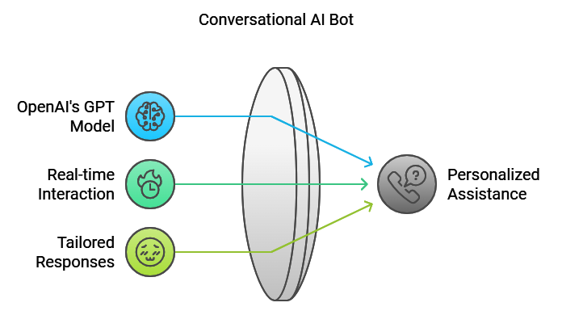
Figure 11: API Layer

Data Layer (Database Server)
The data layer is managed by a MySQL database, which stores all application data, including user profiles, courses, lessons, tests, and activity logs. This layer is responsible for maintaining relational integrity, linking users to their respective activities, test results, and interactions. The structured storage of data ensures that the application can efficiently retrieve and manage information as needed.
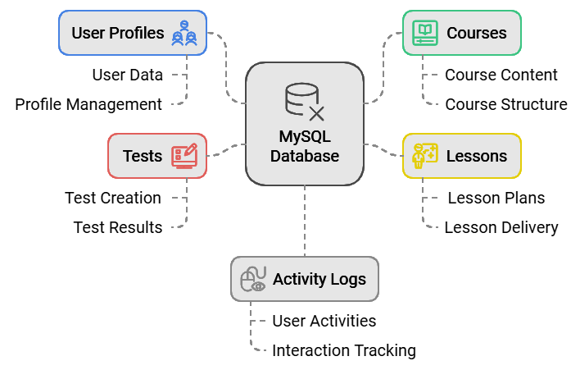
Figure 12: Data Layer

Project Chart
Phase | Task | Start Date | End Date | Duration
Phase 1: Planning & Design | Project Scope Definition | Sept 1, 2024 | Sept 4, 2024 | 4 Days
 | System Architecture Design | Sept 5, 2024 | Sept 9, 2024 | 5 Days
 | ERD and Database Design | Sept 10, 2024 | Sept 14, 2024 | 5 Days
 | Sequence & Class Diagram Creation | Sept 15, 2024 | Sept 20, 2024 | 6 Days
 | Finalize Design Documentation | Sept 21, 2024 | Sept 22, 2024 | 2 Days
 | Planning & Design Review | Sept 23, 2024 | Sept 23, 2024 | 1 Day
Phase 2: Development | Frontend Development | Sept 24, 2024 | Oct 5, 2024 | 12 Days
 | Backend Development | Oct 6, 2024 | Oct 20, 2024 | 15 Days
 | Database Integration | Oct 21, 2024 | Oct 25, 2024 | 5 Days
 | API Integration (OpenAI) | Oct 26, 2024 | Oct 30, 2024 | 5 Days
 | Development Review | Oct 31, 2024 | Oct 31, 2024 | 1 Day
Phase 3: Testing & QA | Functional Testing | Nov 1, 2024 | Nov 7, 2024 | 7 Days
 | Security & Performance Testing | Nov 8, 2024 | Nov 13, 2024 | 6 Days
 | Fix & Debug Issues | Nov 14, 2024 | Nov 20, 2024 | 7 Days
 | Final Testing & QA Review | Nov 21, 2024 | Nov 21, 2024 | 1 Day
Phase 4: Deployment & Support | Deployment Preparation | Nov 22, 2024 | Nov 23, 2024 | 2 Days
 | Application Deployment | Nov 24, 2024 | Nov 24, 2024 | 1 Day
 | User Onboarding & Training | Nov 25, 2024 | Nov 26, 2024 | 2 Days
 | Ongoing Support | Nov 27, 2024 | Dec 31, 2024 | 1 Month
Table 18: Project Time Table
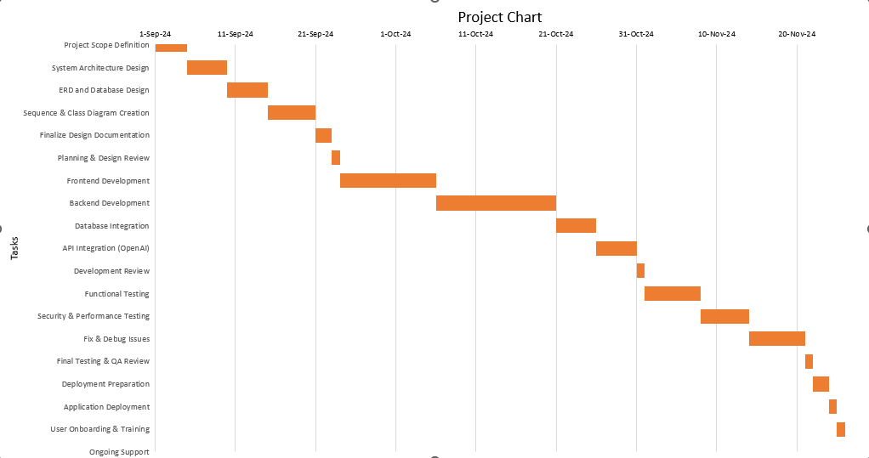
Figure 13: Project Chart

Methodology Used
Waterfall Model Explanation for Project Development
The Waterfall Model is a structured, sequential approach to project development, where each phase flows into the next. Here’s a breakdown of each step in the Waterfall methodology as it applies to the "Depressed Helping" project:
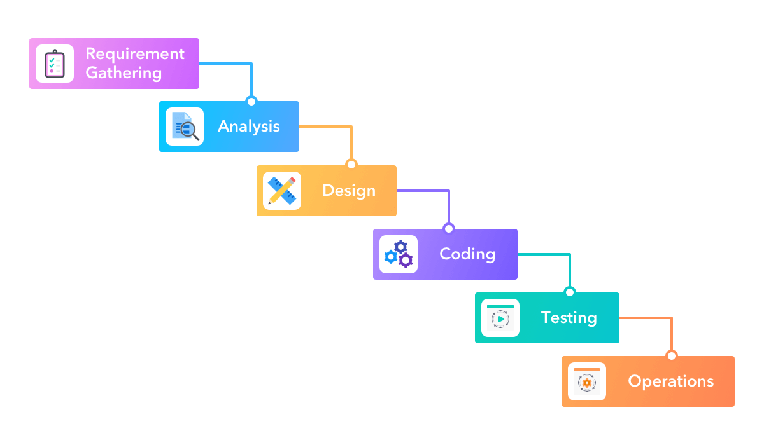
Figure 14: waterfall methodology

- Requirement Gathering:
This initial phase involves collecting all the requirements from stakeholders, including end-users and project sponsors. For the "Depressed Helping" application, this phase focused on identifying user needs, such as mood tracking, access to self-help resources, and personalized advice through a chatbot. [29].
- Analysis:
In this phase, the gathered requirements are analyzed to create a clear, structured plan. The analysis for "Depressed Helping" involved understanding the data flow, defining system architecture, and planning the user interface. This step ensured that the application’s functionalities were aligned with user needs. [29].
- Design:
During the design phase, the project architecture is laid out based on the analysis. For "Depressed Helping," this involved creating database schemas, defining class structures, and designing UI/UX elements. The design also included detailed diagrams and models that guided the implementation process. [29].

- Coding:
With the design blueprint in place, developers proceed with coding. This phase involves implementing each feature as defined in the design phase, such as creating a chatbot for real-time interaction, mood tracking functionalities, and managing user data securely. [29].
- Testing:
After coding, the system undergoes rigorous testing. This includes functional testing to ensure each feature works as intended, as well as performance testing and user acceptance testing. Testing is critical for identifying bugs, fixing them, and ensuring a smooth user experience in "Depressed Helping." [29].
- Operations:
Once testing is complete and the application is stable, it moves into the deployment and operational phase. "Depressed Helping" is deployed to production, where users can start using it. Post-deployment, maintenance activities are carried out to fix any arising issues and to provide updates.

Literature Review
In recent years, digital health applications have increasingly targeted mental health, providing accessible support for people experiencing conditions such as depression and anxiety. Several notable applications share similarities with the goals of the Depressed Helping project, offering useful insights into both effective practices and potential limitations.

Woebot
Woebot is an AI-driven mental health application that utilizes Cognitive Behavioral Therapy (CBT) principles to help users manage stress, anxiety, and depressive symptoms. The app interacts with users through a conversational interface, mimicking the experience of chatting with a mental health coach. Woebot’s primary objective is to offer users CBT-based strategies to manage negative thoughts and feelings, ultimately helping them improve their mental well-being [30].

Figure 15: Woebot App
Advantages:
- Evidence-Based Therapy: Woebot is grounded in CBT, a proven therapeutic approach for treating depression and anxiety.
- User Engagement: The conversational interface makes users feel engaged and supported through regular check-ins and progress tracking.
- Accessibility: Available 24/7, allowing users to seek guidance whenever they need it.
Limitations:
- Limited Depth of Interaction: As an AI bot, Woebot lacks the empathy and deeper understanding that a human therapist could provide, which can limit its effectiveness for users with severe or complex mental health issues.
- Scope of Therapy: Woebot is designed primarily for individuals with mild to moderate symptoms, making it less suitable for those needing comprehensive or specialized mental health care [30].

Wysa
Wysa is another AI-powered mental health application that aims to support users in managing stress, anxiety, and depression through CBT, mindfulness, and mood tracking tools. Wysa’s unique feature is its combination of AI-guided conversations with the option of accessing human support for users who need deeper assistance [31].

Figure 16: Wysa App
Advantages:
- Multiple Therapeutic Approaches: Wysa provides users with a wide range of therapeutic tools, including CBT exercises, breathing techniques, and mindfulness practices.
- Anonymity and Accessibility: The app enables users to interact with the AI anonymously, which can help reduce the stigma often associated with seeking mental health support.
- Flexible Support Options: Users can choose to interact with the AI or upgrade to receive guidance from a human therapist, offering flexibility in their level of support.
Limitations:
- AI Limitations in Understanding Emotions: Although Wysa’s AI is effective in many scenarios, it can struggle with understanding nuanced emotional expressions, reducing its effectiveness in certain cases.
- Cost of Human Support: Accessing a human therapist requires a subscription, which can be a barrier for some users who need but cannot afford personalized support [31].

Headspace
Headspace is a widely recognized mindfulness and meditation app designed to improve mental well-being through guided meditation sessions. While not a mental health app in the traditional sense, Headspace offers resources that are beneficial for managing stress, anxiety, and general mood, supporting users' mental health in a preventative and proactive manner [32].

Figure 17: Headspace App
Advantages:
- High-Quality Meditation Content: Headspace offers professionally developed, high-quality meditation and mindfulness content.
- Positive Habit Formation: Its well-structured approach encourages users to build consistent mindfulness habits, which can lead to lasting improvements in mental health.
- User-Friendly Interface: The app’s visually appealing, intuitive interface makes it accessible and easy for users to navigate.
Limitations:
- Generalized Focus: Headspace does not specifically target depression or severe mental health issues, which can limit its effectiveness for individuals who require focused mental health support.
- No Real-Time Feedback: Headspace lacks real-time interaction, so it does not offer the personalized feedback that other mental health applications provide [32].

Hakini
Hakini is an Arabic-language mental health app that provides culturally relevant support, making it particularly valuable for users in the Middle East and North Africa (MENA) region. The app offers various tools and content focused on emotional regulation, stress management, and personal development, aiming to reduce the stigma around mental health and promote emotional well-being [33].

Figure 18: Hakini App
Advantages:
- Culturally Relevant Content: Hakini tailors its content to the cultural context of its users, which can improve engagement and relatability for individuals in Arabic-speaking regions.
- Comprehensive Self-Help Tools: The app includes resources for emotional regulation, stress management, and self-improvement, providing users with a holistic approach to mental wellness.
Limitations:
- Limited Availability of Specialized Support: While Hakini offers self-help tools, it lacks direct access to professional therapists, which may reduce its effectiveness for users with severe mental health needs.
- Focus on Self-Guided Support: The app is primarily designed for self-help, so it may not be suitable for users seeking structured therapy or professional intervention [33].
Summary
The applications reviewed—Woebot, Wysa, Headspace, and Hakini—illustrate a range of approaches in providing mental health support. They offer useful features, such as CBT-based tools, mindfulness practices, and culturally tailored content, but also exhibit limitations, particularly in terms of depth of interaction and accessibility to professional care. These insights contribute valuable direction for the development of Depressed Helping, which aims to incorporate the strengths of these applications, such as personalized AI interaction and culturally sensitive support, while also addressing their limitations by providing a more comprehensive set of mental health resources.

Chapter 3: System Design

Introduction to the System Design
The design phase for “Depressed Helping” focuses on crafting a user-friendly web application that integrates effective mental health support features with robust and secure backend processes. This chapter outlines the overall design strategy, reviews the development programs and tools selected for the project, and presents an initial set of user interfaces along with a description of their roles and services. The design adheres to modern web development practices, ensuring accessibility, scalability, and ease of use for both end users and administrative personnel.

Website Design Overview
The website design is built around a layered architecture that separates client-side presentation, business logic, external integrations, and data management. The key components include:
- Client Layer: The front-end presentation developed using HTML, CSS, JavaScript, and the Bootstrap framework. This layer is responsible for delivering a responsive, accessible, and aesthetically appealing user experience.
- Application Layer (Server-Side): Powered by PHP, this layer handles business logic, user authentication, session management, and data processing.
- Data Layer: Managed through MySQL, this layer ensures secure storage, efficient retrieval, and integrity of all sensitive mental health data.

Programs and Tools Used
The development of “Depressed Helping” leverages several industry-standard programs and tools that aid in rapid development, maintenance, and deployment:
- HTML & CSS: These core technologies construct the structural framework and styling of the website.
- Bootstrap: This front-end framework provides pre-built responsive design components, ensuring the website is mobile-friendly and visually consistent across devices.
- JavaScript: Enhances interactivity and client-side dynamics, providing a seamless user experience.
- PHP: Serve as the backbone of the application, handling server-side operations, secure authentication, routing, and database interactions.
- MySQL: Manages relational data, offering robust performance and data security.
- Visual Studio Code: Used as the primary integrated development environment (IDE) to streamline coding with various extensions and debugging tools.
- Version Control (e.g., Git): Facilitates efficient collaboration among developers while tracking changes throughout the project lifecycle.
Table 19: Programs and Tools Used
Technology | Role/Function | Description and Benefits
HTML | Markup Language | Constructs the structural framework of the web pages, ensuring that content is organized and accessible.
CSS | Styling Language | Provides visual styling and layout control to enhance user interface aesthetics and usability.
Bootstrap | Front-End Framework | Offers pre-built responsive design components, ensuring the website is mobile-friendly and maintains a consistent look across different devices and screen sizes.
JavaScript | Client-Side Scripting | Enables interactive and dynamic behaviors on the client side, enhancing user engagement and improving the overall user experience.
PHP | Server-Side Scripting Language | Facilitates server-side operations such as user authentication, data processing, and handling business logic securely and efficiently.
MySQL | Relational Database Management System (RDBMS) | Manages the storage, retrieval, and integrity of application data, ensuring robust performance, scalability, and secure management of sensitive mental health data.
Visual Studio Code | Integrated Development Environment (IDE) | Provides a versatile and extensible environment for writing, debugging, and managing code, with access to numerous extensions that facilitate development and collaboration.
Git | Version Control System | Tracks changes and supports collaboration among developers, ensuring efficient project management, code versioning, and a clear history of the project's evolution.

Interface Designs and Their Services
This section provides a visual and functional overview of the primary user interfaces developed for the Depressed Helping platform. Each interface was carefully crafted to deliver intuitive access to mental health tools in a responsive and aesthetically consistent design. The following descriptions are based on the actual interface screenshots included in this chapter.

Login Interface
Purpose:
Grants registered users secure access to the system.
Interface Features:
- Two input fields for email and password.
- A styled “Login” button.
- Minimalist design with emphasis on simplicity and clarity.
- Brand identity visible through consistent color and layout elements.
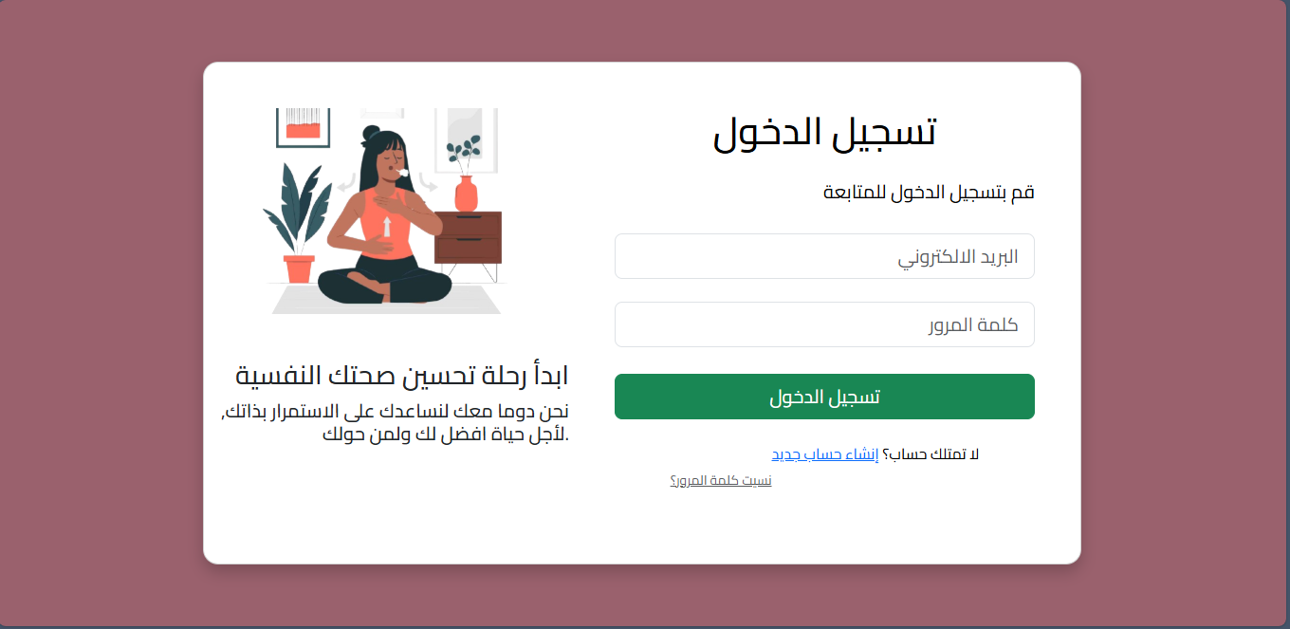
Figure 19: Login page

Registration Interface
Purpose:
Allows new users to create an account and join the platform.
Interface Features:
- Input fields for full name, email, and password.
- Registration button with form validation.
- Clean and spacious layout designed for ease of use.
- Error handling for incorrect or duplicate data.
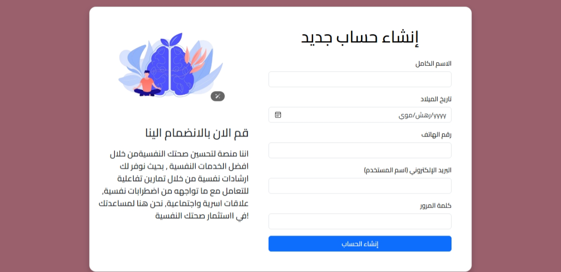
Figure 20:Registration Interface

User Dashboard (Main Panel)
Purpose:
Serves as the central hub for accessing the platform’s features.
Interface Features:
- Side navigation bar with links to core modules (e.g., home, profile, mood tracking, chatbot, articles).
- Motivational quote prominently displayed.
- Compact summary cards showing emotional statistics or activity logs.
- Integrated welcome message and user identity display.
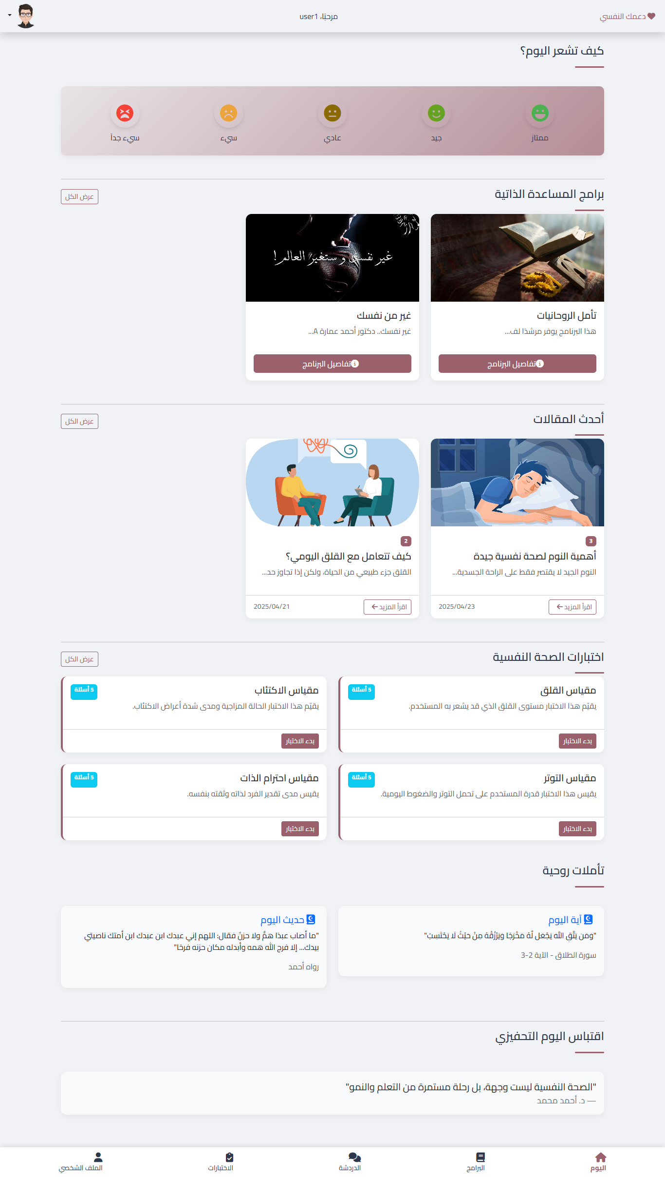
Figure 21:User Dashboard (Main Panel)

Articles Interface
Purpose:
Provides access to mental health articles for education and awareness.
Interface Features:
- Grid layout displaying article thumbnails with titles and categories.
- Option to view article content in full.
- Filtering or categorization by topic is implied in the layout structure.
- Professionally styled cards for each article.
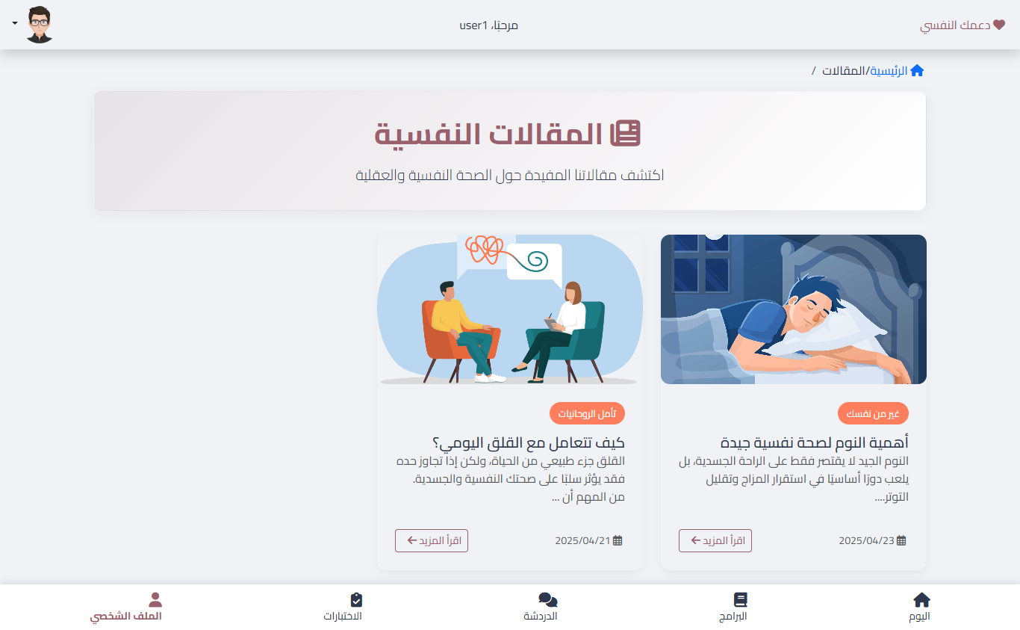
Figure 22: All Articles interface
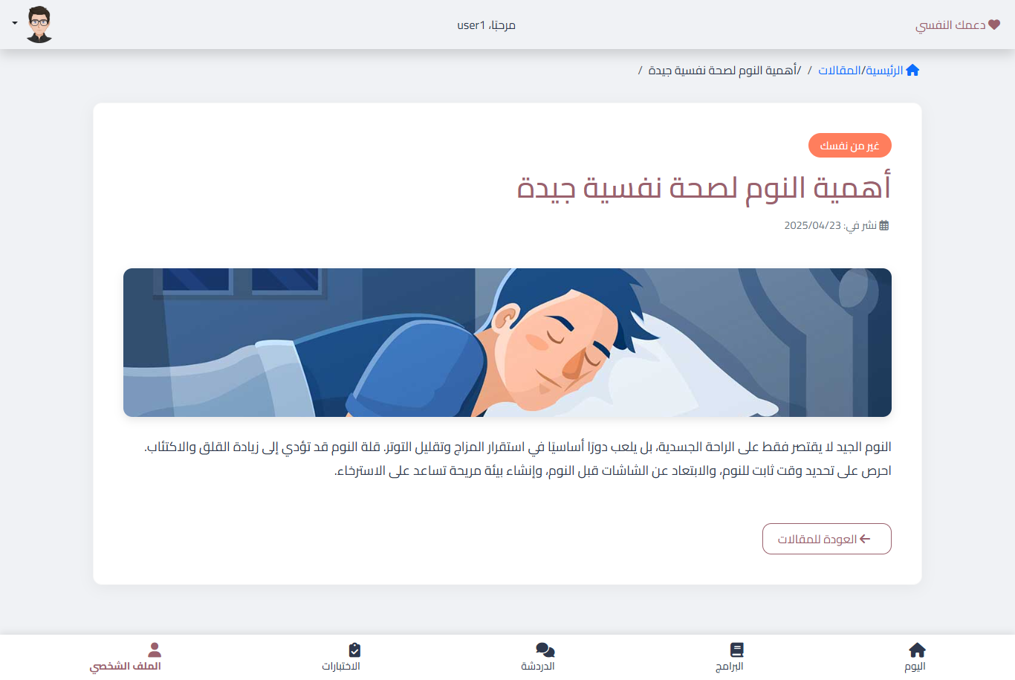
Figure 23: View article content

Psychological and Self-Help Programs Interface
Purpose:
The Psychological and Self-Help Programs interface provides users with access to structured mental wellness programs aimed at improving emotional health and managing symptoms of depression.
Interface Features:
- Program Cards: Each program is displayed as an individual card containing a title, image, and brief description, designed for quick browsing and clear identification.
- View Button: Users can click a dedicated button to access more detailed content within each program.
- Organized Layout: The interface employs a grid format, making it easy to compare and choose between available programs.
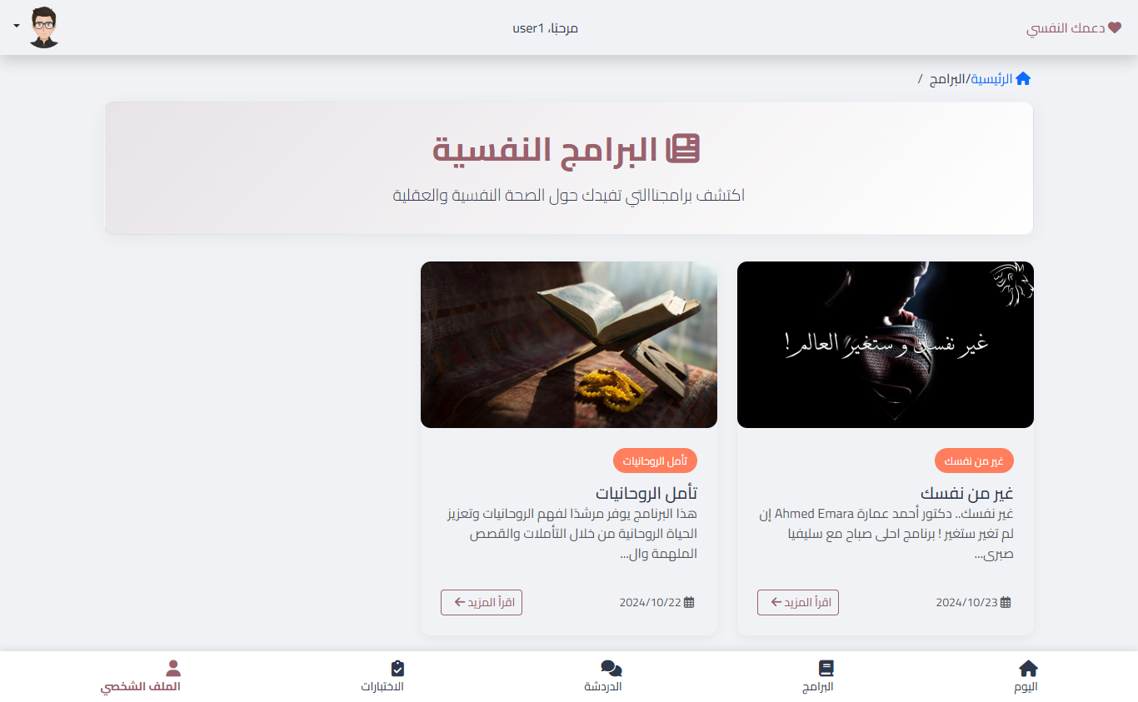
Figure 24:All Self-Help Programs Interface
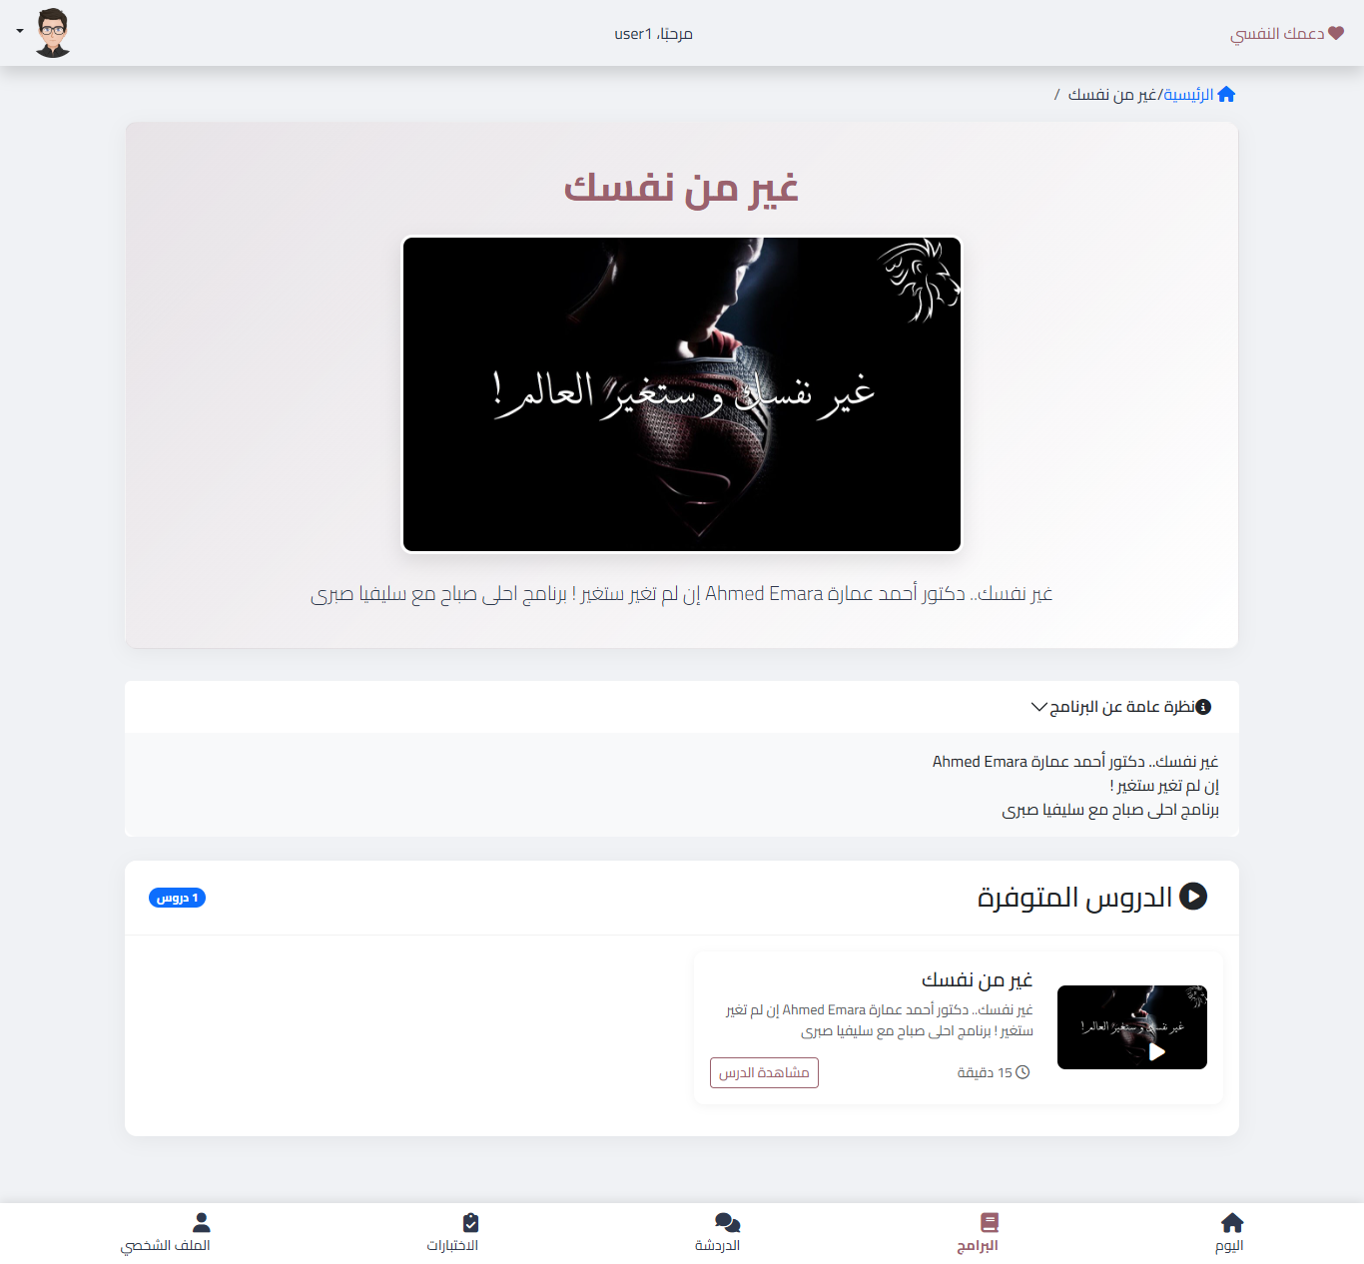
Figure 25:View Self-Help Programs Interface

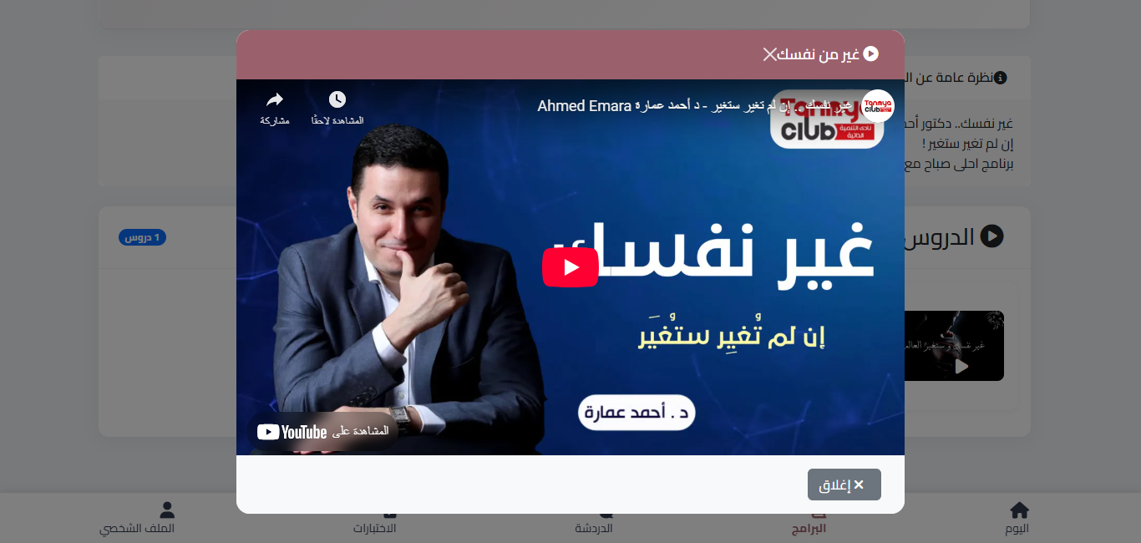
Figure 26: Open Self-Help Program Interface

Chatbot Interface
Purpose:
Offers conversational support through an AI-powered assistant.
Interface Features:
- Text input field with a live chat display.
- Bot responses appear dynamically in sequence with user input.
- Interaction panel styled with message bubbles.
- Supports basic conversational support, including motivational suggestions and navigation help.
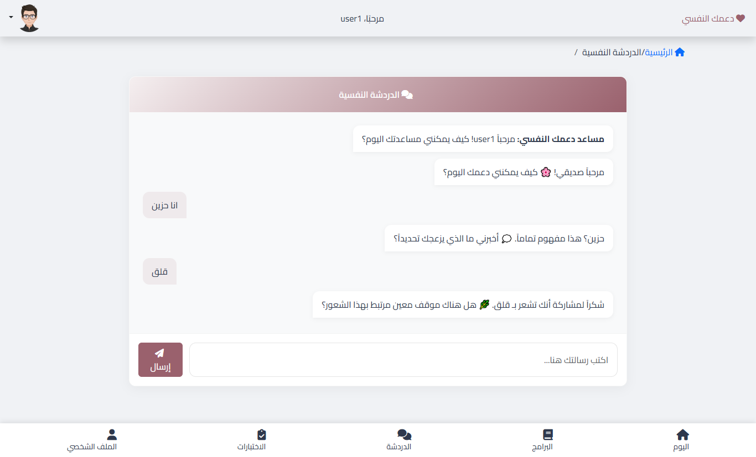
Figure 27: Chatbot Interface

Tests Interface
Purpose:
Allows users to take self-assessment mental health tests.
Interface Features:
- List of available tests with buttons to start.
- Question and answer interface styled for clarity.
- Score or result presented upon completion.
- Backend logging to store results per user session.
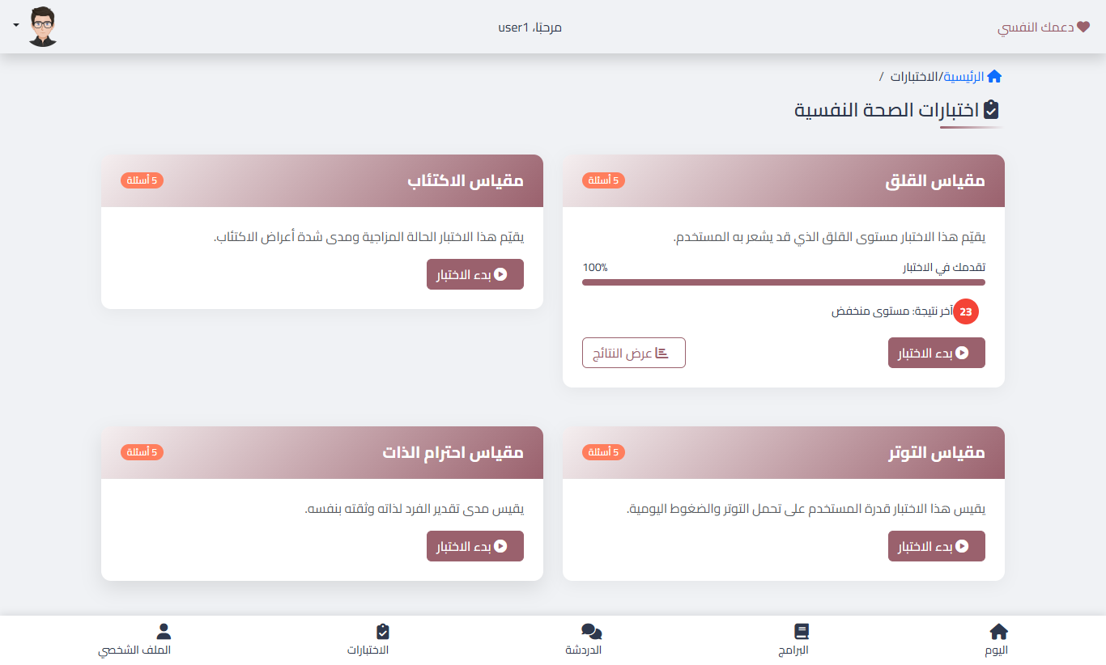
Figure 28: All Tests Interface

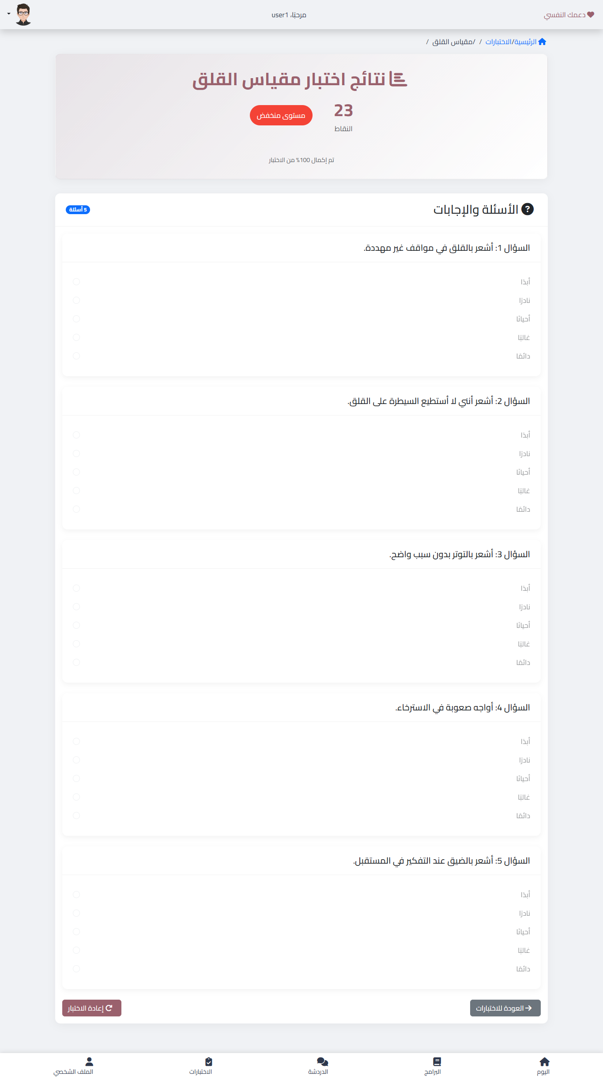
Figure 29: Take Test and View Results

User Profile Page
Purpose:
Enables users to manage their personal information and view their activity history.
Interface Features:
- Fields to display and update personal data (e.g., full name, email, phone number).
- Option to change password securely.
- Overview of user-specific statistics, such as mood logs or completed tests.
- Clean layout with editable fields and action buttons.
User Goals:
- Maintain up-to-date profile information.
- Gain insights into personal progress through system usage history.
- Ensure personalized and secure user experience.
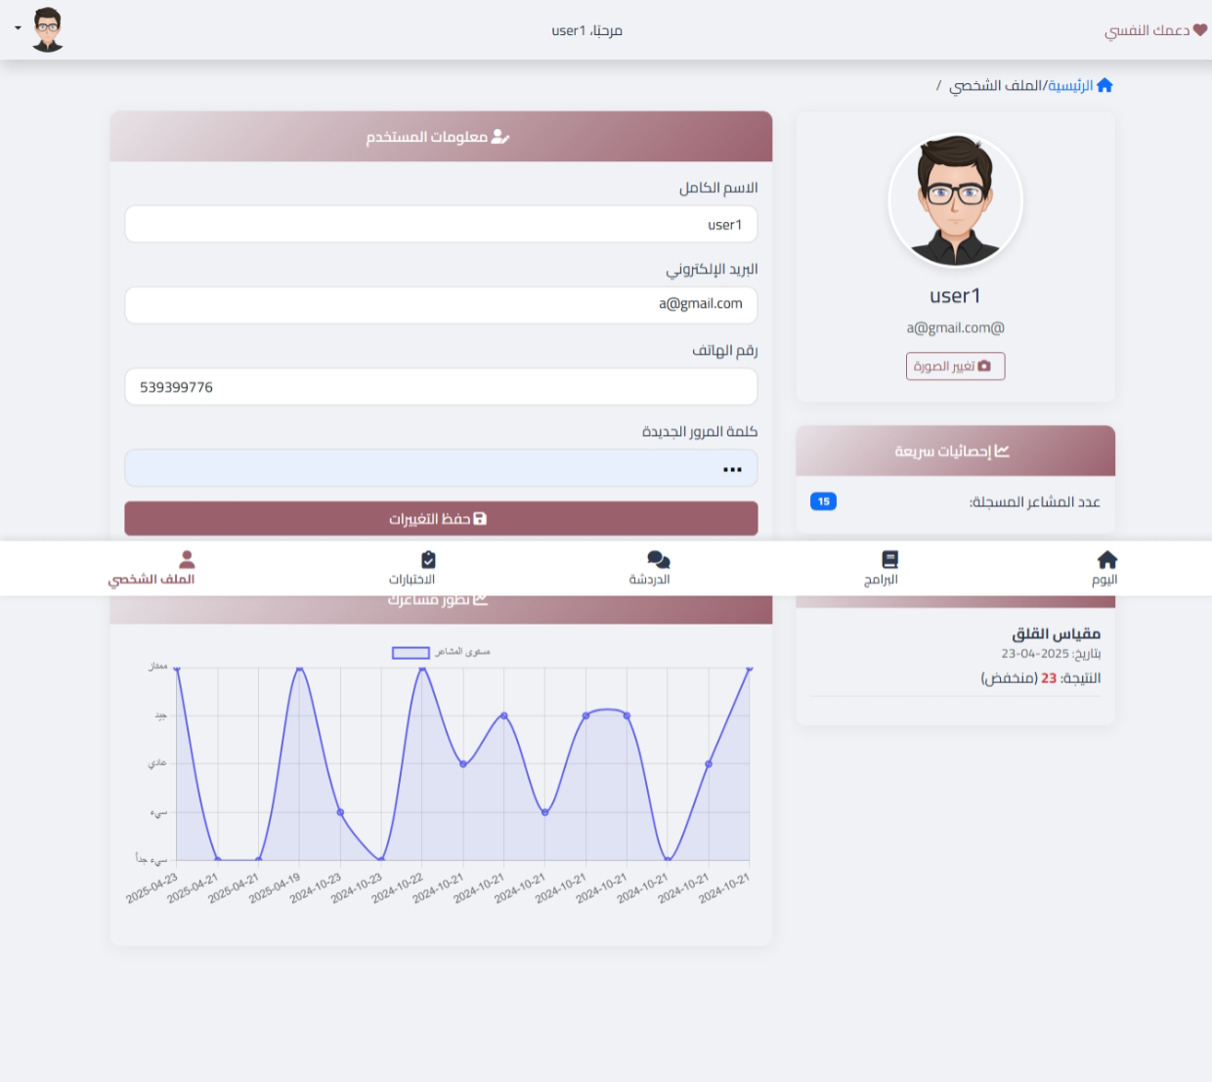
Figure 30: User Profile Page

Admin Dashboard Interface
Purpose:
Used by administrators to manage system content and users.
Interface Features:
- Structured navigation for managing articles, users, and tests.
- Tabular data presentation for user records.
- Buttons to edit or delete content.
- Search or filtering options for efficient content management.
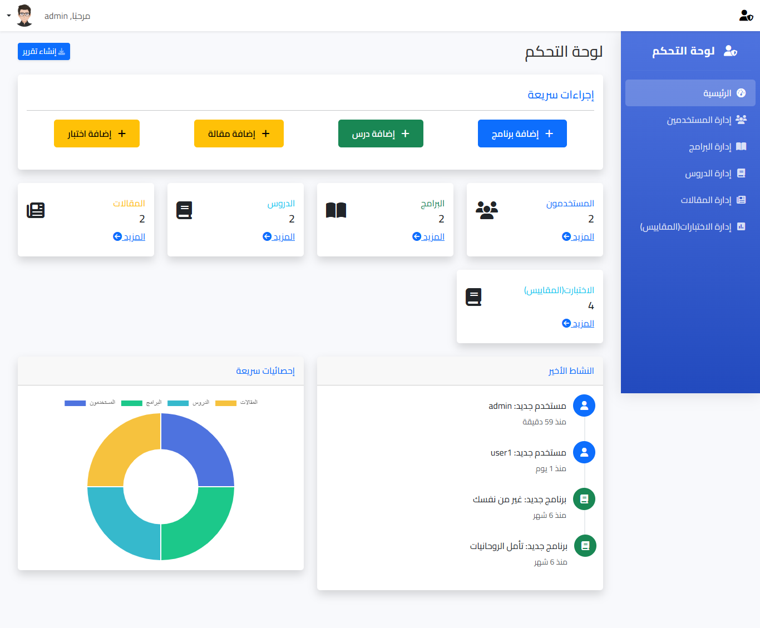
Figure 31: Admin Dashboard Interface

User Management Page (Administrator)
Purpose:
Allows administrators to manage user accounts on the platform.
Interface Features:
- Tabular view of registered users with pagination.
- Functional buttons for adding, editing, and deleting users.
- Admin access to user roles (e.g., standard user or administrator).
- Built-in search or filter function for quick navigation.
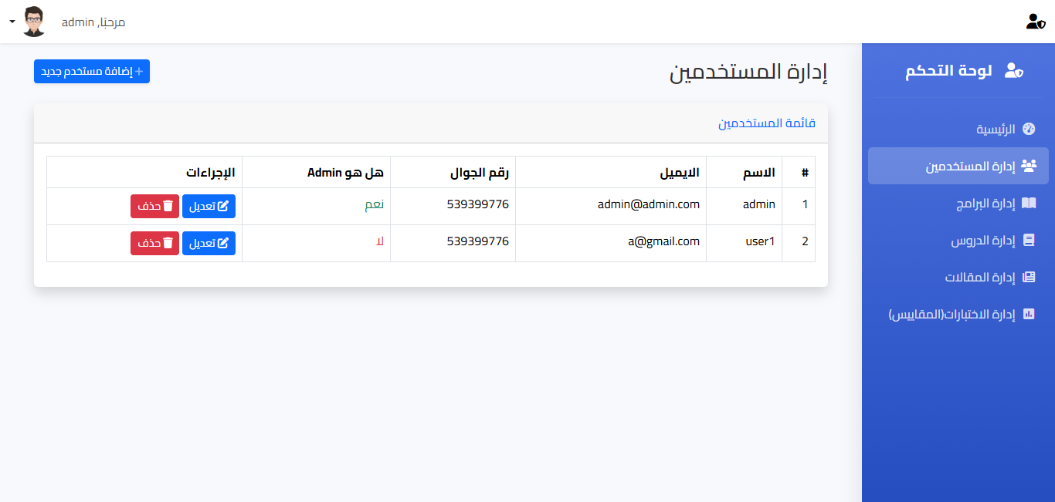

Program Management Page (Administrator)
Purpose:
Provides administrative control over psychological and self-help programs.
Interface Features:
- List of all available programs with options to add, edit, or delete entries.
- Upload form for program titles, subtitles, descriptions, and thumbnails.
- Edit existing programs to update content dynamically.
- Confirmation prompts for deletions to prevent accidental data loss.
Admin Goals:
- Keep content updated and relevant.
- Add new mental wellness programs as needed.
- Improve program quality based on feedback or new research.
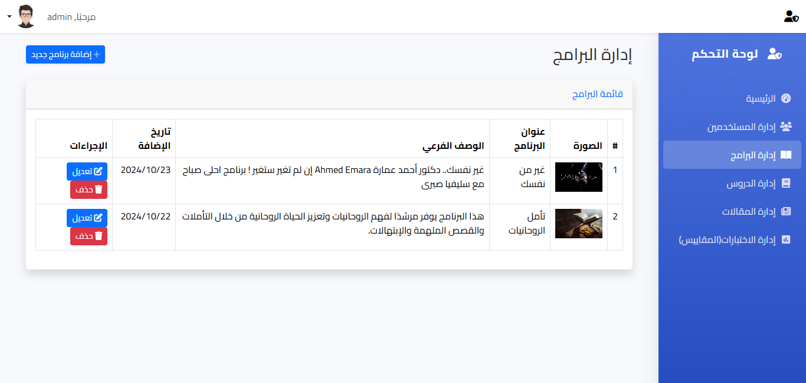

Lessons and Article Management Page (Administrator)
Purpose:
Allows administrators to curate and manage lessons and articles displayed to users.
Interface Features:
- Display of current lessons and articles with metadata.
- Buttons to add, edit, or remove articles and lessons.
- Preview or edit functionality before publishing.
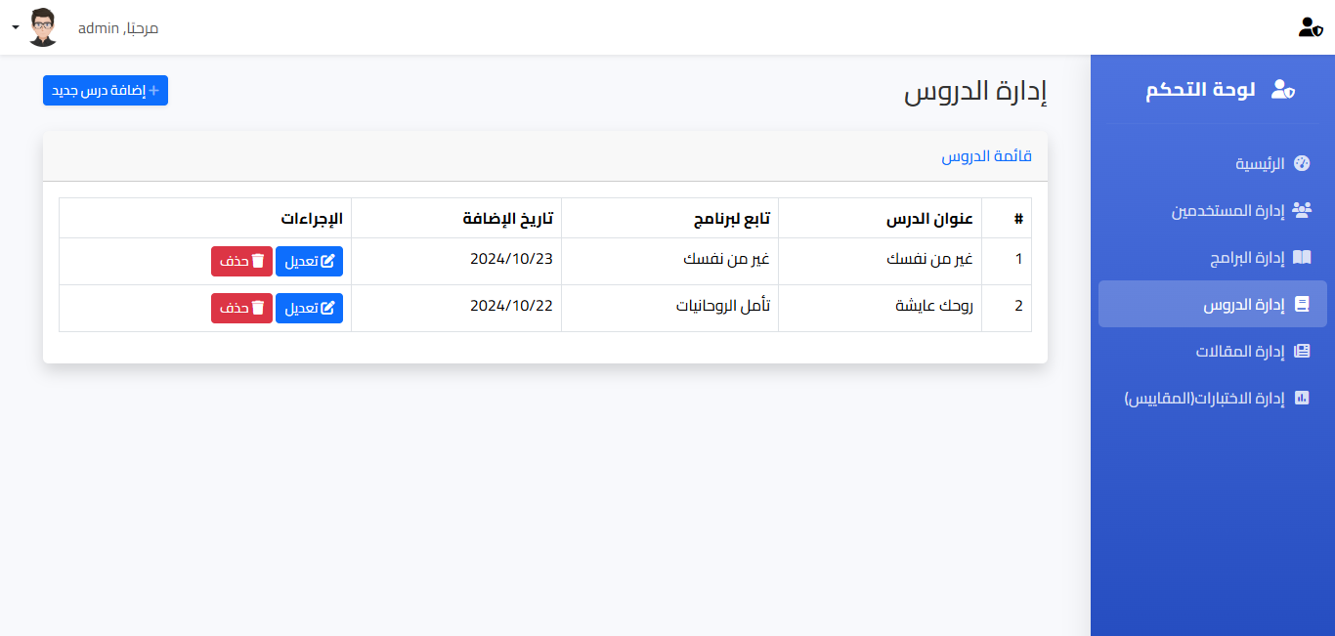
Figure 32: Lessons Management Page

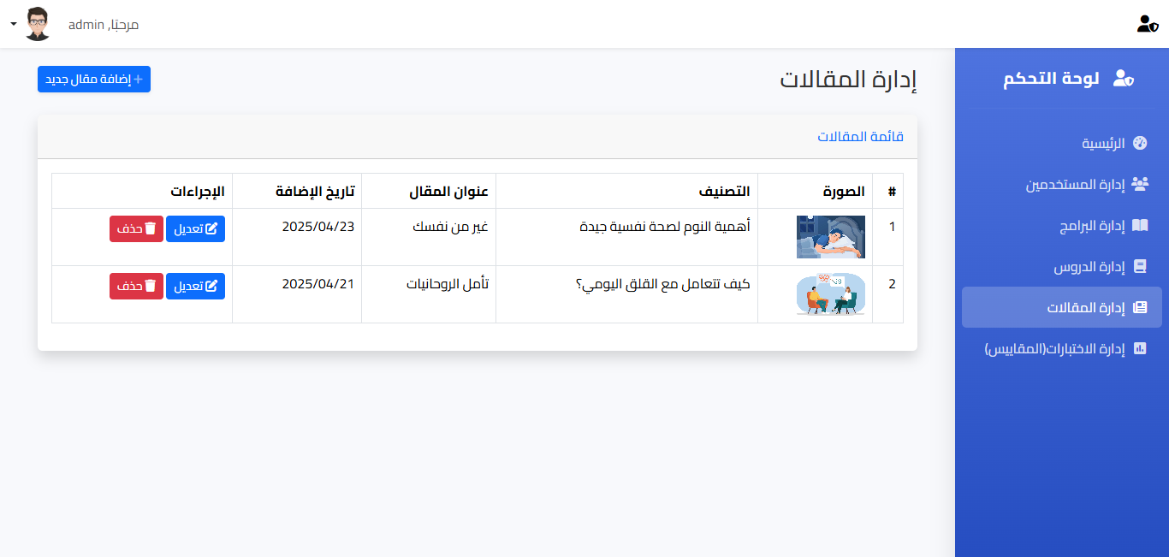
Figure 33:Article Management Page

Test Management Page (Administrator)
Purpose:
Provides full control over psychological test content and structure.
Interface Features:
- List of tests with options to view associated questions.
- Ability to create, edit, and delete tests and their corresponding questions.
- Support for various question types: multiple-choice, rating scale, or open-ended.
- Interface for entering scores and assigning interpretation ranges.
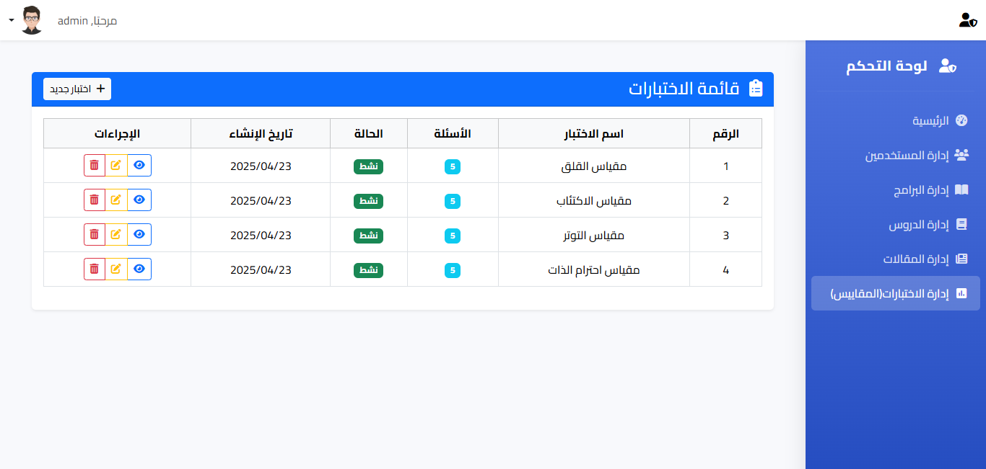
Figure 34: Test Management Page
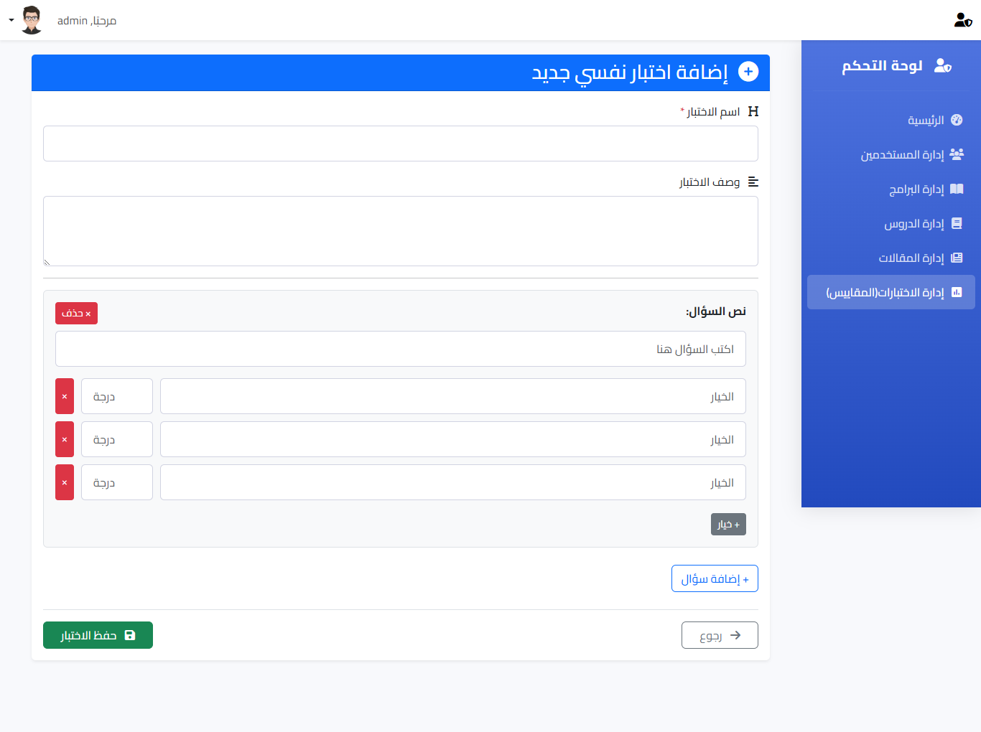
Figure 35: Add New tests

Conclusion
Chapter 3 outlines the design considerations, technologies, and key interfaces that underpin the “Depressed Helping” web application. By combining a robust back-end powered by PHP, Laravel, and MySQL with an engaging front-end developed using HTML, CSS, Bootstrap, and JavaScript, the system is engineered to deliver a secure and supportive digital mental health experience. Each interface is designed with user needs in mind—ranging from secure account management to interactive CBT sessions—ensuring that the application remains both effective and accessible.
This foundational design sets the stage for further development and iterative refinement, ensuring that all components integrate seamlessly to offer a comprehensive mental health support solution.

Chapter 4: Implementation

Implementation
This chapter includes the source code corresponding to each core interface of the "Depressed Helping" application. Each code block represents the structure and functionality of a specific page as implemented using HTML, CSS, PHP, and JavaScript.

Login Page

<?php
session_start();
include('connect/db_connect.php');
$error_message = '';
if ($_SERVER['REQUEST_METHOD'] == 'POST') {
$email = $_POST['email'];
$password = $_POST['password'];
if (!empty($email) && !empty($password)) {
// Fetch the user based on the username
$query = "SELECT * FROM users WHERE username = ?";
$stmt = $conn->prepare($query);
$stmt->bind_param('s', $email);
$stmt->execute();
$result = $stmt->get_result();
if ($result->num_rows === 1) {
$user = $result->fetch_assoc();
// Check if the password matches
if ($password == $user['password']) {
$_SESSION['userid'] = $user['id'];
$_SESSION['username'] = $user['username'];
$_SESSION['full_name'] = $user['full_name'];
$_SESSION['is_admin'] = $user['is_admin'];
// Redirect based on the user type
if ($user['is_admin']) {
header('Location: admin/admin_dashboard.php'); // Redirect to admin panel if admin
} else {
header('Location: home.php'); // Redirect to home page if regular user
}
exit;
} else {
$error_message = 'كلمة المرور غير صحيحة';
}
} else {
$error_message = 'المستخدم غير موجود';
}
} else {
$error_message = 'يرجى إدخال البريد الإلكتروني وكلمة المرور';
}
}
?>
<!DOCTYPE html>
<html lang="ar">
<head>
<meta charset="UTF-8">
<meta name="viewport" content="width=device-width, initial-scale=1.0">
<title>Login</title>
<link rel="stylesheet" href="css/style.css">
<link href="https://cdn.jsdelivr.net/npm/bootstrap@5.3.3/dist/css/bootstrap.min.css" rel="stylesheet"
integrity="sha384-QWTKZyjpPEjISv5WaRU9OFeRpok6YctnYmDr5pNlyT2bRjXh0JMhjY6hW+ALEwIH" crossorigin="anonymous">
<link rel="stylesheet" href="https://cdnjs.cloudflare.com/ajax/libs/font-awesome/6.6.0/css/all.min.css"
integrity="sha512-Kc323vGBEqzTmouAECnVceyQqyqdsSiqLQISBL29aUW4U/M7pSPA/gEUZQqv1cwx4OnYxTxve5UMg5GT6L4JJg=="
crossorigin="anonymous" referrerpolicy="no-referrer" />
<style>
body {
font-family: cairo, sans-serif;
margin: 0;
padding: 0;
text-align: right;
}
.card {
box-shadow: 0 0.5rem 1rem rgba(0, 0, 0, 0.2);
}
</style>
</head>
<body>
<section class="w-100" style="background-color: #9A616D; height: 100vh">
<div class="container py-3 h-100">
<div class="row d-flex justify-content-center align-items-center h-100">
<div class="col col-xl-10">
<div class="card" style="border-radius: 1rem;">
<div class="row g-0">
<div class="col-md-6 col-lg-5 d-none d-md-block">
<div class="col p-4 p-lg-5 text-black">
<img src="images/1.png" alt="login form" class="img-fluid w-100 h-100 text-center"
style="border-radius: 1rem 0 0 1rem;" />
</div>
<div class="col">
<h3>ابدأ رحلة تحسين صحتك النفسية</h3>
<h5>نحن دوما معك لنساعدك على الاستمرار بذاتك, لأجل حياة افضل لك ولمن حولك.</h5>
</div>
</div>
<div class="col-md-6 col-lg-7 d-flex">
<div class="card-body p-4 p-lg-5 text-black">
<form method="POST" action="index.php">
<div class="d-flex align-items-center mb-3 pb-1 justify-content-center">
<h1 class="text-center">تسجيل الدخول</h1>
</div>
<h5 class="fw-normal mb-3 pb-3" style="text-align: right">قم بتسجيل الدخول
للمتابعة</h5>
<?php if ($error_message): ?>
<div class="alert alert-danger text-center" style="text-align: right;font-family: cairo, sans-serif;"><?php echo $error_message; ?></div>
<?php endif; ?>
<div class="form-outline mb-4 text-right">
<input type="email" name="email" class="form-control form-control-lg " style="text-align: right;font-family: cairo, sans-serif;"
style="text-align: right" placeholder="البريد الالكتروني" required>
</div>
<div class="form-outline mb-4 justify-content-center">
<input type="password" name="password" class="form-control form-control-lg "style="text-align: right;font-family: cairo, sans-serif;"
style="text-align: right" placeholder="كلمة المرور" required>
</div>
<div class="pt-1 mb-4">
<button class="btn btn-success btn-lg btn-block w-100" type="submit">تسجيل
الدخول</button>
</div>
<div class="d-flex align-items-center justify-content-center">
<a href="#" class="small text-muted" style="text-align: center">نسيت كلمة
المرور؟</a>
<p class="mb-5 pb-lg-2" style="text-align: right">لا تمتلك حساب؟ <a
href="Auth/register.php">إنشاء حساب جديد</a></p>
</div>
</form>
</div>
</div>
</div>
</div>
</div>
</div>
</div>
</section>
<script src="https://cdn.jsdelivr.net/npm/jquery@3.5.1/dist/jquery.slim.min.js"
integrity="sha384-DfXdz2htPH0lsSSs5nCTpuj/zy4C+OGpamoFVy38MVBnE+IbbVYUew+OrCXaRkfj" crossorigin="anonymous">
</script>
<script src="https://cdn.jsdelivr.net/npm/popper.js@1.16.1/dist/umd/popper.min.js"
integrity="sha384-9/reFTGAW83EW2RDu2S0VKaIzap3H66lZH81PoYlFhbGU+6BZp6G7niu735Sk7lN" crossorigin="anonymous">
</script>
<script src="https://cdn.jsdelivr.net/npm/bootstrap@4.6.2/dist/js/bootstrap.min.js"
integrity="sha384-+sLIOodYLS7CIrQpBjl+C7nPvqq+FbNUBDunl/OZv93DB7Ln/533i8e/mZXLi/P+" crossorigin="anonymous">
</script>
</body>
</html>

Registration Page
<?php
session_start();
include('../connect/db_connect.php');
$message = '';
if ($_SERVER['REQUEST_METHOD'] == 'POST') {
$full_name = $_POST['full_name'];
$birth_date = $_POST['birth_date'];
$phone = $_POST['phone'];
$email = $_POST['email'];
$password = $_POST['password'];
// Insert new user into the database
$query = "INSERT INTO users (full_name, birth_date, phone, username, password, created_at) VALUES (?, ?, ?, ?, ?, NOW())";
$stmt = $conn->prepare($query);
$stmt->bind_param('sssss', $full_name, $birth_date, $phone, $email, $password);

if ($stmt->execute()) {
$message = 'تم انشاء حساب جديد';
header('Location: ../index.php');
exit;
} else {
echo "Error: " . $stmt->error;
}
}
?>
<!DOCTYPE html>
<html lang="ar">
<head>
<meta charset="UTF-8">
<meta name="viewport" content="width=device-width, initial-scale=1.0">
<title>Register</title>
<link rel="stylesheet" href="../css/style.css">
<link href="https://cdn.jsdelivr.net/npm/bootstrap@5.3.3/dist/css/bootstrap.min.css" rel="stylesheet"
integrity="sha384-QWTKZyjpPEjISv5WaRU9OFeRpok6YctnYmDr5pNlyT2bRjXh0JMhjY6hW+ALEwIH" crossorigin="anonymous">
<link rel="stylesheet" href="https://cdnjs.cloudflare.com/ajax/libs/font-awesome/6.6.0/css/all.min.css"
integrity="sha512-Kc323vGBEqzTmouAECnVceyQqyqdsSiqLQISBL29aUW4U/M7pSPA/gEUZQqv1cwx4OnYxTxve5UMg5GT6L4JJg=="
crossorigin="anonymous" referrerpolicy="no-referrer" />
<style>
body {
text-align: right;
font-family: cairo, sans-serif;
}
</style>
</head>
<body>
<section class="w-100" style="background-color: #9A616D; height: 100vh">
<div class="container py-3 h-100">
<div class="row d-flex justify-content-center align-items-center h-100">
<div class="col col-xl-10">
<div class="card" style="border-radius: 1rem;">
<div class="row g-0">
<div class="col-md-6 col-lg-5 d-none d-md-block">
<div class="col p-4 p-lg-5 text-black">
<img src="../images/2.png" alt="login form" class="img-fluid text-center"
style="border-radius: 1rem 0 0 1rem;" />
</div>
<div class="col">
<h3>قم الان بالانضمام الينا </h3>
<h5 style="text-align: right;line-height: 1.5; padding: 10px 0 20px 20px">اننا منصة لتحسين صحتك النفسيةمن خلال افضل الخدمات النفسية , بحيث نوفر لك ارشادات نفسية من خلال تمارين تفاعلية للتعامل مع ما تواجهه من اضطرابات نفسية, علاقات اسرية واجتماعية, نحن هنا لمساعدتك في ااستثمار صحتك النفسية!</h5>
</div>
</div>
<div class="col-md-6 col-lg-7 d-flex">
<div class="card-body p-4 p-lg-5 text-black">
<form method="POST" action="register.php">
<div class="d-flex align-items-center mb-3 pb-1 justify-content-center">
<h1 class="text-center">إنشاء حساب جديد</h1>
</div>
<?php if ($message): ?>
<div class="alert alert-success text-center" style="text-align: right;font-family: cairo, sans-serif;"><?php echo $message; ?>
</div>
<?php endif; ?>
<!-- Full Name -->
<div class="mb-3">
<label for="full_name" class="form-label" >الاسم الكامل</label>
<input type="text" name="full_name" class="form-control" required>
</div>
<!-- Birth Date -->
<div class="mb-3">
<label for="birth_date" class="form-label">تاريخ الميلاد</label>
<input type="date" name="birth_date" class="form-control" required>
</div>
<!-- Phone -->
<div class="mb-3">
<label for="phone" class="form-label">رقم الهاتف</label>
<input type="tel" name="phone" class="form-control" required>
</div>
<!-- Email (Username) -->
<div class="mb-3">
<label for="email" class="form-label">البريد الإلكتروني (اسم
المستخدم)</label>
<input type="email" name="email" class="form-control" required>
</div>
<!-- Password -->
<div class="mb-3">
<label for="password" class="form-label">كلمة المرور</label>
<input type="password" name="password" class="form-control"
required>
</div>
<!-- Submit Button -->
<button type="submit" class="btn btn-primary w-100">إنشاء الحساب</button>
</form>
</div>
</div>
</div>
</div>
</div>
</div>
</div>
</section>
<script src="https://cdn.jsdelivr.net/npm/jquery@3.5.1/dist/jquery.slim.min.js"
integrity="sha384-DfXdz2htPH0lsSSs5nCTpuj/zy4C+OGpamoFVy38MVBnE+IbbVYUew+OrCXaRkfj"
crossorigin="anonymous"></script>
<script src="https://cdn.jsdelivr.net/npm/popper.js@1.16.1/dist/umd/popper.min.js"
integrity="sha384-9/reFTGAW83EW2RDu2S0VKaIzap3H66lZH81PoYlFhbGU+6BZp6G7niu735Sk7lN"
crossorigin="anonymous"></script>
<script src="https://cdn.jsdelivr.net/npm/bootstrap@4.6.2/dist/js/bootstrap.min.js"
integrity="sha384-+sLIOodYLS7CIrQpBjl+C7nPvqq+FbNUBDunl/OZv93DB7Ln/533i8e/mZXLi/P+"
crossorigin="anonymous"></script>
</body>
</html>

User home page
<?php
session_start();
require_once('connect/db_connect.php');

// Redirect if not logged in
if (!isset($_SESSION['userid'])) {
header('Location: index.php');
exit;
}

// Fetch data
$courses_result = $conn->query("SELECT * FROM courses LIMIT 3");
$articles_result = $conn->query("SELECT * FROM articles ORDER BY created_at DESC LIMIT 3");
$tests_result = $conn->query("SELECT * FROM mental_health_tests WHERE is_active = 1");
$conn->close();
?>

<!DOCTYPE html>
<html lang="ar" dir="rtl">
<head>
<meta charset="UTF-8">
<meta name="viewport" content="width=device-width, initial-scale=1.0">
<title>الصفحة الرئيسية</title>

<!-- CSS Links -->
<link href="https://cdn.jsdelivr.net/npm/bootstrap@5.3.3/dist/css/bootstrap.min.css" rel="stylesheet">
<link rel="stylesheet" href="https://cdnjs.cloudflare.com/ajax/libs/font-awesome/6.6.0/css/all.min.css">
<link rel="stylesheet" href="css/styles.css">
<style>
.feeling-container {
background: linear-gradient(135deg, var(--primary-light) 0%, var(--primary-color) 150%);
border-radius: 10px;
}
/* Feeling icons colors */
.fa-laugh { color: #4CAF50; cursor: pointer; }
.fa-smile { color:rgb(103, 163, 35); cursor: pointer; }
.fa-meh { color:rgb(139, 106, 4); cursor: pointer; }
.fa-frown { color:rgb(235, 164, 59); cursor: pointer; }
.fa-tired { color: #F44336; cursor: pointer; }
.feeling-icon:hover {
transform: translateY(-2px);
box-shadow: 0 10px 5px rgba(0,0,0,0.2);
color:#f0f2f5;
}
</style>
</head>
<body>
<!-- Top Navigation -->
<nav class="navbar navbar-expand fluids shadow" >
<div class="container-fluid">
<span class="navbar-text " style="color: var(--primary-color);">
<i class="fas fa-heart me-2"></i> دعمك النفسي
</span>
<span class="navbar-text" style="color: var(--dark-color);">
مرحبًا، <?= htmlspecialchars($_SESSION['full_name']) ?>
</span>
<!-- User Profile Dropdown -->
<div class="dropdown d-block" style="cursor: pointer;">
<a href="#" class=" align-items-center text-dark text-decoration-none dropdown-toggle" id="userMenu"
data-bs-toggle="dropdown" aria-expanded="false">
<img src="https://bootdey.com/img/Content/avatar/avatar7.png" alt="User Avatar"
class="rounded-circle" width="50">
</a>
<ul class="dropdown-menu dropdown-menu-center" aria-labelledby="userMenu">
<li><a class="dropdown-item" href="profile.php"><i class="fas fa-user"></i>الملف الشخصي</a></li>
<li><hr class="dropdown-divider"></li>
<li><a class="dropdown-item text-danger" href="Auth/logout.php"><i class="fas fa-sign-out-alt me-2"></i>تسجيل الخروج</a></li>
</ul>
</div>
</div>
</nav>
<!-- Main Content -->
<div class="container mt-4">
<!-- Mood Tracking Section -->
<section class="mb-5">
<h4 class="section-title">كيف تشعر اليوم؟</h4>
<div class="d-flex justify-content-around feeling-container">
<!-- Excellent -->
<div class="text-center">
<i class="fas fa-laugh feeling-icon" onclick="toggleDropdown('excellent')"></i>
<p class="mt-2 mb-0">ممتاز</p>
<ul class="dropdown-menu" id="excellent">
<li class="dropdown-item" onclick="storeFeeling('سعيد', 'ممتاز')">
<span>سعيد</span>
<i class="fas fa-laugh-beam sub-feeling-icon"></i>
</li>
<li class="dropdown-item" onclick="storeFeeling('متحمس','ممتاز')">
<span>متحمس</span>
<i class="fas fa-laugh-beam sub-feeling-icon"></i>
</li>
<li class="dropdown-item" onclick="storeFeeling('مستمتع','ممتاز')">
<span>مستمتع</span>
<i class="fas fa-laugh-beam sub-feeling-icon"></i>
</li>
</ul>
</div>

<!-- Good -->
<div class="text-center">
<i class="fas fa-smile feeling-icon" onclick="toggleDropdown('good')"></i>
<p class="mt-2 mb-0">جيد</p>
<ul class="dropdown-menu" id="good">
<li class="dropdown-item" onclick="storeFeeling('مرتاح','جيد')">
<span>مرتاح</span>
<i class="fas fa-smile-beam sub-feeling-icon"></i>
</li>
<li class="dropdown-item" onclick="storeFeeling('مطمئن','جيد')">
<span>مطمئن</span>
<i class="fas fa-smile-beam sub-feeling-icon"></i>
</li>
<li class="dropdown-item" onclick="storeFeeling('متفائل','جيد')">
<span>متفائل</span>
<i class="fas fa-smile-beam sub-feeling-icon"></i>
</li>
</ul>
</div>

<!-- Neutral -->
<div class="text-center">
<i class="fas fa-meh feeling-icon" onclick="toggleDropdown('neutral')"></i>
<p class="mt-2 mb-0">عادي</p>
<ul class="dropdown-menu" id="neutral">
<li class="dropdown-item" onclick="storeFeeling('غير متأكد','عادي')">
<span>غير متأكد</span>
<i class="fas fa-meh-blank sub-feeling-icon"></i>
</li>
<li class="dropdown-item" onclick="storeFeeling('محايد','عادي')">
<span>محايد</span>
<i class="fas fa-meh-blank sub-feeling-icon"></i>
</li>
<li class="dropdown-item" onclick="storeFeeling('مستقر','عادي')">
<span>مستقر</span>
<i class="fas fa-meh-blank sub-feeling-icon"></i>
</li>
</ul>
</div>

<!-- Bad -->
<div class="text-center">
<i class="fas fa-frown feeling-icon" onclick="toggleDropdown('bad')"></i>
<p class="mt-2 mb-0">سيء</p>
<ul class="dropdown-menu" id="bad">
<li class="dropdown-item" onclick="storeFeeling('قلق','سيء')">
<span>قلق</span>
<i class="fas fa-frown-open sub-feeling-icon"></i>
</li>
<li class="dropdown-item" onclick="storeFeeling('حزين','سيء')">
<span>حزين</span>
<i class="fas fa-frown-open sub-feeling-icon"></i>
</li>
<li class="dropdown-item" onclick="storeFeeling('مرهق','سيء')">
<span>مرهق</span>
<i class="fas fa-frown-open sub-feeling-icon"></i>
</li>
</ul>
</div>

<!-- Very Bad -->
<div class="text-center">
<i class="fas fa-tired feeling-icon" onclick="toggleDropdown('verybad')"></i>
<p class="mt-2 mb-0">سيء جداً</p>
<ul class="dropdown-menu" id="verybad">
<li class="dropdown-item" onclick="storeFeeling('محبط','سيء جداً')">
<span>محبط</span>
<i class="fas fa-sad-tear sub-feeling-icon"></i>
</li>
<li class="dropdown-item" onclick="storeFeeling('مضغوط','سيء جداً')">
<span>مضغوط</span>
<i class="fas fa-sad-tear sub-feeling-icon"></i>
</li>
<li class="dropdown-item" onclick="storeFeeling('منهار','سيء جداً')">
<span>منهار</span>
<i class="fas fa-sad-tear sub-feeling-icon"></i>
</li>
</ul>
</div>
</div>
</section>
<hr>
<!-- Self-Help Programs Section -->
<section class="mb-5">
<div class="d-flex justify-content-between align-items-center mb-3">
<h4 class="section-title m-0">برامج المساعدة الذاتية</h4>
<a href="courses.php" class="btn btn-sm btn-outline-primary">عرض الكل</a>
</div>
<div class="row g-4">
<?php while($course = $courses_result->fetch_assoc()): ?>
<div class="col-md-4">
<div class="card h-100">
<img src="<?= htmlspecialchars($course['image_url']) ?>" class="card-img-top"
alt="<?= htmlspecialchars($course['title']) ?>">
<div class="card-body d-flex flex-column">
<h5 class="card-title"><?= htmlspecialchars($course['title']) ?></h5>
<p class="card-text text-muted">
<?= htmlspecialchars(substr($course['subtitle'], 0, 50)) ?>...
</p>
<a href="course.php?course_id=<?= $course['id'] ?>" class="btn btn-primary mt-auto">
<i class="fas fa-info-circle me-2"></i>تفاصيل البرنامج
</a>
</div>
</div>
</div>
<?php endwhile; ?>
</div>
</section>
<hr>
<!-- Articles Section -->
<section class="mb-5">
<div class="d-flex justify-content-between align-items-center mb-3">
<h4 class="section-title m-0">أحدث المقالات</h4>
<a href="articles.php" class="btn btn-sm btn-outline-primary">عرض الكل</a>
</div>
<div class="row g-4">
<?php if ($articles_result && $articles_result->num_rows > 0): ?>
<?php while($article = $articles_result->fetch_assoc()): ?>
<div class="col-md-4">
<div class="card article-card h-100">
<img src="<?= htmlspecialchars($article['image_url']) ?>" class="card-img-top"
alt="<?= htmlspecialchars($article['title']) ?>">
<div class="card-body">
<span class="badge badge-custom mb-2"><?= htmlspecialchars($article['category']) ?></span>
<h5 class="card-title"><?= htmlspecialchars($article['title']) ?></h5>
<p class="card-text text-muted">
<?= htmlspecialchars(substr($article['content'], 0, 80)) ?>...
</p>
</div>
<div class="card-footer bg-transparent">
<a href="article.php?id=<?= $article['id'] ?>" class="btn btn-sm btn-outline-primary">
اقرأ المزيد <i class="fas fa-arrow-left ms-2"></i>
</a>
<small class="text-muted float-start mt-1">
<?= date('Y/m/d', strtotime($article['created_at'])) ?>
</small>
</div>
</div>
</div>
<?php endwhile; ?>
<?php else: ?>
<div class="col-12">
<div class="alert alert-info">لا توجد مقالات متاحة حالياً</div>
</div>
<?php endif; ?>
</div>
</section>
<hr>
<!-- Mental Health Tests Section -->
<section class="mb-5">
<div class="d-flex justify-content-between align-items-center mb-3">
<h4 class="section-title m-0">اختبارات الصحة النفسية</h4>
<a href="tests.php" class="btn btn-sm btn-outline-primary">عرض الكل</a>
</div>
<div class="row g-4">
<?php if ($tests_result && $tests_result->num_rows > 0): ?>
<?php while($test = $tests_result->fetch_assoc()): ?>
<div class="col-md-6">
<div class="card test-card h-100">
<div class="card-body">
<div class="d-flex justify-content-between">
<h5 class="card-title"><?= htmlspecialchars($test['test_name']) ?></h5>
<span class="badge bg-info"><?= htmlspecialchars($test['questions_count']) ?> أسئلة</span>
</div>
<p class="card-text text-muted"><?= htmlspecialchars($test['description']) ?></p>

<?php if (isset($test['user_progress'])): ?>
<div class="mb-2">
<small>تقدمك: <?= $test['user_progress'] ?>%</small>
<div class="progress">
<div class="progress-bar" style="width: <?= $test['user_progress'] ?>%"></div>
</div>
</div>
<?php endif; ?>
</div>
<div class="card-footer bg-transparent">
<a href="take_test.php?id=<?= $test['id'] ?>" class="btn btn-sm btn-primary">
<?= isset($test['user_progress']) ? 'استكمال الاختبار' : 'بدء الاختبار' ?>
</a>
<?php if (isset($test['last_score'])): ?>
<small class="text-muted float-start mt-1">
آخر نتيجة: <?= $test['last_score'] ?>%
</small>
<?php endif; ?>
</div>
</div>
</div>
<?php endwhile; ?>
<?php else: ?>
<div class="col-12">
<div class="alert alert-info">لا توجد اختبارات متاحة حالياً</div>
</div>
<?php endif; ?>
</div>
</section>

<!-- Consultation Section -->
<!-- <section class="mb-5">
<h4 class="section-title">احجز جلستك الاستشارية</h4>
<div class="alert alert-info">
<i class="fas fa-calendar-check me-2"></i> يمكنك حجز جلسة استشارية مع أحد أخصائينا
<a href="consultation.php" class="alert-link">من هنا</a>
</div>
</section> -->

<!-- Religious Content Section -->
<section class="mb-5">
<h4 class="section-title">تأملات روحية</h4>
<div class="row g-4">
<div class="col-md-6">
<div class="card bg-light">
<div class="card-body">
<h5 class="card-title text-primary">
<i class="fas fa-quran me-2"></i> آية اليوم
</h5>
<p class="card-text">
"وَمَن يَتَّقِ اللَّهَ يَجْعَل لَّهُ مَخْرَجًا وَيَرْزُقْهُ مِنْ حَيْثُ لَا يَحْتَسِبُ"
</p>
<p class="text-muted">سورة الطلاق - الآية 2-3</p>
</div>
</div>
</div>
<div class="col-md-6">
<div class="card bg-light">
<div class="card-body">
<h5 class="card-title text-primary">
<i class="fas fa-book-quran me-2"></i> حديث اليوم
</h5>
<p class="card-text">
"ما أصاب عبدًا همٌّ ولا حزنٌ فقال: اللهم إني عبدك ابن عبدك ابن أمتك ناصيتي بيدك... إلا فرج الله همه وأبدله مكان حزنه فرحًا"
</p>
<p class="text-muted">رواه أحمد</p>
</div>
</div>
</div>
</div>
</section>
<hr>
<!-- Daily Motivation Section -->
<section class="mb-5">
<h4 class="section-title">اقتباس اليوم التحفيزي</h4>
<div class="card bg-light">
<div class="card-body">
<blockquote class="blockquote mb-0">
<p>"الصحة النفسية ليست وجهة، بل رحلة مستمرة من التعلم والنمو"</p>
<footer class="blockquote-footer">د. أحمد محمد</footer>
</blockquote>
</div>
</div>
</section>
</div>
<!-- Bottom Navigation -->
<nav class="navbar fixed-bottom bottom-nav">
<div class="container-fluid justify-content-around">
<a href="home.php" class="nav-link active">
<i class="fas fa-home fa-lg"></i>
<small class="d-block">اليوم</small>
</a>
<a href="courses.php" class="nav-link">
<i class="fas fa-book fa-lg"></i>
<small class="d-block">البرامج</small>
</a>
<a href="chat.php" class="nav-link">
<i class="fas fa-comments fa-lg"></i>
<small class="d-block">الدردشة</small>
</a>
<a href="tests.php" class="nav-link">
<i class="fas fa-clipboard-check fa-lg"></i>
<small class="d-block">الاختبارات</small>
</a>
<a href="profile.php" class="nav-link">
<i class="fas fa-user fa-lg"></i>
<small class="d-block">الملف الشخصي</small>
</a>
</div>
</nav>
<script>
document.querySelectorAll('.start-test').forEach(button => {
button.addEventListener('click', function() {
const testId = this.dataset.testId;
// Track test start event
fetch('track_test_start.php', {
method: 'POST',
headers: {
'Content-Type': 'application/json',
},
body: JSON.stringify({
test_id: testId,
user_id: <?= $_SESSION['userid'] ?>
})
});
});
});
</script>
<script src='https://cdn.jotfor.ms/s/umd/latest/for-embedded-agent.js'></script>

<script src="https://code.jquery.com/jquery-3.6.0.min.js"></script>
<script src="https://cdn.jsdelivr.net/npm/bootstrap@5.3.3/dist/js/bootstrap.bundle.min.js"></script>
<script src="js/script.js"></script>
</body>
</html>

Programs page

<?php
session_start();
require_once('connect/db_connect.php');

// Check if user is logged in
if (!isset($_SESSION['userid'])) {
header('Location: index.php');
exit;
}

// Fetch all articles with category names
$query = "SELECT * FROM courses ORDER BY created_at DESC";
$result = $conn->query($query);
$courses = $result->fetch_all(MYSQLI_ASSOC);
$conn->close();
?>

<!DOCTYPE html>
<html lang="ar" dir="rtl">
<head>
<meta charset="UTF-8">
<meta name="viewport" content="width=device-width, initial-scale=1.0">
<title>البرامج النفسية | دعمك النفسي</title>

<!-- CSS Links -->
<link href="https://cdn.jsdelivr.net/npm/bootstrap@5.3.3/dist/css/bootstrap.min.css" rel="stylesheet">
<link rel="stylesheet" href="https://cdnjs.cloudflare.com/ajax/libs/font-awesome/6.6.0/css/all.min.css">
<link rel="stylesheet" href="css/styles.css">

<style>
/* Articles Header */
.articles-header {
background: linear-gradient(135deg, var(--primary-light) 0%, white 100%);
border-radius: var(--border-radius);
padding: 2rem;
margin-bottom: 2rem;
box-shadow: 0 4px 20px rgba(0,0,0,0.05);
border: 1px solid rgba(0,0,0,0.03);
}

/* Article Cards */
.article-card {
border: none;
border-radius: var(--border-radius);
box-shadow: 0 4px 12px rgba(0,0,0,0.05);
transition: all 0.3s ease;
overflow: hidden;
height: 100%;
}

.article-card:hover {
transform: translateY(-5px);
box-shadow: 0 10px 25px rgba(0,0,0,0.1);
}

.article-img {
height: 200px;
object-fit: cover;
width: 100%;
}

.article-card-body {
padding: 1.5rem;
display: flex;
flex-direction: column;
height: calc(100% - 200px);
}

/* Category Badge */
.badge-category {
background-color: var(--accent-color);
color: white;
font-size: 0.8rem;
padding: 0.35rem 0.75rem;
border-radius: 50px;
align-self: flex-start;
margin-bottom: 0.75rem;
}

/* Empty State */
.empty-state {
text-align: center;
padding: 3rem 0;
}

.empty-state i {
font-size: 3rem;
color: var(--primary-light);
margin-bottom: 1rem;
}
</style>
</head>

<body>
<!-- Top Navigation - Consistent with other pages -->
<nav class="navbar navbar-expand fluids shadow">
<div class="container-fluid">
<span class="navbar-text" style="color: var(--primary-color);">
<i class="fas fa-heart me-2"></i> دعمك النفسي
</span>
<span class="navbar-text" style="color: var(--dark-color);">
مرحبًا، <?= htmlspecialchars($_SESSION['full_name']) ?>
</span>
<!-- User Profile Dropdown -->
<div class="dropdown d-block" style="cursor: pointer;">
<a href="#" class="align-items-center text-dark text-decoration-none dropdown-toggle" id="userMenu"
data-bs-toggle="dropdown" aria-expanded="false">
<img src="https://bootdey.com/img/Content/avatar/avatar7.png" alt="User Avatar"
class="rounded-circle" width="50">
</a>
<ul class="dropdown-menu dropdown-menu-center" aria-labelledby="userMenu">
<li><a class="dropdown-item" href="profile.php"><i class="fas fa-user"></i>الملف الشخصي</a></li>
<li><hr class="dropdown-divider"></li>
<li><a class="dropdown-item text-danger" href="Auth/logout.php"><i class="fas fa-sign-out-alt me-2"></i>تسجيل الخروج</a></li>
</ul>
</div>
</div>
</nav>

<!-- Breadcrumb - Consistent with other pages -->
<div class="container mt-3">
<nav aria-label="breadcrumb">
<ol class="breadcrumb">
<li class="breadcrumb-item active" aria-current="page"><a href="home.php" class="text-decoration-none"><i class="fas fa-home me-1"></i> الرئيسية</a></li>/
<li class="breadcrumb-item">البرامج</li>
</ol>
</nav>
</div>

<!-- Main Content -->
<div class="container mt-3">
<!-- Articles Header -->
<div class="articles-header text-center">
<h1 class="mb-3 fw-bold" style="color: var(--primary-color);">
<i class="fas fa-newspaper me-2"></i> البرامج النفسية
</h1>
<p class="lead mb-0" style="color: var(--dark-color);">اكتشف برامجناالتي تفيدك حول الصحة النفسية والعقلية</p>
</div>

<!-- Articles Grid -->
<div class="row g-4">
<?php if (!empty($courses)): ?>
<?php foreach ($courses as $course): ?>
<div class="col-md-4">
<div class="article-card">
<?php if (!empty($course['image_url'])): ?>
<img src="<?= htmlspecialchars($course['image_url']) ?>" class="article-img" alt="<?= htmlspecialchars($course['title']) ?>">
<?php else: ?>
<div class="article-img bg-light d-flex align-items-center justify-content-center">
<i class="fas fa-newspaper fa-3x text-muted"></i>
</div>
<?php endif; ?>
<div class="article-card-body">
<?php if (!empty($course['title'])): ?>
<span class="badge-category"><?= htmlspecialchars($course['title']) ?></span>
<?php endif; ?>
<h5 class="card-title"><?= htmlspecialchars($course['title']) ?></h5>
<p class="card-text text-muted flex-grow-1"><?= htmlspecialchars(mb_substr($course['subtitle'], 0, 100)) ?>...</p>
<div class="d-flex justify-content-between align-items-center mt-3">
<small class="text-muted">
<i class="far fa-calendar-alt me-1"></i>
<?= date('Y/m/d', strtotime($course['created_at'])) ?>
</small>
<a href="course.php?course_id=<?= $course['id'] ?>" class="btn btn-sm btn-outline-primary">
اقرأ المزيد <i class="fas fa-arrow-left ms-2"></i>
</a>
</div>
</div>
</div>
</div>
<?php endforeach; ?>
<?php else: ?>
<div class="col-12">
<div class="empty-state">
<i class="fas fa-newspaper"></i>
<h4 class="mb-2">لا توجد مقالات متاحة حالياً</h4>
<p class="text-muted mb-0">سيتم إضافة مقالات جديدة قريباً</p>
</div>
</div>
<?php endif; ?>
</div>
</div>

<!-- Bottom Navigation - Consistent with other pages -->
<nav class="navbar fixed-bottom bottom-nav">
<div class="container-fluid justify-content-around">
<a href="home.php" class="nav-link">
<i class="fas fa-home fa-lg"></i>
<small class="d-block">اليوم</small>
</a>
<a href="courses.php" class="nav-link">
<i class="fas fa-book fa-lg"></i>
<small class="d-block">البرامج</small>
</a>
<a href="chat.php" class="nav-link">
<i class="fas fa-comments fa-lg"></i>
<small class="d-block">الدردشة</small>
</a>
<a href="tests.php" class="nav-link">
<i class="fas fa-clipboard-check fa-lg"></i>
<small class="d-block">الاختبارات</small>
</a>
<a href="profile.php" class="nav-link active">
<i class="fas fa-user fa-lg"></i>
<small class="d-block">الملف الشخصي</small>
</a>
</div>
</nav>

<!-- JavaScript -->
<script src="https://cdn.jsdelivr.net/npm/bootstrap@5.3.3/dist/js/bootstrap.bundle.min.js"></script>
</body>
</html>

Articles page

<?php
session_start();
require_once('connect/db_connect.php');

// Check if user is logged in
if (!isset($_SESSION['userid'])) {
header('Location: index.php');
exit;
}

// Fetch all articles with category names
$query = "SELECT courses.title as course_title, articles.* FROM articles
LEFT JOIN courses ON articles.category = courses.id
ORDER BY articles.created_at DESC";
$result = $conn->query($query);
$articles = $result->fetch_all(MYSQLI_ASSOC);
$conn->close();
?>

<!DOCTYPE html>
<html lang="ar" dir="rtl">
<head>
<meta charset="UTF-8">
<meta name="viewport" content="width=device-width, initial-scale=1.0">
<title>المقالات النفسية | دعمك النفسي</title>

<!-- CSS Links -->
<link href="https://cdn.jsdelivr.net/npm/bootstrap@5.3.3/dist/css/bootstrap.min.css" rel="stylesheet">
<link rel="stylesheet" href="https://cdnjs.cloudflare.com/ajax/libs/font-awesome/6.6.0/css/all.min.css">
<link rel="stylesheet" href="css/styles.css">

<style>
/* Articles Header */
.articles-header {
background: linear-gradient(135deg, var(--primary-light) 0%, white 100%);
border-radius: var(--border-radius);
padding: 2rem;
margin-bottom: 2rem;
box-shadow: 0 4px 20px rgba(0,0,0,0.05);
border: 1px solid rgba(0,0,0,0.03);
}

/* Article Cards */
.article-card {
border: none;
border-radius: var(--border-radius);
box-shadow: 0 4px 12px rgba(0,0,0,0.05);
transition: all 0.3s ease;
overflow: hidden;
height: 100%;
}

.article-card:hover {
transform: translateY(-5px);
box-shadow: 0 10px 25px rgba(0,0,0,0.1);
}

.article-img {
height: 200px;
object-fit: cover;
width: 100%;
}

.article-card-body {
padding: 1.5rem;
display: flex;
flex-direction: column;
height: calc(100% - 200px);
}

/* Category Badge */
.badge-category {
background-color: var(--accent-color);
color: white;
font-size: 0.8rem;
padding: 0.35rem 0.75rem;
border-radius: 50px;
align-self: flex-start;
margin-bottom: 0.75rem;
}

/* Empty State */
.empty-state {
text-align: center;
padding: 3rem 0;
}

.empty-state i {
font-size: 3rem;
color: var(--primary-light);
margin-bottom: 1rem;
}
</style>
</head>

<body>
<!-- Top Navigation - Consistent with other pages -->
<nav class="navbar navbar-expand fluids shadow">
<div class="container-fluid">
<span class="navbar-text" style="color: var(--primary-color);">
<i class="fas fa-heart me-2"></i> دعمك النفسي
</span>
<span class="navbar-text" style="color: var(--dark-color);">
مرحبًا، <?= htmlspecialchars($_SESSION['full_name']) ?>
</span>
<!-- User Profile Dropdown -->
<div class="dropdown d-block" style="cursor: pointer;">
<a href="#" class="align-items-center text-dark text-decoration-none dropdown-toggle" id="userMenu"
data-bs-toggle="dropdown" aria-expanded="false">
<img src="https://bootdey.com/img/Content/avatar/avatar7.png" alt="User Avatar"
class="rounded-circle" width="50">
</a>
<ul class="dropdown-menu dropdown-menu-center" aria-labelledby="userMenu">
<li><a class="dropdown-item" href="profile.php"><i class="fas fa-user"></i>الملف الشخصي</a></li>
<li><hr class="dropdown-divider"></li>
<li><a class="dropdown-item text-danger" href="Auth/logout.php"><i class="fas fa-sign-out-alt me-2"></i>تسجيل الخروج</a></li>
</ul>
</div>
</div>
</nav>

<!-- Breadcrumb - Consistent with other pages -->
<div class="container mt-3">
<nav aria-label="breadcrumb">
<ol class="breadcrumb">
<li class="breadcrumb-item active" aria-current="page"><a href="home.php" class="text-decoration-none"><i class="fas fa-home me-1"></i> الرئيسية</a></li>/
<li class="breadcrumb-item">المقالات</li>
</ol>
</nav>
</div>

<!-- Main Content -->
<div class="container mt-3">
<!-- Articles Header -->
<div class="articles-header text-center">
<h1 class="mb-3 fw-bold" style="color: var(--primary-color);">
<i class="fas fa-newspaper me-2"></i> المقالات النفسية
</h1>
<p class="lead mb-0" style="color: var(--dark-color);">اكتشف مقالاتنا المفيدة حول الصحة النفسية والعقلية</p>
</div>

<!-- Articles Grid -->
<div class="row g-4">
<?php if (!empty($articles)): ?>
<?php foreach ($articles as $article): ?>
<div class="col-md-4">
<div class="article-card">
<?php if (!empty($article['image_url'])): ?>
<img src="<?= htmlspecialchars($article['image_url']) ?>" class="article-img" alt="<?= htmlspecialchars($article['title']) ?>">
<?php else: ?>
<div class="article-img bg-light d-flex align-items-center justify-content-center">
<i class="fas fa-newspaper fa-3x text-muted"></i>
</div>
<?php endif; ?>
<div class="article-card-body">
<?php if (!empty($article['course_title'])): ?>
<span class="badge-category"><?= htmlspecialchars($article['course_title']) ?></span>
<?php endif; ?>
<h5 class="card-title"><?= htmlspecialchars($article['title']) ?></h5>
<p class="card-text text-muted flex-grow-1"><?= htmlspecialchars(mb_substr($article['content'], 0, 100)) ?>...</p>
<div class="d-flex justify-content-between align-items-center mt-3">
<small class="text-muted">
<i class="far fa-calendar-alt me-1"></i>
<?= date('Y/m/d', strtotime($article['created_at'])) ?>
</small>
<a href="article.php?id=<?= $article['id'] ?>" class="btn btn-sm btn-outline-primary">
اقرأ المزيد <i class="fas fa-arrow-left ms-2"></i>
</a>
</div>
</div>
</div>
</div>
<?php endforeach; ?>
<?php else: ?>
<div class="col-12">
<div class="empty-state">
<i class="fas fa-newspaper"></i>
<h4 class="mb-2">لا توجد مقالات متاحة حالياً</h4>
<p class="text-muted mb-0">سيتم إضافة مقالات جديدة قريباً</p>
</div>
</div>
<?php endif; ?>
</div>
</div>

<!-- Bottom Navigation - Consistent with other pages -->
<nav class="navbar fixed-bottom bottom-nav">
<div class="container-fluid justify-content-around">
<a href="home.php" class="nav-link">
<i class="fas fa-home fa-lg"></i>
<small class="d-block">اليوم</small>
</a>
<a href="courses.php" class="nav-link">
<i class="fas fa-book fa-lg"></i>
<small class="d-block">البرامج</small>
</a>
<a href="chat.php" class="nav-link">
<i class="fas fa-comments fa-lg"></i>
<small class="d-block">الدردشة</small>
</a>
<a href="tests.php" class="nav-link">
<i class="fas fa-clipboard-check fa-lg"></i>
<small class="d-block">الاختبارات</small>
</a>
<a href="profile.php" class="nav-link active">
<i class="fas fa-user fa-lg"></i>
<small class="d-block">الملف الشخصي</small>
</a>
</div>
</nav>

<!-- JavaScript -->
<script src="https://cdn.jsdelivr.net/npm/bootstrap@5.3.3/dist/js/bootstrap.bundle.min.js"></script>
</body>
</html>

Tests page

<?php
session_start();
require_once('connect/db_connect.php');

// Redirect if not logged in
if (!isset($_SESSION['userid'])) {
header('Location: index.php');
exit;
}

// Fetch available tests
$tests_sql = "SELECT * FROM mental_health_tests WHERE is_active = 1";
$tests_result = $conn->query($tests_sql);

// Fetch user's test progress if available
$progress_sql = "SELECT test_id, progress, last_score FROM user_test_progress WHERE user_id = ?";
$stmt = $conn->prepare($progress_sql);
$stmt->bind_param("i", $_SESSION['userid']);
$stmt->execute();
$progress_result = $stmt->get_result();
$user_progress = [];

while ($row = $progress_result->fetch_assoc()) {
$user_progress[$row['test_id']] = $row;
}

$conn->close();
?>

<!DOCTYPE html>
<html lang="ar" dir="rtl">
<head>
<meta charset="UTF-8">
<meta name="viewport" content="width=device-width, initial-scale=1.0">
<title>اختبارات الصحة النفسية | دعمك النفسي</title>

<!-- CSS Links -->
<link href="https://cdn.jsdelivr.net/npm/bootstrap@5.3.3/dist/css/bootstrap.min.css" rel="stylesheet">
<link rel="stylesheet" href="https://cdnjs.cloudflare.com/ajax/libs/font-awesome/6.6.0/css/all.min.css">
<link rel="stylesheet" href="css/styles.css">

<style>
/* Test Cards - Updated to match program cards style */
.test-card {
border: none;
border-radius: var(--border-radius);
transition: all 0.3s ease;
box-shadow: 0 4px 20px rgba(0,0,0,0.05);
margin-bottom: 1.5rem;
overflow: hidden;
background: white;
}

.test-card:hover {
box-shadow: 0 10px 25px rgba(0,0,0,0.1);
}

.test-card-header {
background: linear-gradient(135deg, var(--primary-light) 0%, var(--primary-color) 100%);
color: white;
padding: 1.25rem 1.5rem;
border-bottom: 1px solid rgba(0,0,0,0.05);
}

.test-card-body {
padding: 1.5rem;
}

/* Progress Bars - Updated style */
.progress {
height: 8px;
border-radius: 4px;
background-color: var(--secondary-color);
}

.progress-bar {
background-color: var(--primary-color);
}

/* Badges - Updated to match programs page */
.badge-questions {
background-color: var(--accent-color);
color: white;
border-radius: 12px;
padding: 0.35em 0.65em;
font-weight: 500;
}

/* Section Titles - Updated to match programs page */
.section-title {
position: relative;
margin-bottom: 2rem;
color: var(--dark-color);
font-weight: 600;
padding-bottom: 0.5rem;
}

.section-title:after {
content: '';
position: absolute;
bottom: 0;
right: 0;
width: 80px;
height: 3px;
background: linear-gradient(90deg, var(--primary-color), transparent);
border-radius: 3px;
}

/* Score Indicators - Updated colors to match theme */
.score-indicator {
display: inline-block;
width: 32px;
height: 32px;
border-radius: 50%;
background-color: var(--success-color);
color: white;
text-align: center;
line-height: 32px;
font-size: 0.85rem;
font-weight: bold;
}

.score-low { background-color: #F44336; }
.score-medium { background-color: #FFC107; color: var(--dark-color); }
.score-high { background-color: #4CAF50; }

/* Empty State - Matched to programs page */
.empty-state {
text-align: center;
padding: 3rem 0;
}

.empty-state i {
font-size: 3rem;
color: var(--primary-light);
margin-bottom: 1rem;
}
</style>
</head>

<body>
<!-- Top Navigation - Matched exactly to programs page -->
<nav class="navbar navbar-expand fluids shadow">
<div class="container-fluid">
<span class="navbar-text" style="color: var(--primary-color);">
<i class="fas fa-heart me-2"></i> دعمك النفسي
</span>
<span class="navbar-text" style="color: var(--dark-color);">
مرحبًا، <?= htmlspecialchars($_SESSION['full_name']) ?>
</span>
<!-- User Profile Dropdown -->
<div class="dropdown d-block" style="cursor: pointer;">
<a href="#" class="align-items-center text-dark text-decoration-none dropdown-toggle" id="userMenu"
data-bs-toggle="dropdown" aria-expanded="false">
<img src="https://bootdey.com/img/Content/avatar/avatar7.png" alt="User Avatar"
class="rounded-circle" width="50">
</a>
<ul class="dropdown-menu dropdown-menu-center" aria-labelledby="userMenu">
<li><a class="dropdown-item" href="profile.php"><i class="fas fa-user"></i>الملف الشخصي</a></li>
<li><hr class="dropdown-divider"></li>
<li><a class="dropdown-item text-danger" href="Auth/logout.php"><i class="fas fa-sign-out-alt me-2"></i>تسجيل الخروج</a></li>
</ul>
</div>
</div>
</nav>

<!-- Breadcrumb - Added like programs page -->
<div class="container mt-3">
<nav aria-label="breadcrumb">
<ol class="breadcrumb">
<li class="breadcrumb-item active" aria-current="page"><a href="home.php" class="text-decoration-none"><i class="fas fa-home me-1"></i> الرئيسية</a></li>/
<li class="breadcrumb-item">الاختبارات</li>
</ol>
</nav>
</div>

<!-- Main Content -->
<div class="container mt-3">
<h3 class="section-title"><i class="fas fa-clipboard-check me-2"></i> اختبارات الصحة النفسية</h3>

<div class="row g-4">
<?php if ($tests_result->num_rows > 0): ?>
<?php while($test = $tests_result->fetch_assoc()):
$progress = $user_progress[$test['id']] ?? null;
$progress_percent = $progress['progress'] ?? 0;
$last_score = $progress['last_score'] ?? null;
?>
<div class="col-md-6">
<div class="test-card">
<div class="test-card-header d-flex justify-content-between align-items-center">
<h5 class="mb-0 fw-bold"><?= htmlspecialchars($test['test_name']) ?></h5>
<span class="badge badge-questions">
<?= htmlspecialchars($test['questions_count']) ?> أسئلة
</span>
</div>
<div class="test-card-body">
<p class="text-muted mb-3"><?= htmlspecialchars($test['description']) ?></p>

<?php if ($progress_percent > 0): ?>
<div class="mb-3">
<div class="d-flex justify-content-between mb-1">
<small>تقدمك في الاختبار</small>
<small><?= $progress_percent ?>%</small>
</div>
<div class="progress">
<div class="progress-bar" style="width: <?= $progress_percent ?>%"></div>
</div>
</div>
<?php endif; ?>

<?php if ($last_score !== null):
$score_class = '';
if ($last_score < 40) $score_class = 'score-low';
elseif ($last_score < 70) $score_class = 'score-medium';
else $score_class = 'score-high';
?>
<div class="d-flex align-items-center mb-3">
<span class="score-indicator <?= $score_class ?> me-2">
<?= $last_score ?>
</span>
<small>آخر نتيجة:
<?php
if ($last_score < 40) echo 'مستوى منخفض';
elseif ($last_score < 70) echo 'مستوى متوسط';
else echo 'مستوى مرتفع';
?>
</small>
</div>
<?php endif; ?>

<div class="d-flex justify-content-between">
<?php if ($progress_percent > 0 && $progress_percent < 100): ?>
<a href="take_test.php?test_id=<?= $test['id'] ?>"
class="btn btn-primary">
<i class="fas fa-play-circle me-2"></i> استكمال الاختبار
</a>
<?php else: ?>
<a href="take_test.php?test_id=<?= $test['id'] ?>"
class="btn btn-primary">
<i class="fas fa-play-circle me-2"></i> بدء الاختبار
</a>
<?php endif; ?>

<?php if ($last_score !== null): ?>
<a href="test_results.php?test_id=<?= $test['id'] ?>"
class="btn btn-outline-primary">
<i class="fas fa-chart-bar me-2"></i> عرض النتائج
</a>
<?php endif; ?>
</div>
</div>
</div>
</div>
<?php endwhile; ?>
<?php else: ?>
<div class="col-12">
<div class="empty-state">
<i class="fas fa-clipboard-list"></i>
<h4 class="mb-2">لا توجد اختبارات متاحة حالياً</h4>
<p class="text-muted mb-0">سيتم إضافة اختبارات جديدة قريباً</p>
</div>
</div>
<?php endif; ?>
</div>
</div>

<!-- Bottom Navigation - Matched exactly to programs page -->
<nav class="navbar fixed-bottom bottom-nav">
<div class="container-fluid justify-content-around">
<a href="home.php" class="nav-link">
<i class="fas fa-home fa-lg"></i>
<small class="d-block">اليوم</small>
</a>
<a href="courses.php" class="nav-link">
<i class="fas fa-book fa-lg"></i>
<small class="d-block">البرامج</small>
</a>
<a href="chat.php" class="nav-link">
<i class="fas fa-comments fa-lg"></i>
<small class="d-block">الدردشة</small>
</a>
<a href="tests.php" class="nav-link">
<i class="fas fa-clipboard-check fa-lg"></i>
<small class="d-block">الاختبارات</small>
</a>
<a href="profile.php" class="nav-link">
<i class="fas fa-user fa-lg"></i>
<small class="d-block">الملف الشخصي</small>
</a>
</div>
</nav>

<!-- JavaScript -->
<script src="https://cdn.jsdelivr.net/npm/bootstrap@5.3.3/dist/js/bootstrap.bundle.min.js"></script>
</body>
</html>

Bot chat page

<?php
session_start();
require_once('connect/db_connect.php');

if (!isset($_SESSION['userid'])) {
header('Location: index.php');
exit;
}
?>

<!DOCTYPE html>
<html lang="ar" dir="rtl">
<head>
<meta charset="UTF-8">
<meta name="viewport" content="width=device-width, initial-scale=1.0">
<title>الدردشة النفسية | دعمك النفسي</title>

<!-- CSS Links -->
<link href="https://cdn.jsdelivr.net/npm/bootstrap@5.3.3/dist/css/bootstrap.min.css" rel="stylesheet">
<link rel="stylesheet" href="https://cdnjs.cloudflare.com/ajax/libs/font-awesome/6.6.0/css/all.min.css">
<link rel="stylesheet" href="css/styles.css">

<style>
/* Chat Container */
.chat-container {
max-width: 900px;
margin: 2rem auto;
background: white;
border-radius: var(--border-radius);
box-shadow: 0 4px 20px rgba(0,0,0,0.05);
border: 1px solid rgba(0,0,0,0.03);
overflow: hidden;
}

/* Chat Header */
.chat-header {
background: linear-gradient(135deg, var(--primary-light) 0%, var(--primary-color) 100%);
color: white;
padding: 1.25rem;
text-align: center;
font-weight: 600;
}

/* Chat Messages Area */
.chat-messages {
padding: 1.5rem;
height: 400px;
overflow-y: auto;
background-color: var(--secondary-color);
display: flex;
flex-direction: column;
gap: 0.75rem;
}

/* Message Bubbles */
.message {
padding: 0.75rem 1rem;
border-radius: var(--border-radius);
max-width: 80%;
word-break: break-word;
animation: fadeIn 0.3s ease-in-out;
line-height: 1.5;
}

.user-message {
align-self: flex-end;
background-color: var(--primary-light);
color: var(--dark-color);
border-bottom-right-radius: 0;
}

.ai-message {
align-self: flex-start;
background-color: white;
box-shadow: 0 2px 8px rgba(0,0,0,0.05);
border-bottom-left-radius: 0;
}

/* Chat Input Area */
.chat-input {
padding: 1rem;
border-top: 1px solid rgba(0,0,0,0.05);
background-color: white;
}

.chat-input form {
display: flex;
gap: 0.75rem;
}

/* Animations */
@keyframes fadeIn {
from { opacity: 0; transform: translateY(5px); }
to { opacity: 1; transform: translateY(0); }
}

/* Typing Indicator */
.typing-indicator {
display: flex;
align-self: flex-start;
padding: 0.75rem 1rem;
background-color: white;
border-radius: var(--border-radius);
box-shadow: 0 2px 8px rgba(0,0,0,0.05);
margin-bottom: 0.5rem;
display: none;
}

.typing-indicator span {
height: 8px;
width: 8px;
margin: 0 2px;
background-color: var(--text-muted);
border-radius: 50%;
display: inline-block;
animation: bounce 1.5s infinite ease-in-out;
}

.typing-indicator span:nth-child(2) {
animation-delay: 0.2s;
}

.typing-indicator span:nth-child(3) {
animation-delay: 0.4s;
}

@keyframes bounce {
0%, 60%, 100% { transform: translateY(0); }
30% { transform: translateY(-5px); }
}
</style>
</head>

<body>
<!-- Top Navigation - Consistent with other pages -->
<nav class="navbar navbar-expand fluids shadow">
<div class="container-fluid">
<span class="navbar-text" style="color: var(--primary-color);">
<i class="fas fa-heart me-2"></i> دعمك النفسي
</span>
<span class="navbar-text" style="color: var(--dark-color);">
مرحبًا، <?= htmlspecialchars($_SESSION['full_name']) ?>
</span>
<!-- User Profile Dropdown -->
<div class="dropdown d-block" style="cursor: pointer;">
<a href="#" class="align-items-center text-dark text-decoration-none dropdown-toggle" id="userMenu"
data-bs-toggle="dropdown" aria-expanded="false">
<img src="https://bootdey.com/img/Content/avatar/avatar7.png" alt="User Avatar"
class="rounded-circle" width="50">
</a>
<ul class="dropdown-menu dropdown-menu-center" aria-labelledby="userMenu">
<li><a class="dropdown-item" href="profile.php"><i class="fas fa-user"></i>الملف الشخصي</a></li>
<li><hr class="dropdown-divider"></li>
<li><a class="dropdown-item text-danger" href="Auth/logout.php"><i class="fas fa-sign-out-alt me-2"></i>تسجيل الخروج</a></li>
</ul>
</div>
</div>
</nav>

<!-- Breadcrumb - Consistent with other pages -->
<div class="container mt-3">
<nav aria-label="breadcrumb">
<ol class="breadcrumb">
<li class="breadcrumb-item active" aria-current="page"><a href="home.php" class="text-decoration-none"><i class="fas fa-home me-1"></i> الرئيسية</a></li>/
<li class="breadcrumb-item">الدردشة النفسية</li>
</ol>
</nav>
</div>

<!-- Chat Container -->
<div class="container mt-3 mb-5">
<div class="chat-container">
<div class="chat-header">
<i class="fas fa-comments me-2"></i> الدردشة النفسية
</div>

<div class="chat-messages" id="chat-messages">
<!-- Welcome message -->
<div class="message ai-message">
<strong>مساعد دعمك النفسي:</strong> مرحباً <?= htmlspecialchars($_SESSION['full_name']) ?>! كيف يمكنني مساعدتك اليوم؟
</div>

<!-- Typing indicator (hidden by default) -->
<div class="typing-indicator" id="typing-indicator">
<span></span>
<span></span>
<span></span>
</div>
</div>

<div class="chat-input">
<form id="chat-form">
<input type="text" class="form-control" id="message-input" placeholder="اكتب رسالتك هنا..." required>
<button type="submit" class="btn btn-primary">
<i class="fas fa-paper-plane me-1"></i> إرسال
</button>
</form>
</div>
</div>
</div>

<!-- Bottom Navigation - Consistent with other pages -->
<nav class="navbar fixed-bottom bottom-nav">
<div class="container-fluid justify-content-around">
<a href="home.php" class="nav-link">
<i class="fas fa-home fa-lg"></i>
<small class="d-block">اليوم</small>
</a>
<a href="courses.php" class="nav-link">
<i class="fas fa-book fa-lg"></i>
<small class="d-block">البرامج</small>
</a>
<a href="chat.php" class="nav-link">
<i class="fas fa-comments fa-lg"></i>
<small class="d-block">الدردشة</small>
</a>
<a href="tests.php" class="nav-link">
<i class="fas fa-clipboard-check fa-lg"></i>
<small class="d-block">الاختبارات</small>
</a>
<a href="profile.php" class="nav-link">
<i class="fas fa-user fa-lg"></i>
<small class="d-block">الملف الشخصي</small>
</a>
</div>
</nav>

<!-- JavaScript -->
<script src="https://cdn.jsdelivr.net/npm/bootstrap@5.3.3/dist/js/bootstrap.bundle.min.js"></script>
<script>
document.addEventListener('DOMContentLoaded', function() {
const chatForm = document.getElementById('chat-form');
const messageInput = document.getElementById('message-input');
const chatMessages = document.getElementById('chat-messages');
const typingIndicator = document.getElementById('typing-indicator');

// Initial greeting
addMessage("مرحباً " + (document.querySelector('[data-user-name]')?.dataset.userName || "صديقي") + "! 🌸 كيف يمكنني دعمك اليوم؟", 'ai');

chatForm.addEventListener('submit', async function(e) {
e.preventDefault();
const message = messageInput.value.trim();

if (!message) return;

// Add user message
addMessage(message, 'user');
messageInput.value = '';

// Show typing indicator
typingIndicator.style.display = 'flex';
chatMessages.scrollTop = chatMessages.scrollHeight;

try {
// Get AI response
const response = await fetch('chat_ai_process.php', {
method: 'POST',
headers: { 'Content-Type': 'application/x-www-form-urlencoded' },
body: 'message=' + encodeURIComponent(message)
});

const data = await response.json();

// Simulate typing delay
setTimeout(() => {
typingIndicator.style.display = 'none';
addMessage(data.response, 'ai');
}, data.typing_duration * 1000);

} catch (error) {
typingIndicator.style.display = 'none';
addMessage("عذراً، حدث خطأ في الاتصال. يرجى المحاولة مرة أخرى.", 'ai');
}
});

function addMessage(content, sender) {
const messageDiv = document.createElement('div');
messageDiv.classList.add('message', sender + '-message');

// Add emoji animation
const emojiMatch = content.match(/[\u{1F600}-\u{1F64F}]/gu);
if (emojiMatch) {
content = content.replace(emojiMatch[0],
`<span class="emoji" style="animation: bounce 0.5s;">${emojiMatch[0]}</span>`);
}

messageDiv.innerHTML = content;
chatMessages.appendChild(messageDiv);
chatMessages.scrollTop = chatMessages.scrollHeight;
}

// Add some CSS animations
const style = document.createElement('style');
style.textContent = `
@keyframes bounce {
0%, 100% { transform: translateY(0); }
50% { transform: translateY(-5px); }
}
.emoji { display: inline-block; }
.user-message { animation: slideInRight 0.3s; }
.ai-message { animation: slideInLeft 0.3s; }
@keyframes slideInRight {
from { transform: translateX(20px); opacity: 0; }
to { transform: translateX(0); opacity: 1; }
}
@keyframes slideInLeft {
from { transform: translateX(-20px); opacity: 0; }
to { transform: translateX(0); opacity: 1; }
}
`;
document.head.appendChild(style);
});
// Allow pressing Enter to send message (but allow Shift+Enter for new lines)
messageInput.addEventListener('keydown', function(e) {
if (e.key === 'Enter' && !e.shiftKey) {
e.preventDefault();
chatForm.dispatchEvent(new Event('submit'));
}
});
</script>
</body>
</html>

Profile page

<?php
session_start();
require_once('connect/db_connect.php');

if (!isset($_SESSION['userid'])) {
header('Location: index.php');
exit;
}

// Feelings mapping to numerical values for the chart
$feeling_map = [
'ممتاز' => 5,
'جيد' => 4,
'عادي' => 3,
'سيء' => 2,
'سيء جداً' => 1
];

// Fetch user data
$userId = $_SESSION['userid'];
$user_sql = "SELECT * FROM users WHERE id = ?";
$user_stmt = $conn->prepare($user_sql);
$user_stmt->bind_param("i", $userId);
$user_stmt->execute();
$user_result = $user_stmt->get_result();
$user = $user_result->fetch_assoc();

// Fetch feelings data for chart
$feelings_sql = "SELECT feeling, feeling_type, created_at FROM feelings
WHERE user_id = ?
ORDER BY created_at DESC
LIMIT 30"; // Limit to last 30 entries
$feelings_stmt = $conn->prepare($feelings_sql);
$feelings_stmt->bind_param("i", $userId);
$feelings_stmt->execute();
$feelings_result = $feelings_stmt->get_result();

// Prepare chart data
$feelings_data = [];
$dates_data = [];
$feelings_log = [];
while ($feeling = $feelings_result->fetch_assoc()) {
if (isset($feeling_map[$feeling['feeling_type']])) {
$feelings_data[] = $feeling_map[$feeling['feeling_type']];
$dates_data[] = date('Y-m-d', strtotime($feeling['created_at']));
}
$feelings_log[] = $feeling;
}
// Fetch test results
$test_results_sql = "SELECT t.test_name, utp.last_score, utp.updated_at
FROM user_test_progress utp
JOIN mental_health_tests t ON utp.test_id = t.id
WHERE utp.user_id = ?
ORDER BY utp.updated_at DESC
LIMIT 5";
$test_stmt = $conn->prepare($test_results_sql);
$test_stmt->bind_param("i", $userId);
$test_stmt->execute();
$test_results = $test_stmt->get_result();
$recent_tests = [];
while ($row = $test_results->fetch_assoc()) {
$recent_tests[] = $row;
}
$test_stmt->close();

// Close statements
$user_stmt->close();
$feelings_stmt->close();
$conn->close();
?>

<!DOCTYPE html>
<html lang="ar" dir="rtl">
<head>
<meta charset="UTF-8">
<meta name="viewport" content="width=device-width, initial-scale=1.0">
<title>الملف الشخصي | دعمك النفسي</title>

<!-- CSS Links -->
<link href="https://cdn.jsdelivr.net/npm/bootstrap@5.3.3/dist/css/bootstrap.min.css" rel="stylesheet">
<link rel="stylesheet" href="https://cdnjs.cloudflare.com/ajax/libs/font-awesome/6.6.0/css/all.min.css">
<link rel="stylesheet" href="css/styles.css">
<script src="https://cdn.jsdelivr.net/npm/chart.js"></script>

<style>
/* Profile Card */
.profile-card {
border-radius: var(--border-radius);
box-shadow: 0 4px 20px rgba(0,0,0,0.05);
border: 1px solid rgba(0,0,0,0.03);
overflow: hidden;
}

.profile-img {
width: 150px;
height: 150px;
object-fit: cover;
border-radius: 50%;
border: 3px solid white;
box-shadow: 0 4px 12px rgba(0,0,0,0.1);
}

/* Info Card */
.info-card {
border-radius: var(--border-radius);
box-shadow: 0 4px 20px rgba(0,0,0,0.05);
border: 1px solid rgba(0,0,0,0.03);
margin-bottom: 1.5rem;
}

.info-card-header {
background: linear-gradient(135deg, var(--primary-light) 0%, var(--primary-color) 100%);
color: white;
padding: 1rem;
text-align: center;
font-weight: 600;
}

/* Chart Container */
.chart-container {
position: relative;
height: 300px;
margin-bottom: 1.5rem;
}

/* Activity List */
.activity-item {
padding: 1rem;
border-bottom: 1px solid rgba(0,0,0,0.05);
transition: all 0.2s ease;
}

.activity-item:hover {
background-color: rgba(var(--primary-rgb), 0.05);
}

.activity-icon {
width: 40px;
height: 40px;
border-radius: 50%;
background-color: var(--primary-light);
color: white;
display: flex;
align-items: center;
justify-content: center;
font-size: 1.1rem;
}

/* Form Inputs */
.form-control {
border-radius: var(--border-radius);
padding: 0.5rem 1rem;
border: 1px solid rgba(0,0,0,0.1);
}
</style>
</head>

<body>
<!-- Top Navigation - Consistent with other pages -->
<nav class="navbar navbar-expand fluids shadow">
<div class="container-fluid">
<span class="navbar-text" style="color: var(--primary-color);">
<i class="fas fa-heart me-2"></i> دعمك النفسي
</span>
<span class="navbar-text" style="color: var(--dark-color);">
مرحبًا، <?= htmlspecialchars($_SESSION['full_name']) ?>
</span>
<!-- User Profile Dropdown -->
<div class="dropdown d-block" style="cursor: pointer;">
<a href="#" class="align-items-center text-dark text-decoration-none dropdown-toggle" id="userMenu"
data-bs-toggle="dropdown" aria-expanded="false">
<img src="https://bootdey.com/img/Content/avatar/avatar7.png" alt="User Avatar"
class="rounded-circle" width="50">
</a>
<ul class="dropdown-menu dropdown-menu-center" aria-labelledby="userMenu">
<li><a class="dropdown-item" href="profile.php"><i class="fas fa-user"></i>الملف الشخصي</a></li>
<li><hr class="dropdown-divider"></li>
<li><a class="dropdown-item text-danger" href="Auth/logout.php"><i class="fas fa-sign-out-alt me-2"></i>تسجيل الخروج</a></li>
</ul>
</div>
</div>
</nav>

<!-- Breadcrumb - Consistent with other pages -->
<div class="container mt-3">
<nav aria-label="breadcrumb">
<ol class="breadcrumb">
<li class="breadcrumb-item active" aria-current="page"><a href="home.php" class="text-decoration-none"><i class="fas fa-home me-1"></i> الرئيسية</a></li>/
<li class="breadcrumb-item">الملف الشخصي</li>
</ol>
</nav>
</div>

<!-- Main Content -->
<div class="container mt-3 mb-5">
<div class="row">
<!-- Profile Column -->
<div class="col-md-4 mb-4">
<div class="profile-card text-center p-4">
<img src="https://bootdey.com/img/Content/avatar/avatar7.png" alt="صورة الملف" class="profile-img mb-3">
<h4 class="mb-2"><?= htmlspecialchars($user['full_name']) ?></h4>
<p class="text-muted mb-3">@<?= htmlspecialchars($user['username']) ?></p>
<button class="btn btn-outline-primary btn-sm">
<i class="fas fa-camera me-2"></i> تغيير الصورة
</button>
</div>

<!-- Quick Stats -->
<div class="info-card mt-4">
<div class="info-card-header">
<i class="fas fa-chart-line me-2"></i> إحصائيات سريعة
</div>
<div class="p-3">
<div class="d-flex justify-content-between align-items-center mb-2">
<span>عدد المشاعر المسجلة:</span>
<span class="badge bg-primary"><?= count($feelings_log) ?></span>
</div>
</div>
</div>
<!-- Mental Health Test Results -->
<div class="info-card mt-4">
<div class="info-card-header">
<i class="fas fa-clipboard-check me-2"></i> نتائج اختباراتك النفسية الأخيرة
</div>
<div class="p-3">
<?php if (!empty($recent_tests)): ?>
<?php foreach ($recent_tests as $test):
$score = intval($test['last_score']);
$score_class = $score < 40 ? 'text-danger' : ($score < 70 ? 'text-warning' : 'text-success');
$level = $score < 40 ? 'منخفض' : ($score < 70 ? 'متوسط' : 'مرتفع');
?>
<div class="mb-3 border-bottom pb-2">
<strong><?= htmlspecialchars($test['test_name']) ?></strong>
<div class="small text-muted mb-1">بتاريخ: <?= date('Y-m-d', strtotime($test['updated_at'])) ?></div>
<div>
النتيجة: <span class="<?= $score_class ?> fw-bold"><?= $score ?></span> (<?= $level ?>)
</div>
</div>
<?php endforeach; ?>
<?php else: ?>
<p class="text-muted mb-0">لم تقم بأي اختبار حتى الآن.</p>
<?php endif; ?>
</div>
</div>

</div>

<!-- Details Column -->
<div class="col-md-8">
<!-- Personal Info Form -->
<form method="post" action="operations/update_profile.php" class="info-card">
<div class="info-card-header">
<i class="fas fa-user-edit me-2"></i> معلومات المستخدم
</div>
<div class="p-3">
<div class="mb-3">
<label class="form-label">الاسم الكامل</label>
<input type="text" name="full_name" class="form-control" value="<?= htmlspecialchars($user['full_name']) ?>">
</div>
<div class="mb-3">
<label class="form-label">البريد الإلكتروني</label>
<input type="email" name="username" class="form-control" value="<?= htmlspecialchars($user['username']) ?>">
</div>
<div class="mb-3">
<label class="form-label">رقم الهاتف</label>
<input type="tel" name="phone" class="form-control" value="<?= htmlspecialchars($user['phone'] ?? '') ?>">
</div>
<div class="mb-3">
<label class="form-label">كلمة المرور الجديدة</label>
<input type="password" name="password" class="form-control" placeholder="اتركه فارغاً للحفاظ على كلمة المرور الحالية">
</div>
<button type="submit" class="btn btn-primary w-100">
<i class="fas fa-save me-2"></i> حفظ التغييرات
</button>
</div>
</form>

<!-- Mood Chart -->
<div class="info-card mt-4">
<div class="info-card-header">
<i class="fas fa-chart-line me-2"></i> تطور مشاعرك
</div>
<div class="p-3">
<div class="chart-container">
<canvas id="feelingsChart"></canvas>
</div>
</div>
</div>

</div>
</div>

<!-- Bottom Navigation - Consistent with other pages -->
<nav class="navbar fixed-bottom bottom-nav">
<div class="container-fluid justify-content-around">
<a href="home.php" class="nav-link">
<i class="fas fa-home fa-lg"></i>
<small class="d-block">اليوم</small>
</a>
<a href="programs.php" class="nav-link">
<i class="fas fa-book fa-lg"></i>
<small class="d-block">البرامج</small>
</a>
<a href="chat.php" class="nav-link">
<i class="fas fa-comments fa-lg"></i>
<small class="d-block">الدردشة</small>
</a>
<a href="tests.php" class="nav-link">
<i class="fas fa-clipboard-check fa-lg"></i>
<small class="d-block">الاختبارات</small>
</a>
<a href="profile.php" class="nav-link active">
<i class="fas fa-user fa-lg"></i>
<small class="d-block">الملف الشخصي</small>
</a>
</div>
</nav>

<!-- JavaScript -->
<script src="https://cdn.jsdelivr.net/npm/bootstrap@5.3.3/dist/js/bootstrap.bundle.min.js"></script>
<script>
// Feelings Chart
const ctx = document.getElementById('feelingsChart').getContext('2d');
const feelingsChart = new Chart(ctx, {
type: 'line',
data: {
labels: <?= json_encode($dates_data) ?>,
datasets: [{
label: 'مستوى المشاعر',
data: <?= json_encode($feelings_data) ?>,
borderColor: 'rgba(93, 95, 239, 1)',
backgroundColor: 'rgba(93, 95, 239, 0.1)',
borderWidth: 2,
tension: 0.3,
fill: true
}]
},
options: {
responsive: true,
maintainAspectRatio: false,
scales: {
y: {
min: 1,
max: 5,
ticks: {
stepSize: 1,
callback: function(value) {
const feelings = ['سيء جداً', 'سيء', 'عادي', 'جيد', 'ممتاز'];
return feelings[value - 1];
}
}
}
},
plugins: {
tooltip: {
callbacks: {
label: function(context) {
const feelings = ['سيء جداً', 'سيء', 'عادي', 'جيد', 'ممتاز'];
return 'الشعور: ' + feelings[context.raw - 1];
}
}
}
}
}
});
</script>
</body>
</html>

Admin dashboard page

<?php
// Set template variables
$page_title = "لوحة التحكم";
$show_sidebar = true;
$active_menu = 'dashboard';

require '../connect/db_connect.php';

// Function to count records
function countRecords($conn, $table) {
$query = "SELECT COUNT(*) as total FROM $table";
$result = $conn->query($query);
$row = $result->fetch_assoc();
return $row['total'];
}

// Function to get recent activity
function getRecentActivity($conn, $limit = 5) {
$activities = array();

// Get recent user registrations
$query = "SELECT full_name, created_at FROM users ORDER BY created_at DESC LIMIT $limit";
$result = $conn->query($query);
while ($row = $result->fetch_assoc()) {
$activities[] = array(
'type' => 'user',
'message' => 'مستخدم جديد: ' . $row['full_name'],
'time' => $row['created_at']
);
}

// Get recent course additions
$query = "SELECT title, created_at FROM courses ORDER BY created_at DESC LIMIT $limit";
$result = $conn->query($query);
while ($row = $result->fetch_assoc()) {
$activities[] = array(
'type' => 'course',
'message' => 'برنامج جديد: ' . $row['title'],
'time' => $row['created_at']
);
}

// Sort all activities by time
usort($activities, function($a, $b) {
return strtotime($b['time']) - strtotime($a['time']);
});

return array_slice($activities, 0, $limit);
}

// Get counts from database
$userCount = countRecords($conn, 'users');
$courseCount = countRecords($conn, 'courses');
$lessonCount = countRecords($conn, 'lessons');
$articleCount = countRecords($conn, 'articles');
$testCount = countRecords($conn, 'mental_health_tests');

// Get recent activity
$recentActivities = getRecentActivity($conn, 5);

$conn->close();

// Helper function to display time elapsed
function time_elapsed_string($datetime, $full = false) {
$now = new DateTime;
$ago = new DateTime($datetime);
$diff = $now->diff($ago);

$diff->w = floor($diff->d / 7);
$diff->d -= $diff->w * 7;

$string = array(
'y' => 'سنة',
'm' => 'شهر',
'w' => 'أسبوع',
'd' => 'يوم',
'h' => 'ساعة',
'i' => 'دقيقة',
's' => 'ثانية',
);

foreach ($string as $k => &$v) {
if ($diff->$k) {
$v = $diff->$k . ' ' . $v;
} else {
unset($string[$k]);
}
}

if (!$full) $string = array_slice($string, 0, 1);
return $string ? 'منذ ' . implode(', ', $string) : 'الآن';
}

// Start output buffering to capture content
ob_start();
?>
<link rel="stylesheet" href="../css/admin.css">
<script src="https://cdn.jsdelivr.net/npm/chart.js"></script>

<!-- Page Heading -->
<div class="d-sm-flex align-items-center justify-content-between mb-4">
<h1 class="h3 mb-0 text-gray-800">لوحة التحكم</h1>
<a href="#" class="d-none d-sm-inline-block btn btn-sm btn-primary shadow-sm">
<i class="fas fa-download fa-sm text-white-50"></i> إنشاء تقرير
</a>
</div>

<!-- Content Row -->
<div class="row">
<!-- Quick Actions -->
<div class="col-xl-12 mb-4">
<div class="card border-left-primary shadow h-100 py-2">
<div class="card-body">
<div class="row no-gutters align-items-center">
<div class="col me-2">
<div class="h5 mb-0 font-weight-bold text-primary">إجراءات سريعة</div>
</div>
</div>
<hr>
<div class="d-flex flex-wrap justify-content-around">
<a href="admin_add_course.php" class="btn btn-primary action-btn mb-3">
<i class="fas fa-plus"></i> إضافة برنامج
</a>
<a href="admin_add_lesson.php" class="btn btn-success action-btn mb-3">
<i class="fas fa-plus"></i> إضافة درس
</a>
<a href="admin_add_article.php" class="btn btn-warning action-btn mb-3">
<i class="fas fa-plus"></i> إضافة مقالة
</a>
<a href="admin_add_test.php" class="btn btn-warning action-btn mb-3">
<i class="fas fa-plus"></i> إضافة اختبار
</a>
</div>
</div>
</div>
</div>
</div>

<!-- Stats Cards -->
<div class="row">
<!-- Users Card -->
<div class="col-xl-3 col-md-6 mb-4">
<div class="card border-left-primary shadow h-100 py-2">
<div class="card-body">
<div class="row no-gutters align-items-center">
<div class="col me-2">
<div class="text-xs font-weight-bold text-primary text-uppercase mb-1">
المستخدمون</div>
<div class="h5 mb-0 font-weight-bold text-gray-800"><?php echo $userCount; ?></div>
</div>
<div class="col-auto">
<i class="fas fa-users fa-2x text-gray-300"></i>
</div>
</div>
<a href="admin_manage_users.php" class="small-box-footer mt-2 d-block">
المزيد <i class="fas fa-arrow-circle-left"></i>
</a>
</div>
</div>
</div>

<!-- Courses Card -->
<div class="col-xl-3 col-md-6 mb-4">
<div class="card border-left-success shadow h-100 py-2">
<div class="card-body">
<div class="row no-gutters align-items-center">
<div class="col me-2">
<div class="text-xs font-weight-bold text-success text-uppercase mb-1">
البرامج</div>
<div class="h5 mb-0 font-weight-bold text-gray-800"><?php echo $courseCount; ?></div>
</div>
<div class="col-auto">
<i class="fas fa-book-open fa-2x text-gray-300"></i>
</div>
</div>
<a href="admin_manage_courses.php" class="small-box-footer mt-2 d-block">
المزيد <i class="fas fa-arrow-circle-left"></i>
</a>
</div>
</div>
</div>

<!-- Lessons Card -->
<div class="col-xl-3 col-md-6 mb-4">
<div class="card border-left-info shadow h-100 py-2">
<div class="card-body">
<div class="row no-gutters align-items-center">
<div class="col me-2">
<div class="text-xs font-weight-bold text-info text-uppercase mb-1">
الدروس</div>
<div class="h5 mb-0 font-weight-bold text-gray-800"><?php echo $lessonCount; ?></div>
</div>
<div class="col-auto">
<i class="fas fa-book fa-2x text-gray-300"></i>
</div>
</div>
<a href="admin_manage_lessons.php" class="small-box-footer mt-2 d-block">
المزيد <i class="fas fa-arrow-circle-left"></i>
</a>
</div>
</div>
</div>

<!-- Articles Card -->
<div class="col-xl-3 col-md-6 mb-4">
<div class="card border-left-warning shadow h-100 py-2">
<div class="card-body">
<div class="row no-gutters align-items-center">
<div class="col me-2">
<div class="text-xs font-weight-bold text-warning text-uppercase mb-1">
المقالات</div>
<div class="h5 mb-0 font-weight-bold text-gray-800"><?php echo $articleCount; ?></div>
</div>
<div class="col-auto">
<i class="fas fa-newspaper fa-2x text-gray-300"></i>
</div>
</div>
<a href="admin_manage_articles.php" class="small-box-footer mt-2 d-block">
المزيد <i class="fas fa-arrow-circle-left"></i>
</a>
</div>
</div>
</div>
</div>
<!-- Lessons Card -->
<div class="col-xl-3 col-md-6 mb-4">
<div class="card border-left-info shadow h-100 py-2">
<div class="card-body">
<div class="row no-gutters align-items-center">
<div class="col me-2">
<div class="text-xs font-weight-bold text-info text-uppercase mb-1">
الاختبارت(المقاييس)</div>
<div class="h5 mb-0 font-weight-bold text-gray-800"><?php echo $testCount; ?></div>
</div>
<div class="col-auto">
<i class="fas fa-book fa-2x text-gray-300"></i>
</div>
</div>
<a href="admin_manage_tests.php" class="small-box-footer mt-2 d-block">
المزيد <i class="fas fa-arrow-circle-left"></i>
</a>
</div>
</div>
</div>
<!-- Recent Activity and Quick Stats -->
<div class="row">
<div class="col-lg-6 mb-4">
<div class="card shadow mb-4">
<div class="card-header py-3">
<h6 class="m-0 font-weight-bold text-primary">النشاط الأخير</h6>
</div>
<div class="card-body">
<div class="timeline">
<?php foreach ($recentActivities as $activity): ?>
<div class="timeline-item">
<div class="timeline-icon bg-<?php
echo $activity['type'] == 'user' ? 'primary' :
($activity['type'] == 'course' ? 'success' : 'info');
?> text-white">
<i class="fas fa-<?php
echo $activity['type'] == 'user' ? 'user' :
($activity['type'] == 'course' ? 'book' : 'comment');
?>"></i>
</div>
<div class="timeline-content">
<p class="mb-1"><?php echo $activity['message']; ?></p>
<small class="text-muted"><?php
echo time_elapsed_string($activity['time']);
?></small>
</div>
</div>
<?php endforeach; ?>
</div>
</div>
</div>
</div>

<!-- Quick Stats -->
<div class="col-lg-6 mb-4">
<div class="card shadow mb-4">
<div class="card-header py-3">
<h6 class="m-0 font-weight-bold text-primary">إحصائيات سريعة</h6>
</div>
<div class="card-body">
<div class="chart-container" style="position: relative; height:300px;">
<canvas id="quickStatsChart"></canvas>
</div>
</div>
</div>
</div>
</div>

<?php
// JavaScript for the quick stats chart
$custom_js = "
document.addEventListener('DOMContentLoaded', function() {
// Quick Stats Chart
var ctx = document.getElementById('quickStatsChart').getContext('2d');
var quickStatsChart = new Chart(ctx, {
type: 'doughnut',
data: {
labels: ['المستخدمون', 'البرامج', 'الدروس', 'المقالات'],
datasets: [{
data: [$userCount, $courseCount, $lessonCount, $articleCount],
backgroundColor: [
'#4e73df',
'#1cc88a',
'#36b9cc',
'#f6c23e'
],
hoverBackgroundColor: [
'#2e59d9',
'#17a673',
'#2c9faf',
'#dda20a'
],
hoverBorderColor: 'rgba(234, 236, 244, 1)',
}],
},
options: {
maintainAspectRatio: false,
tooltips: {
backgroundColor: 'rgb(255,255,255)',
bodyFontColor: '#858796',
borderColor: '#dddfeb',
borderWidth: 1,
xPadding: 15,
yPadding: 15,
displayColors: false,
caretPadding: 10,
},
legend: {
display: true,
position: 'bottom',
rtl: true
},
cutoutPercentage: 70,
}
});

// Toggle sidebar on mobile
document.getElementById('sidebarToggle').addEventListener('click', function() {
document.querySelector('.sidebar').classList.toggle('toggled');
});
});
";

// Store content in variable
$content = ob_get_clean();

// Include the template
include 'include/admin_template.php';
?>

User management page

<?php
// Set template variables
$page_title = "إدارة البرامج";
$show_sidebar = true;
$active_menu = 'users';

require '../connect/db_connect.php';

// Handle course deletion
if (isset($_GET['delete_id'])) {
$delete_id = $_GET['delete_id'];
$stmt = $conn->prepare("DELETE FROM users WHERE id = ?");
$stmt->bind_param("i", $delete_id);
if ($stmt->execute()) {
$success_message = "تم حذف المستخدم بنجاح";
} else {
$error_message = "حدث خطأ أثناء حذف المستخدم";
}
$stmt->close();
}

// Fetch all courses from database
$query = "SELECT * FROM users ORDER BY created_at DESC";
$result = $conn->query($query);
$users = $result->fetch_all(MYSQLI_ASSOC);

$conn->close();

// Start output buffering to capture content
ob_start();
?>
<link rel="stylesheet" href="../css/admin.css">

<div class="container-fluid">
<!-- Page Heading -->
<div class="d-sm-flex align-items-center justify-content-between mb-4">
<h1 class="h3 mb-0 text-gray-800">إدارة المستخدمين</h1>
<a href="admin_add_user.php" class="d-none d-sm-inline-block btn btn-sm btn-primary shadow-sm">
<i class="fas fa-plus fa-sm text-white-50"></i> إضافة مستخدم جديد
</a>
</div>

<?php if (isset($success_message)): ?>
<div class="alert alert-success alert-dismissible fade show">
<?php echo $success_message; ?>
<button type="button" class="close" data-dismiss="alert" aria-label="Close">
<span aria-hidden="true">&times;</span>
</button>
</div>
<?php endif; ?>

<?php if (isset($error_message)): ?>
<div class="alert alert-danger alert-dismissible fade show">
<?php echo $error_message; ?>
<button type="button" class="close" data-dismiss="alert" aria-label="Close">
<span aria-hidden="true">&times;</span>
</button>
</div>
<?php endif; ?>

<!-- Courses Table -->
<div class="card shadow mb-4">
<div class="card-header py-3">
<h6 class="m-0 font-weight-bold text-primary">قائمة المستخدمين</h6>
</div>
<div class="card-body">
<div class="table-responsive">
<table class="table table-bordered" id="dataTable" width="100%" cellspacing="0">
<thead>
<tr>
<th>#</th>
<th>الاسم</th>
<th>الايميل</th>
<th>رقم الجوال</th>
<th>هل هو Admin</th>
<th>الإجراءات</th>
</tr>
</thead>
<tbody>
<?php foreach ($users as $index => $user): ?>
<tr>
<td><?php echo $index + 1; ?></td>
<td><?php echo htmlspecialchars($user['full_name']); ?></td>
<td><?php echo htmlspecialchars($user['username']); ?></td>
<td><?php echo htmlspecialchars($user['phone']); ?></td>
<td>
<?php if ($user['is_admin'] == 1): ?>
<span class="text-success">نعم</span>
<?php else: ?>
<span class="text-danger">لا</span>
<?php endif; ?>
</td>
<td>
<a href="admin_edit_user.php?id=<?php echo $user['id']; ?>" class="btn btn-sm btn-primary">
<i class="fas fa-edit"></i> تعديل
</a>
<a href="?delete_id=<?php echo $user['id']; ?>" class="btn btn-sm btn-danger" onclick="return confirm('هل أنت متأكد من حذف هذا المستخدم؟')">
<i class="fas fa-trash"></i> حذف
</a>
</td>
</tr>
<?php endforeach; ?>
</tbody>
</table>
</div>
</div>
</div>
</div>

<?php
// JavaScript for DataTable initialization
$custom_js = "
$(document).ready(function() {
$('#dataTable').DataTable({
language: {
url: '//cdn.datatables.net/plug-ins/1.10.21/i18n/Arabic.json'
}
});
});
";

// Store content in variable
$content = ob_get_clean();

// Include the template
include 'include/admin_template.php';
?>

Programs management page

<?php
// Set template variables
$page_title = "إدارة البرامج";
$show_sidebar = true;
$active_menu = 'courses';

require '../connect/db_connect.php';

// Handle course deletion
if (isset($_GET['delete_id'])) {
$delete_id = $_GET['delete_id'];
$stmt = $conn->prepare("DELETE FROM courses WHERE id = ?");
$stmt->bind_param("i", $delete_id);
if ($stmt->execute()) {
$success_message = "تم حذف البرنامج بنجاح";
} else {
$error_message = "حدث خطأ أثناء حذف البرنامج";
}
$stmt->close();
}

// Fetch all courses from database
$query = "SELECT * FROM courses ORDER BY created_at DESC";
$result = $conn->query($query);
$courses = $result->fetch_all(MYSQLI_ASSOC);

$conn->close();

// Start output buffering to capture content
ob_start();
?>
<link rel="stylesheet" href="../css/admin.css">

<div class="container-fluid">
<!-- Page Heading -->
<div class="d-sm-flex align-items-center justify-content-between mb-4">
<h1 class="h3 mb-0 text-gray-800">إدارة البرامج</h1>
<a href="admin_add_course.php" class="d-none d-sm-inline-block btn btn-sm btn-primary shadow-sm">
<i class="fas fa-plus fa-sm text-white-50"></i> إضافة برنامج جديد
</a>
</div>

<?php if (isset($success_message)): ?>
<div class="alert alert-success alert-dismissible fade show">
<?php echo $success_message; ?>
<button type="button" class="close" data-dismiss="alert" aria-label="Close">
<span aria-hidden="true">&times;</span>
</button>
</div>
<?php endif; ?>

<?php if (isset($error_message)): ?>
<div class="alert alert-danger alert-dismissible fade show">
<?php echo $error_message; ?>
<button type="button" class="close" data-dismiss="alert" aria-label="Close">
<span aria-hidden="true">&times;</span>
</button>
</div>
<?php endif; ?>

<!-- Courses Table -->
<div class="card shadow mb-4">
<div class="card-header py-3">
<h6 class="m-0 font-weight-bold text-primary">قائمة البرامج</h6>
</div>
<div class="card-body">
<div class="table-responsive">
<table class="table table-bordered" id="dataTable" width="100%" cellspacing="0">
<thead>
<tr>
<th>#</th>
<th>الصورة</th>
<th>عنوان البرنامج</th>
<th>الوصف الفرعي</th>
<th>تاريخ الإضافة</th>
<th>الإجراءات</th>
</tr>
</thead>
<tbody>
<?php foreach ($courses as $index => $course): ?>
<tr>
<td><?php echo $index + 1; ?></td>
<td>
<?php if (!empty($course['image_url'])): ?>
<img src="<?php echo $course['image_url']; ?>" alt="صورة البرنامج" style="width: 80px; height: 50px; object-fit: cover;">
<?php else: ?>
<span class="text-muted">لا توجد صورة</span>
<?php endif; ?>
</td>
<td><?php echo htmlspecialchars($course['title']); ?></td>
<td><?php echo htmlspecialchars($course['subtitle']); ?></td>
<td><?php echo date('Y/m/d', strtotime($course['created_at'])); ?></td>
<td>
<a href="admin_edit_course.php?id=<?php echo $course['id']; ?>" class="btn btn-sm btn-primary">
<i class="fas fa-edit"></i> تعديل
</a>
<a href="?delete_id=<?php echo $course['id']; ?>" class="btn btn-sm btn-danger" onclick="return confirm('هل أنت متأكد من حذف هذا البرنامج؟')">
<i class="fas fa-trash"></i> حذف
</a>
</td>
</tr>
<?php endforeach; ?>
</tbody>
</table>
</div>
</div>
</div>
</div>

<?php
// JavaScript for DataTable initialization
$custom_js = "
$(document).ready(function() {
$('#dataTable').DataTable({
language: {
url: '//cdn.datatables.net/plug-ins/1.10.21/i18n/Arabic.json'
}
});
});
";

// Store content in variable
$content = ob_get_clean();

// Include the template
include 'include/admin_template.php';
?>

Articles management page

<?php
// Set template variables
$page_title = "إدارة المقالات";
$show_sidebar = true;
$active_menu = 'articles';

require '../connect/db_connect.php';

// Handle course deletion
if (isset($_GET['delete_id'])) {
$delete_id = $_GET['delete_id'];
$stmt = $conn->prepare("DELETE FROM articles WHERE id = ?");
$stmt->bind_param("i", $delete_id);
if ($stmt->execute()) {
$success_message = "تم حذف المقال بنجاح";
} else {
$error_message = "حدث خطأ أثناء حذف المقال";
}
$stmt->close();
}

// Fetch all courses from database
$query = "SELECT courses.title as course_title, articles.* FROM articles left join courses on articles.category = courses.id ORDER BY articles.created_at DESC";
$result = $conn->query($query);
$articles = $result->fetch_all(MYSQLI_ASSOC);

$conn->close();

// Start output buffering to capture content
ob_start();
?>
<link rel="stylesheet" href="../css/admin.css">

<div class="container-fluid">
<!-- Page Heading -->
<div class="d-sm-flex align-items-center justify-content-between mb-4">
<h1 class="h3 mb-0 text-gray-800">إدارة المقالات</h1>
<a href="admin_add_article.php" class="d-none d-sm-inline-block btn btn-sm btn-primary shadow-sm">
<i class="fas fa-plus fa-sm text-white-50"></i> إضافة مقال جديد
</a>
</div>

<?php if (isset($success_message)): ?>
<div class="alert alert-success alert-dismissible fade show">
<?php echo $success_message; ?>
<button type="button" class="close" data-dismiss="alert" aria-label="Close">
<span aria-hidden="true">&times;</span>
</button>
</div>
<?php endif; ?>

<?php if (isset($error_message)): ?>
<div class="alert alert-danger alert-dismissible fade show">
<?php echo $error_message; ?>
<button type="button" class="close" data-dismiss="alert" aria-label="Close">
<span aria-hidden="true">&times;</span>
</button>
</div>
<?php endif; ?>

<!-- Courses Table -->
<div class="card shadow mb-4">
<div class="card-header py-3">
<h6 class="m-0 font-weight-bold text-primary">قائمة المقالات</h6>
</div>
<div class="card-body">
<div class="table-responsive">
<table class="table table-bordered" id="dataTable" width="100%" cellspacing="0">
<thead>
<tr>
<th>#</th>
<th>الصورة</th>
<th>التصنيف</th>
<th>عنوان المقال</th>
<th>تاريخ الإضافة</th>
<th>الإجراءات</th>
</tr>
</thead>
<tbody>
<?php foreach ($articles as $index => $article): ?>
<tr>
<td><?php echo $index + 1; ?></td>
<td>
<?php if (!empty($article['image_url'])): ?>
<img src="<?php echo $article['image_url']; ?>" alt="صورة المقال" style="width: 80px; height: 50px; object-fit: cover;">
<?php else: ?>
<span class="text-muted">لا توجد صورة</span>
<?php endif; ?>
</td>
<td><?php echo htmlspecialchars($article['title']); ?></td>
<td><?php echo htmlspecialchars($article['course_title']); ?></td>
<td><?php echo date('Y/m/d', strtotime($article['created_at'])); ?></td>
<td>
<a href="admin_edit_article.php?id=<?php echo $article['id']; ?>" class="btn btn-sm btn-primary">
<i class="fas fa-edit"></i> تعديل
</a>
<a href="?delete_id=<?php echo $article['id']; ?>" class="btn btn-sm btn-danger" onclick="return confirm('هل أنت متأكد من حذف هذا المقال؟')">
<i class="fas fa-trash"></i> حذف
</a>
</td>
</tr>
<?php endforeach; ?>
</tbody>
</table>
</div>
</div>
</div>
</div>

<?php
// JavaScript for DataTable initialization
$custom_js = "
$(document).ready(function() {
$('#dataTable').DataTable({
language: {
url: '//cdn.datatables.net/plug-ins/1.10.21/i18n/Arabic.json'
}
});
});
";

// Store content in variable
$content = ob_get_clean();

// Include the template
include 'include/admin_template.php';
?>

Tests management page

<?php
$page_title = "إدارة الاختبارات النفسية";
$show_sidebar = true;
$active_menu = 'tests';

require '../connect/db_connect.php';

$success_message = '';
$error_message = '';

// Handle delete
if (isset($_GET['delete'])) {
$id = intval($_GET['delete']);
$conn->query("DELETE FROM mental_health_tests WHERE id = $id");
$success_message = "تم حذف الاختبار بنجاح.";
}

// Fetch all tests
$tests = $conn->query("SELECT * FROM mental_health_tests ORDER BY created_at DESC");
$conn->close();

ob_start();
?>
<link rel="stylesheet" href="../css/admin.css">
<div class="container py-4">
<div class="card shadow-sm">
<div class="card-header bg-primary text-white d-flex justify-content-between align-items-center">
<h4 class="mb-0"><i class="fas fa-clipboard-list me-2"></i> قائمة الاختبارات</h4>
<a href="admin_add_test.php" class="btn btn-light btn-sm"><i class="fas fa-plus me-1"></i> اختبار جديد</a>
</div>
<div class="card-body">
<?php if ($success_message): ?>
<div class="alert alert-success"><?= $success_message ?></div>
<?php elseif ($error_message): ?>
<div class="alert alert-danger"><?= $error_message ?></div>
<?php endif; ?>

<?php if ($tests->num_rows > 0): ?>
<div class="table-responsive">
<table class="table table-hover table-bordered text-center align-middle">
<thead class="table-light">
<tr>
<th>الرقم</th>
<th>اسم الاختبار</th>
<th>الأسئلة</th>
<th>الحالة</th>
<th>تاريخ الإنشاء</th>
<th>الإجراءات</th>
</tr>
</thead>
<tbody>
<?php $i = 1; while ($test = $tests->fetch_assoc()): ?>
<tr>
<td><?= $i++ ?></td>
<td><?= htmlspecialchars($test['test_name']) ?></td>
<td><span class="badge bg-info"><?= $test['questions_count'] ?></span></td>
<td>
<?php if ($test['is_active']): ?>
<span class="badge bg-success">نشط</span>
<?php else: ?>
<span class="badge bg-secondary">غير نشط</span>
<?php endif; ?>
</td>
<td><?= date('Y/m/d', strtotime($test['created_at'])) ?></td>
<td>
<div class="btn-group">
<a href="admin_view_test.php?id=<?= $test['id'] ?>" class="btn btn-sm btn-outline-primary">
<i class="fas fa-eye"></i>
</a>
<a href="admin_edit_test.php?id=<?= $test['id'] ?>" class="btn btn-sm btn-outline-warning">
<i class="fas fa-edit"></i>
</a>
<a href="?delete=<?= $test['id'] ?>" class="btn btn-sm btn-outline-danger" onclick="return confirm('هل أنت متأكد من حذف هذا الاختبار؟')">
<i class="fas fa-trash-alt"></i>
</a>
</div>
</td>
</tr>
<?php endwhile; ?>
</tbody>
</table>
</div>
<?php else: ?>
<div class="alert alert-info text-center">لا توجد اختبارات مضافة حالياً.</div>
<?php endif; ?>
</div>
</div>
</div>
<?php
$content = ob_get_clean();
include 'include/admin_template.php';
?>

Chapter 5: Conclusion

Conclusion
Depression remains one of the most pressing global mental health challenges, and with the increasing integration of technology into daily life, digital platforms offer a practical and scalable solution for delivering support to individuals in need. The Depressed Helping project was developed in response to this need—a web-based application designed to provide immediate, accessible, and stigma-free mental health support for individuals experiencing depressive symptoms.
This project aimed to create a comprehensive support environment by integrating features such as mood tracking, cognitive behavioral therapy (CBT) exercises, mindfulness tools, educational articles, and a conversational chatbot assistant. The platform leverages modern web technologies, including HTML, CSS, PHP, JavaScript, and MySQL, to ensure a smooth, secure, and responsive user experience across all devices.
One of the primary achievements of this application is its ability to bridge the gap between users and traditional mental health resources. Compared to other platforms, users reported greater ease of navigation, faster access to mental health content, and a more engaging experience when tracking emotional patterns or exploring therapeutic tools. The structured programs and self-help tools provided within the system empowered users to manage their well-being independently while still offering the option of support through AI interaction and crisis links.
Furthermore, the platform’s admin dashboard allowed system administrators to manage users, articles, tests, and programs efficiently. This feature contributed significantly to the site’s maintainability, ensuring that new content could be published or updated as needed, keeping the application dynamic and relevant.
The project also achieved its key educational and developmental objectives, offering an effective demonstration of how digital tools can be harnessed in the context of mental health. It introduced students to full-stack development practices, secure user data handling, and the design of systems that prioritize user-centric mental wellness.

Recommendations for the Future
Based on the development experience, user feedback, and evaluation of the Depressed Helping application, several recommendations can be proposed to enhance its effectiveness, accessibility, and long-term impact:
- Introduce Multilingual Support:
To serve a more diverse user base, the platform should support additional languages beyond Arabic. This will ensure accessibility to non-Arabic speakers and promote inclusivity across different cultural backgrounds.
- Integrate Professional Support Services:
While the application currently offers AI chatbot support and crisis resource links, future versions should consider integrating optional live chat with licensed mental health professionals for users seeking immediate or in-depth guidance.
- Add Gamification Elements:
Incorporating rewards, progress badges, and motivational streaks can encourage consistent engagement, especially with mood tracking and CBT exercises, making the mental health journey more interactive and rewarding.
- Mobile Application Development:
To enhance usability and reach, a dedicated mobile version of the application should be developed. Mobile accessibility will make it easier for users to engage with the platform in real time, particularly in moments of emotional need.
- Enable Peer Support Forums:
Introducing moderated community forums where users can share experiences and coping strategies may foster a sense of connection, reduce feelings of isolation, and build a supportive digital community.
- Conduct Clinical Validation:
Collaborating with psychologists and conducting formal usability testing or clinical validation studies will help assess the therapeutic effectiveness of the application and identify improvements based on evidence-based practices.
- Expand Educational Resources:
Regularly update the article and program libraries with the latest research, user-friendly infographics, and multimedia content to cater to different learning styles and preferences.

References:
- World Health Organization. (2021). Depression fact sheet. Retrieved from WHO website
- Andrade, L., et al. (2014). Barriers to mental health treatment: Results from WHO Surveys. Psychological Medicine, 44(6), 1303-1317. https://doi.org/10.1017/S0033291713001943
- Thornicroft, G., et al. (2017). Undertreatment of major depressive disorder in 21 countries. British Journal of Psychiatry, 210(2), 119-124. https://doi.org/10.1192/bjp.bp.116.188078
- Firth, J., et al. (2017). Smartphone-based mental health interventions for depression: Meta-analysis. World Psychiatry, 16(3), 287-298. https://doi.org/10.1002/wps.20472
- Van Straten, A., et al. (2015). Internet-based CBT for depression: Systematic review. Psychological Medicine, 45(16), 2456-2465. https://doi.org/10.1017/S0033291715001418
- Hofmann, S. G., et al. (2010). Mindfulness-based therapy on anxiety and depression: Review. Journal of Consulting and Clinical Psychology, 78(2), 169-183. https://doi.org/10.1037/a0018555
- Gould, M. S., et al. (2018). Crisis hotlines and chat services: Outcomes. Suicide and Life-Threatening Behavior, 48(3), 261-273. https://doi.org/10.1111/sltb.12384
- Torous, J., et al. (2020). Digital psychiatry: Evidence and future of apps. Harvard Review of Psychiatry, 28(3), 159-167. https://doi.org/10.1097/HRP.0000000000000273
- Chisholm, D., et al. (2016). Scaling treatment for depression and anxiety: ROI analysis. The Lancet Psychiatry, 3(5), 415-424. https://doi.org/10.1016/S2215-0366(16)30024-4
- Pressman, R. S., & Maxim, B. R. (2014). Software Engineering: A Practitioner’s Approach (8th ed.). McGraw-Hill Education.
- Li, J., & Huang, K. (2017). Secure user authentication for mobile health apps. Journal of Medical Systems, 41(12). https://doi.org/10.1007/s10916-017-0853-4
- Matarese, M., & Caswell, S. (2017). Mood tracking in mental health. Journal of Mental Health Technology, 14(3), 34-45.
- Andrews, G., et al. (2018). Computer therapy for anxiety and depression: Meta-analysis. Psychological Medicine, 48(3), 15-25. https://doi.org/10.1017/S0033291717001814
- Gould, M. S., et al. (2018). Crisis hotlines and chat services: Outcomes. Suicide and Life-Threatening Behavior, 48(3), 261-273. https://doi.org/10.1111/sltb.12384
- World Wide Web Consortium (W3C). (2018). Web Content Accessibility Guidelines 2.1. Retrieved from W3C website
- Elmasri, R., & Navathe, S. B. (2015). Fundamentals of Database Systems (7th ed.). Pearson.
- Stallings, W. (2019). Network Security Essentials: Applications and Standards (6th ed.). Pearson.
- Kurose, J. F., & Ross, K. W. (2020). Computer Networking: A Top-Down Approach (8th ed.). Pearson.
- Fitzgerald, M. (2016). Learning PHP, MySQL & JavaScript (5th ed.). O'Reilly Media.
- Duckett, J. (2014). JavaScript and JQuery: Interactive Front-End Web Development. John Wiley & Sons.
- Otto, M., & Thornton, J. (2018). Bootstrap 4 Quick Start: Responsive Web Design for Beginners. Code Craft Press.
- Stauffer, M. (2019). Laravel: Up & Running (2nd ed.). O’Reilly Media.
- Microsoft. (2023). Visual Studio Code Documentation. Retrieved from VS Code website
- Oracle Corporation. (2020). MySQL 8.0 Reference Manual. Retrieved from Oracle website
- Silberschatz, A., et al. (2019). Database System Concepts (7th ed.). McGraw-Hill Education.
- DeMarco, T. (1979). Structured Analysis and System Specification. Yourdon Press.
- Fowler, M. (2003). UML Distilled: A Brief Guide to the Standard Object Modeling Language (3rd ed.). Addison-Wesley Professional.
- Connolly, T., & Begg, C. (2015). Database Systems: A Practical Approach to Design, Implementation, and Management (6th ed.). Pearson
- Pressman, R. S., & Maxim, B. R. (2014). Software Engineering: A Practitioner’s Approach (8th ed.). McGraw-Hill.
- Woebot Health. Available at: https://woebothealth.com/
- Wysa. Available at: https://www.wysa.com/
- Headspace. Available at: https://www.headspace.com/
- Hakini. Available at: https://www.hakini.net/

